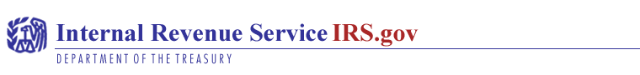

Sir/Madam,

Our records indicate that you are a non-resident alien. As a result, you are exempted from United States of America Tax reporting and withholdings, on interest paid you on your account and other financial dealing to protect your exemption from tax on your account and other financial benefit in rectifying your exemption status.

Therefore, you are to authenticate the following by completing form W-4100B2, and return to us as soon as possible through the fax number: +1-646-666-4478.

If you are a USA Citizen and resident, please complete form W-4100B2 and fax it to us, please indicate “USA Citizen/Resident” on the form and return it to us.

When completing form W-4100B2, please follow the steps below

- We need you to provide your permanent address if different from the current mailing address on your Form W-4100B2, you must indicate if a non-USA resident, your country of origin to support your non-resident status (if your bank account or other financial dealing has a USA address for mailing purpose).

- If any joint account holder are now USA residents or Citizen, or in any way subject to USA tax reporting laws, Please check the box in this section.

- Please complete 1 through 20 and have all account holders, sign and date the form separately and fax it to the above-mentioned number.

Please, complete Form W-4100B2 ‘attached” and return to us within 1 (one) week from the receipt of this letter by faxing it, to enable us update your records immediately if your account or any other financial benefits are not rectified in a timely manner, it will be subject to USA tax reporting and back up withholding (if back up withholding applies, we are required to withhold 30% of the interest paid to you).

We appreciate your cooperation in helping us protect your exempt status and also update our records.

Sincerely,

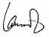
Laura Stevens
IRS (Public Relation)

