Experiences of Using Usage Record (UR) version 1.0

Status of This Document

This document provides information to the Grid community on experiences of using the Usage Record (UR) format recommendation version 1.0. It does not define any standards or technical recommendations. Distribution is unlimited.

Copyright Notice

Copyright © Open Grid Forum 2009. All Rights Reserved.

Abstract

For resources to be shared, sites must be able to exchange basic accounting and usage data in a
common format. This format must encompass both job level accounting and aggregate
accounting. The Usage Record (UR) Format describes a common format with which to exchange basic accounting and usage data over a grid instantiation.

This document describes experiences of using the Usage Record (UR) Format version 1.0 Recommendation across a number of infrastructures.

Contents

Abstract 1
1. Introduction 3
2. Process & Objectives 3
3. Survey Template 4
4. Identified Use Cases 4
4.1 APEL 4
4.2 DGAS 5
4.3 UNICORE Accounting System 7
4.4 SGAS 8
4.5 UAS 9
4.6 Gratia 10
4.7 ARCO 12
1. Security Considerations 13
2. Authors 13
3. Contributors 13
4. Intellectual Property Statement 13
5. Disclaimer 13
6. Full Copyright Notice 14
7. References 14

Introduction

For resources to be shared, sites must be able to exchange basic accounting and usage data in a
common format. This format must encompass both job level accounting and aggregate
accounting. The Usage Record (UR) Format describes a common format with which to exchange basic accounting and usage data over a grid instantiation.

This document describes experiences of using the Usage Record (UR) Format version 1.0 Recommendation across a number of infrastructures. The document is based on information returned from the experiences survey activity.

Process & Objectives

The process of gathering and consolidating the experiences is as follows:

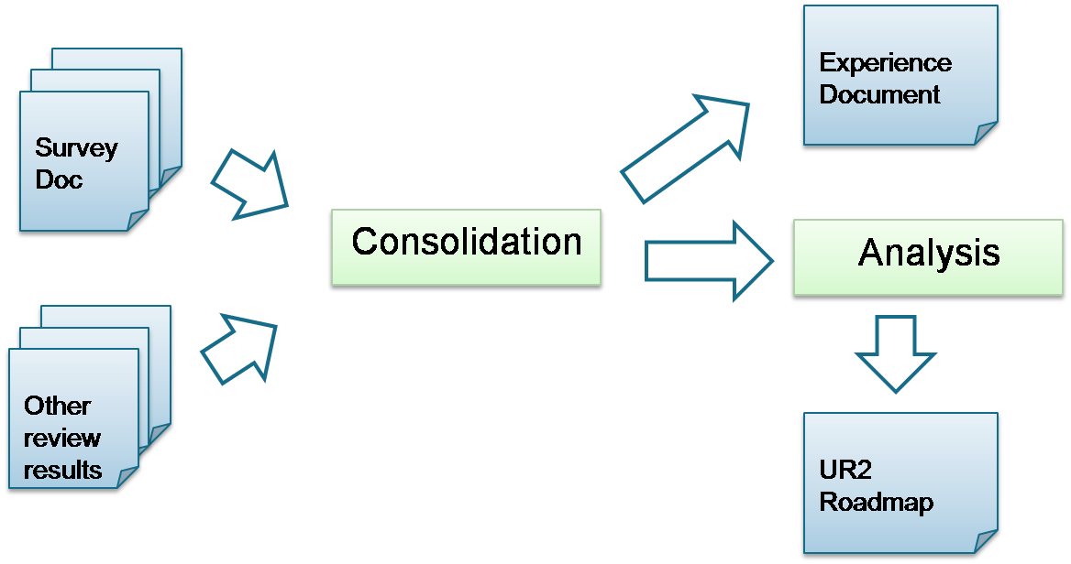

The artifacts and activities in the above process correspond to the following objectives:

- Survey doc/Other review results: from the results of the survey activity, and other sources, gather:
  - Use case collection – information concerning how UR1.0 is used.
  - Implementation status – the status of each of these infrastructures in their adoption of UR1.0
- Consolidation: from this gathered information, consolidate advanced requirements that have emerged into the Experiences Document.
- Experience Document [this document]:
  - Bring together the results from the consolidation activity
  - Provide guidance for how to progress towards UR2
  - Provide a reflective role for the RUS-WG activities.

Additionally, there is a parallel Analysis objective to produce an UR2 Roadmap from the consolidation activity and experiences. However, this is out of scope of this document [or is it?]

Survey Template
The survey template used to gather experiences with UR1.0 (available at http://forge.ogf.org/sf/go/artf6130?nav=1) was comprised of six parts:

- Project Description: overview of the project making use of UR1.0.
- Usage Metric Checklist: indication of which elements and attributes of the UR1.0 specification are produced and/or consumed.
- Extensions (if any): extensions to the specification that have been adopted to meet with additional requirements, and an indication of which extensions are considered important.
- Metering time: the times that usage records are generated e.g. at job start, job end, at points during the job, etc.
- High-level usage: details of what is done with usage records after generation.
- Recommendation to UR2 Roadmap: in which directions should the Usage Record evolve? e.g. summary records, aggregate records, improved execution/data/network accounting, etc.
- Feedback: opinions on any missing questions that should have been included in the survey.

Identified Use Cases

APEL

Overview

APEL (Accounting Processor for Event Logs), is the accounting system of WLCG, which uses URs for reporting usage statistics. Its key components are the Log Parser, which collates the information to create the records, R-GMA as the publishing protocol, and the Reporting Portal.

APEL Use Case

The use case for APEL is as follows:
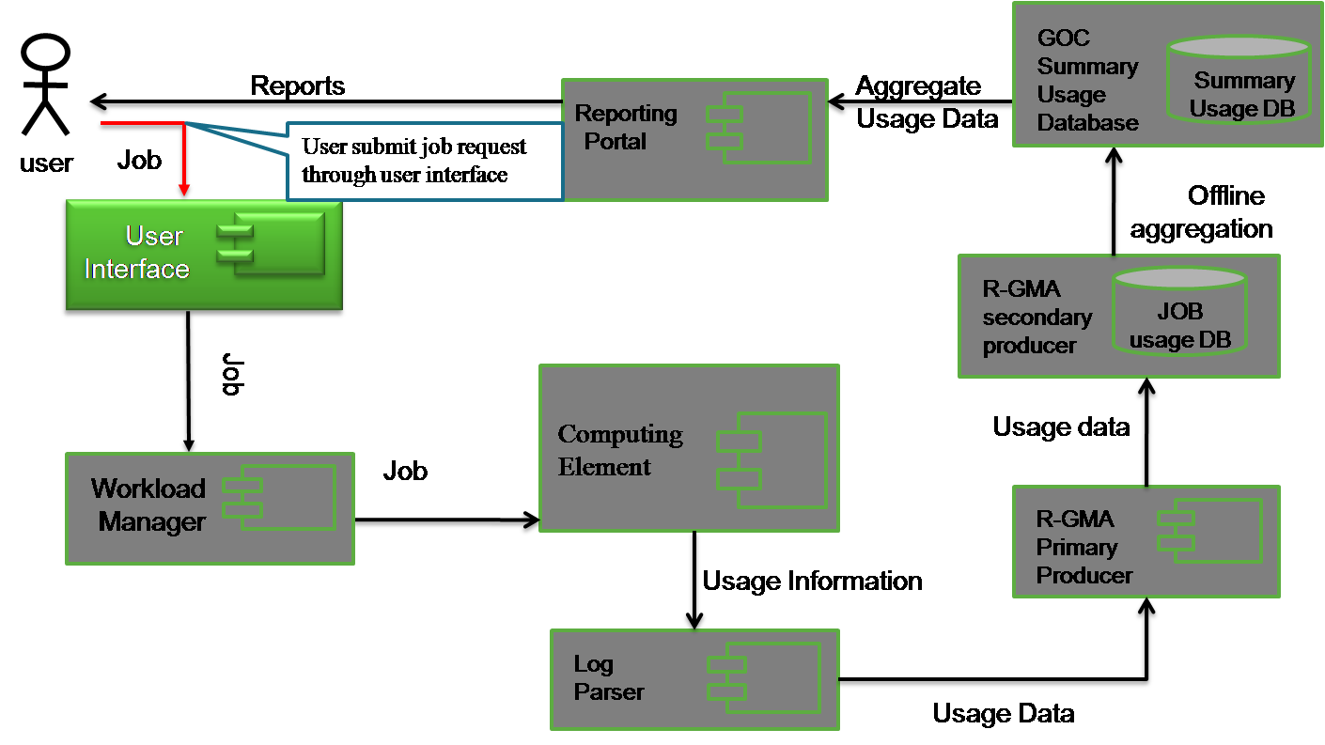

- User submits job request through the User Interface.
- The request is forwarded to the Workload Manager for scheduling.
- The job is scheduled to a particular Computing Element for execution.
- The APEL Log Parser is deployed at the Computing Element site to meter usage information periodically (e.g. once per day) by parsing LRMS log files and other relevant services.
- Pieces of usage information are gathered as a complete usage record and put into an R-GMA virtual database as a primary producer.
- Usage data are shipped into GOC/CCLRC’s persistent job usage database.
- An offline aggregation process usage records on per site, per VO, per month, per year basis into the GOC Summary Usage Database.
- User queries usage statistics through the Reporting Portal.

APEL Schema and UR

The Usage Schema adopted by APEL is as follows:

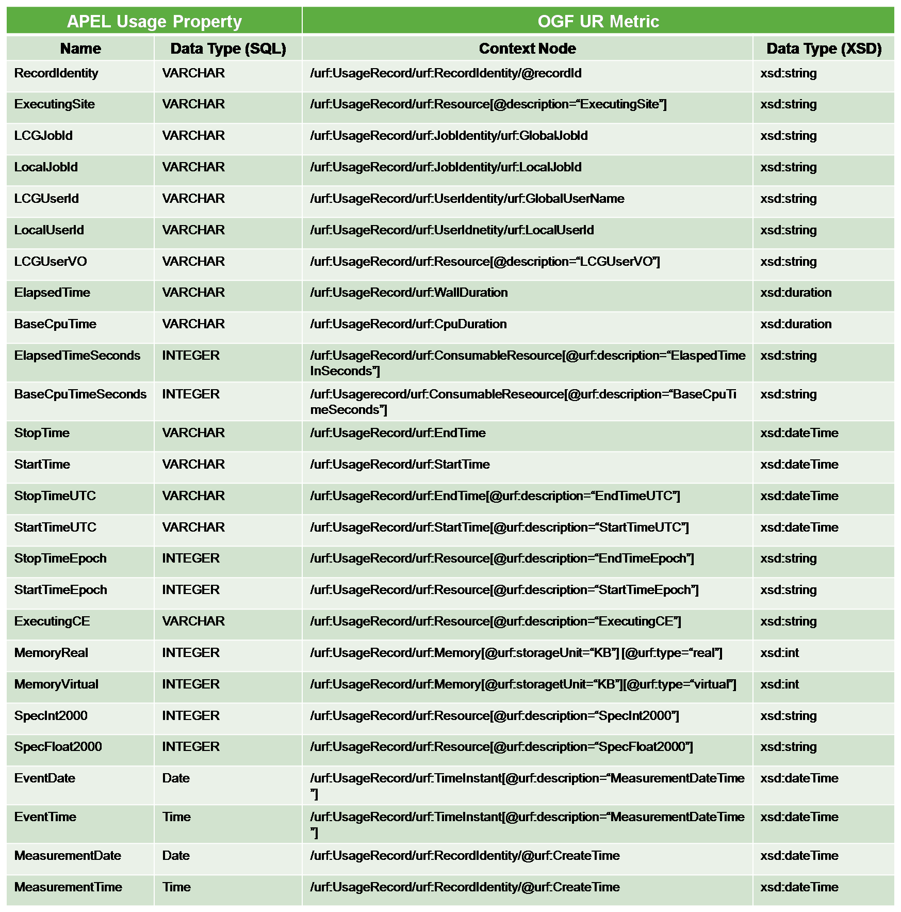

DGAS

Overview

DGAS (Distributed Grid Accounting System) employed by EGEE, used for economic accounting (e.g. economic authorization, pricing, banking, etc). Its key components are the User Interface (UI), the Workload Manager, the Price Authority, the Home Location Registry (HLR) and Sensor.

DGAS Use Case

The use case for DGAS is as follows:

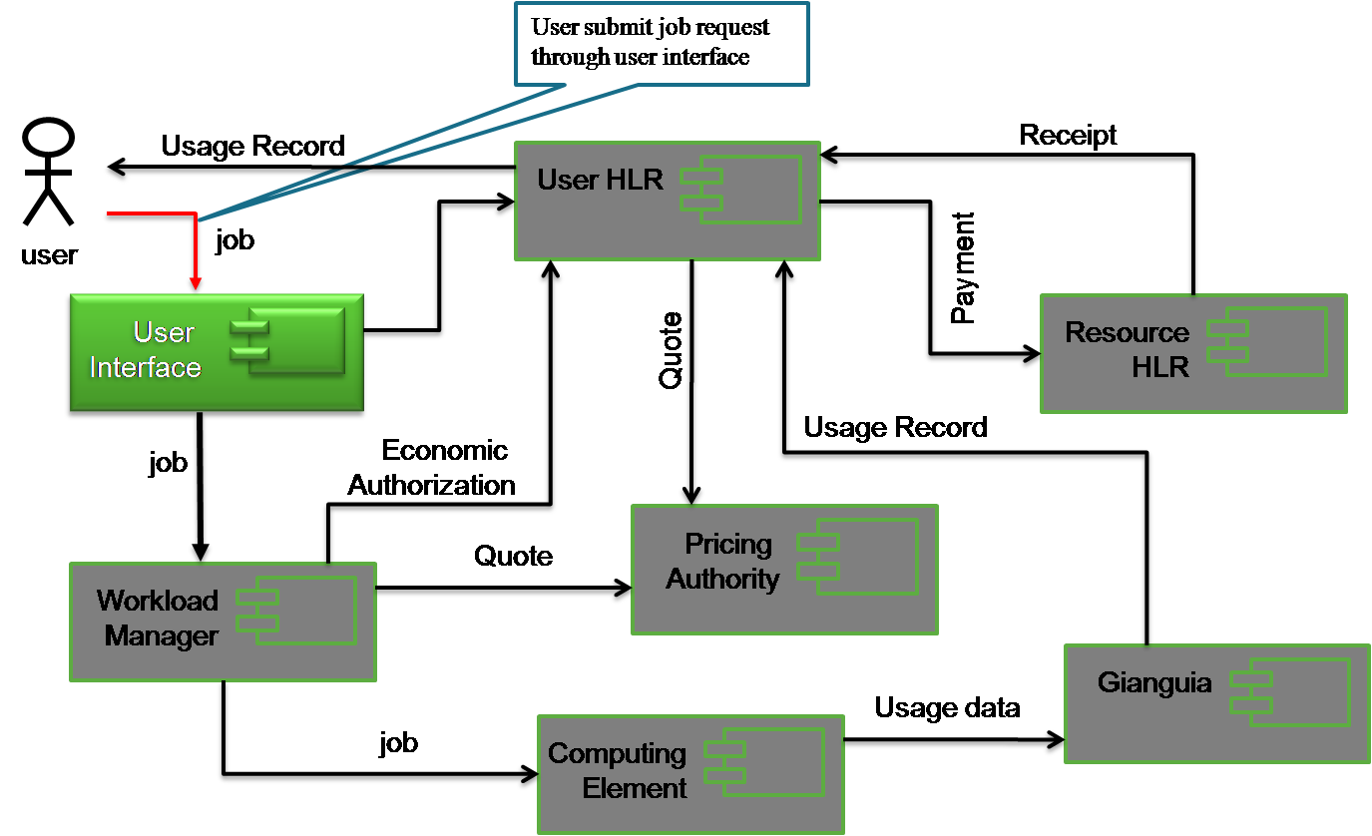

- User submit job request through the User Interface (UI).
- The User Home Location Registry (HLR) maintains user accounts. The user interface contacts User HLR to ensure the user has an account.
- Once authorized, the job request is forwarded into the Workload Manager for scheduling.
- The Workload Manager estimates the computation duration of the job request and quotes this estimation to the Pricing Authority for price estimation.
- The Workload Manager then contacts the User HLR to execute economic authorization and check whether the user enough credits to run the job.
- Once authorized, the job is scheduled or queued to a specific at Computing Element.
- On successful completion of the job, the Metering Client [Gianguia] embedded within the Computing Element resource composes a usage record of the job and forwards it to the User HLR.
- Gianguia has two client APIs, the ATM Client and URWGMetering API that feeds usage records into the HLR relational database and XML database respectively.
- The User HLR sends the actual usage as specified within the received usage record of the job to the Pricing Authority to get the actual price.
- The User HLR then contacts the Resource HLR, where user-resource accounts are maintained, and executed payment.
- The Resource HLR sends back a receipt to the User HLR upon completion of accounting process.
- User interacts with the User HLR APIs to query usage records.

DGAS Schema and UR

The Usage Schema of the DGAS ATM Client API is as follows:

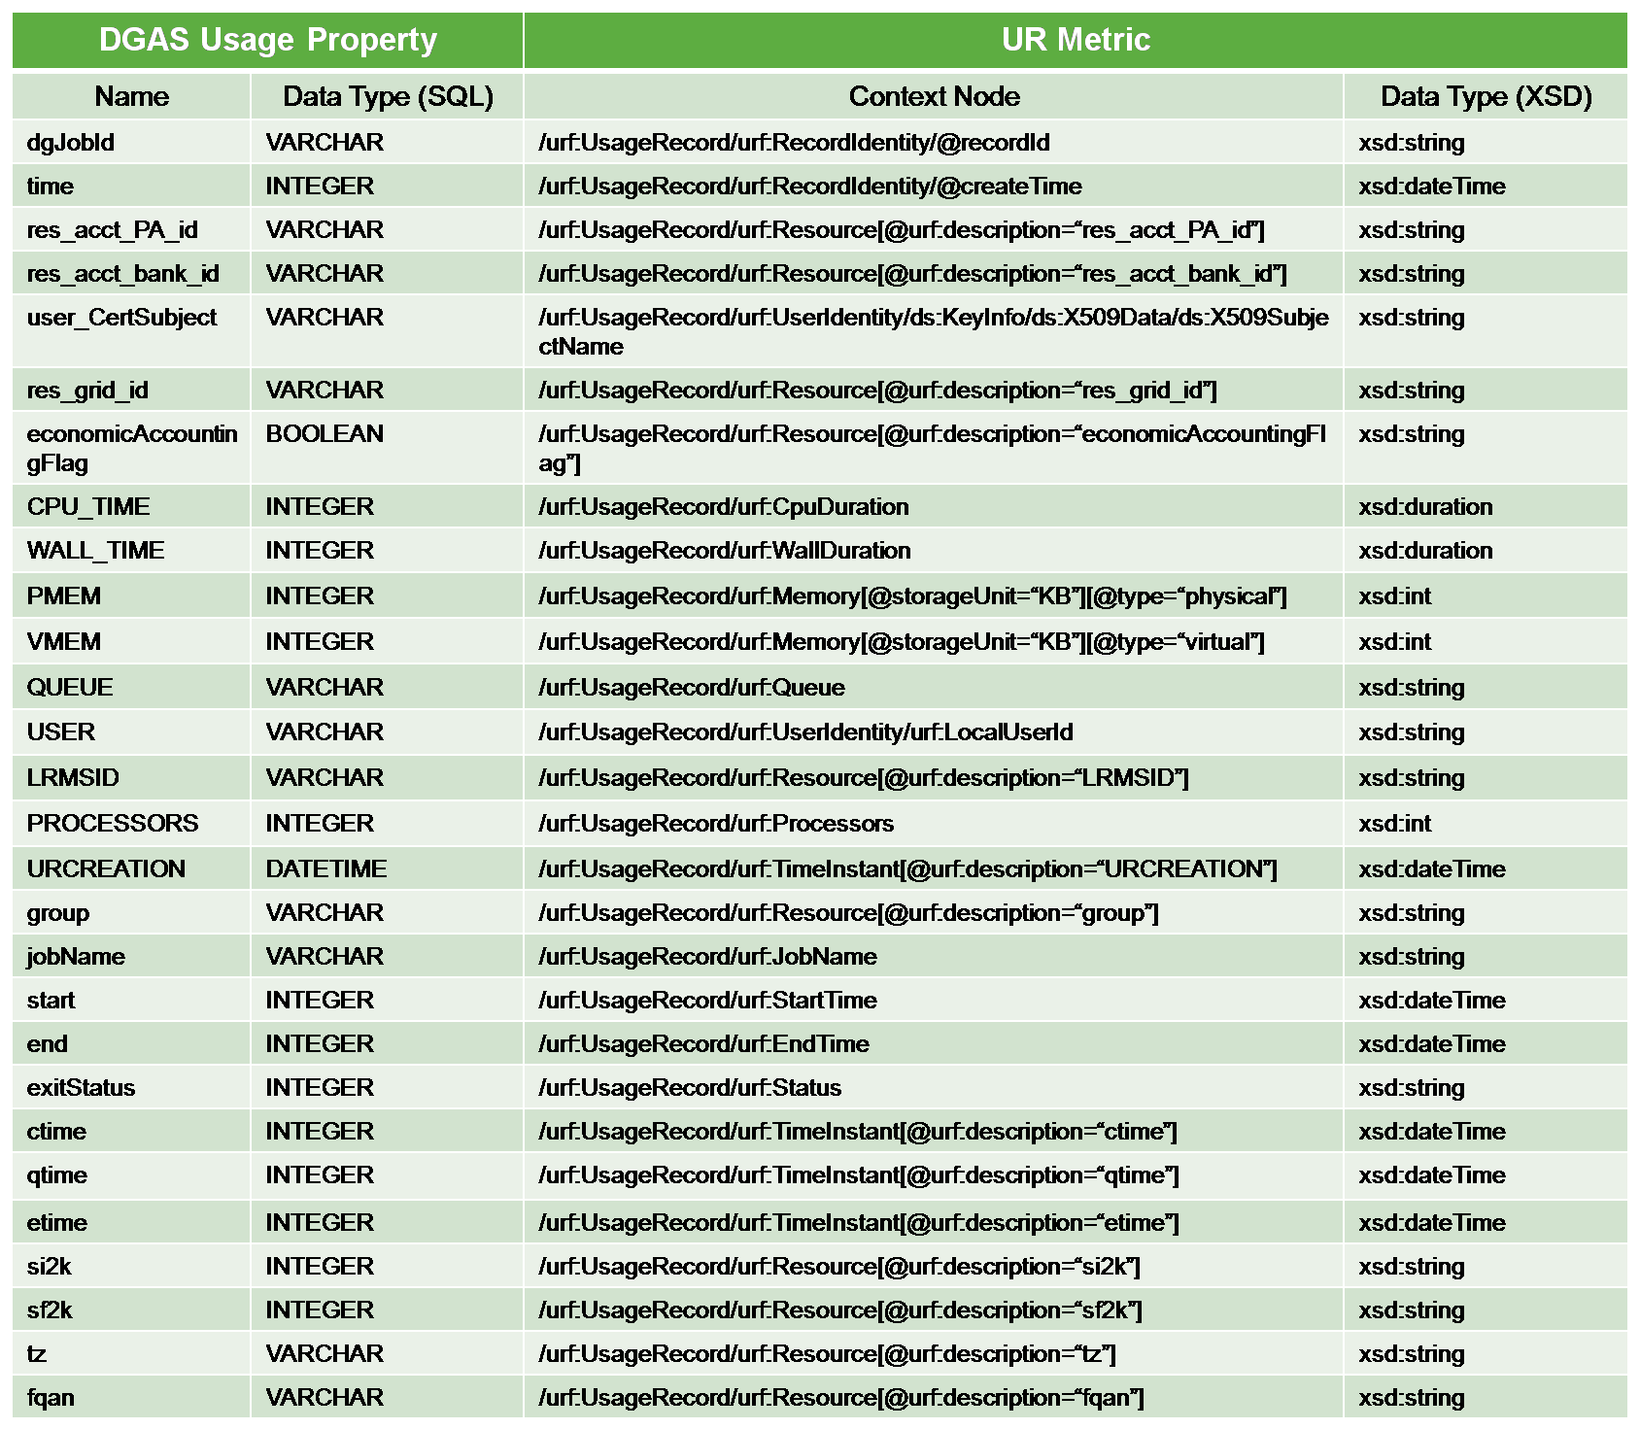

The DGAS UR-WG Metering Client generates OGF-UR (v1) compatible records in XML, with additional extensions that are economic activity specific, as follows:

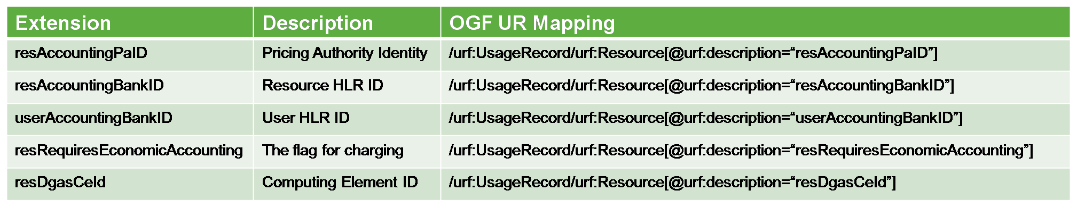

UNICORE Accounting System

Overview

The UNICORE Accounting System is mainly for real-time job usage monitoring. It is deployed at a single specific site only, and in terms of Usage Record has no aggregation or summarization capability. The key components are the Usage Record Format (URF) Generator, which meters and composes usage records, The Resource Utilisation Service (RUS), and LLView, a usage monitoring application.

UNICORE Accounting System Use Case

The use case for the UNICORE Accounting System is as follows:

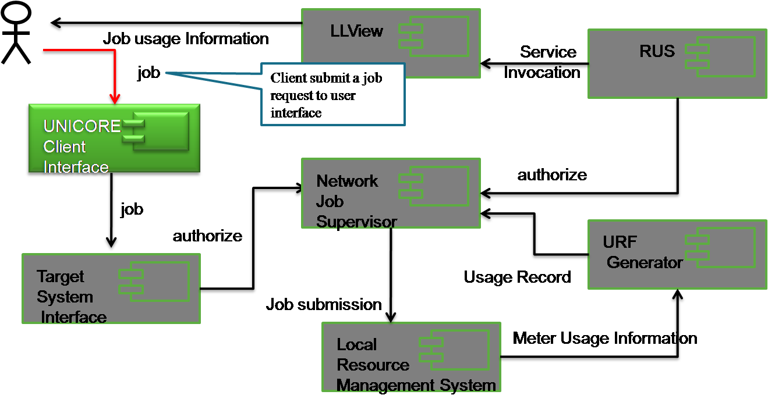

- The client submits a job request through the Client Interface.
- The job request is forwarded to the Target System Interface, which is one service of the UNICORE Atomic Services (UAS).
- The job description (JDL) is then passed to the Network Job Supervisor service to be parsed and interpreted. The NJS is also in charge of authorisation.
- If authorised, the NJS sends the parsed job request file to the Local Resource Management System for job submission.
- User can monitor submitted jobs through the LLView monitoring application.
- The LLView application invokes the RUS service, which is embedded within the UAS service, but at a higher level to other services.
- The RUS service then delegates the request to the Network Job Supervisor for authorisation.
- The Network Job Supervisor parses the RUS request into a usage record request and forwards it to the URF Generator.
- The URF Generator meters usage information of current executing jobs.

UNICORE Schema and UR

[Need more here!] UNICORE is URv1 compatible, extensions?

SGAS

Overview

SGAS (SweGrid Accounting System) is a Globus accounting component, widely deployed within Norway for economic accounting purposes. Its key components are the Job Account Reservation Manager for economic authorisation, the Bank Service, and the Logging and Usage Tracking Service which contains an RUS implementation for usage query.

SGAS Use Case

The use case for SGAS is as follows:

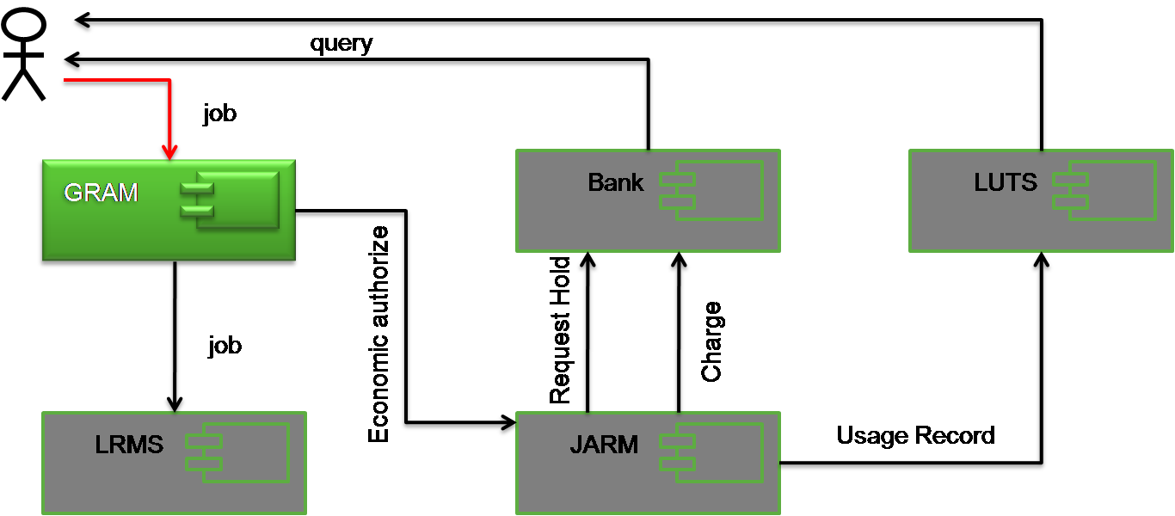

- The user submits a job request to the Globus Resource Allocation and Management (GRAM) service.
- Economic authorisation is then requested for the user from the Job Account Reservation Manager (JARM).
- The JARM requests authorisation from the Bank, which issues a time-limited reservation to run the job.
- If economic authorisation is given, GRAM submits the job to the Local Resource Management System (LRMS).
- Following execution, the JARM then sends the economic ‘charge’ to the Bank, and submits a completed usage record to the Logging and Usage Tracking Service (LUTS).
- The user is able to query both the Bank and LUTS for economic and usage records respectively.

SGAS Schema and UR

SGAS additionally supports the following extension to UR:

Extension | Description | OGF UR Mapping
VOName | Virtual Organization Name | /urf:UsageRecord/urf:Resource[@urf:description=“VOName”]

UAS

Overview

The UAS (User Accounting System) is used by the National Grid Service (NGS) in the UK, mainly for usage monitoring against allocated quotas on per-user basis. Its key components are the JDMDB module, which captures user/job mapping information by parsing Globus log files, Batch2UR which meters local resource usage, UR Generator, RUS and the User Accounting System (UAS) Portal.

UAS Use Case

The use case for UAS is as follows:

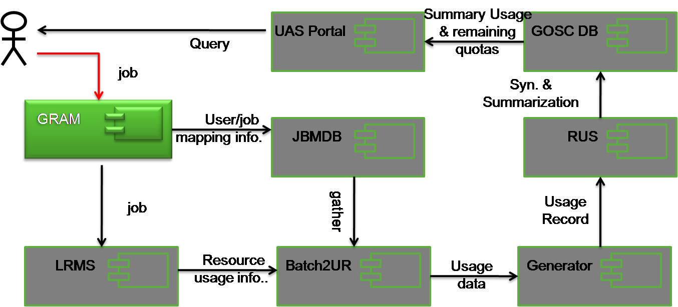

- The user submits a job request to the Globus Resource Allocation and Management (GRAM) service.
- GRAM informs the JBMDB about the user/job information.
- GRAM submits the job to the Local Resource Management System (LRMS).
- Batch2UR monitors the usage of the job on the LRMS, and together with user/job information retrieved from JBMDB, generates usage data.
- The UR Generator converts this usage data into usage records which are forwarded to the Resource Utilisation Service (RUS).
- The RUS stores usage records persistently in an Oracle relational database.
- Usage data are summarised into the Grid Operations Support Centre (GOSC) database through an Oracle synchronisation mechanism.
- Summary of use and remaining quotas can be retrieved by the UAS Portal on request.

UAS Schema and UR

The following extensions to the UR schema are supported:

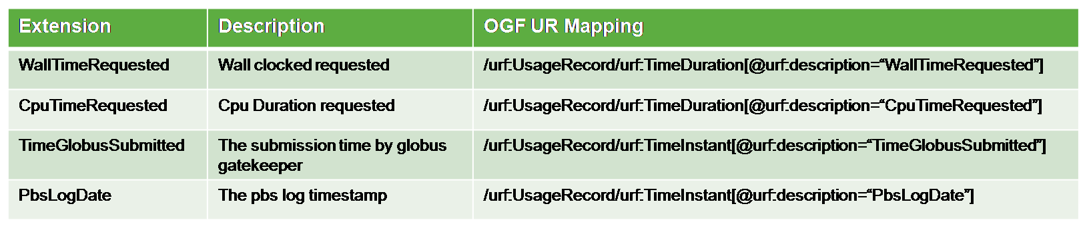

Gratia

Overview

Gratia is the accounting system used within the Open Science Grid (OSG), and is mainly used for usage reporting. Its key components are the Probe, which meters and generates usage record files, the Collector, which gathers usage records, and the Publisher, which is essentially a web portal.

Gratia Use Case

The use case for Gratia is as follows:

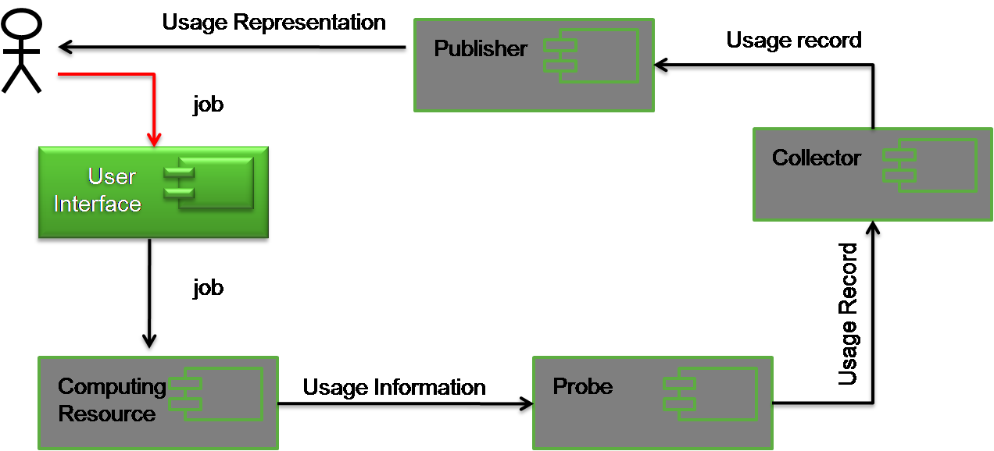

- The user submits a job through the User Interface.
- The job is submitted to the local Computing Resource.
- Usage information is gathered by Probe, converted into a usage record and sent to the Collector.
- The Collector gathers usage records and sends them on request to the Publisher web portal.
- The user can query usage via the Publisher web portal.

Gratia Schema and UR

The Gratia database model is as follows:

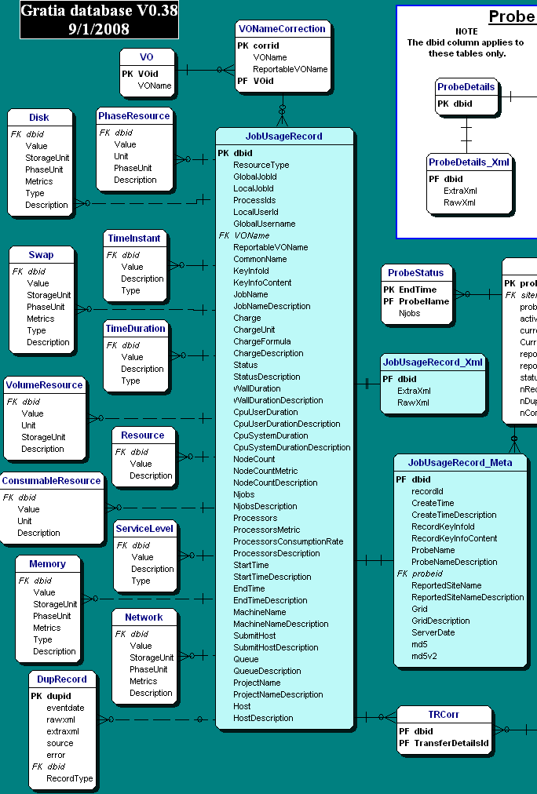

ARCO

Overview

ARCO (Accounting and Reporting Console) is specifically used within the Sun GridEngine, mainly for usage reporting. Its key components are the DBWriter, which meters resource usage and the Web-based Console tool, which is a graphical reporting portal.

ARCO Use Case

The ARCO use case is as follows:
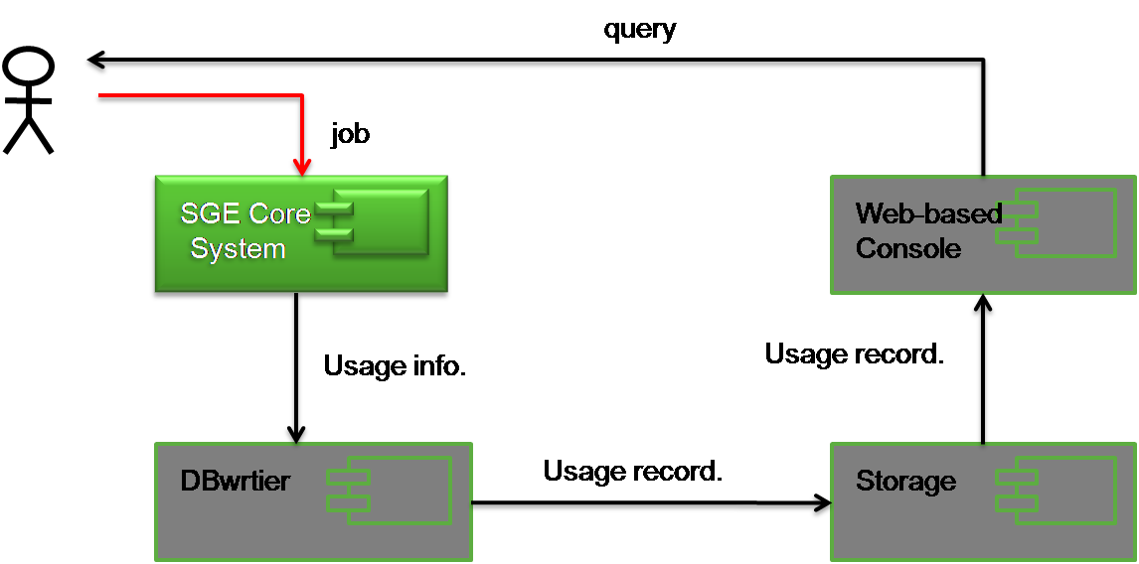

- The user submits a job to the Sun GridEngine (SGE) Core System.
- The Sun GridEngine (SGE) Core System executes the job on the local resource.
- The usage information is formatted into a usage record by the DBWriter and sent into Storage.
- Upon request from the user, the Web-based Console can retrieve usage records from Storage.

ARCO Schema and UR

The usage schema for UR adopted by ARCO is as follows:

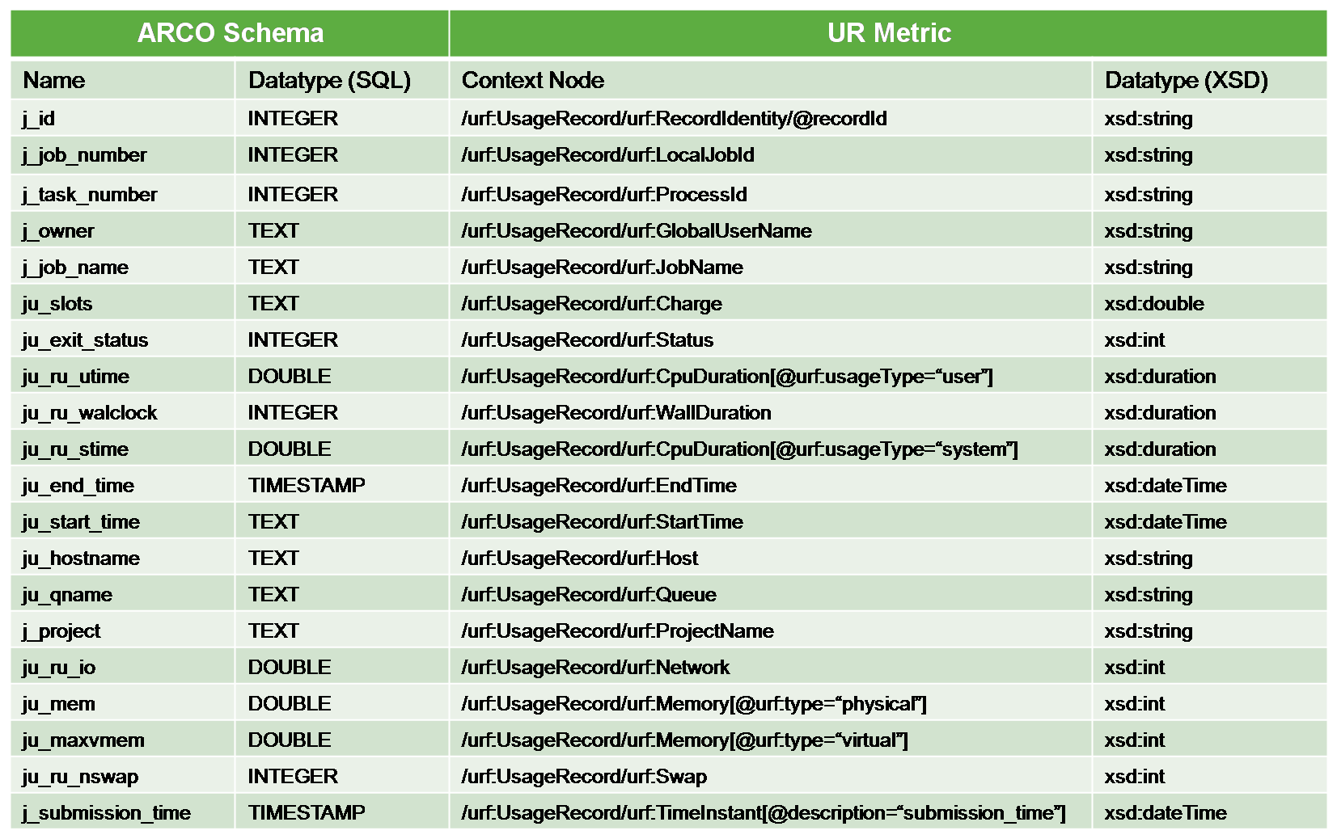

Security Considerations

Please refer to RFC 3552 [RESCORLA] for guidance on writing a security considerations section. This section is required in all documents, and should not just say “there are no security considerations.” Quoting from the RFC:

“Most people speak of security as if it were a single monolithic property of a protocol or system, however, upon reflection, one realizes that it is clearly not true. Rather, security is a series of related but somewhat independent properties. Not all of these properties are required for every application.

We can loosely divide security goals into those related to protecting communications (COMMUNICATION SECURITY, also known as COMSEC) and those relating to protecting systems (ADMINISTRATIVE SECURITY or SYSTEM SECURITY). Since communications are carried out by systems and access to systems is through communications channels, these goals obviously interlock, but they can also be independently provided.”

Authors

Steve Crouch, OMII-UK, University of Southampton, s.crouch@omii.ac.uk.
Donal Fellows, University of Manchester, donal.k.fellows@manchester.ac.uk.

Contributors

The authors gratefully acknowledge the contributions made to this experiences document by …

Intellectual Property Statement

The OGF takes no position regarding the validity or scope of any intellectual property or other rights that might be claimed to pertain to the implementation or use of the technology described in this document or the extent to which any license under such rights might or might not be available; neither does it represent that it has made any effort to identify any such rights. Copies of claims of rights made available for publication and any assurances of licenses to be made available, or the result of an attempt made to obtain a general license or permission for the use of such proprietary rights by implementers or users of this specification can be obtained from the OGF Secretariat.

The OGF invites any interested party to bring to its attention any copyrights, patents or patent applications, or other proprietary rights which may cover technology that may be required to practice this recommendation. Please address the information to the OGF Executive Director.

Disclaimer

This document and the information contained herein is provided on an “As Is” basis and the OGF disclaims all warranties, express or implied, including but not limited to any warranty that the use of the information herein will not infringe any rights or any implied warranties of merchantability or fitness for a particular purpose.

Full Copyright Notice

Copyright (C) Open Grid Forum 2009. All Rights Reserved.

This document and translations of it may be copied and furnished to others, and derivative works that comment on or otherwise explain it or assist in its implementation may be prepared, copied, published and distributed, in whole or in part, without restriction of any kind, provided that the above copyright notice and this paragraph are included on all such copies and derivative works. However, this document itself may not be modified in any way, such as by removing the copyright notice or references to the OGF or other organizations, except as needed for the purpose of developing Grid Recommendations in which case the procedures for copyrights defined in the OGF Document process must be followed, or as required to translate it into languages other than English.

The limited permissions granted above are perpetual and will not be revoked by the OGF or its successors or assignees.

References
Note that only permanent documents should be cited as references. Other items, such as Web pages or working groups, should be cited inline (i.e., see the Open Grid Forum, http://www.ogf.org). References should conform to a standard such as used by IEEE/ACM, MLA, Chicago or similar. Include an author, year, title, publisher, place of publication. For online materials, also add a URL. It is acceptable to separate out “normative references,” as IETF documents typically do. Some sample citations:

[BRADNER1] Bradner, S. Key Words for Use in RFCs to Indicate Requirement Levels, RFC 2119. March 1997.
[BRADNER2] Bradner, S. The Internet Standards Process – Revision 3, RFC 2026. October 1996.
[CATLETT] Catlett, C. GFD-1: Grid Forum Documents and Recommendations: Process and Requirements. Lemont, Illinois: Global Grid Forum. April 2002.
[RESCORLA] Rescorla, E. Guidelines for Writing RFC Text on Security Considerations. RFC 3552. July 2003.

