ByteIO Interface
Mark Morgan, Andrew Grimshaw
Department of Computer Science, University of Virginia

The ByteIO interface represents a small subset of functionality which we believe captures an important, common case for data access. While access to data can span a large gambit of possible scenarios (access to files, access to databases, access to repositories of metadata, etc.), a very common rendering for data access is through a simple file interface. Further, we also believe that access to grids through the use of readily available, common protocols such as NFS and CIFS is important for the adoptability of grid technology. This document describes a prototype interface for a ByteIO port type – a simple web service port type which is reminiscent of a posix-like interface. This prototype addresses the various requirements for a simple, basic data access layer which NFS and CIFS modules can easily be written to interface with.

The ByteIO interface (which is described in UML in Figure 1) contains four “posix-like” functions. It’s important to note that this interface implies a session-less communication semantic, but that this design does not prohibit session capable client semantics. In fact, we assume that a number of common file interface APIs will be implemented in client libraries to provide convenient mechanisms for data access (for example, true posix style functions, C++/Java/C# streams, etc.). Further, applications which would benefit from a more session oriented service structure can easily achieve this functionality via a web service wrapper on top of the existing session-less semantics given below.

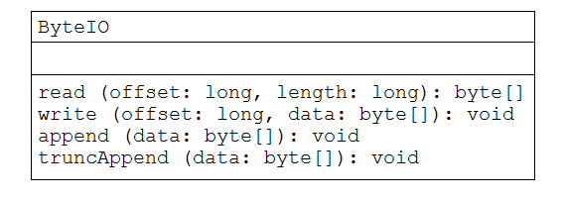
Figure 1: UML for ByteIO Interface

read
Input: long offset
long length
Output: byte[]
Faults: IOFault

The read function is used to retrieve a block of data from a given ByteIO service resource. The client specifies an offset in the file at which to start reading and the number of bytes to read. The result from this call is a byte array with 0 or more elements (up to the limit given by the client). Clients should be aware that short arrays can be returned if the end of the file is reached.

write
Input: long offset
byte[] data
Output: None
Faults: IOFault

Clients use the write function to write a given block of data into a ByteIO service resource. The client may write to any offset within the file (greater then or equal to zero) and if the offset specified is larger then the file size, the semantics are to grow the file as needed.

append
Input: byte[] data
Output: None
Faults: IOFault

The append function is used to append a block of data to the end of a ByteIO service resource. This function should be considered atomic.

truncAppend
Input: byte[] data
Output: None
Faults: IOFault

The truncAppend function is used to both truncate a ByteIO resource and append data to that freshly truncated endpoint. In otherwords, the file is first truncated, and then any data contained in the input data array (which is allowed to be of size 0), is appended to the empty file. This operation should be considered atomic.

