Information & Data Modeling in OGSA Grids
Architecture Paper
Sergio Andreozzi

Proposal for replacement of Figure no.3
https://forge.gridforum.org/sf/docman/do/listDocuments/projects.ogsa-wg/docman.root.working_drafts.information_modeling_arch

https://forge.gridforum.org/sf/docman/do/listDocuments/projects.ogsa-wg/docman.root.working_drafts.information_modeling_arch

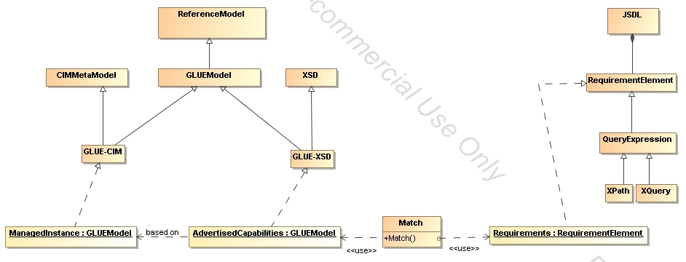
- Resource requirements are contained in a JSDL document
  - They are currently expressed in a descriptive way with a JSDL-specific schema
    - (not represented in this diagram)
  - The plan is to represent requirements as query expressions on resource capabilities description
    - XQuery is the current candidate
- Resource Capabilities are typically advertised via an information service following a certain schema
  - In the current diagram, we show an XSD-based description of resource capabilities based on GLUE 2
- Managed resources may be represented via CIM-based systems;
  - GLUE 2 will be also rendered based on the CIM metamodel
- Open issues:
  - Does this approach fit the purpose of the paper?
  - Check correctness of the UML Class diagram?
  - Should we generalized this diagram to different resource descriptions?
    - GLUE, …
  - Should we represents different Requirement Elements specializations?

