A Basic Execution Service
V0.3 – 7th March 2005
Authors: Newhouse, Morgan, Grimshaw, …

Motivation
The purpose of this document is to describe, for discussion purposes, a web service interface to initiate, monitor & control activity on computational resources. This web service interface will enable the creation, destruction and status determination of ‘entities’ (e.g. jobs, services, resources, …) within a container – an abstract representation of computational capability. Such a container may be a single machine, a cluster managed through a Distributed Resource Manager (DRM) such as Load Leveller, Sun Grid Engine, Portable Batch System, etc. or an interface into a web service hosting environment. Operational differences between container implementations are not expected to be reflected in the service implementation.

Considerable effort has been undertaken within the OGSA-WG EMS (Execution Management System) design team to define the different services and their interactions. The current high-level architecture for the execution of ‘legacy’ binary applications is encapsulated in this diagram:
Provisioning
Deployment
Configuration
Information Services
Service
Container
Data
Container
Accounting Services
Execution Planning Services
Candidate Set Generator (Work -Resource mapping)
Job Manager
Reservation
The purpose of this service interface is to tackle the issues surrounding the ‘Service Container’ and to form part of the OGSA Basic Execution Profile. Other services described within the above architecture are considered to be out of scope of this activity.

Assumptions
By the time we reach the point of invoking the Basic Execution Service (BES) we assume that the following issues have been resolved:
- The placement decision (where the ‘thing’ is going to run) has already been determined.
- The ‘thing’ that is going to run has already been determined elsewhere.

An essential pre-requisite to the following model is an AbstractName that provides a globally unique identifier in time and space. It is expected that the structure of the AbstractName will be defined by the various naming activities taking place within the OGSA-WG (e.g. Resource Naming Service, WS-Naming, Naming Profile, etc.) – it is not our intention to duplicate work in this area. A further constraint on the abstract name is that it is typed and has version information relating to the type. An example of such work that meets these criteria is the Life Science Identifier (LSIDs).

The word ‘activity’ will be used frequently from this point in the document. Within this context an activity could be the execution of a legacy binary, the initiation of a web service within a container. From the perspective of an external observer this is a self contained operation. If it can be further decomposed, such decomposition does not visible through the service interface.

Service Interface

initiateActivityFromJSDL
Input: AbstractName submissionIdentifier, String jobDescriptionDocument
Output: AbstractName activityIdentifier
Faults: UnsupportedFeatureFault, JobSpecificationFault

The submissionIdentifier provides a unique identifier that is associated with the invocation of this operation and the associated jobDescriptionDocument. Subsequent invocations of this method which reuse this submissionIdentifier must associate the previous ‘failed’ invocation attempt with this attempt.

The jobDescriptionDocument is a well formed XML document that conforms to JSDL 1.0. If it is not well formed then a JobSpecificationFault is returned. The service implementation may not support all the possible features within the JSDL specification, e.g. ftp transfer. If a feature is requested in the jobDescriptionDocument that is not supported by the service then an UnsupportedFeatureFault is returned by the service.

On success an AbstractName identifying the requested activity is returned from the service.

initiateActivityFromName
Input: AbstractName activityDescriptionIdentifier
Output: AbstractName activityIdentifier
Faults: UnsupportedFeatureFault, ActivitySpecificationFault, UnsupportedJobTypeFault

The activityDescriptionIdentifier is an AbstractName that can be resolved by the service to obtain a description of the job. The BES may use the type and type version information within the AbstractName to decide not to further process the activityDescriptionIdentifier by throwing an UnsupportedJobTypeFault. This would allow JSDL and xRSL documents (referenced through the AbstractName) to be consumed by the same service interface. A syntax error in this referenced document is reflected in a ActivitySpecificationFault. A well formed document may request features not supported within the service implementation which will result in an UnsupportedFeatureFault.

On success an AbstractName identifying the requested activity is returned from the service.

getActivityStatus
Input: AbstractName[] activityIdentifier
Output: String[][] activityStates
Fault: UnknownActivityFault

If the service is not able to resolve the activityIdentifier then it throws an UnknownActivityFault. If the activityIdentifier is known then the current activity state is returned. The activity may satisfy more than one of the supported activity states, e.g. execution complete and files staging out.

terminateActivity
Input: AbstractName[] activityIdentifier
Output: Boolean[] activityTerminated
Fault: UnknownActivityFault

If the service is not able to resolve one of the activityIdentifier then it throws an UnknownActivityFault. If the activityIdentifier is known and the job is Active, the job is terminated. If the termination succeeds then activityTerminated is set to true, if it fails it is set to false. If the activity is known and the activity is not Active then activityTerminated is set to false.

getSupportedActivityStates
Inputs: None
Outputs: String[] activityStates

The service returns an array of the possible activity states supported by the BES. These states are drawn from those defined in Section 4 (Activity States).

Activity States
The job’s activity states can pass through the following stages:
State | Description
Arrived | Job has been accepted into the container.
Staging-In | Input files are being moved to the machine.
Staged-In | Input files are now on the machine.
Pending | The local scheduler has not yet scheduled the job for execution.
Active | Job is executing.
Suspended | Job execution has been suspended.
Complete | Job execution is complete.
StagingOut | Output files are being moved off the machine.
StagedOut | Output files are now off the machine.
CleanUp | The job and any remaining artefacts are being removed from the container.
Done | Job has completed successfully.
Failed | Job failed.

Open Issues
Semantics: How much policy evaluation at this stage? What about security?

Survey of Existing Infrastructures
This section contains some background information on other infrastructures.

GT4 GRAM

States
State | Description
Unsubmitted | Job has not yet been submitted.
StageIn | Job is waiting for stage in of executable or input files to complete.
Pending | The local scheduler has not yet scheduled the job for execution.
Active | Job is executing.
Suspended | Job execution has been suspended.
StageOut | Job execution has completed; output files are being staged out.
CleanUp | Job execution and stage out have completed; clean up tasks are underway.
Done | Job has completed successfully.
Failed | Job failed.

State Transition Diagram
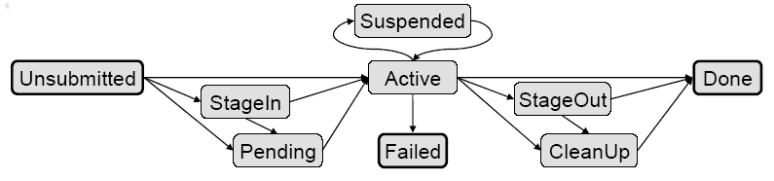

GridSAM

States
State | Description
Pending | Job has not yet started.
Staging-In | Input files are being moved to the machine.
Staged-In | Input files are now on the machine.
Active | The job is executing.
Executed | Job execution is complete.
Staging-Out | Output files are being moved from the machine.
Staged-Out | Output files have been removed from the machine.
Done | Job execution is complete and the files have left the machine.
Failed | Job failed.

State Transition Diagram
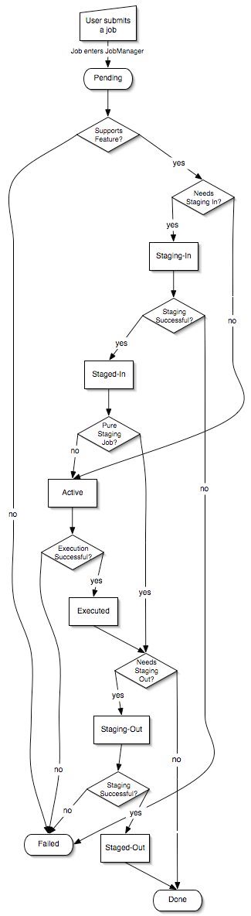

Life Science Identifiers: LSID
Life Science Identifiers [LSID] are a proposal to Object Management Group [OMG] to provide a standarised naming scheme for biological entities in the Life Science domain. Although focussed on life science related objects the structure and principles are equally applicable to other domains. Life Science Identifiers (LSIDs) are persistent, location-independent, resource identifiers that are intended to be semantically opaque, in that the LSID assigned to a
resource should not be counted on to describe the characteristics or attributes of the
resource that the LSID refers to. LSIDs are expressed as a URN namespace and share the following functional capabilities of URNs:
- Global scope
- Global uniqueness
- Persistence
- Extensibility
- Independence
- Resolution

The following examples (which draw heavily on the life sciences world) illustrate the structure of the LSID:

URN:LSID:ebi.ac.uk:SWISS-PROT.accession:P34355:3
URN:LSID:rcsb.org:PDB:1D4X:22
URN:LSID:ncbi.nlm.nih.gov:GenBank.accession:NT_001063:2

The first three fields are case insensitive while the sixth field (relating to the revision of the object) is optional and may be omitted.
URN:LSID:Authority:Namespace:Object
or
URN:LSID:Authority:Namespace:Object:Revision

The authority identification is usually an Internet domain name normally owned by the organization that assigns an LSID in question. Such organization is responsible for ensuring the uniqueness of the string created from the namespace, object and revision identifications. In the case where the authority identification string is not an Internet domain name, the authority should take care to ensure that it is a unique string and if possible, register that unique string with the organization that is currently the authority for the URN Namespace Identifier (NID) “lsid”.

The namespace identification is an alphanumeric sequence that constrains the scope in which the subsequent object identification is resolved. The object identification is an alphanumeric sequence. The revision identification is an alphanumeric sequence. It is an optional component of the LSID.

Further detail on LSID can be found in the specification document [LSID] from which this text has been drawn as well as details on interface bindings in Java, Web Services, etc.

Security Considerations

References
GT4-GRAM:
RNS:
GridSAM:

