Basic EMS Service
Andrew Grimshaw, Mark Morgan
Department of Computer Science, University of Virginia
Christopher Smith, Platform
Steven Newhouse, OMII
William Lee, Imperial College London
Dave Berry, National eScience Centre
Steve McCough
Abdeslem Djaoui, Rutherford Appleton Laboratory

Abstract

The ability to launch new services dynamically is a key requirement for grids. Creating new web service endpoints and resources is a complicated process – creating running legacy binary application instances is substantially more complex and equally important. Both of these execution scenarios must be addressed. The Basic EMS (Execution Management Services) group is attempting to lay down a framework for just these situations. This document introduces a draft set of services based on the current EMS outputs as well as those of the OMII and EGEE groups.
1. Definitions

Confusion has arisen inside the EMS group revolving around the uses and meanings of the words Job and Task. These terms carry significant implicit meaning when considered in the context of the execution of new service endpoints and applications. Additionally, the implicit baggage of these terms is different for every individual. To some, a job is a collection of tasks which could represent a workflow, and array of tasks, a single task to perform, etc., while to others the exact opposite could be implied. This confusion has also occurred in other OGSA groups revolving around other “overloaded” terms. To avoid such confusion in this document and to proactively avoid further ambiguities, we introduce a new set of terms which we will use throughout. We intentionally choose these terms to escape the baggage and could just as easily have used descriptions like foos, bars, and zebras. These terms are defined as follows:

Actor
An Actor is the single smallest unit of execution that is represented in the grid. It is a new service endpoint or resource, or a new running instance of a legacy binary. In the context of the grid an Actor is atomic.

Application Descriptor
An Application Descriptor is a web service resource which represents all of the information related to a specific “type” of application. It not only serves as a place holder with which to identify application types (for example, giving us the ability to talk not about the BLAST application generically, but rather specifically identifying “the application referenced by this handle”), but it also gives us a convenient place to store data and metadata about an application.

Abstract Name (AN)
Historically, Grids have featured multi-tiered naming schemes to facilitate various levels of indirection, representation, and identification of grid endpoints. Traditionally one would expect any such naming architecture to feature human readable semi-static bindings (such as in a file system) in one of the higher level tiers, and a highly dynamic physical address or location dependent name at the lowest level (i.e. URL, IP/port, etc.). Between these two levels it’s often useful to have a completely static name which is guaranteed globally unique and which for the lifetime of the endpoint serves as that endpoint’s handle or identity. This identity is what we refer to as the Abstract Name. An Abstract Name is a reference to a grid service instance and has the following properties:
- It is globally unique in both space and time
- It can cheaply be compared against other Abstract Names for equality
- It contains type (and type version) information

Annotation
Recently in some of the various OGSA groups there has been a conscious effort to cease using the term “metadata” to describe information attached to or describing other resources. Keeping in line with those trends, we use the term Annotation throughout this document to indicate a piece of information which describes a property or piece of information about a resource to which it refers. No implementation is inferred by the use of this term.
2. An Execution Scenario

In this section, we describe at a high level the various execution management pieces that can be involved in the life-cycle of a client-launched application. Components are grouped by the phase of the solution creation and execution life-cycle in which they play a role. Additionally, we describe some of the higher level interactions between those port types. A more in-depth view of these various entities follows in section 3.

2.1 Application Selection

Before a client can execute or create new Actors the client must first identify which executables or web service resources he or she wishes to launch or create. Application Descriptors provide a means for clients and other EMS components to talk about types of applications or endpoints without resorting to comparing binaries, port types, etc. These descriptor resources conceptually act as repositories of annotations about application types and provide a means of universally referring to those application types at an abstract level.

Behind Application Descriptors sit File Descriptors. These resources are instances of the ByteIO port type (a port type which supports the stereotypical interfaces and properties of a file instance in the grid) with certain required annotations. In particular, File Descriptor instances serve as the remotely accessible representations of required or statically provision-able files for any given application type. In the case of an Actor which is ultimately a web service endpoint, the Application Descriptor which represents that application type may have no attached File Descriptors (though nothing prevents them from having them). However, in the case of legacy applications, File Descriptors are the prime repositories of the legacy application’s implementation. These files represent the known binary implementations for that application type as well as any other required files such as configuration files, shared libraries, etc. Each File Descriptor includes annotations which identify binary architecture and operating system compatibility, versioning information, and so on. The Application Descriptor contains a list of 0 or more Abstract Names referencing these File Descriptors and thereby linking the application type with the files required to successfully launch or create them. Together, these two port types completely identify everything that needs to be known in order to launch an application instance.

2.2 Actor Provisioning

After a client (be it a user, or a piece of software) has identified an Application Description to launch, it next asks a Service Container resource to create a new instance of the required application type. The request to create this application can come from any suitably knowledgeable source (such as a user who has specifically identified the target Service Container, or a more complex piece of scheduling software which has come to the placement decision through other, algorithmic means). Regardless of how the placement decision is made, the Service Container is always the endpoint to which creation requests flow.

Service Containers always start or create new web service resources regardless of whether or not the create request is ultimately intended for the launch of a legacy application instance. In the case of a legacy application instance, the actor which the Service Container creates (the Proxy Actor) is a special web service resource specifically designed to launch and manage legacy binaries. By using this proxy as a front-end to legacy applications we are able to greatly simplify the Service Container as well as more transparently handle the different creation types.

Once the Service Container has been selected and contacted, the File Descriptors that belong to the target Application Descriptor must be provisioned. These files often will include the binaries necessary to run the legacy jobs as well as any required shared or dynamic libraries. They may also include static configuration and data files.

3. EMS Port Types and Data Types

This section of the document provides a more detailed look at the various web service resources that make up this EMS implementation proposal. Each section discusses a single web service port type. Included in Appendix A is a UML diagram showing the relationships between these various types.

3.1 Application Descriptor

An Application Descriptor is a web service resource which completely describes a “type” of Actor or application. This resource provides a means of talking about a specific type of application to be launched or created at a higher, more abstract level than discussing port types, binaries, etc. The Application Descriptor resource can also be used to describe annotations, requirements, etc. about the application (things like “this application is a legacy executable or a web service”, “this executable always takes the following command line arguments”, etc.) The Application Descriptor resource will also contain a list of File Descriptor resources that are known to satisfy the given application type (see File Descriptor below).

3.2 File Descriptor

This service endpoint contains all of the port type methods of a standard generic file along with additional annotations that describe the file. These resources are assumed to represent architecture dependent binary files that are required to run an application. For example, a File Descriptor resource might represent a program executable, a shared or dynamic library, etc. It is also possible that File Descriptor resources can be used to indicate other required, but architecture agnostic, files such as configuration files and static (non-changing) input files. An Aplication Descriptor maintains a list of these File Descriptors (which could be a list of length 0) and there is an implicit assumption that any File Descriptor in that list (which matches the target architecture constraints) is required in order to correctly create an instance of the indicated application. This information is used as part of the provisioning step.

3.3 Application Instance Descriptor

An Application Instance Descriptor is not a service resource like the other components in the EMS prototype, but rather is an important data structure used to describe the plan to execute a legacy application or Actor. This structure contains information regarding the type of application to run as well as values describing what inputs to use for the particular execution, what outputs might be generated, what environment to include when creating the actor, etc.

Combined with the File Descriptors and Application Descriptions identified above, the Application Instance Descriptor functions similarly to a JSDL document and the three together could generally be described equally well by such a package.

3.7 Service Container

The Service Container is responsible for managing the resources of a specific runtime or web hosting environment. It is this endpoint which receives requests to launch new web service endpoints as well as the manager that maintains information about the environment in which those new endpoints exist. Note that in the case of a Proxy Actor (representing a running legacy executable), the Service Container is merely responsible for creating the wrapper web service resource and not specifically involved in the legacy application’s execution.

3.9 Actor

The Actor is a web service resource which represents the smallest unit of creation/execution. All resources created by Service Containers
are Actors of one type or another. When a client wishes to create a new running legacy application instance, a web service resource called a Proxy Actor is created on the Service Container and it is this Proxy Actor that directly maintains and manipulates the legacy binary launch.

Appendix A: UML

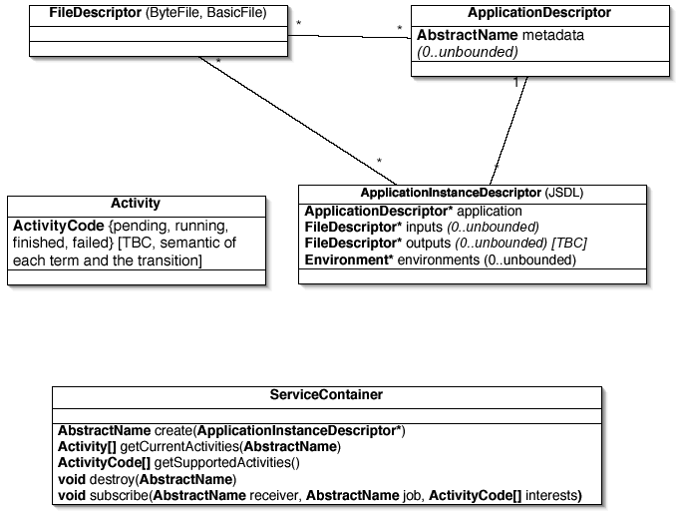

Due to time constraints, only Grimshaw and Morgan have currently had the opportunity to read through and comment on this document. The content is based off of discussions and meetings with the other listed authors.
The ByteIO port type has been defined in OGSA-Data and is essentially a file with read, write, trunk, etc. operations.
The use of the term “statically” here is perhaps somewhat misleading. Rather then referring to files which are static libraries, etc. what is intended instead is to indicate a type of file that is generally required by an application but which doesn’t typically change, or changes infrequently. It is a file which can be provisioned once and possibly cached for long periods of time.
It’s worth noting that the Application Description functions similarly to an ACS and as such the two are more or less interchangeable.

