Grid Scheduling Use Cases

Status of this Memo
This document provides information to the community regarding the Grid scheduling use case scenarios used in the definition of a Grid Scheduling Architecture (GSA-RG). Distribution of this document is unlimited. This is a DRAFT document and continues to be revised.

Abstract
Grids will provide a large variety of complex services. The interactions of those services require an extensible and integrated resource management. Although such a coordinated scheduling of services is currently not readily available. Access to resources is typically subject to individual access, accounting, priority, and security policies of the resource owners. Those policies are typically enforced by local management systems. Therefore, an architecture that supports the interaction of independent local management systems with higher-level scheduling services is an important component for Grids. Further, user of a Grid may also establish individual scheduling objectives. Future Grid scheduling and resource management systems must consider those constraints in the scheduling process. Taking into account different policies is also important for the implementation of various economic and business models.
The goal of the Grid Scheduling Architecture research group (GSA-RG) is to define a scheduling architecture that supports cooperation between different scheduling instances for arbitrary Grid resources. Considered resources include network, software, data, storage and processing units. The research group will particularly address the interaction between resource management and data management. Co-allocation and the reservation of resources are key aspects of the new scheduling architecture, which will also include the integration of user or provider defined scheduling policies.
The group will begin with identifying a set of relevant use-cases based on experiences obtained by existing Grid projects. Then, it will determine the required components of a modular scheduling architecture and their interactions.


GLOBAL GRID FORUM
office@gridforum.org
www.ggf.org

Full Copyright Notice
Copyright © Global Grid Forum (2003). All Rights Reserved.
This document and translations of it may be copied and furnished to others, and derivative works that comment on or otherwise explain it or assist in its implementation may be prepared, copied, published and distributed, in whole or in part, without restriction of any kind, provided that the above copyright notice and this paragraph are included on all such copies and derivative works. However, this document itself may not be modified in any way, such as by removing the copyright notice or references to the GGF or other organizations, except as needed for the purpose of developing Grid Recommendations in which case the procedures for copyrights defined in the GGF Document process must be followed, or as required to translate it into languages other than English.
The limited permissions granted above are perpetual and will not be revoked by the GGF or its successors or assigns.
This document and the information contained herein is provided on an "AS IS" basis and THE GLOBAL GRID FORUM DISCLAIMS ALL WARRANTIES, EXPRESS OR IMPLIED, INCLUDING BUT NOT LIMITED TO ANY WARRANTY THAT THE USE OF THE INFORMATION HEREIN WILL NOT INFRINGE ANY RIGHTS OR ANY IMPLIED WARRANTIES OF MERCHANTABILITY OR FITNESS FOR A PARTICULAR PURPOSE.

Intellectual Property Statement
The GGF takes no position regarding the validity or scope of any intellectual property or other rights that might be claimed to pertain to the implementation or use of the technology described in this document or the extent to which any license under such rights might or might not be available; neither does it represent that it has made any effort to identify any such rights. Copies of claims of rights made available for publication and any assurances of licenses to be made available, or the result of an attempt made to obtain a general license or permission for the use of such proprietary rights by implementers or users of this specification can be obtained from the GGF Secretariat.
The GGF invites any interested party to bring to its attention any copyrights, patents or patent applications, or other proprietary rights which may cover technology that may be required to practice this recommendation. Please address the information to the GGF Executive Director (see contact information at GGF website).
Contents

1Introduction 4
2<Use Case Name> 5
2.1Summary 5
2.2Customers 5
2.3Scenarios 5
2.4Involved resources 5
2.5Functional requirements 5
2.6Workflow of Scheduling Process 5
2.7Involved Scheduling Components/Services 5
2.8Failure Considerations 5
2.9Security Considerations 5
2.10Accounting Considerations 5
2.11Performance Considerations 5
2.12Use case Situation Analysis 5
2.13References 5
3Editor Information 6

Introduction
One of the first milestones of the GSA-RG’s charter is the identification of relevant use-cases for Grid scheduling.
This document is a collection of the use case scenarios contributed by GSA-RG participants or solicited from others.
Based on this document the GGSA-RG will identify and specify common requirements to support the creation of Grid schedulers which serve the use-cases. This information will be used to identify components, services and protocols for a Grid scheduling architecture. Services and protocols from other GGF groups are considered as potential basic building blocks of such an architecture and will be used wherever possible.
Note, that it is not the task of the Research Group to define protocols or algorithms. Instead, the RG identifies the requirements for Grid scheduling, designs a suitable Grid scheduling architecture including existing services as well as currently missing components and their interaction.

Agent-based scheduling with Calana

Summary
The concept of virtual organizations has a big impact on resource usage: grid computing enables organizations to use the resources of different organizations seamlessly. Beside the benefits, this usage pattern also raises new problems: Organizations want to enforce their policies when advertising their resources. When using resources of other organizations, users may want to specify their goals on a per-job basis.
This use case describes a market-based attempt to enable all stakeholders in a grid to integrate their individual policies in the resource allocation process. As the real economy shows, markets are a powerful mean to coordinate many market participants.

Fraunhofer ITWM’s Calana [1] implements a market-based scheduler. As section 2.6 shows, Calana uses auctions to allocate resources. It consists of two components: The broker and the agents. Users sent the job scheduling request along with some preference information to the broker component, which then starts an auction by notifying all attached agents. The agents are running at the providers site and send bids to a central broker in order to run a job. They can implement various bidding strategies in order to meet their local policies. When the auction finishes, all bids are compared against each other. The user’s preferences are taken into account by judging the bids accordingly. The best bid wins the auction and will be the execution location for the job.
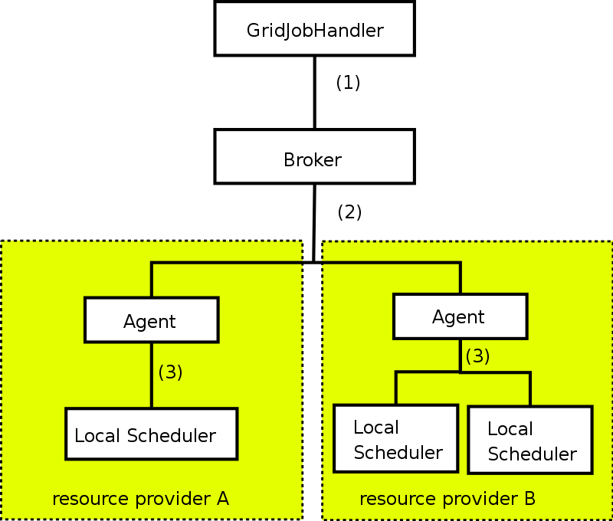

Figure 1: Architecture overview: the GridJobHandler uses the broker component to create a valid schedule (1). Resource providers use an agent in order to connect their local scheduling systems to the architecture (3). The broker and agents interact to create the schedules (2).

As an additional benefit, there is no need for a centralized information system to provide dynamic information: Since the agents reside at the provider’s site, they can retrieve all necessary information locally.

Customers
Calana is designed as a general-purpose grid scheduler and therefore aims at no specific user group. However, based on the architecture of Calana, we assume there will be three stakeholder groups:

- Providers of computational power may use an agent-based scheduler to sell their computational power as well as any other resource, e.g. software licenses.
- Users use Calana to find cheaper or more powerful resources.
- A computational economy allows service providers to act as a merchant without owning resources: for example, a merchant may bid on a job issued by one broker and start a second auction at another broker to obtain the resources needed to execute the job.

Scenarios
In general, there are no limitations on the usage of Calana. Since each resource provider can adjust the agent to interact with the local resource management system, almost all resources can be integrated.
Different from other use cases, we expect the strategy of all stakeholders to be more important.

Involved resources
Since Calana relies on the GADL [3], there is no limitation regarding the type of resource. The GADL provides a XML-based language to describe resources and workflows. Each resource needs to provide a resource description for the static properties. The dynamic properties are handled by the agent.

Functional requirements
- Authentication, authorization, user right delegation & job integrity verification. Authentication and authorization are essential for every Grid based job submission scenario. To enable the scheduler to act on behalf of the user, the respective rights have to be delegated from the user to the scheduler. This use case also requires that the integrity of a job (parts of the job) can be verified anytime during the scheduling process.
- Job parsing & validation. The job description has to be parsed and formally validated (job preprocessing).
- Information retrieval (static & dynamic). The dynamic information will be retrieved locally during the scheduling (see below). We do not rely on a centralized information system for dynamic information. Static information is needed to find execution candidates. This is currently done by using the GADL [3].
- Resource preselection. This is done implicitly within Calana: By submitting a bid, an agent states that the corresponding provider has a resource the job will be able to run upon. The agent can decide this by retrieving the GADL descriptions.
- Scheduling. The scheduling decision is made by an auction, see section 2.6.
- Advance reservation. We rely on an advance reservation for each provider in order to ensure the job can be executed at the provider’s site.
- Workflow execution/processing. Calana relies on the GridJobHandler [2] in order to execute workflows. The GridJobHandler is capable of executing workflows specified in GADL.
- Billing/accounting Since all scheduling decisions are made by the broker, it is possible to track prices etc. here.
- Failure management. We rely on the GridJobHandler to react on failures. This way, it is possible to specify alternative workflows in case of failures. The scheduler does not implement special techniques.

Workflow of Scheduling Process
The scheduling workflow corresponds to an auction. We can distinguish these steps:
- An agent attaches itself to the central broker.
- The request is received by the broker.
- A “Call for Bids” is sent to all attached agents, containing information about the job and the estimated runtime of the job (e.g., a normalized walltime) along with information about the user.
- The provider’s agent consider the creation of a bid. It has to judge whether the job can be executed at the local site or not. The GADL description contains all needed static information. If the local strategy suggests bid creation, the agent obtains an advance reservation from the target machine and submits a bid to the broker.
- The broker then judges all bids, taking the user’s preferences into account.
- The agents are notified about the winner of the auction.
- The schedule is delivered.
The result is a schedule which can be used by the GridJobHandler to execute the job.

Involved Scheduling Components/Services
Involved components are:
- The GridJobHandler
- The Calana Broker
- Various Calana Agents
- Local resource management systems.

Failure Considerations
Based on section 2.6, the following failures have to be taken into account:
- (Processing of the job request)
  - The parser doesn’t support the job description
- (Gathering of static information)
  - The included GADL references can not be resolved.
- (Scheduling)
  - No suitable resource found.
  - Timeout.
  - Local resource information cannot be retrieved.
- (Advance reservation)
  - No advance reservation can be made
- (Workflow execution/processing)
  - Any error during the execution of the workflow is handled by the GridJobHandler.

Security Considerations
The security considerations do not differ significantly from the other use-cases.

Accounting Considerations
As stated above, the broker can also serve as an accounting service: simple logging of the auction data provides all basic data needed for accounting purposes on the inter-domain level. For the local domain accounting, each provider’s agent may log the auction it has won.

Performance Considerations
As in use case 1, the communication seems to have the main impact. Since the auction announcements are broadcasted, they are the limiting factor.
- Service programming model. We use a multiagent system to implement the architecture. Both broker and provider agents can be seen as individual agents, connected by a message layer that provides secure message transport and
Currently, we use XMPP as messaging protocol [4].
- Communication Failure. XMPP takes care of all message handling issues.
- Scalability. The number of messages directly corresponds to the number of attached agents. However, since the message transfer can be handled by separate XMPP servers that may also be distributed, we think we can handle the traffic. Furthermore, one may also choose to implement a hierarchy of brokers in order to partition the attached agents.
In addition, since Calana doesn’t rely on a centralized information system for dynamic information, the additional periodic updates of the information system doesn’t occur.

Use case Situation Analysis
Calana is currently in the beta stage. It will be improved continuously and available under terms of the GPL. An integration with various resource management systems, e.g. Globus and Unicore, will be available. We plan to use this solution in various industry projects.

References

[1] M. Dalheimer, F.-J. Pfreundt, P. Merz: Calana – A General-purposa Agent-based Grid Scheduler. In Proceedings of the 14th IEEE International Symposium on High Performance Distributed Computing (HPDC-14). To appear.
[2] A. Hoheisel. User tools and languages for graph-based grid workflows. In Grid Workflow 2004 Special Issue of Concurrency and Computation: Practice and Experience, 2004.
[3] A. Hoheisel and U. Der. An XML-based Framework for Loosely Coupled Applications on Grid Environments. In S. et al., editor, ECCS 2003, volume 2657 of LNCS, pages 245–254. Springer, 2003.
[4] IETF RFC 3920 - Extensible Messaging and Presence Protocol (XMPP).

Editor Information
Mathias Dalheimer
Fraunhofer Institut für Techno- und Wirtschaftsmathematik
Competence Center High Performance Computing
67663 Kaiserslautern, Germany

