Execution Service Interfaces
Version 1.0

Status of This Memo
This memo provides interface specifications for Job creation and management. Distribution is unlimited.
Copyright Notice
Copyright © Global Grid Forum (2006). All Rights Reserved.
Trademarks
OGSA is a trademark of the Global Grid Forum.

Abstract
We present Web Services interfaces for use in scenarios in which clients may request job factory services to create new jobs defined by job descriptions, which clients can subsequently inspect, control, and monitor. We define, more specifically, job factory service properties for monitoring and discovery of job factories; job factory service operations for job creation; job properties for monitoring and discovery of jobs; and job operations for control of jobs. This specification is experimental. It is not proposed as a candidate standard at this stage, but rather is presented with the pragmatic goal of reconciling similar but different interfaces defined previously within the Globus and Unicore communities, and thus encouraging experimentation with the implementation of interoperable Grid systems.

Contents
1. Introduction 3
2. Goals and Nongoals 3
3. Architecture 5
3.1 Component Model 5
3.2 State Model 6
3.2.1 Commentary on the States 8
4. Job Factory Interface 10
4.1 Job Factory Interface: Resource Modeling 10
4.2 Job Factory Interface: Operations 12
4.2.1 CreateManagedJob 12
4.3 Job Factory Interface: Extensions to JSDL 1.0 14
4.3.1 Support for Idempotent Execution Semantics 14
4.3.2 Support for Libraries 14
5. Job Interface 15
5.1 Job Interface: Resource Modeling 15
5.2 Job Interface: Operations 16
5.2.1 Release 16
5.2.2 Abort 17
5.2.3 Hold 17
6. Security Considerations 18
Editor Information 18
Contributors 18
Acknowledgments 18
Intellectual Property Statement 18
Full Copyright Notice 18
References 19
Appendix A. Job Factory Schema 21
Appendix B. Job Factory WSDL 1.1 22
Appendix C. Job Schema 23
Appendix D. Job WSDL 1.1 24
7. Appendix E: Reconciliation Discussions 25
7.1 State Model 25
7.1.1 OGSA Basic Execution Service State Model 25
7.1.2 Globus GRAM State Model 28
7.1.3 Unicore/GS State Model 29
7.2 Resource Model 29
7.3 Job Properties 30
8. Issues to be Discussed and Things to be Done 31
8.1 To Do 31
8.2 Issues to Discuss 31

Introduction

We present Web Services interfaces for use in scenarios in which clients may request job factory services to create new jobs defined by job descriptions, which clients can subsequently inspect, control, and monitor. We define, more specifically:
- Job factory service properties for monitoring and discovery of information about job factories.
- Job factory service operations for job creation.
- Job properties for monitoring and discovery of information about jobs.
- Job operations for control of jobs.
In support of these operations, we also define a state transition model for jobs.
We assume an OGSA WSRF Base Profile 1.0 infrastructure in the presentation of these interfaces.
This specification is experimental. It is not proposed as a candidate standard at this stage, but rather is presented with the pragmatic goal of reconciling similar but different interfaces defined previously within the Globus and Unicore communities, and thus encouraging experimentation with the implementation of interoperable Grid systems.

Goals and Nongoals
Goals:
- Address GRAM and Unicore/GS functionality: We pragmatically adopt as our scope the functionality defined within the Globus GRAM and Unicore/GS Atomic Services interfaces for job creation and management.
- Reconcile GRAM and Unicore/GS: We want to produce a specification that reconciles the similar but different specifications for Web Services-based Execution Service Interfaces (ESI) developed within the Globus Alliance (GRAM) and Unicore/GS Atomic Services (UAS) specifications, in a manner acceptable to both parties.
- Use JSDL: We adopt the GGF Job Submission Description Language [JSDL] as a basis for describing computational activities.
- WSRF OGSA Base Profile 1.0 Platform: We assume that these specifications will be constructed as extensions to the WSRF OGSA Base Profile 1.0 [OGSA WSRF Basic Profile].
- Model Job Management Service: We address modeling of job management, as a WS-Resource, that serves as a management interface for the job (activity) described by the JSDL document.
- Extensible Support for Resource Models: We provide basic discovery capabilities for the CIM [CIM] based resource model that underpins the JSDL specification. We allow for extensions to this mechanism to support discovery of more complex resource models, such as the GLUE Schema [GLUE].
- Address reliability: One issue that arises in execution management is the potentially high stakes of errors in the management protocol. Specifically, while a client may well be expected to tolerate rejection and even execution failure, it is undesirable to have execution management state “disappear” or get duplicated due to message-layer, client, or provider failures. Thus, we want our protocol to provide for “exactly once” job submission semantics. A recent draft of WS-Addressing has recently been approved. This may provide an acceptable replacement for the WS GRAM idempotence mechanism. If not, then it is acceptable to define a standard element in the job description language as a supported extension (including required semantics).
- Use WS-RF modeling conventions: The use of WSRF modeling conventions and implementation tooling can simplify the rendering of all management interfaces. In particular, WS-Addressing mechanisms can be used to provide transportable references to specific execution instances, and WS-ResourceProperties mechanisms can be used to model a domain-extensible set of metadata/annotations for communicating the status of the ESI actor in its management lifecycle. Additionally, WS-BaseNotification can be useful to render the idiom of asynchronous transmission of metadata/annotations from the provider to the client or another interested third party.
Nongoals:
- Use WS-Agreement: While WS-Agreement [WS-Agreement] has attractive properties as a framework and protocol for negotiating service level agreements, we do not use it here.
- Address advance reservation: Advance reservation is an important requirement for many Grid scenarios. However, we do not address it here.
- Address bulk operations: The ability to submit, monitor, and control multiple jobs can be an important performance optimization, but we do not address this capability here.
- Generic management frameworks: Management specifications, such as WSDM, can presumably be used to manage job factories, However, we do not address this relationship here.
- Define alternative renderings: It is straightforward to define alternative renderings of the interfaces presented here that adopt conventions other than the WSRF OGSA Base Profile to define and interact with state: for example, those defined in WS-Transfer, WS-Management, and related specifications, or alternatively a set of domain-specific operations. However, we do not present such alternative renderings.
- Address server-side workflow: Current execution management interfaces allow for various forms of server side workflow: e.g., GRAM multijobs, Unicore Abstract Job Objects, and BPEL in CGSP. However, we do not address multi-part execution here. (Note that the current formulation of JSDL supports a limited form of workflow through the provision of pre-staging and post-staging of files. This specification assumes the existence of this level of workflow and accommodates it accordingly.)

Architecture

Component Model
Figure 1 depicts the components of the ESI model.
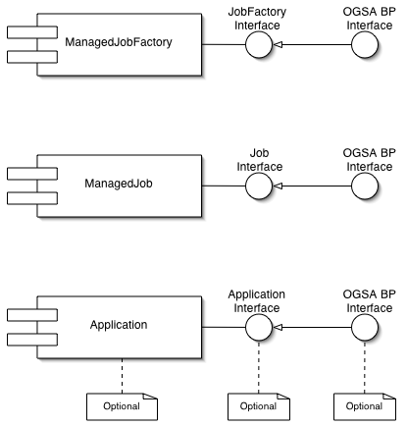
Figure 1: ESI Component Model
These components are described in detail below, except for the Application, which although part of the model is not the target of this specification. The Application is the executable or service that the client actually wants to have executed. It may be missing entirely from the model, in which case the Job interface will have been extended to provide the service or function. It may be a service and have an interface, which may intern extend the OGSA Basic Profile to provide basic discovery of its capabilities.

State Model
The ESI state model is based converged model capturing the important aspects of the state model from Basic Execution Services, the GRAM state model, and the Action Status model of Unicore. These references can be found in Section 7.1 at the end of this document. The user can obtain information about state transitions via notifications and can be query a resource property to determine the current state. Figure 2 depicts the ESI states and the transitions between them.
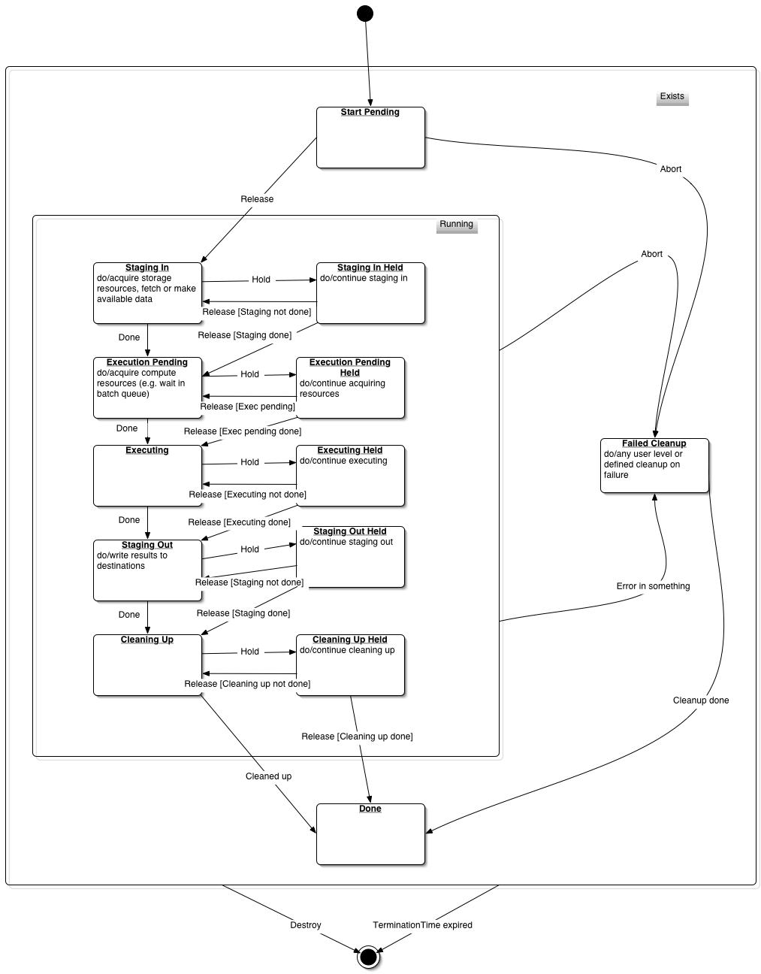
Figure 2: ESI State Transition Model
The notation is a simplified UML formulation. The format used for a transition is event [guard]. The transition indicated occurs when the event occurs subject to the guard being true. The “do/” clause within a state indicates the activity taking place in the state. States can have super-states (larger boxes). All of the sub-states have the transitions starting from the enclosing super-states. For example, “Staging in”, Execution Pending”, “Executing” etc. have transitions to “Failed Cleanup” via an Abort event.
Note that this model shows the states of a Job. These states do not distinguish between different fault statuses (e.g. non-fatal termination) or exit codes, i.e. a job in the "Done" state may have completed successfully, failed, been aborted etc.

Commentary on the States
Exists is the super-most state. All Jobs that have been created by the ManagedJobFactory are in the Exists state. Jobs that leave the Exists state are no longer accessible by the client. The only events that transitions out of Exists are the expiry of the (WS-Resource’s) TerminationTime or explicit termination by the Destroy operation from WS-ResourceLifetime.
The sub-states of Exists are Start Pending, Running, Failed Cleanup and Done. A Job will enter as Pending. The Job will remain in Pending until it receives a Release event from the Job Release operation, which will move it to Running.
Jobs in the Failed Cleanup state have terminated execution early for a reason, either they have received an Abort event, or there has been an error in execution and further processing of the job has stopped. The Failed Cleanup state allows the job management system to clean up the partially executed job. Once this is complete, the Job moves to the Done state. Jobs whose execution completes successfully move to the done state from only two of the sub-states of Running.
A Job whose processing has started but is not yet complete is in one of the sub-states of Running. These sub-states occur in pairs, “Running sub-state” and “Running sub-state held”. Transition to “Running sub-state held” from “Running sub-state” is triggered by a Hold event from the Hold operation on the Job Interface. While in the “Running sub-state held” state the execution/execution pending/staging/cleanup respectively continues, but exit from the “Running sub-state held” state only happens with a Release event from the Job Release operation, i.e. Hold events hold the processing of the state model and not the processing of the incarnated commands.
Table 1 contains a summary of the legal transitions based on events.

 | Release | Hold | Abort | Error | Actions Done | Termination  Time Up
Pending | See diagram | No effect | See diagram | N/A | N/A | Exit
Staging In | No effect | See diagram | See diagram | See diagram | See diagram | Exit
… Held | See diagram | No effect | See diagram | Q1 | See diagram | Exit
Execution Pending | No effect | See diagram | See diagram | See diagram | See diagram | Exit
… Held | See diagram | No effect | See diagram | Q1 | See diagram | Exit
Executing | No effect | See diagram | See diagram | See diagram | See diagram | Exit
… Held | See diagram | No effect | See diagram | Q1 | See diagram | Exit
Staging Out | No effect | See diagram | See diagram | See diagram | See diagram | Exit
… Held | See diagram | No effect | See diagram | Q1 | See diagram | Exit
Cleaning Up | No effect | See diagram | See diagram | See diagram | See diagram | Exit
… Held | See diagram | No effect | See diagram | Q1 | See diagram | Exit
Failed Clean Up | No Effect | No Effect | No effect | No effect | See diagram | Exit
Done | No effect | No Effect | No effect | N/A | N/A | Exit
Table 1: Event State Table
Note that when a Release, Hold or Abort event is received and there is no transition defined in the diagram, then there is no effect on the Job state.

Job Factory Interface
The ESI Job Factory extends the OGSA Basic Profile with the CreateManagedJob operation and provides a number of Resource properties describing the resource on which the managed job will run, e.g. a resource description of the execution service. In this version of ESI, the job description is based on the Job Submission Description Language Version 1.0 [JSDL 1.0] plus some extensions specified in this document. As is apparent from the state model above, there is an implicit workflow associated with a JSDL job description, e.g. StageIn -> Execute -> StageOut. Although complete workflow is beyond the scope of this document, this common use case is provided for in the specification in line with its presence in JSDL 1.0.
In addition to this simple workflow model, JSDL 1.0 also assumes an underlying resource model based loosely on the Common Information Model [CIM] from the DMTF. Since clients composing JSDL 1.0 job descriptions will need to know what constraints are placed on their job description by this resource model, this specification includes a description of the execution resource in the Resource properties of the ManagedJobFactory.
It is expected that later versions of JSDL, and hence this specification, will allow for the description of more varied and rich applications beyond simple POSIX-like applications, e.g. deployment of Web services or simple and complex multi-job workflows.

Job Factory Interface: Resource Modeling
Table 2 lists the resource properties associated with a job factory. These were derived from the implied resource model inherent in JSDL 1.0, the Unicore resource model and the GRAM resource description. See section 7.2 for a summary of these.
Table 2: Job Factory Interface Resource Properties
Name | N | Type | Description
Name | 1 | String | A human-readable name for the Job Factory.
LocalResourceManagerType | 1 | String | The local resource manager type (e.g, Condor, LSF, PBS, etc.)
TotalNumberofJobs | 1 | Integer | The number of Managed Jobs associated with this factory. Jobs that have been destroyed as not included, so this is a "live Job" count.
JobReference | ≥ 0 | EPR | An EPR to each Managed Job associated with this Job Factory.
Description | 0 or 1 | String | General text describing the resource/site/system/...
Execution Service Location | 0..1 | URL | The location of the execution service.
Job Credential Service | 0..1 | EPR | The credential service providing authorization credentials for the Managed Job.
File Credential Service | 0..1 | EPR | The credential service providing authorizations credentials for the file transfers needed by the Managed Job.
Resource Description | These are resource description elements taken from JSDL.
OperatingSystem | 1 | jsdl:OperatingSystem | The Operating System running on the local resource.
CPUArchitecture | 1 | jsdl:CPUAchitecture | The CPU architecture on the local resource
CPUCount | 1 | jsdl:TotalCPUCount | The total number of CPUs available at the local resource
CPUSpeed | 1 | jsdl:IndividualCPUSpeed | The speed of each CPU in the local resource
PhysicalMemory | 1 | jsdl:TotalPhysicalMemory | The total physical memory to jobs on the local resource
VirtualMemory | 1 | jsdl:TotalVirtualMemory | The total virtual memory available to jobs on the local resource
NetworkBandwidth | 1 | jsdl:IndividualNetworkBandwidth | The maximum network bandwidth available to jobs on the local resource
Library | ≥ 0 | esi:Library | An ESI extension to JSDL describing libraries made available to jobs on the local resource.
Job Request Constraints | The following resource properties, if published, impose constraints to the maximum value the local resource allows jobs to consume. If one of the following RPs is not published in the Job Factory Interface, then the local resource grants unlimited usage of this resource property to any submitted job. For individual descriptions JSDL 1.0 specification.
WallTime | 0..1 | jsdl-posix:WallTimeLimit | See JSDL 1.0
FileSize | 0..1 | jsdl-posix:FileSizeLimit | See JSDL 1.0
CoreDump | 0..1 | jsdl-posix:CoreDumpLimit | See JSDL 1.0
DataSegment | 0..1 | jsdl-posix:DataSegmentLimit | See JSDL 1.0
LockedMemory | 0..1 | jsdl-posix:LockedMemoryLimit | See JSDL 1.0
Memory | 0..1 | jsdl-posix:MemoryLimit | See JSDL 1.0
OpenDescriptors | 0..1 | jsdl-posix:OpenDescriptorsLimit | See JSDL 1.0
PipeSize | 0..1 | jsdl-posix:PipeSizeLimit | See JSDL 1.0
StackSize | 0..1 | jsdl-posix:StackSizeLimit | See JSDL 1.0
CPUTime | 0..1 | jsdl-posix:CPUTimeLimit | See JSDL 1.0
ProcessCount | 0..1 | jsdl-posix:ProcessCountLimit | See JSDL 1.0
VirtualMemory | 0..1 | jsdl-posix:VirtualMemoryLimit | See JSDL 1.0
ThreadCount | 0..1 | jsdl-posix:ThreadCountLimit | See JSDL 1.0
Extensibility | ≥ 0 | Any | Extensibility elements: can be used to accommodate GLUE and other resource descriptions
ResourcePropertyNames | 1 |  | Inherited from WSRF OGSA Base Profile
FinalWSResourceInterface | 1 |  | Inherited from WSRF OGSA Base Profile
WSResourceInterfaces | 1 |  | Inherited from WSRF OGSA Base Profile
ResourceEndpointReference | 1 |  | Inherited from WSRF OGSA Base Profile
CurrentTime | 1 |  | Inherited from the WS-ResourceLifetime specification
TerminationTime | 1 |  | Inherited from the WS-ResourceLifetime specification

Job Factory Interface: Operations
The job factory interface defines the following operations:
- CreateManagedJob: This operation creates a job, subscribes the client for notifications if requested, and replies with an endpoint references (EPRs) to the Job created. The operation’s input consists of a job, an optional initial termination time for the job resource, and an optional state notification subscription request. The Job starts in the "Start Pending" state, see section 3.2.
- The operations defined in the WS-ResourceProperties GetResourceProperty, GetMultipleResourceProperties, QueryResourceProperties portTypes.
- The operations defined in the WS-ResourceLifetime ImmediateResourceDestruction and ScheduledResourceDestruction portTypes.
- The operations defined in the WS-BaseNotification NotificationProducer portType.

CreateManagedJob
When a requestor wishes to create a new job, the requestor must issue a request message of the following form:

<esi:CreateManagedJob>
<esi:desc>
jsdl:job
</esi:desc>
<esi:Subscription>
wsnt:Subscribe
</esi:Subscription>?
<esi:InitialTerminationTime>
[xsd:dateTime | xsd:duration]
</esi:InitialTerminationTime>?
</esi:CreateManagedJob>
The components of the CreateManagedJob message are further described as follows:
/esi:CreateManagedJob/esi:desc
This component contains a JSDL job description.
/esi:CreateManagedJob/esi:Subscription
An optional element, indicating that the client would like to receive notification message as described in the subscription request as described in [WS-BaseNotification]. This optional request provides an efficient means of subscribing to the newly created job without additional round-trip messages. Clients who subscribe afterwards must check the current status of the job, since the inherent race-condition means some state-changes may have occurred prior to the separate subscription request.
/esi:CreateManagedJob/InitialTerminationTime
An optional element, indicating the requestor’s suggestion for the initial setting of the termination time resource property [WS-ResourceLifetime] of the Job WS-Resource.
There are two forms of this element, absolute time and duration. If the type of this element is xsd:dateTime, the value of the element is to be interpreted as an “absolute time”. If the type of this element is xsd:duration, the value of the element is to be interpreted as a “relative time” or “duration”. Regardless of the form, time is relative to the time source used by the JobFactory.
The duration form is used to “compute” the “absolute time” form in the following fashion. The value of this element in “absolute time” form is computed by adding the xsd:duration value to the current time value of the JobFactory.
The “absolute time” form (whether computed from a duration, or contained within the request message) is used to initialize the value of the TerminationTime resource property of the Job resource.
If the JobFactory is unable or unwilling to set the TerminationTime resource property of the Job resource to the given value of the “absolute time” form or a value greater, then the CreateManagedJob request MUST fault. If the value is not “in the future” relative to the current time as known by the JobFactory, the request MUST fault. The use of the xsi:nil attribute with value “true” indicates there is no scheduled termination time requested for the Job. If the element does not include the time zone designation, the value of the element MUST be interpreted as universal time (UTC) time. If a fault is returned, the operation MUST NOT have an effect.
If this element is not included, the initial value of the TerminationTime resource property is dependent on the implementation of the JobFactory.
If a JobFactory accepts the request it MUST update the TerminationTime resource property of the resulting Job WS-Resource to the value specified in the message or to a value “in the future” relative to the requested time.

If the JobFactory accepts the request to create a job, it MUST start the Job in the "Start Pending" state and respond with a CreateManagedJobResponse message of the following form:

<esi:CreateManagedJobResponse>
<esi:JobReference>
wsa:EndpointReferenceType
</esi:JobReference>
</esi:CreateManagedJobResponse>
Further constraints on the CreateManagedJobResponse message are as follows:
/esi:AddResponse/esi:JobReference
An EndpointReference as described in [WS-Addressing]. This endpoint reference refers to the Job WS-Resource created by the JobFactory to represent the Job. The Web Service associated with the Job returned by the CreateManagedJobResponse MUST implement the message exchanges and resource properties specified by the ScheduledResourceTermination interface and the ImmediateResourceTermination interface [WS-ResourceLifetime]. .
The wsa:Action MUST contain the URI http://docs.ggf.org/esi/.../CreateManagedJobResponse.
If the WS-Resource does not respond to the CreateManagedJobRequest message with the CreateManagedJobResponse message, then it MUST send a fault. This specification defines the following faults associated with failure to process the CreateManagedJobRequest message:
CreateManagedJobFault:
The operation was unable to create a Job based on the request. The failure may be the result of problems in the JSDL, the Subscription, or the Termination Time request.
This fault, or a specialization thereof, SHOULD be sent upon failure although other fault messages MAY be returned instead. If a fault is returned, the operation MUST NOT have an effect.
It is RECOMMENDED that where the fault cause can be identified, the appropriate fault from [WS-ResourceLifetime] or [WS-BaseNotification] SHOULD be thrown.

Job Factory Interface: Extensions to JSDL 1.0
The following are extensions to the JSDL Job description are needed to support the use cases known to the authors.

Support for Idempotent Execution Semantics
If idempotent execution is required, following element SHOULD be used to identify uniquely a managed job instance to the client using a client-generated identifier. If present in a Job description, an implementation of the ManagedJobFactory MUST NOT execute the job containing this identifier more than once.
The following element MAY appear as an immediate child element of the jsdl:JobIdentification element of the job description.

<esi:IdempotentJobID>
wsa:AttributedURI
</esi:IdempotentJobID>

Support for Libraries
This element MAY be used to identify libraries and other software components that are available at a resource. They MAY also be added to the Job Description Resource element to indicate that the job requires the giver library or software package.

<esi:Library>
<LibraryName .../>?
<LibraryVersion .../>?
<Description .../>?
</esi:Library>

Job Interface
The Job Interface provides basic job information and management functions. It exposes the Job state based on the state model discussed in Section 3.2. The ESI Job Interface extends the OGSA Basic Profile with a number of operations and provides a number of Resource properties describing the job.
In addition to the state model in section 3.2, the Job's resource properties expose other information about the job. Some of these are associated with the JSDL used to create the job and others deal with the management of subscription and lifetime properties.

Job Interface: Resource Modeling
Table 3 lists the resource properties associated with a job.
Table 3: Job Interface Resource Properties
Name | N | Type | Description
OriginalJSDL | ≥ 0 | String | JSDL as submitted by the client
ExecutionJSDL | ≥ 0 | String | JSDL following any transformation performed by Job Factory
Log | 1
JobFactoryReference | 1 | EPR | The EPR of the Factory that created this Job.
WorkingDirectoryReference | 1 | EPR | A reference to the file service for the working directory of the job..
StageInReference | ≥ 0 | EPR | A reference to the file service for the stage in elements of the job.
StageOutReference | ≥ 0 | EPR | A reference to the file service for the stage out elements of the job.
StorageReference | ≥ 0 | EPR | A reference to other file services used by the Job.
JobState | 1 | StateType | The current state of the job according to the Job state model from Section 3.2
SubscriptionReference | ≥ 0 | EPR | An optional element, only present if a notification subscription was requested, created by the JobFactory, and MUST implement the message exchanges and resource properties specified by the ScheduledResourceTermination interface and the ImmediateResourceTermination interface [WS-ResourceLifetime].
Extensibility | ≥ 0 | Any
ResourcePropertyNames | 1 | QName List | Inherited from the WSRF OGSA Base Profile specification
FinalWSResourceInterface | 1 | QName | Inherited from the WSRF OGSA Base Profile specification
WSResourceInterfaces | 1 | QName List | Inherited from the WSRF OGSA Base Profile specification
ResourceEndpointReference | 1 | EPR | Inherited from the WSRF OGSA Base Profile specification
CurrentTime | 1 | DateTime | Inherited from the WS-ResourceLifetime specification
Termination Time | ≥ 0 | DateTime | Inherited from the WS-ResourceLifetime specification
Topics | ≥ 0 |  | Inherited from the WS-BaseNotification specification’s NotificationProducer portType
FixedTopicSet | 1
TopicExpressionDialect | ≥ 1

Job Interface: Operations
The job interface defines the following operations:
- Release: Requests that the job be released, if currently in "Start Pending" or one of the "Held" states.
- Abort: Requests that the job be aborted. Note that this request does not destroy the WS-Resource associated with the job; WS-ResourceLifetime operations can be used for that purpose.
- Hold: Requests that the job be moved to the "Held" state corresponding to its current state at the time the message is received by the Job. If the Job is already in a "Held" state, this operation has no effect.
- The operations defined in the WS-ResourceProperties GetResourceProperty, GetMultipleResourceProperties, QueryResourceProperties portTypes.
- The operations defined in the WS-ResourceLifetime ImmediateResourceDestruction and ScheduledResourceDestruction portTypes.
- The operations defined in the WS-BaseNotification NotificationProducer portType.

Release
A Job MUST support a message exchange pattern that allows a service requestor to request that the job be released from the "Start Pending" or one of the "Held" states.
The format of the resume request message is:
<esi:ReleaseRequest/>

The wsa:Action MUST contain the URI: “http://www.ggf.org/esi/.../ReleaseRequest”.
If the Job accepts the ReleaseRequest message, upon receipt of this message the Job MUST either return the following ReleaseResponse message to acknowledge successful resumption of execution, or return a fault message indicating failure. If the Job was executing at the time the request to resume was received, the Job MUST respond with the ReleaseResponse message to indicate that execution is continuing.
<esi:ReleaseResponse/>
The wsa:Action MUST contain the URI http://docs.ggf.org/esi/.../ReleaseResponse.
This specification defines the following fault associated with failure to process the ReleaseRequest message:
JobNotReleasedFault:
The Job could not be released for some reason.
This fault, or a specialization thereof, SHOULD be sent upon failure although other fault messages MAY be returned instead. If a fault is returned, the operation MUST NOT have an effect.

Abort
A Job MUST support a message exchange pattern that allows a service requestor to request that the job be aborted.
The format of the abort request message is:
<esi:AbortRequest/>

The wsa:Action MUST contain the URI: “http://www.ggf.org/esi/XXX/AbortRequest”.
If the Job accepts the AbortRequest message, upon receipt of this message the Job MUST either return the following AbortResponse message to acknowledge successful termination of execution, or return a fault message indicating failure. Note that the execution of the Job activity terminated by this operation, but that access to Resource Properties, files and other resources are not affected by this operation and the client MAY still perform operations on the Job. The WS-ResourceLifetime operation SHOULD be used to destroy the Job completely.
<esi:AbortResponse/>
The wsa:Action MUST contain the URI http://docs.ggf.org/esi/.../AbortResponse.
This specification defines the following fault associated with failure to process the AbortRequest message:
JobNotAbortedFault:
The Job could not be aborted for some reason.
This fault, or a specialization thereof, SHOULD be sent upon failure although other fault messages MAY be returned instead. If a fault is returned, the operation MUST NOT have an effect.

Hold
A Job MUST support a message exchange pattern that allows a service requestor to request that the job be held.
The format of the hold request message is:
<esi:HoldRequest/>

The wsa:Action MUST contain the URI: “http://www.ggf.org/esi/XXX/HoldRequest”.
If the Job accepts the HoldRequest message, upon receipt of this message the Job MUST either return the following HoldRequest message to acknowledge successful suspension of the activity of the Job, or return a fault message indicating failure.
<esi:HoldResponse/>
The wsa:Action MUST contain the URI http://docs.ggf.org/esi/.../HoldResponse.
This specification defines the following fault associated with failure to process the HoldResponse message:
JobNotHeldFault:
The Job could not be held for some reason.
This fault, or a specialization thereof, SHOULD be sent upon failure although other fault messages MAY be returned instead. If a fault is returned, the operation MUST NOT have an effect.

Security Considerations
TBD.

Editor Information
TBD

Contributors
We gratefully acknowledge the contributions made to this document by Karl Czajkowski, Michel Dresher, Stuart Martin, Steve Tuecke, Sven van den Berghe.

Acknowledgments
We are grateful to numerous colleagues for discussions on the topics covered in this document, and to the people who provided comments on the public drafts. Thanks in particular to (in alphabetical order, with apologies to anybody we have missed).

Intellectual Property Statement
The GGF takes no position regarding the validity or scope of any intellectual property or other rights that might be claimed to pertain to the implementation or use of the technology described in this document or the extent to which any license under such rights might or might not be available; neither does it represent that it has made any effort to identify any such rights. Copies of claims of rights made available for publication and any assurances of licenses to be made available, or the result of an attempt made to obtain a general license or permission for the use of such proprietary rights by implementers or users of this specification can be obtained from the GGF Secretariat.
The GGF invites any interested party to bring to its attention any copyrights, patents or patent applications, or other proprietary rights which may cover technology that may be required to practice this recommendation. Please address the information to the GGF Executive Director.

Full Copyright Notice
Copyright (C) Global Grid Forum (2004, 2005). All Rights Reserved.
This document and translations of it may be copied and furnished to others, and derivative works that comment on or otherwise explain it or assist in its implementation may be prepared, copied, published and distributed, in whole or in part, without restriction of any kind, provided that the above copyright notice and this paragraph are included on all such copies and derivative works. However, this document itself may not be modified in any way, such as by removing the copyright notice or references to the GGF or other organizations, except as needed for the purpose of developing Grid Recommendations in which case the procedures for copyrights defined in the GGF Document process must be followed, or as required to translate it into languages other than English.
The limited permissions granted above are perpetual and will not be revoked by the GGF or its successors or assigns.
This document and the information contained herein is provided on an "AS IS" basis and THE GLOBAL GRID FORUM DISCLAIMS ALL WARRANTIES, EXPRESS OR IMPLIED, INCLUDING BUT NOT LIMITED TO ANY WARRANTY THAT THE USE OF THE INFORMATION HEREIN WILL NOT INFRINGE ANY RIGHTS OR ANY IMPLIED WARRANTIES OF MERCHANTABILITY OR FITNESS FOR A PARTICULAR PURPOSE."

References
[GGF Documents] Catlett, C.: Global Grid Forum Documents and Recommendations: Process and Requirements. GGF, revised April 2002. http://www.gridforum.org/documents/GFD.1.pdf.
[OGSA Glossary] Treadwell, J. (ed.) Open Grid Services Architecture Glossary of Terms. Global Grid Forum OGSA-WG. GFD-I.044, January 2005. http://www.ggf.org/documents/GWD-I-E/GFD-I.044.pdf.
[OGSA-Related Naming Guidelines] Kishimoto, H.: OGSA related working group research group and specification naming guideline, version 1.0. GGF, May 2005.
https://forge.gridforum.org/projects/ggf-editor/document/OGSA_related_working_group_research_group_and_specification_naming_guideline/en/1.
[OGSA Use Cases] Foster, I., Gannon, D., Kishimoto, H. and Von Reich, J. (eds.): Open Grid Services Architecture Use Cases. GGF OGSA Working Group (OGSA-WG), GFD-I.029, October 2004. http://www.ggf.org/documents/GWD-I-E/GFD-I.029v2.pdf.
[OGSA WSRF Basic Profile] Foster, I., Maguire, T. and Snelling, D.: OGSA WSRF Basic Profile 1.0. GGF OGSA Working Group (OGSA-WG), 2005, forthcoming in the GGF document series, 2005. http://www.ggf.org/documents/final.htm.
[WS-ADDRESSING] Gudgin, M. and Hadley, M. Web Services Addressing 1.0 - Core, 2005. www.w3.org/TR/ws-addr-core.
Unambiguous Web Service Endpoint Profile
Web Service Endpoint Name Specification
Web Service Endpoint Address Identifier Profile
Endpoint Reference Resolution Specification
[CIM]
[OGSA-BES]

- Job Factory Schema
The XML types and elements used in this specification for the Job Factory are defined in the following XML Schema.

<xsd:schema
TBD
</xsd:schema>

- Job Factory WSDL 1.1
The following is the WSDL 1.1 for the Web service methods described in this specification for the Job Factory. This WSDL 1.1 is compliant with WS-I Basic Profile 1.1 [WS-I Basic Profile 1.1].

<?xml version="1.0" encoding="UTF-8"?>
<wsdl:definitions name="ManagedJobFactory"
TBD
</wsdl:definitions>

- Job Schema
The XML types and elements used in this specification for the Job Factory are defined in the following XML Schema.

<xsd:schema
TBD
</xsd:schema>

- Job WSDL 1.1
The following is the WSDL 1.1 for the Web service methods described in this specification for the Job. This WSDL 1.1 is compliant with WS-I Basic Profile 1.1 [WS-I Basic Profile 1.1].

<?xml version="1.0" encoding="UTF-8"?>
<wsdl:definitions name="JobManagement"
TBD
</wsdl:definitions>

Appendix E: Reconciliation Discussions

State Model
The following Table summarizes the comparison between the three state models used to create the ESI State Model.

OGSA-BES State | Approximate GRAM State | Approximate Unicore/GS State
New | Unsubmitted | READY
Pending |  | HELD - Need to Add
Staging In | StageIn | STAGINGIN
Execution Pending | Pending | QUEUED
Running | Active | RUNNING
Execution Complete |  | READY
Staging Out | StageOut | STAGINGOUT
Cleaning Up | CleanUp | Missing in Unicore/GS - Add
Complete | Done | SUCCESSFUL
Exception | Failed | FAILED
Suspended |  | HELD - Need to Add
Shutting Down |  | Missing in Unicore/GS not needed
Terminated |  | FAILED
Other |  | UNDEFINED
Unknown |  | UNDEFINED

OGSA Basic Execution Service State Model
In the OGSA-BES specification the following is the state model recommended.
These states are defined as follows:
New
This is the initial state of the activity. An activity will be in this state when the JSDL document specified by the ‘createActivityFromJSDL’ operation has been parsed and accepted as by the BES. All sub actions (staging in and staging out) are in the “New” sub-state (See Figure 3). Under normal execution the activity transitions to the “Pending” state. If the createInSuspendedState Boolean flag is set then the activity will move to the “Suspended” state immediately after the “New” state.
Pending
If there the createInSuspendedState Boolean flag is false or not set then the activity will move to the “Pending” state. The implementation is responsible for moving the activity from the “Pending” state to the “StagingIn” state. The Pending state states that nothing in the job description has been executed but that the activity is pending execution of the application, staging in or staging out actions.
StagingIn
The “StagingIn” state is a composite state and consists of a sub-state net for each staging in action in the activity. There may be zero or more staging in actions defined in the job description according to the JSDL standard. From the “Pending” state the activity will transition to the “StagingIn” state. It will stay in the “Staging In” state until all staging in actions have moved to a terminal state (“Done”, “Exception”, or “Terminated”). If the terminal state of any staging in action is “Exception” then the activity will move to the “Exception” state. Transistion from the “StagingIn” state will only occur when all staging in actions are in a terminal state (Done, Exception, or Terminated). There is no order implied on the execution of the staging in actions it is assumed that they are executing concurrently. For more information on the substate net of the “StagingOut” state see Figure 3.
ExecutionPending
The activity transitions to the “ExecutionPending” state when all of the staging in actions have reached the “Terminated” or “Done” state. The executable is in place but the required resources (e.g. available memory or processors) are not yet available so the execution cannot yet start. Execution is pending until these resources are available. When the resources are available the activity will transition into the “Running” state.
Running
When the resources available to start the execution action and the activity has started the activity will move into the “Running” state.
ExecutionComplete
When the activity is completed running it will move to the “ExecutionComplete” state from the “Running’ state. This only means that the Activity has completed. It does not denote the state of the execution of the activity. That is to say the error status from the executing operating system.
StagingOut
“StagingOut” state is a composite state and consists of a sub-state net for each staging out action in the activity. From the “ExecutionComplete” state the activity will transition to the “StagingOut” state.There may be zero or more staging out actions defined in the job description according to the JSDL standard. The activity will stay in the “StagingOut” state until all staging out actions have moved to a “Terminal” state (“Done”, “Exception”, “Terminated”). If the terminal state of any staging out actions is “Exception” then the activity will move to a “Exception” state. Transition from the “StagingOut” state will only occur when all staging in actions are in a terminal state (“Done”, “Exception”, or “Terminated”). There is no order implied on the execution of the staging out actions it is assumed that they are executing concurrently. For more information on the sub-state net of the “StagingOut” state see Figure 3.
CleaningUp
When all of the ‘staging-out’ actions have reached the non exception terminal (“Terminated” or “Done’) state the activity will move into the “CleaningUp” state. The implementation of the service MAY perform some cleaning up actions to clean up after execution and staging of the activity.
Complete
When the CleaningUp state completes its actions it will move to the “Completed” state. This is a terminal state for the activity.
Exception
If any of the staging actions enter the ‘exception’ state then the whole activity enters the ‘exception’ state. Any other exception during the execution of actions in a state or during a transition from one state to another should halt execution and move directly to the “Exception” state. This is a terminal state.
Suspended
If any of the staging actions enter the ‘suspended’ state the whole activity enters the ‘suspended’ state. When the RequestActivityStateChanges is called with a request to move to the “Suspended” state then the activity should be moved to the “Suspended” state unless it is already in a terminal state. A subsequent call to RequestActivityStateChanges should change the state to the requested state. If the activity is suspended while the activity is in any of the staging states then all of the staging actions will be moved into a suspended state.
ShuttingDown
This is a state that the activity enters into following a request to ‘terminate’ the activity via the call to RequestActivityStateChanges with the state request “Terminated”. Following such a call the BES will attempt to cancel any activity that has not already ‘failed’ or ‘completed’.
Terminated
When the request to terminate the activity is completed then the activity will move from the “ShuttingDown” state to the “Terminated” state. This means that all staging actions are in a terminal state. All of the actions have entered an ‘exception’, ‘completed’ or ‘terminated’ state.
Other
An activity within the BES can transition to the ‘other’ state from any other state. This environment specific state is further qualified in the ‘OverallStatus’ element.
Unknown
The state of this activity cannot be determined. Instead of throwing a fault the error is recorded within the ActivityStatus document.

Globus GRAM State Model

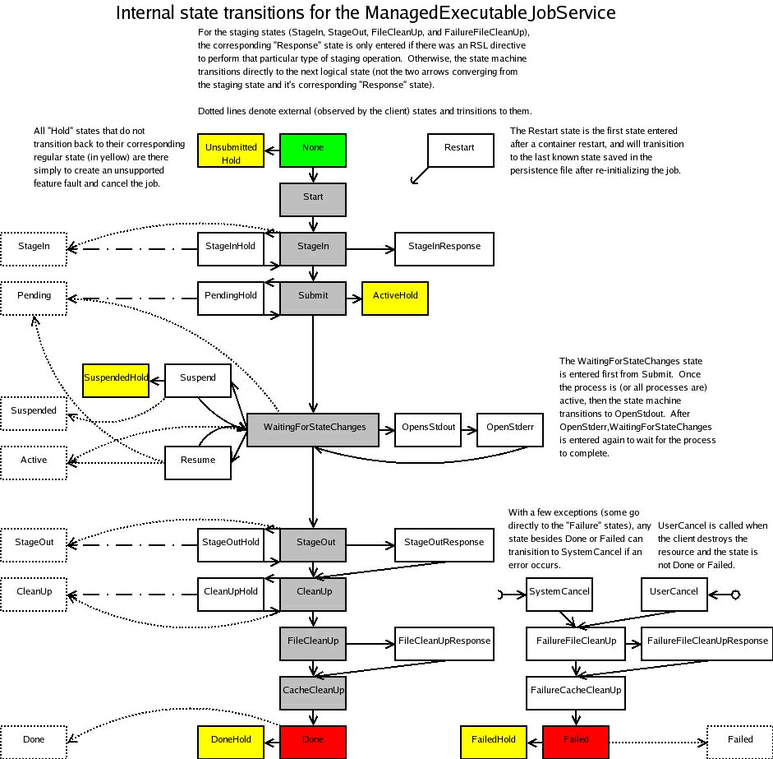

Unicore/GS State Model
TBD

Resource Model
The following table summarises the differences between the resource models used to derive that of this specification.
Table 4 is provided for purposes of comparison while developing the specification: it should either be deleted or moved to an Appendix. Green means we have consensus across things; purple means can be handled as extensibility elements.
Table 4: ESI, GRAM, and UAS Job Factory Resource Properties
Proposed ESI | GRAM | Unicore/GS
Name |  | Name
 | localResourceManager | localResourceManager
 | hostCPUType | Uses JSDL Types
 | hostManufacturer
OperatingSystem | hostOSName | OperatingSystem
OSversion | hostOSVersion
 | scratchBaseDirectory
TotalNumberOfJobs |  | TotalNumberOfJobs
JobReference |  | JobReference
Description |  | Description
Resources |  | Resources
Extensibility | Extensibility | Extensibility
 |  | IndividualPhysicalMemory
 |  | ApplicationResource
 |  | Processor (set of JSDL types)
 |  | TextInfo
 |  | NumericInfo
 |  | StorageReference
Execution Service Location | globusLocation
 | condorArchitecture
 | condorOS
 | delegationFactoryEndpoint
 | stagingDelegationFactoryEndpoint
 | GLUECE
 | GLUECESummary
GRAM extensibility
The following may be required by some GRAM instances. It is hoped however, that these can be supported by the provided mechanisms:
- condorArchitecture: Condor architecture label.
- condorOS: Condor OS label.
- GLUECE: GLUE data
- GLUECESummary: GLUE data summary

Job Properties

Table 5 is provided for purposes of comparison while developing the specification.
Table 5: ESI, GRAM, and UAS Job Resource Properties
Proposed ESI | GRAM | UAS
OriginalJSDL | ServiceLevelAgreement | OriginalJSDL
 |  | ExecutionJSDL
Log | Fault | Log
JobFactoryReference |  | TargetSystemReference
WorkingDirectoryReference |  | WorkingDirectoryReference
StageInReference |  | StageInReference
StageOutReference |  | StageOutReference
StorageReference |  | StorageReference
StatusInfo | State | StatusInfo
Extensibility
 | localUserId
 | userSubject
 | holding
 | stdoutURL
 | stderrURL
 | credentialPath
 | exitCode

Note that Globus has State, Fault, and exitCode. We need to ensure that the states and properties described in section 5.1 capture all the Globus use cases.

Issues to be Discussed and Things to be Done

To Do
- Pending: Karl to draft a constraint based language to describe resources that simply captures the current use cases addressed by this spec, while allowing for more complex scenarios.
- Done: Stuart to add comments from call and send via email.
- Done: David to produce version 0.5.
- Pending: Ian to produce version 0.6.
- Pending: Update references and discussion of WSRF and WSN to the current versions, new Resource Properties, etc.
- Pending: Globus team to confirm that the Job Properties (section 5.1) capture all the Globus use cases.
- Pending: Editors to complete reconciliation tables inline with final ESI states and properties, see sections 3.24.15.1.
- Pending: Editors to fix the URIs and Namespaces according to GFD.58 http://www.ggf.org/documents/GFD.58.pdf
- Pending: Add editors and contributors sections.
- Pending: Add security section.
- Pending: Add definition of JSDL extension for libraries and software packages.
- Pending: Add description of Unicore State model.
- Pending: Michel to do new version of the schema and WSDL.
- Pending: Remove Appendix E after people have learned the history.

Issues to Discuss
- Pending: Accommodation of baseline Security model and cross support for delegation models.
- Pending: File name representation in support of FTP, GridFTP, and other protocols. The reference should be independent of the protocol.
- Pending: Agree to Karl's proposal for constraints based language when draft is available.
- Pending: Do jobs start in suspended, running or either state? And if either, how do we specify which?
- Pending: Decide on editors, contributors, and acknowledgements lists.
- Pending: What happens if there is a processing error in a “Running sub-state held” state, does this get propagated to Failed Cleanup immediately or only on a Release event?
- Pending: For the EPRs exposed by the Job's resource properties, do we need to specify that they are OGSA Base Profile compliant? That way, we can look at the FinalWSResourceInterface resource of a StageInReference and know if it is a UAS SMS or a Globus RTF (or a DMIS interface some day soon.
- Pending: Do we actually need the Log and the Execution JSDL?
- Pending: Do we need fault and exitCode?
- Pending: How do we provide clients access to the application? There is consensus that this be implemented by resource properties, rather than additional operations. However, is this resource property an EPR to an OGSA BP compliant resource or is it a generic {any} mailbox? Or do we support both or leave it as an implementation extension.
- Pending: Do we need a named element for a GLUE description?
- Pending: It is a bad idea to have hold and release operations not be qualified with a target state, i.e. have them change the "hold required bit" associated with a named state. It should be possible to release a hold before the state machine gets there.
- Pending: There is no point in having EPRs to some file services that are not normatively referenced in the spec.

These credential services should be optional in the sense that the client MAY ignore them. In particular it should be possible to submit to a Globus based implementation of ESI without GSI, e.g. using the OGSA Basic Security Profiles.

