Functional Components of Grid Service Provider Authorisation Middleware

Status of This Document

This document provides information to the Grid community. Distribution is unlimited.

Copyright Notice

Copyright © Global Grid Forum (2006). All Rights Reserved.

Abstract

This document describes the various components that make up the authorization decision function of a Grid resource service provider. It looks at the different ways in which the various components can be combined together, and data flows between the components. This document is for informational purposes only and is not intended to form a grid standard.

Contents

Abstract 1
1. Introduction 2
2. Notational Conventions 2
3. Definitions 2
4. Model 3
5. Functional Composition 4
6. The Context Handler 6
7. Relationship of CVS to STS and PIP 6
8. Security Considerations 7
9. Contributors 7
10. Intellectual Property Statement 7
11. Disclaimer 8
12. Full Copyright Notice 8
13. References 8

Introduction

This document described the functional components that make up the authorization decision function of a resource service provider. It looks at the different ways in which the various components can be combined together, and data flows between the components. This model is compared to the XACMLv2 model, and the differences noted.

Notational Conventions

The key words ‘MUST,” “MUST NOT,” “REQUIRED,” “SHALL,” “SHALL NOT,” “SHOULD,” “SHOULD NOT,” “RECOMMENDED,” “MAY,” and “OPTIONAL” are to be interpreted as described in RFC 2119 [BRADNER1]

Definitions

Attribute Authority (AA), synonymous with Identity Provider (IdP), is the entity that asserts that a particular user possesses a set of attributes.

Attribute assertion is a statement made by an issuer that a subject possesses a particular set of attributes.

Credential is an attribute assertion digitally signed by the issuer (i.e. it is a security token) so that it can be cryptographically validated.

An authentic credential is a credential that was issued by the AA that purported to issue it.

A valid credential is an authentic credential that is trusted by the resource’s authorisation service to grant some form of access to the resource. For example, a project manager credential issued by university A is both authentic and valid for use within university A, but is only authentic but not valid for use within bank B.

Capability is a cryptographically protected permission to perform a particular task.
An authentic capability is a capability that was issued by the authority that purported to issue it.
A valid capability is an authentic capability that is trusted by the resource’s authorisation service to grants the holder some form of access to the resource. For example, a capability to print 10 pages on a printer issued by university A is both authentic and valid for use within university A, but is only authentic but not valid for use within bank B.

Editors Note. The current version of the document does not specify how capabilities might be used.

Policy Enforcement Point (PEP) is that part of an application which enforces the results returned from a policy engine

Policy Decision Point (PDP) an application independent policy engine that makes authorisation decisions based upon its policy and information about the subject and the requested mode of access.

Context Handler. The entity that is responsible for handling the communications between the PEP and the CVS and the PDP.

Credential Validation Service (CVS) - synonymous with the validation service of Microsoft’s Security Token Service - is an application independent policy engine that validates credentials (or security tokens) and returns the valid attributes of the subject.

Credential Issuing Service (CIS) – synonymous with the issuing service of Microsoft’s Security Token Service – is an application independent service of an IdP/AA that issues credentials.

Service Provider (SP) is the application dependent and independent software that provides an authorised user with access to a grid resource or grid service.

Policy Information Point (PIP) - the application independent component that acts as a source of attribute values [XACML]

Model

A user is issued with credentials by the Credential Issuing Service (CIS) of one or more Attribute Authorities. The credentials will give the user the necessary rights to access a grid service provider. The credentials may be pushed to the SP by the user or pulled by the SP, or a mixture of both. The CIS will have a policy (credential issuing policy or privacy policy or credential release policy) that will say who is entitled to receive the issued credentials. Some CISs may only issue credentials to their rightful holders e.g. credit card issuers; others may issue them to trusted SPs e.g. Shibboleth IdPs. This is determined by the CIS’s credential issuing policy.

The SP has a policy which says which credentials are acceptable (or trusted) and which attributes are needed in order to gain access to the service. Unacceptable credentials are ignored by the SP. If a user has insufficient attributes he is denied access; if he has greater or equal to the required attributes he is granted access.

The SP software comprises application dependent and application independent code. We are only concerned with modeling the application independent code and the interfaces between the application dependent and application independent code.

The authorization decision function is application independent code. It requires the following functional components:

- a Credential Retriever – this functional component is responsible for pulling credentials from one or more AAs when insufficient credentials are provided by the user
- a Credential Decoder – this functional component is responsible for parsing credentials and storing them in a local internal representation ready for passing to the credential validator. A system may have several credential decoders, in order to handle credentials in different formats, e.g. SAML assertions, X.509 PKC, X.509 ACs, proprietary credentials etc.
- a Credential Authenticator – this functional component validates that a credential is authentic, i.e. that it really was issued by the AA that claimed to have issued it. This usually entails checking that the digital signature on the credential is valid. Since credentials come in different formats, different credential authenticators will be needed. Some credential authenticators may need access to CRLs if the credentials are long lived. Others may not, if the credentials are short lived and need never be revoked.
- a Credential Validation Policy Enforcer – this functional component is responsible for validating an authentic credential, i.e. it ensures that a credential is trusted according to the resource’s policy rules.
- a Credential Validation Service – this functional component returns a set of valid attributes for a user, optionally given a set of credentials for the user. It encapsulates the functions of the credential retriever, decoder, authenticator and policy enforcer.
- a Policy Decision Point – this functional component is responsible for returning an authorisation decision given the user’s access request and optionally the user’s valid attributes or the user’s credentials. Before the PDP can make an authorization decision, it has to either be given the validated attributes of the user or validate the credentials itself. Note that the user may provide any arbitrary set of credentials, e.g. member of university X, member of grid project Y, registered doctor, certified engineer etc. issued by any arbitrary set of attribute authorities (AAs).

Functional Composition

The functional components can be constructed in various ways. Figures 1 to 4 show the different ways in which the CIS, CVS and PDP can be integrated with the PEP. The fundamental difference between the four modes of construction is how the PEP interacts with the authorization service, whether it:
- Pushes credentials to one or more CVSs and then pushes the valid attributes to the PDP for an authorization decision (Figure 1)
- Pushes credentials to the PDP for an authorization decision (Figure 2)
- Passes the user’s authenticated name or ID and meta-information to one or more CISs to one or more CVSs and then pushes the valid attributes to the PDP for an authorization decision (Figure 3) or
- Passes the user’s authenticated name or ID and CIS meta-information to the PDP for an authorization decision (Figure 4).
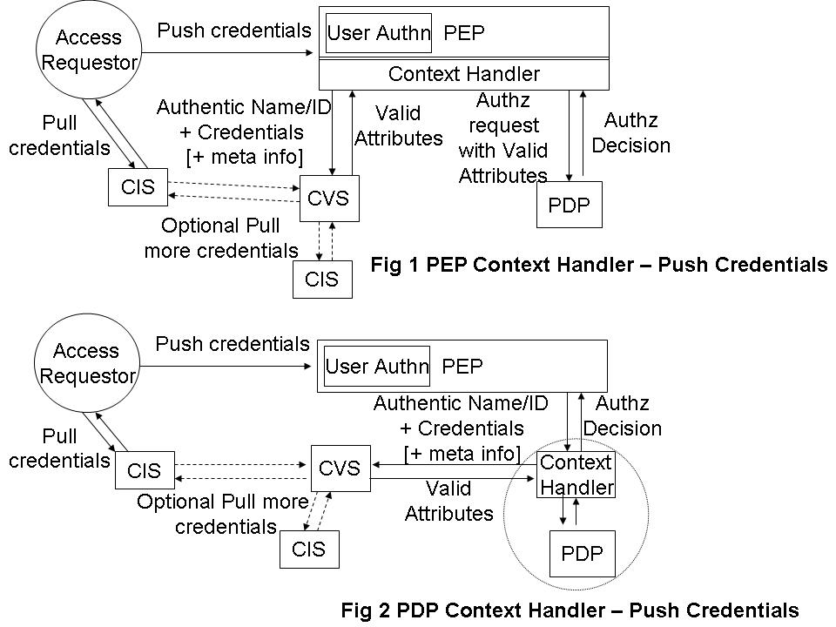

Examples of all four modes of operation are already implemented. The PERMIS authorization system has implemented all 4 modes of operation; the GGF Authz SAML protocol implements Figures 2 and 4, whilst GT4 GridShib has implemented Figure 3. The XACML PDP implements the PDP functionality of Figures 1 and 3.

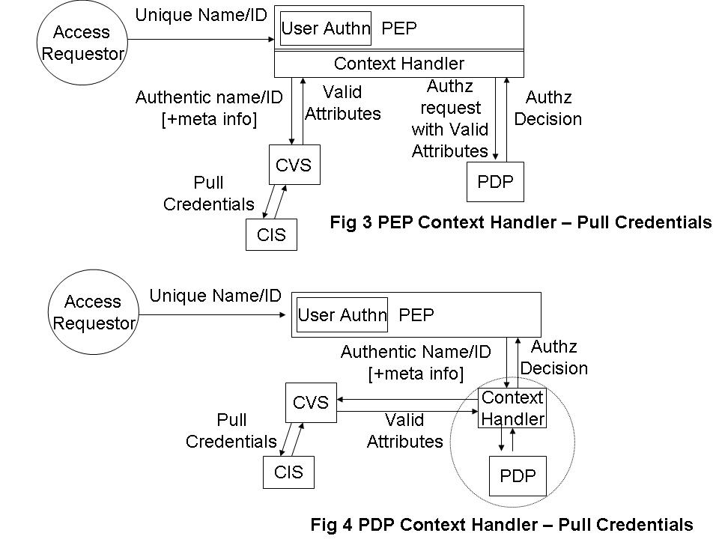

Figure 5 shows how the CVS functionality can be constructed from the various functional components that operate with credentials.

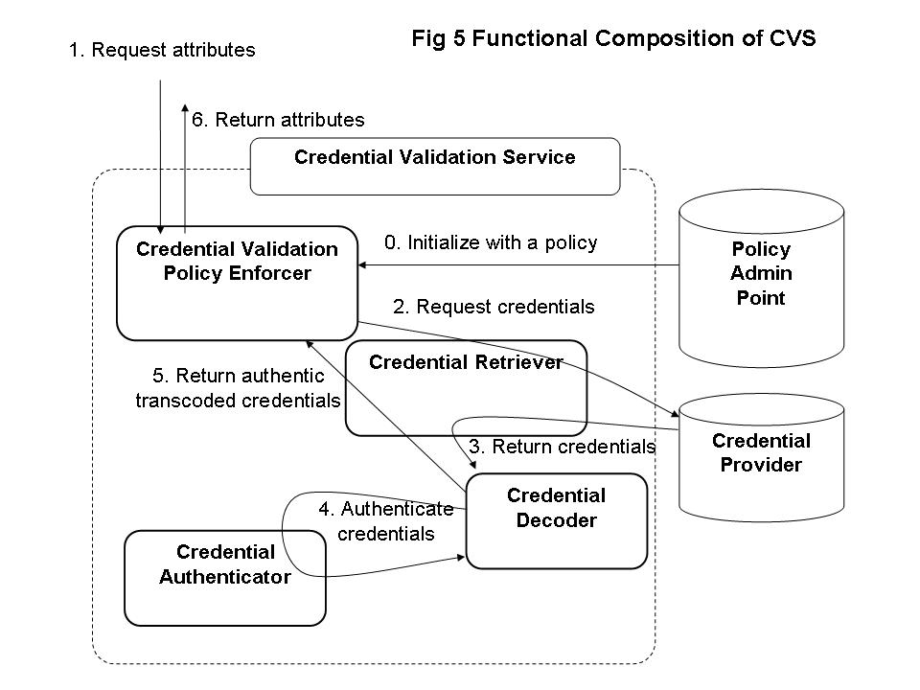

The Context Handler

The context handler has three interfaces, one for talking to the PEP, a second for talking to the CVS and a third for talking to the PDP. Each of these 3 interfaces could be APIs or open protocols. The functionality required of the three interfaces is as follows

6.1 PEP-Context Handler
PEP→CH, the authenticated name or ID of the user, the credentials of the user (optional), meta information to one or more CISs (optional), and the user’s access request
CH→PEP, the authorization decision plus optional obligations.

6.2 Context Handler-CVS
CH→CVS, the authenticated name or ID of the user, the credentials of the user (optional), and meta information to one or more CISs (optional)
CVS→CH, the validated attributes of the user.

6.3 Context Handler-PDP
CH→PDP, the authenticated name or ID of the user, the validated attributes of the user and the user’s access request.
PDP→CH, the authorization decision plus optional obligations.

One can see that the PEP→CH and CH→PDP protocols are very similar. The only difference is that the former optionally passes credentials and CIS meta-information, and the latter passes validated attributes. These could easily be combined into one protocol if there is a way of signaling the difference between an attribute, a credential and CIS meta-information. This is the approach taken in the OGF protocol profile Use of XACML Request Context to Obtain an Authorisation Decision [OGFXACML].

The CH→CVS protocol is quite different to the previous protocol, and this is the subject of a separate OGF protocol profile Use of WS-TRUST and SAML to access a CVS [OGFCVS].

Relationship of CIS, CVS to STS and PIP

WS-Trust [WSTRUST] is a proposal from Microsoft, IBM and others that enables security token interoperability by defining a request/response SOAP protocol whereby clients can request from some trusted authority that a particular security token be exchanged for another one. The security token service (STS) is the trusted authority that responds to WS-Trust requests.

Madsen identifies that an STS actually has three different functionalities, namely: security token exchange, security token issuing and security token validation. The last two functions are special simplified cases of the first. In this document we are interested in the two simplified functions, security token (or credential) issuing and security token (or credential) validation. Therefore we have decided to give these specialized functions their own names – the credential issuing service (CIS) and credential validation service (CVS) – rather than the generic name STS, since STS implies a much greater functionality than that which is required here.

XACML [XACML] is a proposal from OASIS that defines a language for expressing access control policies in XML. XACML has nothing to say about security tokens or credentials. The nearest it comes this is to define a Policy Information Point (PIP) as the system entity that acts as a source of (asserted) attribute values. Since the CVS described in this document is a source of attribute values that are ready to be passed to an XACML conformant PDP, then one can consider that the CVS is a specialized type of PIP that can process credentials and/or security tokens according to a credential validation policy, and that can return valid attributes in exchange for the input credentials.

The only difference between an attribute value assertion and a credential is the digital signature of the latter. If there is a trusted connection between a CIS and the PEP or PDP, then the digital signature isn’t needed, and the CIS could issue unsigned attribute value assertions ready for consumption by the PDP. In this case, the CIS is acting as a PIP, since it is a source of attribute values. In grid environments it is not usually the case that we have trusted connections between entities, and therefore credential issuing and credential validation services will usually be needed. The OGF protocol profile for fetching credentials from a CIS is specified in [OGFAA].

Security Considerations

This entire document is concerned with security.

Contributors

Contact information for authors. You can also use this section to recognize contributions by people who are not listed on the title page, but made a useful contribution (it’s OK to mention the nature of the contribution).

The actual Authors (or Editors) listed on the title page are those committed to taking permanent stewardship for this document – receiving communication in the future and otherwise being responsive to its content. The GFSG recommends at most three Author/Editors be listed on the title page, unless there are compelling reasons to list more.

Intellectual Property Statement

The OGF takes no position regarding the validity or scope of any intellectual property or other rights that might be claimed to pertain to the implementation or use of the technology described in this document or the extent to which any license under such rights might or might not be available; neither does it represent that it has made any effort to identify any such rights. Copies of claims of rights made available for publication and any assurances of licenses to be made available, or the result of an attempt made to obtain a general license or permission for the use of such proprietary rights by implementers or users of this specification can be obtained from the OGF Secretariat.

The OGF invites any interested party to bring to its attention any copyrights, patents or patent applications, or other proprietary rights which may cover technology that may be required to practice this recommendation. Please address the information to the OGF Executive Director.

Disclaimer
This document and the information contained herein is provided on an “As Is” basis and the OGF disclaims all warranties, express or implied, including but not limited to any warranty that the use of the information herein will not infringe any rights or any implied warranties of merchantability or fitness for a particular purpose.

Full Copyright Notice

Copyright (C) Open Grid Forum (2006). All Rights Reserved.

This document and translations of it may be copied and furnished to others, and derivative works that comment on or otherwise explain it or assist in its implementation may be prepared, copied, published and distributed, in whole or in part, without restriction of any kind, provided that the above copyright notice and this paragraph are included on all such copies and derivative works. However, this document itself may not be modified in any way, such as by removing the copyright notice or references to the OGF or other organizations, except as needed for the purpose of developing Grid Recommendations in which case the procedures for copyrights defined in the OGF Document process must be followed, or as required to translate it into languages other than English.

The limited permissions granted above are perpetual and will not be revoked by the OGF or its successors or assignees.

References
Note that only permanent documents should be cited as references. Other items, such as Web pages or working groups, should be cited inline (i.e., see the Open Grid Forum, http://www.ogf.org). References should conform to a standard such as used by IEEE/ACM, MLA, Chicago or similar. Include an author, year, title, publisher, place of publication. For online materials, also add a URL. Some sample citations:

[BRADNER1] Bradner, S. Key Words for Use in RFCs to Indicate Requirement Levels, RFC 2119. March 1997.
[BRADNER2] Bradner, S. The Internet Standards Process – Revision 3, RFC 2026. October 1996.
[CATLETT] Catlett, C. GFD-1: Grid Forum Documents and Recommendations: Process and Requirements. Argonne, Illinois: Global Grid Forum. April 2002.
[OGFAA] V. Venturi, T. Scavo, D.W. Chadwick, “OGSA Attribute Exchange Profile Version 1.0”, 29 Oct 2007.
[OGFCVS] David Chadwick, Linying Su. “Use of WS-TRUST and SAML to access a CVS”. OGF Authz WG Draft, 22 May 2007
[OGFXACML] David Chadwick, Linying Su, Romain Laborde. “Use of XACML Request Context to access a PDP”, OGF Authz WG Draft, 22 May 2007
[SAML] OASIS. “Assertions and Protocol for the OASIS Security Assertion Markup Language (SAML) V2.0”, OASIS Standard, 15 March 2005
[SAMLPROF] OASIS “Profiles for the OASIS Security Assertion Markup Language (SAML) V2.0”, OASIS Standard, 15 March 2005
[WSTRUST] Anthony Nadalin (Editor) “Web Services Trust Language (WS-Trust)”, Feb 2005 available from ftp://www6.software.ibm.com/software/developer/library/ws-trust.pdf
[XACML] “OASIS eXtensible Access Control Markup Language (XACML)” v2.0, 6 Dec 2004, available from http://www.oasis-open.org/committees/tc_home.php?wg_abbrev=xacml

The WS-Trust specification is available from ftp://www6.software.ibm.com/software/developer/library/ws-trust.pdf
Paul Madsen “WS-Trust: Interoperable Security for Web Services“ Available from http://www.xml.com/pub/a/ws/2003/06/24/ws-trust.html

