Cloud Computing Reference Architecture – Straw man Model V2
Comments and Recommendations

Purpose and objectives
The Reference Architecture Analysis Team (RAAT) formed to analyze existent Reference Architectures and to help develop version 1.0 of the Cloud Computing Reference Architecture. This reference architecture will serve as an architectural framework, which consists of high-level architectural components and breakdown, relationships and stakeholders. Further the defined Cloud Computing Reference Architecture needs to be technology neutral and consistent with the cloud computing definition defined by the National Institute of Standards and Technology (NIST).

Cloud computing, based on NIST’s definition, must possess three service models: software as a service (SaaS), platform as a service (Paas), infrastructure as a service (IaaS); four deployment models, private, community, public, hybrid cloud; and five essential characteristics, on-demand self-service, broad network access, resource pooling, rapid elasticity, measured service.

The RAAT reviewed NIST CCRATWG 004 V2 and NIST provided Straw man Model v2. With that in mind, the objective of this report is to summarize the RAAT’s views regarding the draft cloud computing reference architecture.

Assumptions:

- The reference architecture is for the purpose of facilitating discussions related to cloud computing. It shows an architectural framework, which consists of high-level architectural components and breakdown, relationships and stakeholders. It is based on best of existent RAs, and includes group recommendations, and may be adopted in whole or in part. It is not intended to show implementation details.

- Horizontal positioning of a component on top of another implies a layered stack, in which the upper layer is built on top of the lower layer. Vertical positioning of boxes implies optional usage.

- The diagram shows the possibility of a horizontal relationship of service models.

Comments:
- Actors:
  - Cloud Developer: We feel that the developer plays an important role in developing cloud based applications for use by both Cloud Consumer and Cloud Provider. We recommend adding the role of developer as a second tier actor , a within the architecture framework as a subclass of user..
  - Cloud Broker: Based on the provided definition of “an entity that manages the use(? The original sentence isn’t clear), performance and delivery of cloud services, and negotiates relationships between Cloud Providers and Cloud Consumers”, we felt that the role of this actor needs to exist on a second tier, but not a part of the first tier of the architecture framework.

  - Cloud Auditor: Isn’t necessary a third-party, Cloud Auditor could be a part of the consumer and or provider organization as a second tier role..

- Business and Operational Support: These two independent boxes should be combined into Cloud Provider Support. Based on the definitions, we think Business and Operation Support go hand-in-hand. Business Support spans further than just the top portion of the Cloud Provider stack. Under Operational Support, security needs to be more than just monitoring. Operational Security needs to include active monitoring, incident response, and forensic.

- Security: Cloud Computing security is complex, and it deserves its own vertical box. Vertical because security is applicable everywhere, Security needs to exist at every layer of the reference architecture including the virtualization layer, as well as facility. We therefore recommend for the Combined Conceptual Reference Diagram to include a vertical box for security.

- Platform Architecture: We recommend for this box to be renamed to Cloud Control Layer.

Recommendations:

- The Combined Conceptual Reference Diagram needs to add or capture the following elements that currently absence.
  - Open Interfaces
  - Inter-cloud resources control
  - Disaster recovery
  - Security incident response
  - Spillage response

- Data as a Service (DaaS) is included with the intent to emphasize the importance of data services, recognizing there may be continuing discussion about placement in the RA.

- Below is the RAAT’s recommended Conceptual Reference Diagram.

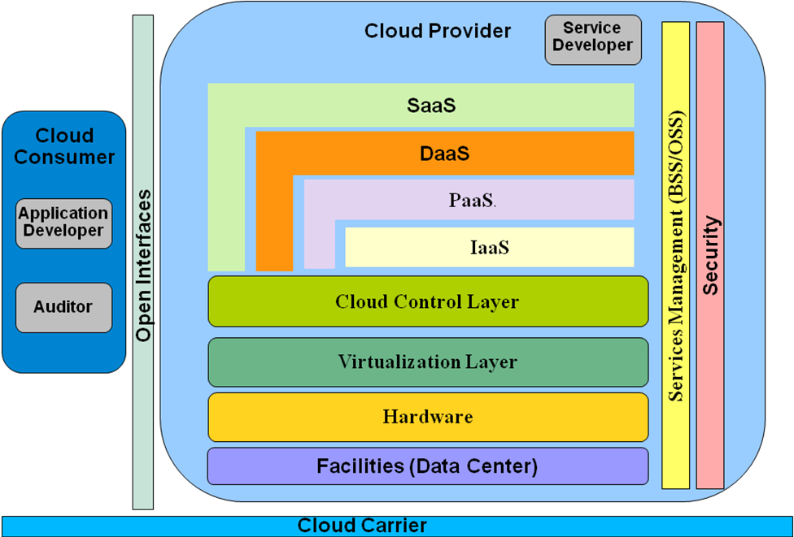

Cloud Consumer (Modified from DMTF profiles)

The Service Consumer is the end user or enterprise that actually uses the service, whether it is Software, Platform, or Infrastructure as a Service.

Depending on the type of service and their role, the Service Consumer works with different user interfaces and programming interfaces. Some user interfaces look like any other application; the Service Consumer does not need to know about cloud computing as they use the application. Other user interfaces provide administrative functions such as starting and stopping virtual machines or managing cloud storage. Service Consumers (Application Developer) writing application code use different programming interfaces depending on the application they are writing.

Service Consumers work with SLAs and contracts, and conduct security audit of provider’s IT and physical security postures.

Cloud Provider (Derived from the DMTF profiles and IETF)

The Service Provider delivers the service to the Service Consumer. The actual task of the provider varies depending on the type of service:
For Software as a Service, the Service Provider installs, manages, and maintains the software. The Service Provider does not necessarily own the physical infrastructure in which the software is running. Regardless, the Service Consumer does not have access to the infrastructure; they can access only the application.
For Platform as a Service, the Service Provider manages the cloud infrastructure for the platform, typically a framework for a particular type of application. The Service Consumer’s application cannot access the infrastructure underneath the platform.
For Infrastructure as a Service, the Service Provider maintains the storage, database, message queue, other middleware, or the hosting environment for virtual machines. The Service Consumer uses that service as if it was a disk drive, database, message queue, or machine, but cannot access the infrastructure that hosts it.

In the Service Provider diagram, the lowest layer of the stack is the facility layer, which house cloud computing systems. The next layer is the firmware and hardware on which everything else is based. Above that is the virtualized resources and images include the basic cloud computing services such as processing power, storage, and middleware. Physical resources at the lowest level are the most complex to share among multiple users. The function of the Resource Abstraction and Virtualization layer is to convert physical resources to virtual resources. Virtual resources are contained in a resource pool. Resources can be allocated to users from the resource pool and released back into the resource pool when they are no longer needed.

The Cloud Control Layer controls and meters who uses the services and to what extent, provisioning to determine how resources are allocated to consumers, and monitoring to track the status of the system and its resources. The Cloud Control Layer provides monitoring and administration of the cloud network platform to keep the whole cloud operating normally. Key features of the Cloud Management Layer include:
- Automatically deploying the cloud system based on the configuration data and policy;
- Real-time monitoring and alerting of cloud status, resource usage, and performance of cloud;
- Reporting and charting of historical events and performance metrics;
- Flexible IT management and operational status displays;
- Authenticating/Authorizing the published cloud service registry;
- Auditing the cloud environment to check whether its running smoothly;
- Controlling the SLA implemented in the cloud system;
- Maintenance concerned with performing repairs, upgrades, and joining new nodes into the Cloud;
- Providing a security mechanism for the Cloud.

To the right is Services Management involves billing to recover costs, capacity planning to ensure that consumer demands will be met, SLA management to ensure that the terms of service agreed to by the Service Provider and the Service Consumer are adhered to, and reporting for administrators.

Security applies to all aspects of the Service Provider’s operations.. Open standards apply to the Service Provider’s operations as well. A well-rounded set of interfaces based on open standards simplify operations within the Service Provider and interoperability with other Service Providers.

RAAT members:

- Cary Landis
- Frederic De Vaulx
- Ken Stavinoha
- Babak Jahromi
- Alan Sill
- Anne Frantzen
- Eugene Luster
- Gary Mazzaferro
- Michele Drgon
- Randy Baklini
- Pat Stingley
- Dean Kemp
- Marlin Pohlman
- Bob Marcus
- Tom Young
- Gregg Brown
- Hung Nguyen

