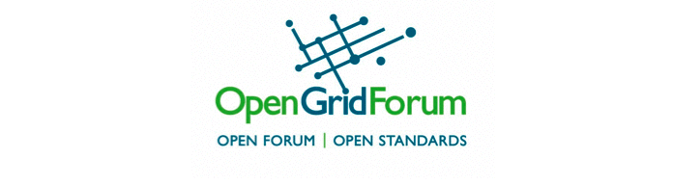

Call for Cloud & Grid Demonstrations

OGF-29 & HPDC 2010
June 21, Chicago, Illinois, USA

The Open Grid Forum (www.ogf.org) and the ACM International Symposium on High Performance Distributed Computing (hpdc2010.eecs.northwestern.edu) are soliciting proposals for demonstrations of cloud and grid computing systems and applications.

The goal of these demonstrations is not only to show novel cloud and grid capabilities, but also to show the use of emerging standards to enable interoperability, portability, and the end-to-end integration of capabilities and services. Besides demonstrating basic cloud and grid capabilities, application scenarios that are applicable to a wide set of stakeholders will be of particular interest. Given the extensive overlap between grids and federated clouds with regards to capabilities necessary to manage distributed computing infrastructures, such as identity management and virtual organizations, demonstrations that illustrate this intersection would also be of particular interest.

While exact infrastructure details are being decided, presenters can expect to have a wired network connection for demonstration purposes.

For further information, please contact:

Craig A. Lee, President, Open Grid Forum, lee@aero.org

