Describing paths in a multidomain connection oriented infrastructure

Some examples

Example 1
First a chain and tree example of how a simple connection path can be described. The difference in the description is how the authorization is grouped in the path description.

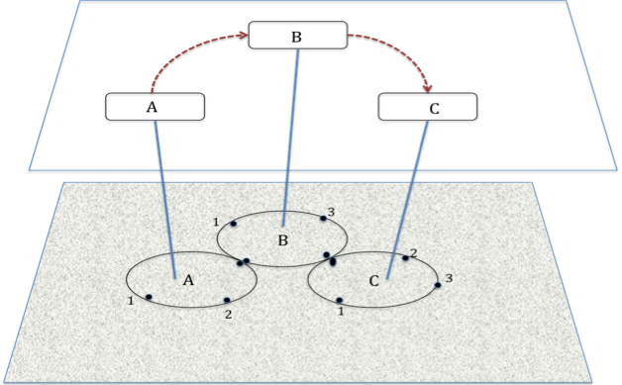

Example – Atomic Networks Controlled by NRMs

In this example there is a topology of data networks. The topology can be described as a set of edge points on a network and points on other places that connect to those points.

In the case the topology would look like

A.1 – userA1
A.2 – userA2
A.B – B.A

B.1 – user B1
B.3 – user B3
B.A –A.B
B.C – C.B

C.1 – user C1
C.2 – user C2
C.3 – user C3
C.B – B.C

In the first example, the networking NSAs are connected as a chain.

NSA-A(R) to NSA-B(P)
NSA-B(R) to NSA-B(P)

Now assume that a request is made to NSA-A to reserve a connection from A.1 to C.3

NSA-A will look in the topology and determine that to make a reservationfrom. A1 to C.3 it must request a reservation from its local NRM from A.1 to A.B and from NSA-B for a reservation between B.A and C.3.

NSA-B gets this request and reserves a connection between B.A and B.C, and requests a reservation from NSA-C for a connection between C.B and C.3.

When the authorization sequence is done there are 3 segments in the reserved connection. Each segment is a connection, with a connection id.

The path of the finished reservation can be represented as a sequence of segments, as follows

Path == [CID-1 (A.1,A.B : CID-2 (B.A, B.C :CID-3(C.B, C.3)))

Example 2 is a simple tree model

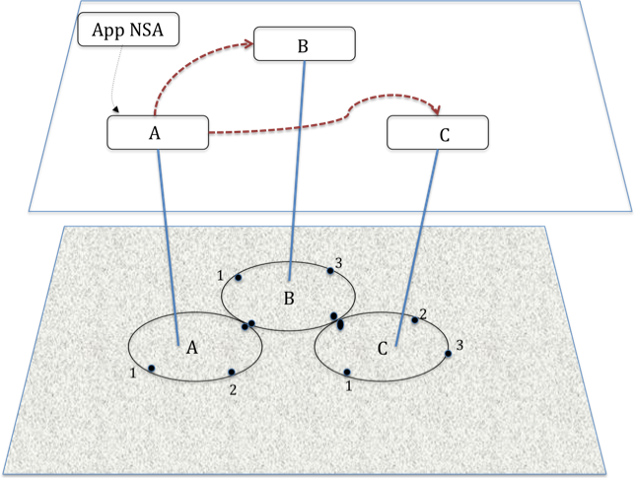

In this case the path would be described as

Path == [CID-1 (A.1,A.B : CID-2 (B.A, B.C):CID-3(C.B, C.3))

Where : means concatenation
, separates edgepoint in a network
() defines the set of segments authorized when creating the CID

This leads to a definition of a Federating NSA

A federating NSA is one which accepts is a provider to one or more NSAs, and gets resources to satisfy requests from one or more other NSA.

One of the things the federating agent does is break a requested connection into segments and then request those segments from other NSAs.

A federating agent returns to its parent a connection with performance and identification parameters, and with a path.

The path it returns MUST contain the requested endpoints of the connection. It may return information about segments in the path. How much it returns in the path is dependent on policy of the agent. The agent policy will likely be determined by SLA between itself, its parents and its children. In some implementation cases a “federation” may have rules about what is to be returned in the path field.

In the chain example the full path is
Path == [CID-1 (A.1,A.B : CID-2 (B.A, B.C :CID-3(C.B, C.3)))

This could be returned as

Path == CID-1(A.1-C.3) or
Path == CID-1(A.1-C.3:CID-2(B.A-C.3))

How this is handled in the federating agents requires the federation agents to have a common understanding the path will be used in coordining activity between themselves.

