Connection Oriented Networks – Networks, Network Agents, Network Services

A Network Service transport Infrastructure consist of Networks interconnected with links. Each network and link is a resource. Network Resources are controlled by Network Service agents.

Agents represent the resource to the outside world. Agents authorize and schedule the use of their resource. Agents may schedule may instantiate the resource at its scheduled time or approve instantiation initiated by another process.

Network clients connect to networks at access ports. Clients can request connection to clients on other access ports.

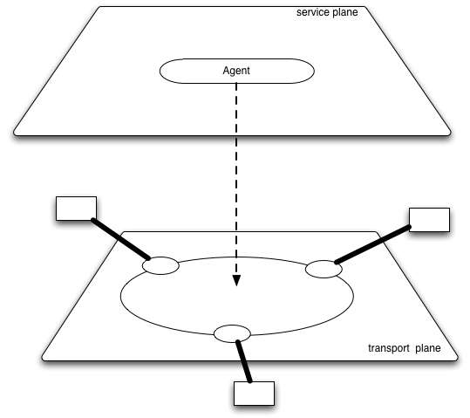
Figure 1 network - transport and agent

Figure 1 shows a with its dataplane and agent. The agent is the sole method of scheduling resources in the network.

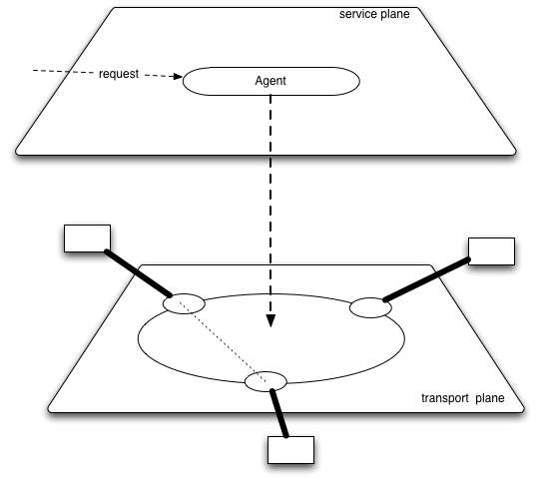
Figure 2 network with segment reserved by agent

Figure 2 shows a connection between ports on a network. The connection is authorized and reserved by the agent.

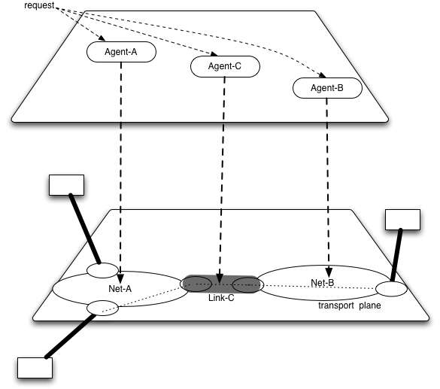
Figure 3 Connection crossing linked networks

Figure 3 shows two networks with a link between them. A connection between clients is created by concatenating segments from networks A and B and from Link C.

The segments from each resource are reserved by the agent for the resource. The method for requesting the segments is discussed in more detail in later sections. For purposed of this discussion the important thing is that each resource must be authorized by its agent.

One can think of an infrastructure of networks and links that are connected at the data layer. Finding a sequence of networks and links that provide a transport connection is called pathfinding.

To make a connection each agent must be contacted and authorize and schedule the segment. Making a request to each agent is accomplished by service plane algorithms that can identify the agents responsible for each resource in a requested connection.

Note that while resources are normally reserved to be part of a specific path, it is possible that resources may be reserved by a third party agent (or broker) and then reallocated to specific applications over time.

The following sections describe the transport and service plane aspects of connection oriented Network infrastructures.

Before going to those descriptions we here define some terms that will be used in the descriptions.

- Network
- Link
- Port
- Segment
- ETE connection
- Network Agent
- Network Service
- Network Service Interface
- Routing Area

Network – A resource which has ports on its edge. A network can reserve and create connections between ports on its network.

Link – A resource which attaches to ports on two networks. A Link can reserve connections between the ports on different networks.

Port - A feature of a network where connections from the network and connections from a link can be concatenated

Segment – A connection across a network or link is called a segment. When segments are concatenated they become larger segments

ETE connection – segment that connects clients of the network

Network Agent – The responsible party for authorizing, scheduling network particular network resources

Network Service – Services provided by a network. These are transport services like providing connection segments or control services like sharing clients accessible from the network

Network Service Interface – the protocol interface between a requestor agent and a network Agent

Routing Area – the set of networks and links which can be used to create connections.

