Anycasting and the Network Service Interface
Joan A. García-Espín (i2CAT)

Contents:
Anycasting 1
Examples 2
Simple workflow (I) – figure 2 3
Simple workflow (II) – figure 3 4
Effects of the Anycast support on the NSI 5
Acronyms 5
References 5

Anycasting
Anycast is a type of data transmission where data is sent from single source to the ‘nearest’ or ‘best’ destination point. Note that both ‘nearest’ and ‘best’ adjectives need to be contextualised (network cost, Geo-spatial coordinates, application constraints, or others).
The group of receivers is identified with single routing address, a.k.a. Anycast address, however only one is receiving the data at the same time (cf. Figure 1).
In Figure 1, yellow circle is the sender of the service request (Requestor Agent), while blue circles –numbered 1 to 4- are the feasible receivers of the request (NS Agents). Once evaluated the Anycast NS request,
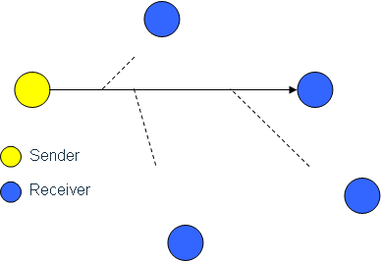
1
2
3
4
Figure 1: Anycasting (source: [1]).
It must be said Grid environments already commonly use point-to-multipoint connections but multicasting and anycasting are more experimental ones and don’t typically meet in operational computation infrastructures [1].

Examples
- Large data transfers/storage.
This is a typical use case present in many professional areas: Grid-FTP-like applications, LHC’s data set collection jobs, enterprise’s data back-ups, storage services ala Cloud, data centres life-motif, and a long etc.
- Remote processing workflows.
Major Industry and Academia entities typically have their own agreements with (super-) computing centres (or even their own computing facilities). However, there is a big pond of smaller centres that cannot afford it and would occasionally like to take profit of that (remote) processing power for their own workflows/purposes. Basing on anycasting service, small centres could occasionally ask for the processing power required and see if it fits their budget, independently of the location of the computing facilities (assuming no large data sets are produced).
- Media services: streaming
Peer-to-peer (p2p) networks allow a kind of anycasting service (note that files downloaded are not only located in one server, but spread over several peers in small parts). However, live streaming of (HD, super HD, 4k, 8k, …) media is not feasible with today’s p2p solutions. Real anycasting service, as described in [2], could fulfil this purpose.
- Pervasive IT services
IaaS (IT definition) and SaaS trends in Future Internet are making internal company services to request for pervasive servers. It must also be noted that some companies even externalise them (i.e. data storage). Moreover, users tend to use wireless access to IT services, which in many cases causes moving service access points to several locations in the network (i.e. distributed security systems in large campuses or companies).

Simple workflow (I) – figure 2
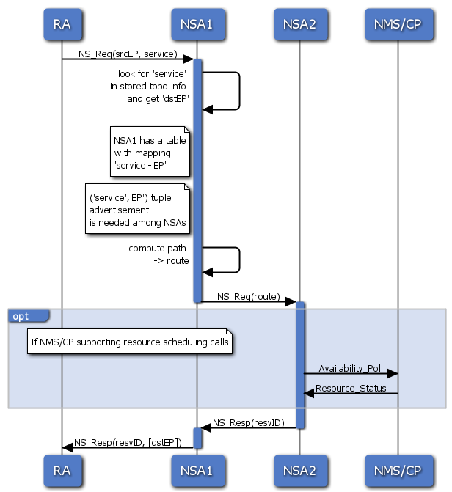
Figure 2: Simple Anycasting: NSA1 has the mapping ‘service’-‘EP’.
Workflow description (created using [3]):

RA->NSA1: NS_Req(srcEP, service)

activate NSA1
NSA1->NSA1: look for 'service' \n in stored topo info \n and get 'dstEP'
note left of NSA1
NSA1 has a table
with mapping
'service'-'EP'
end note
note left of NSA1
('service','EP') tuple
advertisement
is needed among NSAs
end note
NSA1->NSA1: compute path \n -> route
NSA1->NSA2: NS_Req(route)
deactivate NSA1

activate NSA2
opt
note over RA,NSA1: If NMS/CP supporting resource scheduling calls
NSA2->NMS/CP: Availability_Poll
NMS/CP->NSA2: Resource_Status
end
NSA2->NSA1: NS_Resp(resvID)
deactivate NSA2
activate NSA1
NSA1->RA: NS_Resp(resvID, [dstEP])
deactivate NSA1

Simple workflow (II) – figure 3
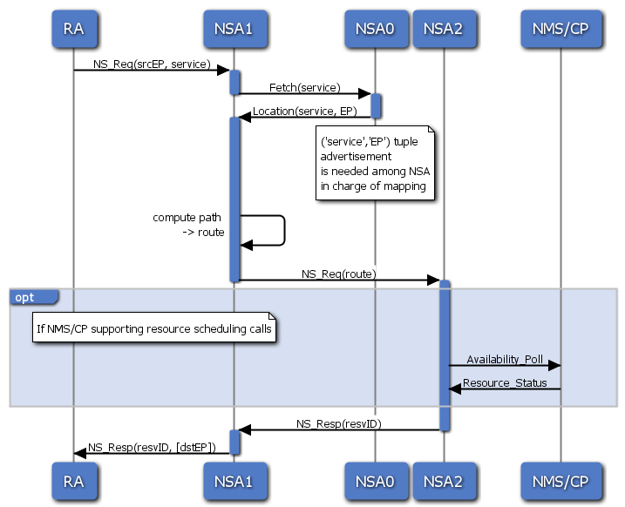
Figure 3: Simple Anycasting: external entity to map ‘service’ to ‘EP’ (DNS-like).
Workflow description (created using [3]):

RA->NSA1: NS_Req(srcEP, service)

activate NSA1
NSA1->NSA0: Fetch(service)
deactivate NSA1
activate NSA0
NSA0->NSA1: Location(service, EP)
deactivate NSA0
activate NSA1
note over NSA0
('service','EP') tuple
advertisement
is needed among NSA
in charge of mapping
end note
NSA1->NSA1: compute path \n -> route
NSA1->NSA2: NS_Req(route)
deactivate NSA1

activate NSA2
opt
note over RA,NSA1: If NMS/CP supporting resource scheduling calls
NSA2->NMS/CP: Availability_Poll
NMS/CP->NSA2: Resource_Status
end
NSA2->NSA1: NS_Resp(resvID)
deactivate NSA2
activate NSA1
NSA1->RA: NS_Resp(resvID, [dstEP])
deactivate NSA1

Effects of the Anycast support on the NSI
Several considerations regarding network/non-network resources and their availability in the interface must be taken into account. Among them, it is very critical to consider:
- Destination EP is not explicitly specified in the service request
- Destination EP is sorted out from service/non-network resource requested (implicit destination)
- NSAs should make public the services they can fetch or register them in a centralised, DNS-like resolution system.
- NSAs need to dialogue with non-network systems, in order to fetch their available services (part of the NSI?)
- The level of detail in service description influences destination end-point selection process (best-match typically used)
- A new set of non-network resource description is needed. In the case of Grid services, description of site, service, cluster, computing/storage element/area, software or host is needed [4].

Acronyms
CP Control Plane
EP End-point
HD High Definition
LHC Large Hadron Collider
NMS Network Management System
NS Network Service
NSA Network Service Agent
RA Requestor Agent

References
[1] N. CIULLI et al., The Grid-GMPLS Control Plane Architecture, Phosphorus deliverable D2.1, the Phosphorus Project (European contract no. 034115), March 2007.
[2] C. Partridge, T. Mendez, W. Milliken, RFC 1546: Host Anycasting Service, IETF, November 1993.
[3] Web Sequence Diagrams, www.websequencediagrams.com
[4] N. CIULLI et al., Routing and Signalling Extensions for the Grid-GMPLS Control Plane, Phosphorus deliverable D2.2, the Phosphorus Project (European contract no. 034115), September 2007.

