Layer Network Models –

G.800, G.805, NML, NSI

This document discusses network models and terminology from ITU standards G.800 and G.805, and OGF working groups NML (naming), and NSI (making connections).

The first section of the document describes layer networks in G.800 terms and discusses how the terms fit example networks. It also discusses some of the needs for OGF groups where network modification is done automatically. This is a data plane discussion. (for the current document this is the only section)

Future sections are planned that will discuss

1) how control plane operates and its needs. This will reference the dataplane description and
2) naming needs for both the dataplane and control plane.

Data Plane
The ITU Recommendation G.805 is a generic functional architecture of transport networks specifically for circuit nets. G.800, which was published after G.805, is a unified architecture of the dataplane of transport networks. which includes both circuit and connectionless networks. G.800 is the latest standard and its terminology is used in the dataplane discriptions. The first section of this document is to define transport networks in G.805 terms, then to describe how to create end to end connections by cross connecting segments from multiple network resources.

Single Layer
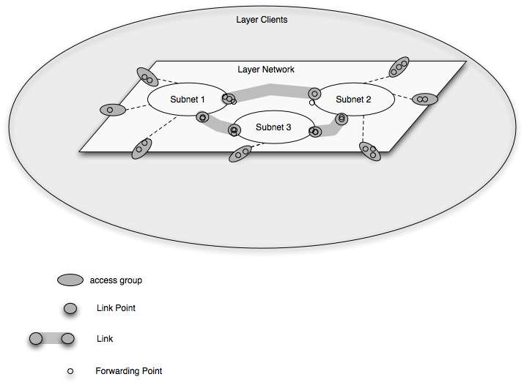
multiple

Figure 1 Layer Network and environment

A layer network is defined as a a set of access points of the same type that can be associated for the purpose of transferring information. An association between access points is called a network connection.

A layer network consists of one or more subnets. Subnets are defined as as set of link ports which are available for transferring characteristic information. Each link port has a set of forwarding points which may be associated with forwarding points in other link ports on the same subnetwork. An association between forwarding points on the same subnet is called a subnet connection.

Link ports on one subnet are associated with link ports on a different subnet by a Link. A Link represents the topological relationship and available capacity between two subnetworks. Each link port may have multiple forwarding points. An association between forwarding points at each end of the link is called a link connection.

An Access point is where clients connect to the network. Multiple access points can be grouped in an access group. An access group has individual inputs on the client side. On the network side it has a link port with a forwarding point for each client input.

A network connection consists of of a sequence of connection segments. Subnet connections and link connections are both connection segments.

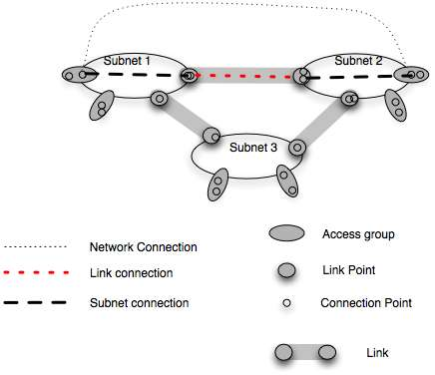
Figure 2 Connections

Figure 2 shows the various connections when creating a network connection between access points at edge of two subnets.

Single Layer Use Case
To give a practical example, if this is assumed to be an Ethernet layer network where the link points are tagged Ethernet and the forwarding points are VLANs. A network connection consists of a VLAN across net A, a VLAN across the Link, and a VLAN across net B. Each VLAN is a segment.

The VLAN in each segment may be the same, If VLAN mapping is possible at link points, then different VLANs may be mapped.

Input to the access group may be a VLANs on a tagged Ethernet or it may be an untagged Ethernet, or a combination. All access points in the link port connected the network are terminated by adding or modifying VLAN tags (labels) and perhaps other information, particularly monitoring (OAM) information.

Implications for creating network connections

Each subnet must be able to create an association between forwarding points in different link ports. This implies that a subnet agent can cause a subnet connection to be created. It also implies (to me at least) that a link and a forwarding point in the link must have related names.

At a link point, a segment from a subnet and a segment from a link must be cross connected under control of a subnet agent. It would be good to have a name for a controllable link point.

At an access group an input port must be mapped to a forwarding point on the link port under control of a subnet agent.

Multi Layer Network

In a multilayer network links in one layer may be made by creating an association through another layer. An example of this would be two Ethernet subnetworks, each with multiple switches. Each has a switch which includes a SONET port . The link between the two subnetworks goes between SONET ports. Figure 3 below shows this topology.

In going between layer networks it is necessary to adapt information from technology at one layer to topology at the other layer. The network at one layer is client and the network at the other layer is server. The adaptation service at an adaptaion point modifies Input from the one layer so it can be carried by the other layer. After modification it is treated as input to the new layer.

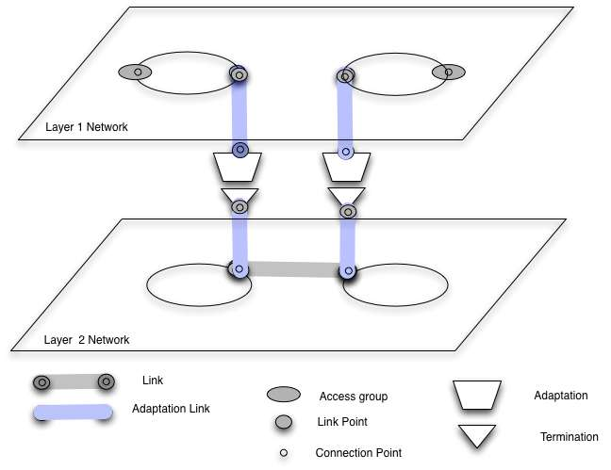
Figure 3 Simple multi layer topology

Using the example of Ethernet and SONET layers, the adaptation could be to encode Ethernet frames in SONET using GFP. This would include selecting SONET channels. The SONET layer would add monitoring and error detecting information for the adapted signal.

Figure 4 below shows connection elements over multilayer networks. The new features, other than a second layer, is the adaptation points between layers. The link connection in layer 1 is carried by the link connection in layer 2.
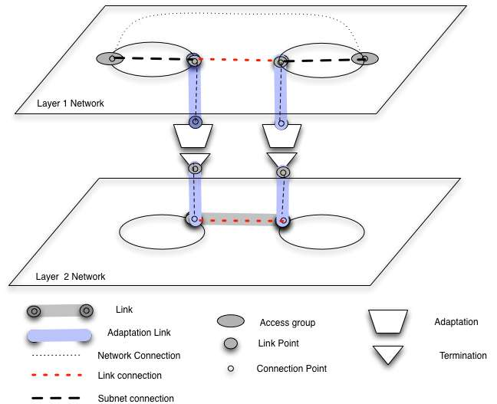
Figure 4 Connections over multi layer network

Implications for creating network connections

Some implications for creating network connections that use two or more layer networks include the following. There may be more, possibly described in G.8080 (ASON) or newer GMPLS documents.

Adaptation points imply conversion from one layer to another.

- One conversion is in resources. A connection on one layer may be carried by multiple connections on another. For example an Ethernet VLAN on one level may be carried by multiple SONET circuits on a different layer.

- A second conversion is in coding. An Ethernet VLAN may be encoded using GFP to be carried by SONET. The adaptation at both ends of a layer network must do the same adaptation.

Topology for all layers and between layers must be known to be able to do pathfinding. Part of topological part of pathfinding is to know adaptation capabilities on links between layers.

Adaptation points between layers must be controlled to match each other ‘s capabilities as connection establishment time.

There are other issues that have to do with adaptations that go through a sequence of more than two layers that has to do with encoding information across multiple layers.

Information carried between users is called user information. Information carried across a layer network is called characteristic information. Characteristic information from one layer is adapted to be carried across a lower layer and adapted back to the original characteristic information.

