Layer Networks – G.805, G.800, NML, NSI

This document discusses network models and terminology from G.800 and G.805, NML (naming), and NSI (making connections). The first section describes layer networks in G.800 terms and discusses how the terms fit example networks. It also discusses some of the requirements for supporting automatic creation of connections. This is a data plane modelling discussion.

Future sections are planned that will discuss 1) how control plane operates and its needs. This will reference the dataplane description and 2) naming needs for both the dataplane and control plane.

Data Plane
The ITU Recommendation G.805 is a generic functional architecture of transport networks. G.800, which was published after G.805, is a unified architecture of the dataplane of transport networks. Both G.805 and G.800 define “building blocks” for describing multi-layer networks. While G.805 is oriented towards describing circuit switched networks, G.800 has been written to support modeling of both circuit and packet switched networks. The aim of first section of this document is to define transport networks in G.800 terms it then goes on to describe the ability to create end to end connections by cross connecting connection segments (as identified in NSI) from multiple network resources.

Single Layer Network

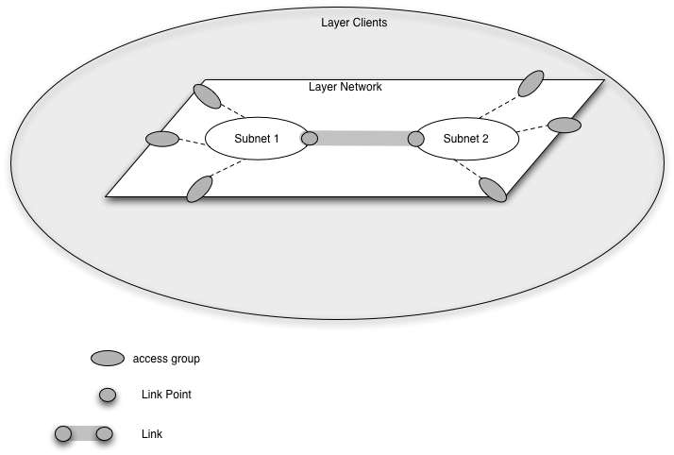
Figure 1 Layer Network and environment

A layer network is defined as a a set of access points of the same type that can be associated for the purpose of transferring information. Access points are end points within a layer network and are the points at which the layer can be accessed from another layer network. Within a layer network an association exists between access points, these are called network connections.

A layer network consists of one or more subnets. Subnets are defined as as set of link ports (a link port is the end point of a link) which are available for transferring characteristic information. Each link port has a set of forwarding points (a forwarding point is a logical channel in a link port) which may be associated with forwarding points in other link ports on the subnetwork. An association between forwarding points on the same subnet is called a subnet connection.

Link ports on one subnet are associated with link ports on anther subnet by a Link. A Link represents the topological relationship and available capacity between two subnetworks. Each link port may have multiple forwarding points. An association between a forwarding point at each end of the link is called a link connection.

An Access point is where clients connect to the network. Multiple access points can be grouped in an access group. A connection group has individual inputs on the client side. On the network side it has a link port with a forwarding point for each client input.

A network connection consists of of a sequence of connection segments, Subnet connections and link connections are both connection segments.

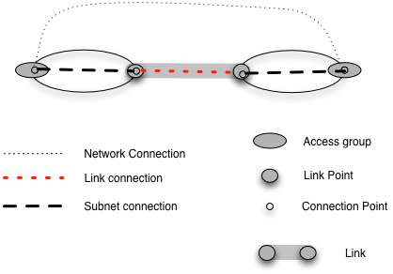
Figure 2 Connections

Figure 2 shows the various connections when creating a network connection between access points at edge of two subnets.

Use Case
If we apply Ethernet as a practical example to figure2, the ports are Ethernet ports and the forwarding points are VLANs. In this case figure 2 can be interpreted as a network connection consisting of a VLAN across net A (the left subnet), a VLAN across the Link, and a VLAN across net B (the right subnet). In this case each VLAN is a segment according to the NSI definition of a segment..

A common VLAN tag may be usedin each segment furthermore, if VLAN mapping is possible at link points, then vlan tags may swapped from one segment to the next.

The client information applied to each access group may be an Ethernet carrying VLANs or it may be an untagged Ethernet, or a combination thereof. All access ports are terminated by adding or modifying VLAN tags (labels) and perhaps other information, particularly monitoring (OAM) information.

Implications for creating network connections

Each subnet must be able to create an association between forwarding points in different link ports. This implies that a subnet agent (the managing agent for the subnetwork known as the network service agent in NSI terminology) has sufficient knowledge of the data plane layer to instigate the creation of a subnet connection . It also implies (to me at least) that a link and a forwarding point in the link must have related names. To create this connection, at a

a link point, a segment from a subnet and a segment from a link must be cross connected under control of a subnet agent. It would be good to have a name for a controllable link point.

At an access group, an input port must be mapped to a forwarding point on the link port under control of a subnet agent.

Multi Layer Network

In a multilayer network, links in one layer may be made by creating an association through another layer. An example of this would be two Ethernet subnetworks, each with multiple switches. Each has a switch which includes a SONET port . The link between the two subnetworks interconnects these SONET ports. Figure 3 below shows this topology.

When passing between network layers it is necessary to adapt information from technology at one layer to topology at the other layer. The network at one layer is client and the network at the other lower layer is server. The adaptation service at an adaptation point modifies input from the one layer so it can be carried by another layer. After modification it is treated as input to the new layer.

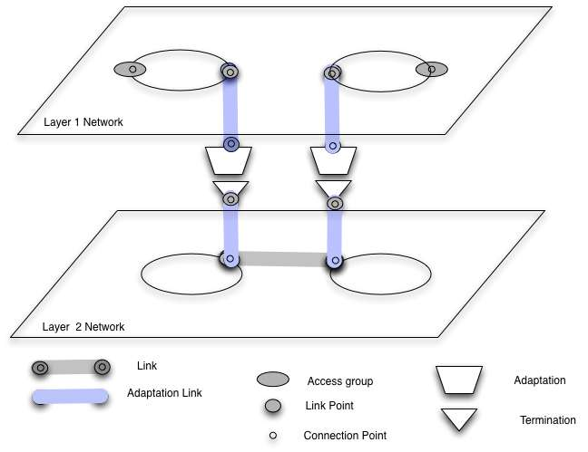

Figure 3 Simple multi layer topology

Using Ethernet and SONET layers as an example, the adaptation performs an encapsulation of Ethernet frames in GFP so that they can be carried by SONET. This is then carried on virtually concatenated SONET channels. The SONET layer adds monitoring and error detecting information for the adapted signal.

Figure 4 below shows connection elements over multilayer networks. The new features, other than a second layer, is the adaptation points between layers. The link connection in layer 1 is carried by the link connection in layer 2.
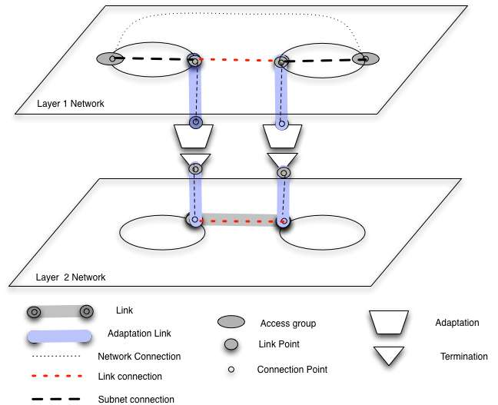
Figure 4 Connections over multi layer network

Implications for creating network connections

Some implications for creating network connections that use two or more layer networks include the following. (There may be more implications, possibly described in G.8080 (ASON) or newer GMPLS documents).

Adaptation points imply convertion from one layer to another.

- One conversion is in resources. A connection on one layer may be carried by multiple connections on another. For example an Ethernet VLAN on one level may be carried by multiple SONET circuits on a different layer.

- A second conversion is in coding. An Ethernet VLAN may be encoded using GFP to be carried by SONET. The adaptation at both ends of a layer network must do the same adaptation. I.e every source termination point requires a matching sink of the same technology at the far end of the circuit.

Topology for all layers and between layers must be known to be able to do pathfinding. To perform pathfinding, adaptation capabilities on links between layers needs to be known

Adaptation points between layers must be controlled to match each layer’s capabilities at connection establishment time.

There are other issues that have to do with adaptations that go through a sequence of more than two layers that has to do with encoding information across multiple layers.

Information carried between users is called user (client?) information Information carried across a layer network is called characteristic information. Characteristic information from one layer is adapted to be carried across a lower layer and adapted back to the original characteristic information.

