Overview of Document

This document describes the architecture of the Network Service Interface (NSI) that is to be defined by the Network Service Interface working group of the OSF.
The interface defines how agents for a Network Service and a user of the service communicate. The document includes a functional description of services which must be supported over the interface. It does not attempt to give details of interface protocol or detail definition of how the services are supported. Thee are left for protocol documents which is to be provided independently by the NSI wg.

The network service capabilities supported by the NSI are primarily connection oriented services and resources to support them. In some places this document uses the term Connection Oriented -Network Service (CO-NS) for to emphasize this, and in most places the connection oriented prefix is assumed.

This architecture defined in this document defines an interface and functions that allow a Network Service to be used with other Network Services to create connections that use resources from multiple services. The interface allows Services to be combined by different mechanisms, and the document includes some examples of how this might be done.

Examples of a network service might be a small wireless capability in a home, a national infrastructure, a campus or business network or a global federation of infrastructure providers. Examples show how these and others might be incorporated into a multidomain network.

The Network Service Interface assumes that a agent controls a set of resources. that The agent is able to authorize, reserve, schedule, instantiate, monitor, teardown, negotiate, and log its resources and the connections which are created from the resources. The interface has many aspects that each support different capabilities.

A quick overview of the document organization follows. Section 2 is an overview of the NSI and the Network Services provided by a Network Service. It also has a glossary of terms. Section 3 describes how the NSI allows a NS to be used in several higher level architecture. Section 4 defines requests for reservations, instantiation and how they should be supported by the protocol; this is the most detailed section and builds on the requirements of the previous section.

Section 5 describes how a NSI supports topology sharing. Section 6 describes aspects of the interface including trust, naming, negotiation, scheduling, monitoring, audit capabilities. Section 7 describes functional requirements of Network Service supported by the interface that must be supported by the interface; these include resiliency, protection, sharing of circuits, [xxx]

Appendix A is an overview of how Web Service be used to support this architecture. Appendix B is an overview of how NS agents might interact with infrastructure from other Services, specifically with Topology and Lookup services, with Authentication and Authorization services, and with monitoring and reporting services.

NSI Architecture overview

The NSI interface

The Network Service Interface is defined as being the interface between a Requestor Agent and a Network Service Agent. This relationship is shown in the following diagram.
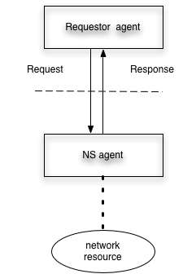

Figure 2-1: NSI operates between the requestor agent and the NS agent

The scope of this NSI architecture document is to define the messaging between Requestor Agent and Network Service Agent and to define the functions supported by the NSI interface. These functions include establishing, monitoring, and terminating dataplane resources as well as controlling and reporting on control plane resources such as calendars, schedules, and performance reports. The detailed protocol and messaging specification for the NSI is defined in a separate messaging recommendation being developed by the NSI working group.

A requestor agent might be an application, server middleware, or another NS agent. A NS agent might support a home network, a department infrastructure, a transatlantic fiber, a national infrastructure provider, an exchange point or a virtual organization with resources from other providers..

Connection Oriented Network Service

Network service
The NSI is used to request connection oriented network services. Where NS or Network service is referred to in this document, a connection oriented network service is assumed.

In general, a ‘connection oriented’ service refers to a service that has a special set of characteristics. Most common current data network services are connectionless. One consequence of this type of service is that it may provide for a fairly predictable set of attributes but those attributes are not completely predictable. Usually, no firm services guarantees are provided. A connection oriented service is one that can have a known and predictable performance in terms of key attributes which might include latency, bandwidth, jitter, and others. Many connection-oriented services are implemented on connection oriented, often physical, links. However, there are protocols that allow for connectionless implementations that attempt to provide connection oriented attributes on connectionless link, for example, pseudowire.

Connections are technology independent. A connection consists of [payload, route, attributes].

Base Elements of Network Services

A dataplane Network Service is created with following base elements.

- Data Service
  - Network
  - Link
  - Combined
- Edge points
- Segments
- Adaptation service

Segment
A segment is the connection from one edge of a Data Service to another. Multidomain ETE connections are made by concatenating segments from different Network Services.

A segment can be created over either Links or Networks. Data Service may be a single network, a single Link, or a set of connected links and networks. Segments are concatenated at edge points, and edge points are always in networks.

Network
A network is the an infrastructure with two or more edge points that is capable of supporting segments between edge points. Edge points exist at the boundary of a network. Edge points part of the network. Links are the resource that attach to edgpoints on networks and carry segments between networks.

Thus the NSI can request the creation of segment from a network by nominating the edge points and associate performance parameters.
This is shown in the following diagram.
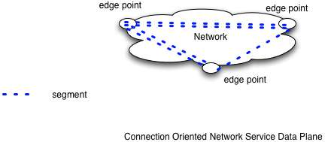

Figure 2-2: Relationship between network-segments, edge points and the network

Link
A link attaches to edge points on two networks. It can carry multiple segments between the edgepoints.

A link is entirely passive, it cannot perform any switching, concatenation or adaptation. An example of a link is a local Gigabit Ethernet trunk between two switches in a PoPs. In this example the segments are VLANs. Another example is a long-haul SONET trunk circuit connecting two networks. In this example the segments are VCGs or sets of SONET channels.



Figure 2-3: Relationship between link-segments, edge points and links

Since a link is passive, the segment on it is provisioned by the networks owning the edgpoints to which the link is attached. Segments on a link are identified by labels such as VLAN id, wavelength, fiber or TDM slot.

Device Note: where an operator wishes to implement a link and retain policy control over usage of this link, the operator will need to implement a NS agent. The functionality of the link will not support segment/connection control but will support policy functions. Enforcement policy by each NS in a ete connection requires that path authorization include each link that has its own policy.

Data Service combining Networks and links
[data plane that includes networks and links]

Adaptation
A network may also provide adaptation such that segments may use different technology stacks at each edge point. For example one edge point may support vlans on an Ethernet trunk while another may support VCGs over SONET. A segment payload may be “adapted” from one technology to another to be carried over the different technologies. In the above example the adaptation might be convert between VLAN over Ethernet and VLAN encode with GFP carried by SONET

Building a connection from segments

As described above, Networks are interconnected with Links. The end of a connection is known as an end-point. The end-point may either be a network edge point or a port on an end device. End devices (hosts, routers, switches) also attach to a network with a link.

Links, networks and end devices are the infrastructure over which connections are made. Connections consist of a chain of concatenated segments between end-points.

The figure below shows a set of networks interconnected by Links. This provides a connected graph over which pathfinding can be performed. The set of networks and links over which pathfinding can be performed is called a connection group or topology at a level, and is discussed in more detail in section below.

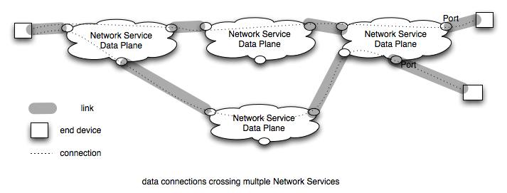
Figure 2-4: Networks connected by links

Note that Networks are active and can control creation of segments between edge points and cross connecting segments at edge points. Networks can enforce policy on their own resources. Links are not able to control access to their resources directly and must depend on networks or middleware to require link policy to be obeyed.

Segments exist over a network or over a link. Each segment has performance characteristics which may be defined by attributes. A connection’s performance is limited by the performance of each segment and the interaction between these segments.

Glossary

Naming of the elements in the architecture is necessary to build a clear definition of what can be requested over an NSI. Final naming will be done in conjunction with the NML working group. The following is a list of concepts and the names.

Requestor Agent - The process dialogs with the NS agent using the NSI interface. The requestor agent might be part of an application, an NS agent, middleware, or a webserver. The request may typically be for connection/segment creation or information from a NS agent regarding the reachability of edge points or existing segment reservations.

Network Service

NS agent – The process that manages Network Service resources. Network Services is typically used to create connection segments, to concatenate segments at edge points, and provide information about reachability of edge points or existing segment reservations.

Network Service resource– The primary Network Service resource is a segment between edge points.. Other Network services are reservations, topology sharing, pathfinding,, monitoring and adaptation.

Network or CO network – Is the infrastructure of a transport network that provides segments between its edgepoints.

Edge point - point where segments from a Network and a Link can interconnect. Note that this is similar to a connection point (CTP) in ITU terminology

End point – Edge point at the end of a connection

End device – A host, switch or router that includes an endpoint

Link – A link is the resource that attaches to two networks and provides its resources to segments between edge points on different networks.

Segment – A connection between two edge points provided by a Network Service. Segments have attributes which affect their performance. Segments may be created by concatenating other segments.

Segments are also known as links using resources from a higher level resource. Some service specific segment types:
Link-segment – is a client service provided over a link
Network-segment – is a client service provided over a network

ETE Connection – a segment that connects two endpoints

Topology information – Information about connectivity. A Network provides information about its edge points and the Links which attach to them. Links provide information about the edgepoints to which they connect. A network may different information to different requestors. For example it may share a limited set of information with a specific requestor.

A network may share internal connectivity that is connectivity between edgepoints in it network. Network internal topology may be used by external pathfinding but may be ignored by the network when reserving resources,

Topology information will use NML naming definitions.

Pathfinding – Determining one or more paths between end points using directed topology information from multiple NSs.. In this document pathfinding is multi-domain and includes finding an ete path including minimally the local segment edgepoints of the path.

Adaptation – The ability to adapt a segment carried with technology A so that it can be concatenated with a segment carried with technology B.

Segment Attributes – characteristics of a segment that are carried by attributes. Attributes can be used in defining policy and requirements.

Resource - device used to provide connection service

Payload – what is carried in a segment. Could be a VLAN, a STS channel, a wave, a light over fiber.

User Service payload – what is presented to the network at either end of a connection.

