Trust and authentication in NSI

This section describes trust and authentication issues that affect NSI interface. The intent is to describe requirements that need to be supported by the NSI protocol.

The actual mechanisms for providing trust, authenticating using the trust, and using authentication to provide security are not defined here. The protocol definition will define standard ways of providing the required capabilities.

The assumption is that each NSA has a trusted identifier that can be shared with other NSAs and other services. Elements of an NSA such as the NSI, NRM and services each use the NSA identity, qualifying their id as NSA-x.service.y for example.

Provisioned trust means that each element is provisioned to know the trusted identifier of the other and is able to authenticate the validity of the identity. [This could be id/pw or public/private key for example]

NSI – NSI

In Figure [ x ] NSI requestor and provider have a configured trust relationship. Using that trust relationship they provide integrity and privacy for communications between the each other.

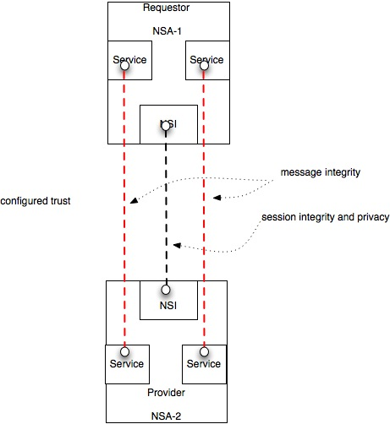
Fig x

Service- Service

Figure [ x ] also shows requestor and provider services which share message sequences with each other. These have configured trust, based on trust between NSAs, which is used to provide message integrity between services.

Attribute provider – Policy Service

Attributes may be included in a request that identify a requestor or a department that is responsible for the request. Figure [y] shows that the authorizer of an attribute must be known to the service that uses an attribute to determine policy. An example of this case is where a user requests is authorized and assigned an individual id and a group id. These id’s are used by the resource provider to determine which resource, if any, should be allocated to a request.

In most current cases attributes are assumed to be from the adjacent NSA so trust between NSAs can be used to ensure integrity of attributes. This is what is supported in version 1 of NSA.

To support this in all cases requires preconfigured trust between provider and user of attributes and a mechanism to carry secure attributes through a chain of NSAs

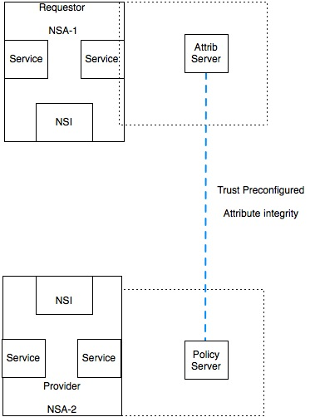
Fig y

NSA/NRM and Control Plane
Figure [z] shows the trust required to allow service reservation and service provisioning to be done by different entities.

The NRM is the part of an NSA that controls local resources. A resource requested by one entity and is reserved by an NRM. The requesting entity shares the identity of the reserved resource with the provisioning entity. The provisioning entity then requests the NRM to setup the resource.

The requesting an provisioning entity must trust each other. The NRM must maintain a reservation id and mechanism to assure that the provisioning requestor has been authorized by the entity that requested the reservation.

This does not have a well understood solution and is not supported in version 1. It is anticipated that it will be supported in later versions. In version 1 only provisioning by NRM base for time of reservation is supported.

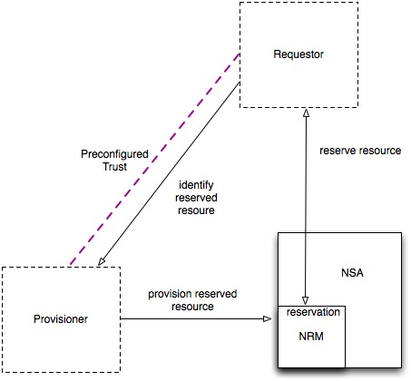
Fig z

