Multi-Level Use Case

The following is a multi-level use case. In this case Link L.3 exists as a wave, and could be used to create a path between User.a and User.b

In order to do this, it would need to do an adaptation to L.3 which would allow it to carry the connection between Net.C and Net.D.

If the wave were able to be multiplexed in units of STS or OTN that would be ok. Perhaps in the future spectrum sharing of this will be possible. With existing equipment an adaptation to create a SONET or OTN link over the wave is first needed, then an adaptation to create a VCG over SONET or SDU over OTN.

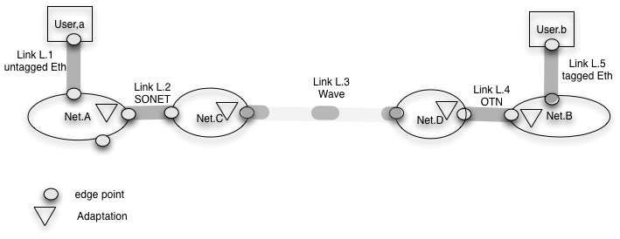

A description of this as topology and a description of a conncetion between User.a and User.b would be helpful.

