Overview of Basic NSI interface

The Network Service Interface defines the message exchange between a requestor Network Service Agent and a provider Network Service Agent. In the NSI context, a network is defined as an abstract construct that has a set of edgepoints and resources which can be used by the provider to create connections between the edgepoints.

The NSI Recommendation describes services which deal with networks and the connections provided on networks. The Recommendation is planned to be deployed over several versions. Version one describes NSI generic functions and the connection reservation service. Other services will be described in future versions.

A picture of a Requestor and Provider NSA in the service plane, and an abstract network as viewed by the provider is shown below. Note that topologically the internals are visible at the service plane, but the internals of the network are not visible.

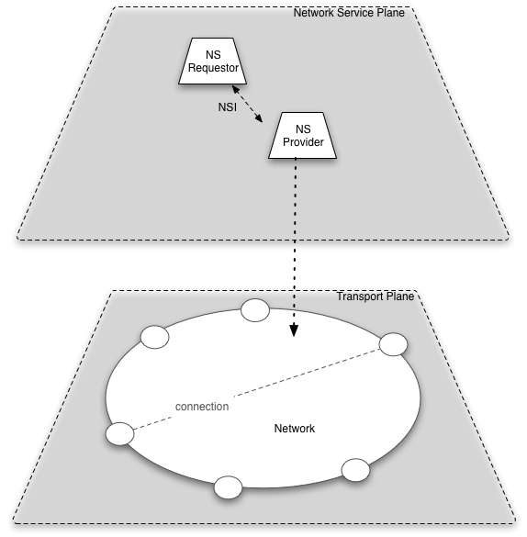

Figure [www] NSA Interface and Network

Overview of a network

As described above, a network is an abstract construct that has a set of edgepoints, and a resource manager which can create connections between the edgepoints. The network also has a calendar that is used for scheduling connections, and a policy that controls what connections are allowed. Reserved connections have a time element, a user element, and performance parameters.

NSI services deal with networks. The connection reservation service supports reservation and scheduling of resources to create a connection and keeps the state of the connection. Future services are anticipated which will share topology information about edgepoints on a network, share service capabilities of the network, provide pathfinding service over multiple networks, as well as other services yet to be defined.

Note that the connection reservation service includes a parameter which alerts the calendar to initiate a connection at its scheduled time. This is a common way of initiating connections on the datatplane. The Recommendation does not require that this method be used. Other methods of initiating reserved connections may be defined in subsequent versions of the Recommendation if there is interest.

Overview of a connection

A connection is defined in NSI as a conduit that allows information to be transferred between two edgepoints on a network.

A connection is an abstract concept that is defined by a set of attributes. The performance of a connection is described as having characteristics based on the technology and service being offered by the provider. The way that a connection is created is out of scope for NSI. What a requestor sees is an abstract network with service capabilities over which connections with specific performance parameters can be made.

A connection is described by a set if attributes which define both its transport performance (e.g. capacity) and its service attributes (e.g. scheduled time). A connection is scheduled by a provider if its resources and policy allow it to do so.

A network is defined by its edge points and by attributes describing service offering of the network. Service offering might include technology, framing, authorization requirements, and scheduling abilities.

Overview of Connection reservation exchange

An example of a connection reservation exchange over the NSI is given below.

Step one – find connection service definitions available from provider

Requestor:
Req[ [pointA-pointB],[connection services] ]
Provider:
Reply [[pointA-pointB], CS1= [p1=range, p2=range, p3=range]]

Step two request a connection at a time

Requestor:
Req [[pointA-pointB], time= 04:15, duration =2:30, [p1=a, p2=b, p3=c]]
Provider:
Reply [Cid,[pointA-pointB], time=04:15, duration=2:30, [p1=a, p21=b, p3=c], state= res]]

The exchange over the NSI is on the network service plane. The exchange deals with both reservations and schedules that are maintained by the Network.

Cooperating Network Service Agents
The basic overview of the NSI assumes that the provider NSA includes a manager for a network with edgepoints, calendar, policy and transport resources. Section 2 gives an overview of the case where several networks collaborate to create connections with segments from multiple networks.

A Network Service Agent requests or provides services on the network service plane using the Network Service Interface. A provider NSA may satisfy a request using resources it manages, or may get resources from other NSA by requesting them over an NSI interface. An NSA that is a provider on NSI and a requestor on a different NSI is called a “complex NSA”.

The part of an NSA that manages local resources is called a Network Resource Manager (NRM). A complex NSA consists of a provider interface, zero or more NRMs, a requestor interface, and a segmentation and aggregation capability. Segmentation is the processs whereby a request about a connection is segmented by a provider NSA into pieces that may then be sent to resource providers. The providers might be a local NRM or remote provider NSA. The NSA aggregates the responses from the providers and sends a response to the original requestor.

The following picture shows a complex NSA which can provide connections to multiple requestors using segments from networks for which it has the NRM and networks from which it requests connections using the NSI interface.
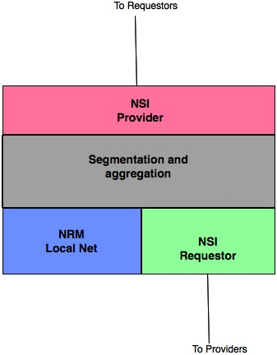

Figure (xx) Complex NSA

Note that the connection reservation service of NSI does not deal with how segmentation and aggregation is done. In the simple case this might be done by configuration of the NSA, and in more complicated cases it might be done by cooperating services that provide topology and pathfinding capabilities for a federated set of NSAs. These cooperating services are not described here but are likely to be defined as services in later versions of the NSI architecture.

However, when segmentation and aggregation are present they present some requirements for NSI, particularly for some aspects of the NSI messaging and path description (see section 3). The following description of the network service plane with complex NSAs describes the service and transport plane architecture to motivate these requirements.

The following description uses two cases to illustrate complex NSA interactions.

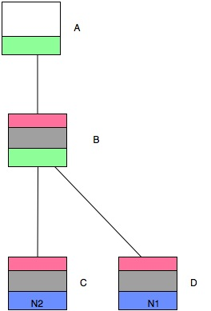

Fig [yyy] Case 1 of multiple NSAs supporting connection request

Case 1 (shown in figure [yyy]) shows two networks, N1 managed by NSA-C, and N2 managed by NSA-D. NSA-A can request services from NSA-B, and NSA-B can request services from NSA-C and NSA-D. NSA-A has only a requestor interface and can get transport connections from NSA-B. NSA-B does not own any resources of its own, but can request connections from NSA-C and NSA-D.

The NSA configuration in Case 1 supports a transport topology with two base networks, N1 and N2, and a complex resource which is a combination of N2 and N2. This is shown in figure [yyy-t]. Note that N1 and N2 need not be connected.

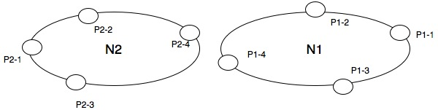
Fig [yyy-t] Case 1 topology

The topology shows two base networks, N1 and N2, each with a set of edgepoints. Connections between edgepoints on N1 can be made by NSA-D, and connections between edgepoints on N2 can be made by NSA-C. NSA-B can get connections across either N1 or N2 by making a request to either NSA-C or NSA-D. This is because NSA-C and NSA-D can delegate authority to NSA-B for selected connection resources.

Note: the ability to support this delegation between NSAs is required in the protocol. [I think this should be spelled out better over the next few months, probably with input from the security group]

If networks N1 and N2 are connected, for example by connecting P2-4 and P1-4, then a hybrid network N-NSA-B is created and NSA-B can create connections between any two edgepoints on N1 or N2. This is shown in figure [yyy-t2] below.

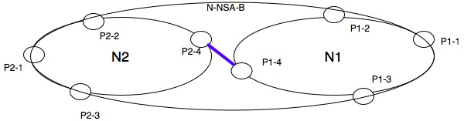
Fig [yyy-t2] Case 1 Connected neworks that present a hybrid network

In this case, NSA-B can be said to manage connections across the large network N-NSA-B. Note that describing how networks interconnect is a topology issue that that is not part of the connection reservation service, but will to be described in future versions of NSI.

This topology/ authorization interaction issue can be very complex. Case 2, shown in figure [zzz] below, illustrates some of this complexity. It includes complex NSAs that have both a NRM supporting local network, and NSI that gets resources from remote NSAs.

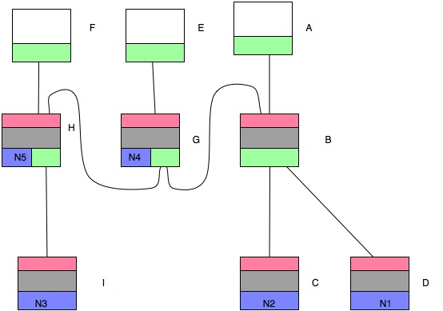

Figure [zzz] Case 2 – NSA service plane topology

The Case 2 grouping for authorization by NSA is shown in fig [wxy]below. The ovals with Nx in them are the networks with specific NRMs. These are indivisible pieces of other networks. One larger oval represents NSA-B, one NSA-H and the large oval covering all nets represents NSA-G.

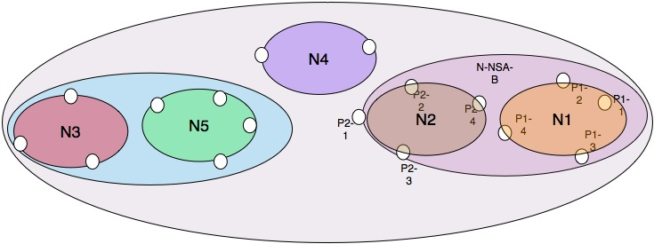

Fig [wxy] Authorization grouping for Case 2

If one assumes that networks are connected at the transport plane, then connections can be made between edgepoints on any network if the request can be segmented into pieces that can be authorized.

Figure [wxyzz] shows one way these networks could be connected in an inter-network topology. Note that transport network connections need be identical to NSA connections on the network service plane.

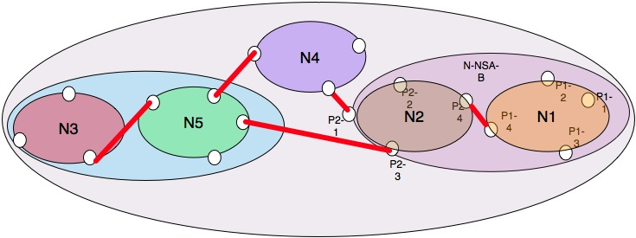

Figure [wxyzz] Case 2 with connected networks

A second possible connection for the same authorization grouping is shown below in fig [wxyza]. This demonstrates topology to be independent of authorization path. Note that authorization grouping may be different for the same topology.
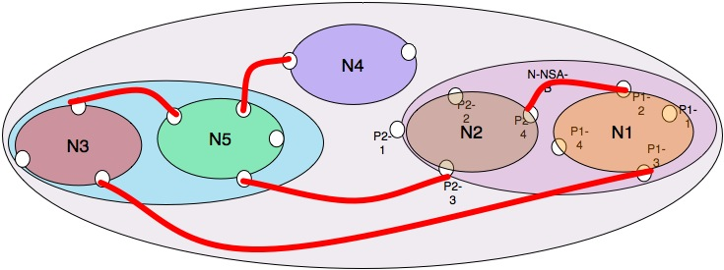

Fig [wxyzza]

These cases are described to make clear that topology sharing, NSA connectivity and pathfinding are inter-related and are complicated. These can be defined in future versions of NSI.

Some names and concepts
Network –an NSA and a set of edgepoints, manager that can oversee connections between the edgepoints
Atomic network – a network which is controlled by a NRM
NRM – the (optional) part of an NSA which manages (owns?) specific set of resources
Authorization Group – set of one or more networks that can be controlled by a particular NSA

Some concepts about relationships between above named concepts

Transport resources are owned by one and only one NRM
An NRM is embodied in one and only one NSA
An NSA many manage resources from its local NRM or from other NSAs
An Authorization Group is the set of networks that can be managed by a specific NSA

An Atomic network is the smallest unit that can exist in other networks
An Atomic network may be in multiple other networks.

Suggestion for the initial version of NSI:
Discuss this topology to the extent above, and perhaps try to determine if there is a description of topology that fits all cases. Otherwise I believe it possible to describe a couple simple use cases that could be included in an appendix and would help in understanding some implementation issues.

Overview of Path

A connection is a conduit between two edgepoints. As described in Section 2, an NSA may break a connection into segments and request those segments from other provider NSAs. When it does that, each segment is itself a connection which is concatenated with the others when they are aggregated to create the requested connection.

Each connection has a path. In a simple case the path is simply the edgepoints at either end of the connection. When a path is segregated, the path is a sequence of segments, each segment described by its edgepoints. The path elements are described in more detail in following sections. For this section this description of a path can be described as follows:

Path == [ingress (-egress, ingress)* - egress]

Ingress and egress are points on the edge of connected networks.

Some statements about paths.
1) Paths must include ingress and egress of the connection.
2) Paths may include additional information about the path, particularly information about segments within paths
3) Some networks may not want information about their segment advertised to a higher level. It is not required.
4) Some networks, particularly networks managed by NRM, may desire to have their information included in connection path. This should be accommodated if possible.

Some questions about paths
- Paths may be used by other applications such as monitoring or billing. This seems like a good possibility and needs to be evaluated.
- Connections may include authorization information (i.e. which NSA authorized a particular segment)
- Connection state for all segments must be coordinated. This might be done using path to determine which NSA is keeping information on each segment.

Suggestion for this version of recommendation: Split out a focused subgroup to investigate this. I hope but don’t know that this could result in either a high level description of paths, or a couple specific cases which can be used in conjunction with the protocol group to jointly define what is required for the first version.

