Network Service Use Cases and Topology descriptions

The following are a set of use cases for describing topology and connections. The initial cases show a simple topology and a connection – or found path – between two users.

The intent is to describe the topology and connection in NML terms, hopefully using the UML model, and perhaps including both UNIS and NDL descriptions.

I believe the relevant topology elements are
Topology –
User
User port or edgepoint
Link
Network
Network port or edgepoint
Adaptations

Connection (or path or route between user a and b)
Segments (over Links and Networks)

The use cases build on one another, so perhaps descriptions can be described as changes to the previous case

Use Cases

Use Case 1
This is a simple case of users connected to two different networks, with Ethernet Links in all cases. The only difference in Links is that L.1 is untagged, the others are tagged.

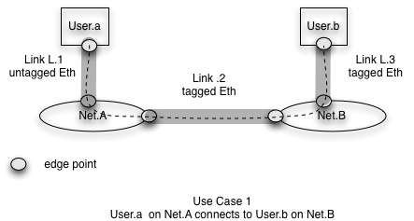

Use Case 2
This changes the link between networks to SONET. It now requires that both Nets have adaptation capability. An interesting question how the adaptation points relate to networks and links

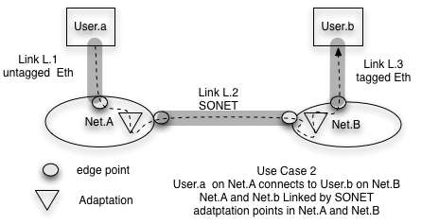

Use Case 2A
This is modified from the earlier case in that the Link between Net.b and User.b is SONET rather than Ethernet. The eliminates the need for adaptation in Net.B. It also adds the complication that the technology at each user is different.

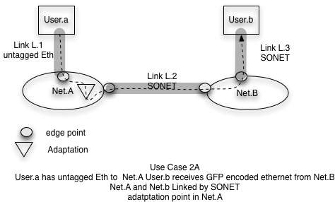

Use Case 3

This case is similar to case 2 except an additional network is inserted between Net.A and Net.B. The requirement here is for describing transit resources that are not related to input technology.

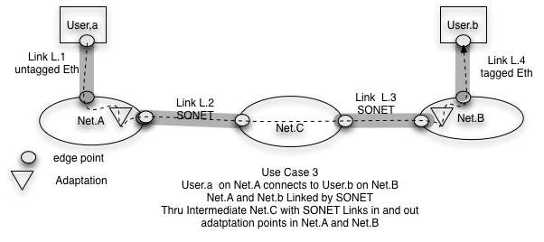

Use Case 4
This case is similar to case 3 except that additional networks with different technologies on Links between them are inserted between Net.A and Net.B

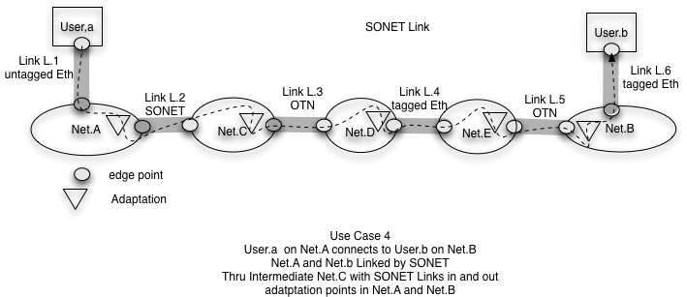

Desired Output

Topology description – some possible actions
This is (most likely) not completely correct, but I include it to help discussion. I note that Links, connections, etc are unidirectional.

Topology at a layer
User.a and User.b are Network devices that have ports
Net.A and Net.B are Groups that have ports
Links L.1, L.2 and L.3 are Links that attach to ports
Adaptation points can adapt between Link technologies; they are part of network

Presumably each element – Link, Network, User and Adaptation is described independently and related to the others.

A connected set of network elements is required to do pathfinding. Users, Links, Networks and adaptation points are network elements. I realize that adaptation may be a service, so this could be changed, but adaptation requires resources so must at least be included in connection description (below).

Connections

Networks and Links are resource providers that can allocate resources to (connection, path, ?) The resource allocated to a particular request by a provider is a segment.

Connections are concatenations of segments from different resource providers

A route (or path or connection ?) consists of a sequence of hops, each of which defines one or more (segment) of the route. A hop may be a link, a net, a hierarchical sequence of hops, or a potential hop. A potential hop may indicate where a segment is needed and some hints about how such a segment may be found.

I note that hop is a GMPLS (among other) name which we may or may not want to keep.

Note that an adaptation point is a resource, normally provided by a Network. It seems right to me that it be included as a segment in a route.

