DCN interdomain topology and naming

NMwg and NML Schema and NSI

DCN interdomain topology consists of a set of networks and hosts interconnected by links. Links attach to networks and hosts at ports (NMwg) or edgepoints (NSI). Hosts or endpoints also connect to networks via links.

A small issue - currently links in NMwg are defined as belonging to ports, but I believe the intent is to define them as independent entities which attach to ports. This change makes them identical to links defined in NSI.

Networks and hosts may be interconnected by links into a topology which is used by path computation algorithms to satisfy a request for a connection between ports. An example of such topology is shown in the figure below.

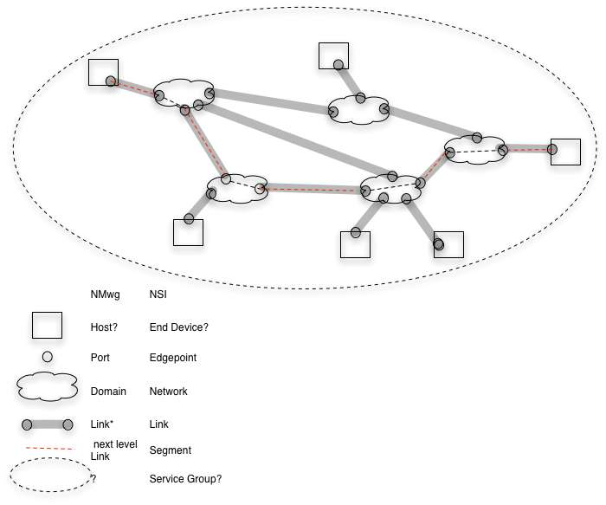
The topology used by a path computation obviously determines which paths are chosen to satisfy a particular request. This topology is collected by querying NS agents for connections to other entities. The collection may be done in different ways for different applications. For example it might be done by a central server that queries all agents or it might be done by having each domain flood information to other domains. It might include networks and hosts from global locations or it might be limited to networks and links used by a particular virtual organization.

NSI includes a concept for the topology used to do pathfinding and is looking for a name for it. Some possible names are “service group” or “topology group”. NMwg has the concept of group, so this can be included in NMwg schema.

In NMwg a connection over a topology is a link. This is not a link in the topology group over which it is created. It is a link at a different level. I.e. a connection in the NSI terminology is a link at a different level in NMwg schema.

To summarize what I think the issues are –

- Names from NML should be used in NSI – need to agree on names like domain/network, port/edgepoint
- NMwg link is being defined as a separate entity from port – it connects to or uses ports at each end of the link and has its own resources.
- Topology or service group should be defined as a NMwg group
- A connection is an alias for different level link - the term “level” may need to be defined in NMwg / NML.
- A segment is a “link at at different level” between ports. Segments exist between ports over a network and between ports over a link. Segments have resources allocated from the higher level link or network.
- Networks/ domains support segments or links at a different level – I am not sure this concept is in NMwg/ NML

NSI will include NML naming in its architecture document.

