Connection Service

1 Basic Requestor and Provider actions

A requestor has the ability to request a connection between one edgepoint to another. The edgepoints between which a provider can make connections defines a network. Thus a requestor NSA can request, schedule and use a connection, between edgepoints of a network, that it gets from a provider NSA.

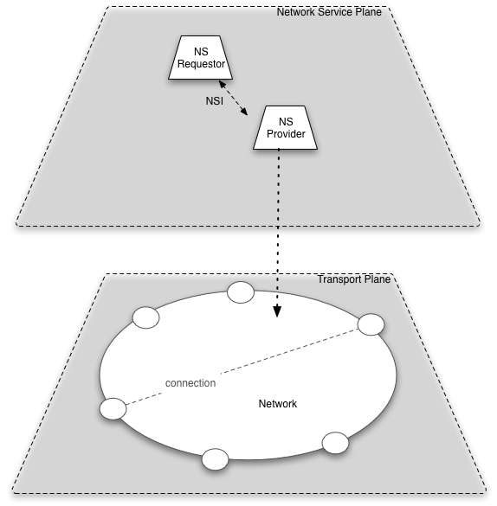

2 Complex NSA Operations

When multiple NSAs can interoperate and an NSA can segment a request and request segments from other NSAs, the interaction between NSA and network becomes more complex.

An NSA that is the ultimate owner of some resource is said to have a Network Resource Manager. An NSA may also include a Requestor NSI interface with which it can request resources from other NSAs. The figure below shows a complex NSA with colors indicating the capabilities in the NSA. Figures with only colors are used in future diagrams
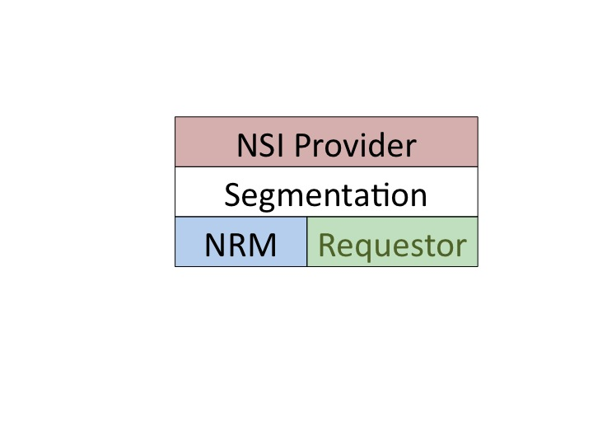
An NSA may get resources from other NSAs, as shown in the figure below.
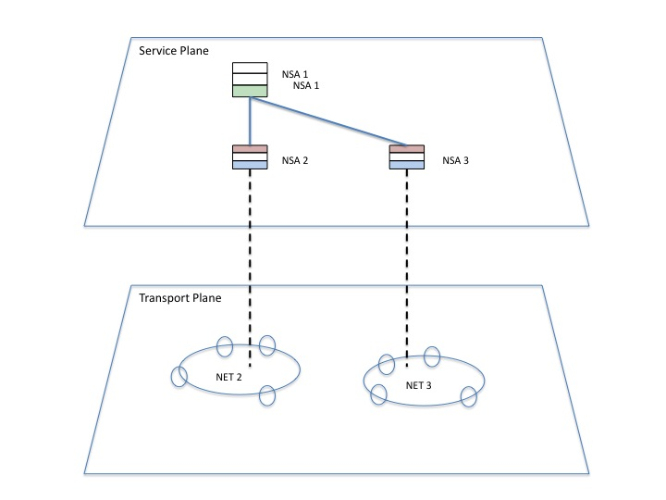
In this figure NSA1 is able to make connections over either Net2 or Net3. Note that Net2 and Net3 are not connected in this example – that is show in the next.

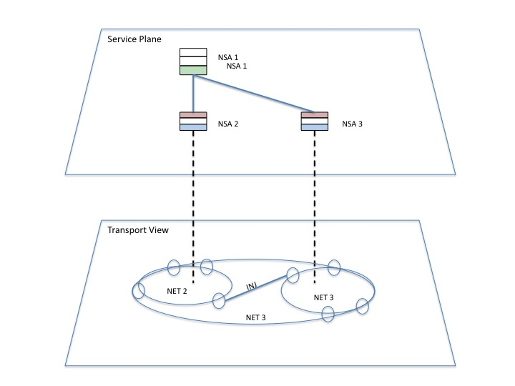

In the case where the two nets are connected (with an Inter-network Junction), then NSA 1 sees a single network that combines Net2 and Net3.

3 Naming network edgepoints

When edgepoints on a network are topologically joined, the junction (according to Tomohiro’s slides) is called an INJ. Connections between the networks are carried over the INJ. A connection at a specific technology and framing is called an STP (service termination point).

The question (in my mind at least) is whether the edgepoints on the network need to have an independent name from the name of the junction between networks. This is under discussion.

To help with defining the discussion from my point of view, the following describes why I think that network edge points should have different names than the junctions between networks.

a) Networks may have multiple junctions between them and so multiple INJs. This would be possible, but the current model is that this would not happen. Allowing multiple INJs between networks would eliminate this concern.

b) INJs are between networks and names include both networks. If a connection is moved from a port then the edgepoint would need to be renamed.

c) INJs seem to be most useful in a topology describing connectivity between networks. A network specific name (e.g. port) seem most useful when making connections within a network.

d) Mapping between INJ and port is the job of an internetwork topology, and pathfinding would look at the topology to find a path, and inform the local NSA what port to use for the path.

