Fault Handling, Protection and Connection Restoration

Fault Handling

Describe fault detection, messaging and actions.
By fault we mean an error condition either during the instantiation phase, or a service disrupting event affecting a provisioned circuit. Error conditions appearing during the reservation phase is discussed in previous sections.
A fault in an operational circuit can be detected in two ways: by the domain in which it happens (e.g. a device failure, fibre cut, etc.), or by the end-system (e.g. lost connection, reduction in throughput).
Faults on inter-domain links are typically detected by both domains, this document needs to specify which domain is originating the action taken, and what the action is.
Faults on segments within a domain are either treated internally (e.g. by circuit failover to protection link), or if they cannot be resolved within the domain, are signaled to all relevant domains and the end-system. Chain or tree, same as for reservation and setup.
Faults detected by the end-system are signaled to the NS agent.
Actions:
- Unprotected: circuit and reservation is terminated (?) and rescheduled
- Protected within domain: performed by domain’s NDs or NS agent, depending on technology
- Protected inter-domain: failover to pre-provisioned path going around the problem area

Protection
The need for circuit resiliency and redundancy stem from operational requirements to support service survivability. In the event of equipment failure (e.g. optical switches) or transport disruption (e.g. fiber optic cable), there may be a requirement to maintain service guarantees to the user if it is so desired. The notion of redundancy may be implemented using different strategies at different layers of the network. Some of the common strategies described below.

Common Redundancy Strategies
1:N Redundancy (where N>0), implies that N+1 resources are committed to support one instance of the resource. An example of this would be to commit N+1 (1 active, N passive) 10Gb/s distinct connections to support a single 10Gb/s connection request. In normal operations, the 10Gb/s traffic will only use one of the connections. In the event of a failure, one of the N passive connections becomes active and takes over the failed connection. A second failure will result in a different connection in the remaining N-1 passive connections to take over.
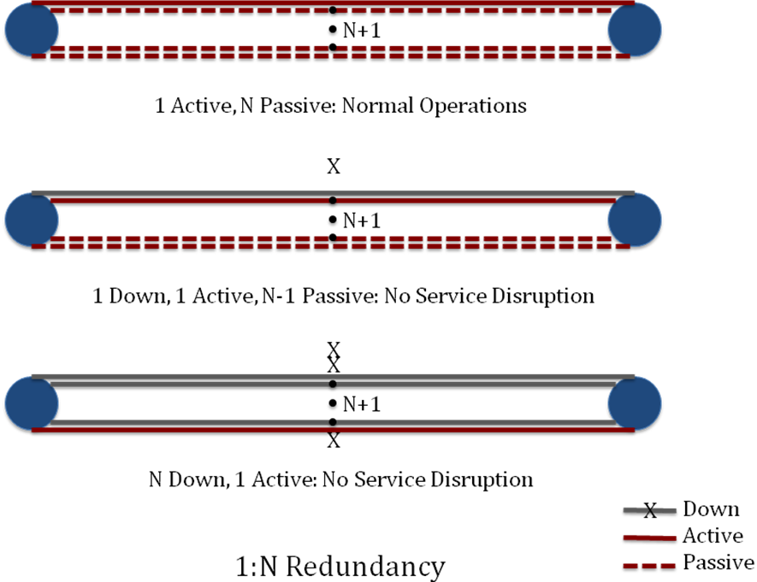

N:1 Redundancy (where N>0), implies that N+1 resources are committed to support N instances of the resource. In normal operations, the single redundant resource is passive until a failure occurs, at which point it becomes active and takes over the failed connection. Further failures will result in degraded or termination of existing services.
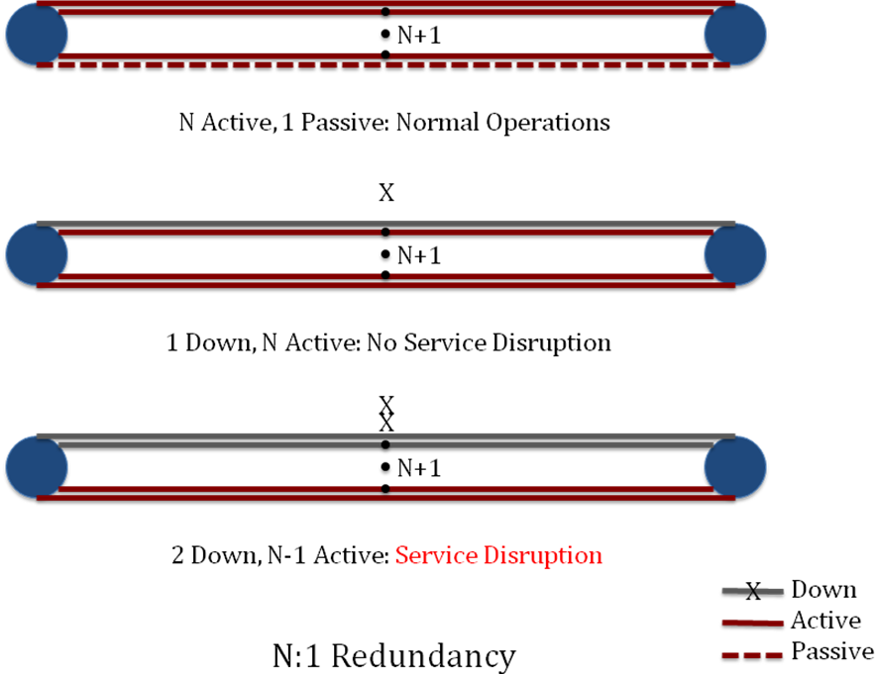

1+N Redundancy (where N > 0), implies that N+1 resources are actively supporting one instance of the resource. An example of this would be the provisioning of N+1 (N+1 active) 10Gb/s distinct connections to support a single 10Gb/s connection request. In normal operations, the 10Gb/s traffic is load balanced over the N+1 10 Gb/s connections. In the event of a single failure, the traffic is redistributed across the remaining N connections. As such, even in the event of N failures, the service, as seen by the user, remains intact.
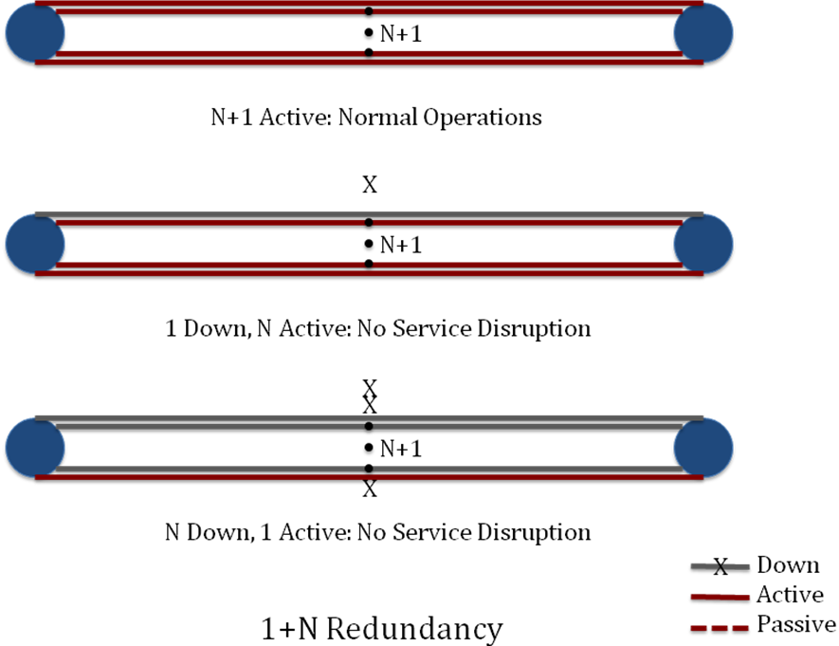

N+1 Redundancy (where N >0), implies that for N+1 resources are actively supporting N instance of the resource. In normal operation, all N+1 resources are actively used. In the event of a failure, the single redundant resource can ensure the services remain intact. Additional failures will result in degraded or termination of the service.

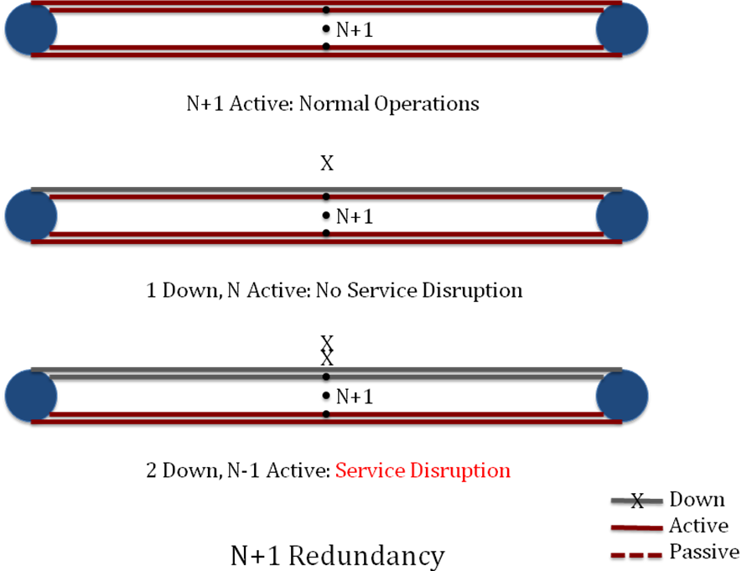

Mesh protection to be described here: Layer 1 (SONET/SDH) or Layer 2 (STP)

Multi-layer redundancy may be implemented by using different redundancy strategies at different layers of the dataplane, and combined to produce a highly redundant service that can be cost effective to deploy. For instance, a service supporting N:1 redundancy at a higher network layer, may sit on a lower network layer with 1+N redundancy (where N might be different for each network layer).
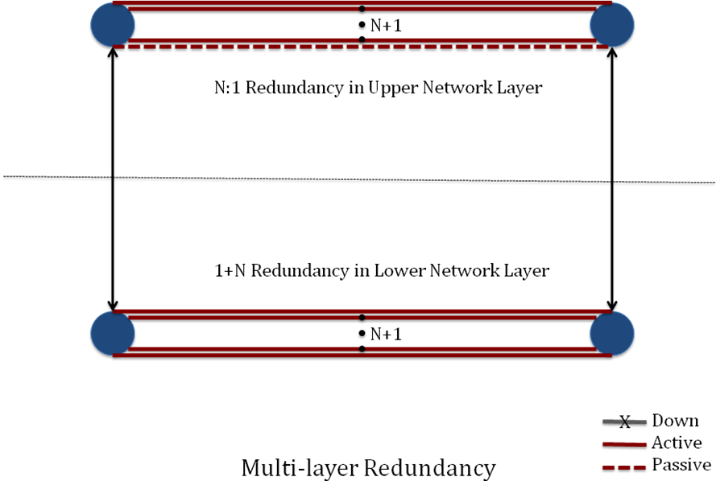

Technical Considerations
The deployment of any of the above redundancy strategies requires some knowledge of the underlying transport technology. For instance, a SONET/SDH can natively support 1:N redundancy, whereas an aggregated Ethernet supports 1+N redundancy. In addition, other characteristics such as switch-over and/or convergence latencies are intimately tied to the technology and/or the protocols implementing the redundancy.
Determining and deploying a viable redundant strategy for a single domain is not trivial. However architecting a multi-domain redundant strategy is significantly more complex. Issues such as redundant capabilities and characteristics can vary greatly due to the heterogeneity of the underlying technologies in the end-to-end connection path.

Connection Restoration
Unprotected circuits are terminated upon detection of error condition, and need to be re-scheduled. Should we foresee a “grace period”, in case of a reasonably short outage?
Restoration of protected circuits can take from 100’s ms (e.g. SONET 1:N protected circuits) to seconds in case of inter-domain level protection. Notification of the circuit being restored is sent from the domain performing the action to all involved domains (really?) and the end-systems (agents).

