Trust and authentication in NSI

This section describes trust and authentication issues that affect NSI interface. The intent is to describe requirements that need to be supported by the NSI protocol.

The actual mechanisms for providing trust, using trust to authenticate connections and authenticated connections to provide integrity and privacy for the connections are not defined in the architecture recommendation. The protocol recommendation will define standard ways of providing trusted connections.

Each NSA is provisioned to know something about its neighbor. What it knows may be that it is wired to its neighbor or to know an id and key of its neigbor.

NSI – NSI

In Figure [ x ] NSI requestor and provider have a trusted connection. Using that connection trust they provide integrity and privacy for communications between the each other.

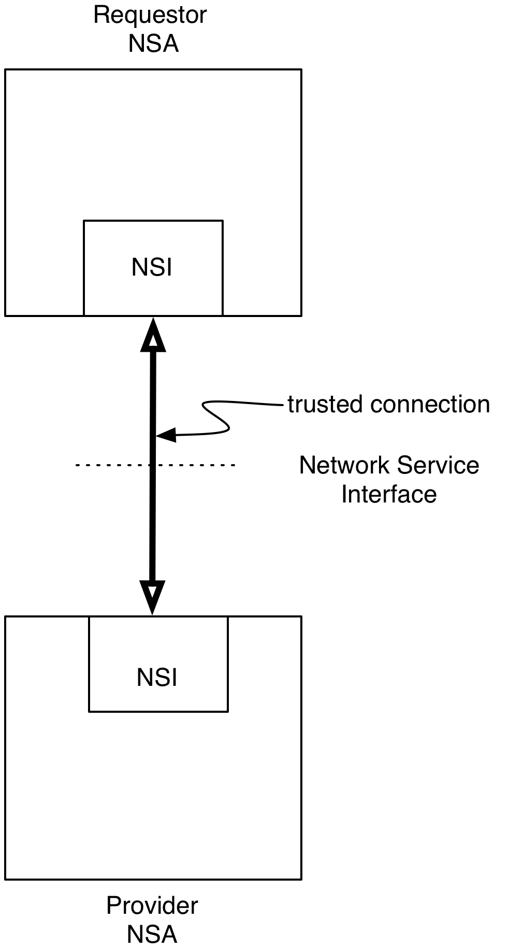
Fig x

Service- Service

Figure [ y ] shows services which share message sequences with each other. These message sequences must provide integrity between the services. The method for doing this is not described in this recommendation. Standard methods are described in the protocol document. These include piggybacking trust on the NSI trusted connection and using separate ids and keys for the services.
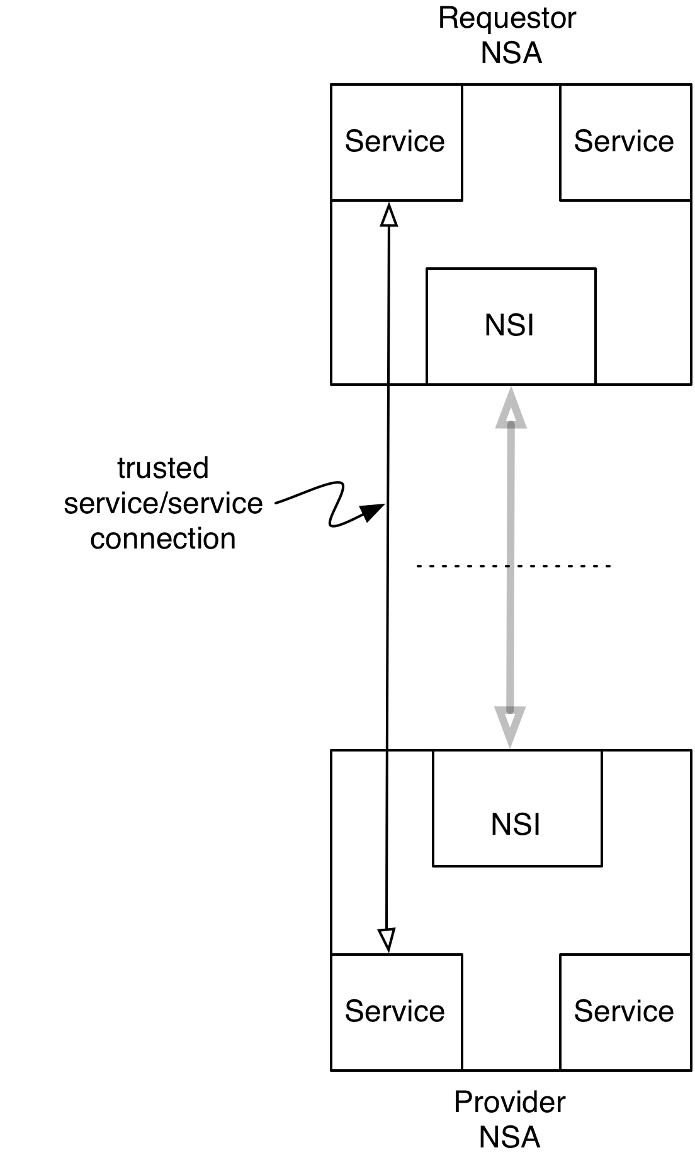
Fig y

Other trust issues

There are other trust issues that may need to be supported by the NSI interface which are not considered in version one of the recommendation. There are sections in appendix xxyy give a slightly fuller description . The two issues are

- Trust between attribute provider and policy server (attribute user), where the two are not in adjacent NSAs.
- Trust between connection reservation authorized on the service plane by provider NSA and provisioned connections on control or data plane.

Appendix xxyy

Attribute provider – Policy Service

Attributes may be included in a request that identify a requestor or a department that is responsible for the request. Figure [y] shows that the authorizer of an attribute must be known to the service that uses an attribute to determine policy. An example of this case is where a user requests is authorized and assigned an individual id and a group id. These id’s are used by the resource provider to determine which resource, if any, should be allocated to a request.

In most current cases attributes are assumed to be from the adjacent NSA so trust between NSAs can be used to ensure integrity of attributes. This is what is supported in version 1 of NSA.

To support this in all cases requires preconfigured trust between provider and user of attributes and a mechanism to carry secure attributes through a chain of NSAs

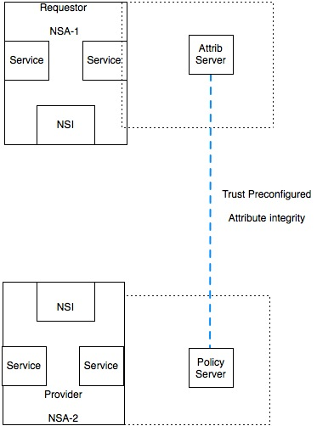
Fig y

NSA/NRM and Control Plane
Figure [z] shows the trust required to allow service reservation and service provisioning to be done by different entities.

The NRM is the part of an NSA that controls local resources. A resource requested by one entity and is reserved by an NRM. The requesting entity shares the identity of the reserved resource with the provisioning entity. The provisioning entity then requests the NRM to setup the resource.

The requesting an provisioning entity must trust each other. The NRM must maintain a reservation id and mechanism to assure that the provisioning requestor has been authorized by the entity that requested the reservation.

This does not have a well understood solution and is not supported in version 1. It is anticipated that it will be supported in later versions. In version 1 only provisioning by NRM base for time of reservation is supported.

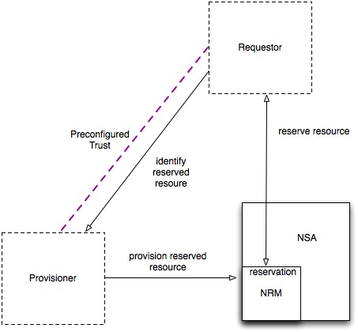
Fig z

