Network Service Interface Architecture
Product of OGF-NSI wg

Overview of Document

This document describes the architecture of a Network Service Interface and of the network service which the interface supports. The network service being supported by the NSI wg is connection oriented, so excludes router based IP networking. In some places the document uses the term CO-NS for connection oriented network service to emphasize the distinction, and in others the connection oriented prefix is assumed.

A quick overview of the document organization is as follows. Section 2 is an over view of NSI a and Netwok Service architecture as well as a glossary of terms used in the architecture. Section 3 describes how the architecture fits with some specific network equipment, , Section 4 describes some enviroments which NSI is able to support, Section 5 describes various functional capabilities that must be possible over the interface, and Section 6 is a more detailed overview of the interface. An appendix shows a WS example of how the interface might be implemented.

A goal of the NSI wg is to create ‘atomic’ capabilities can be combined in a number of ways, similar to the way Unix shell commands can be combined to use capabilities in different ways. A NS might be a small wireless capability in a home. It might be a national infrastructure. It might be operated by an individual or campus or by an infrastructure provider.

By combining the atomic capabilities connections can be created from multiple network services. For example, service organizations can interoperate to provide connections to user communities as is the case with the current IP network. In this model, users request an end to end connection and have little or no control of how the connection is provided or over the resources that support those connections.

Another example is that atomic capabilities are available to users directly and allow distributed network resources to be requested and combined by the user. The user in this case might be an individual process, an virtual organization , or middleware. Middleware could include this into larger resource management schemes such as Grid and Cloud computing.

NSI Architecture overview

The NSI interface

The OGF NSI working group has defined an Network Service Interface as being the interface between a Requestor Agent and a Network Service Agent.

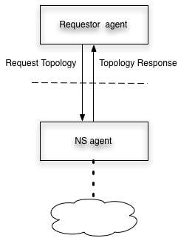

A user agent might be a server middleware, adifferent NSI agent, or something else to be defined. ANS agent might supporting a home network, a department infrastructure, a national infrastructure provider, an exchange point or something else. The NSI wg charter is to define the messages between Requestor Agent and Network Service Agent to support establishing, monitoring, and terminating network connections.

The group decided on these names after discussing other names for each side of the interface and deciding that those names implied implementations that might be allowed, but are not required by this interface. Some of the rejected names (for information purposes) were Network Service organization, User, Network Service Provider, and User organization.

Connection Oriented Network Service

The NSI wg is concerned with defining connection oriented network services. The full description is used here to emphasize this point At later points in the document NS or Network assumes the connection oriented qualification.

A connection oriented network service provides connections between edge points. Network service can be provided in two atomic ways:

- Link
- Network

Network service can also be provided by a set of Links and Networks.

Each service provides connection segments which can be concatenated with segments from another service under control of the NSI. Concatenated segments are also segments.

Networks and Links have very different characteristics.

Network
A network has edge-points where a link connects to the network. At the edge point each network segment may be concatenated with a segment from the link. The network service controls this concatenation.

In addition, the network supports segments between edgepoints. This allows the network to create a segment consisting of a segment from two links each connected to an edge point and a network segment between the two edge points.

A network may also provide adaptation such that segments implemented on different technology may be concatenated.

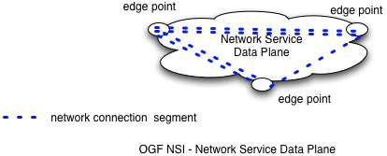

Link
A link connects edge points on two networks. A link provides connection segments between the networks.

A link may have its own policy for how its segments can be used. Enforcing this policy is dependent on how NS are requests are authorized.

A link does no switching, concatenation or adaptation. Since there is nothing to control on a link, some way of accessing Link policy must be implemented in the infrastructure that creates segments including links. In many cases link policy will be administered by the same agent that administers network policy, but this is not required.

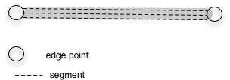

Link with Connection Segments

Combining multiple NS

As described above, a Network Services can be interconnected with Links. End devices (hosts, routers, switches) also attach to a NS with a link.

Links, networks and end devices are the infrastructure over which dynamic connections are made. Dynamic connections consist of concatenated segments between end-devices.

The figure below shows a set of NS dataplanes interconnected by Links. This provides a connected graph over which pathfinding can be done. The set of networks and links over which pathfinding can be done is called a connection group and is discussed in more detail in section below.

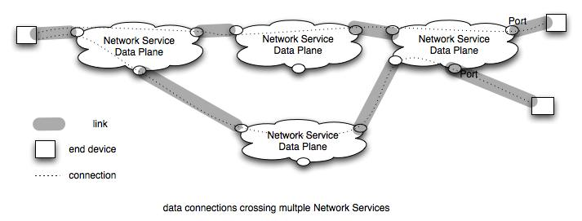

Note that Networks are active and can control creation of segments between edge points and cross connecting segments at edge points. Networks can enforce policy on their own resources. Links are not able to control access to their resources directly and must depend on networks or middleware to require link policy to be obeyed.

Segments exist over a network or over a link. Each segment has performance characteristics which may be defined by attributes. An ete connection’s performance is limited by the performance of each segment and the interaction between segments.

Glossary

Naming of the elements in the architecture is necessary to build a clear definition of what can be requested over an NSI. Final naming will be done in conjunction with the NML working group. The following is a list of concepts and the name currently assigned to them.

Requestor Agent - The process that participates in dialog with the NS agent. The requestor agent might be part of an application, another NS, middleware, a webserver. The request is for resource or information from a NS

NS agent – The process that manages Network Services. Network Services provide connection segments, the ability to concatenate segments at edge points, and information about potential segments.

Network Service – The fundamental Network service is a segment and the ability to concatenate segments. Other Network services are segment reservations, topology information, pathfinding, authorization.

Network – for purposes of NSI a Network is a connection oriented network
CO-network – a CO network provides segments between network edge points, concatenates segments at edge points.

Network edge points – An edge point is a part of the network where Links can connect and where segments from a link can be cross connected to segments from the network.

Link – A link is the connection to a network. Links are a network resource which can have their own policy. Links provide segments to create ete connections.

Segment – A connection between two edge points provided by a Network Service. Segments my have attributes which affect their performance. Segments may be created by concatenating other segments.
Link segment – segment provided by a link
Network segment – segment provided by a network

Ete connection – a segment that connects two end devices

Topology information – Information about connectivity. A Network provides information about end devices and networks to which it is connected. The information provided may different for different requestors. A network may, but is not required, to share internal connectivity with others. For NSI the expectation is that Topology information will use NML naming definitions.

Pathfinding – Determining one or more paths between end points using a directed topology information from multiple NSs.

Adaptation – The ability to tranform a connection carried on a link with one technology so that it can be carried on a link with a different technology.

Segment Attributes – characteristics of a segment that are carried by attributes. Attributes can be used in defining policy and requirements.

Resource -

Connections – network and user views

The architecture discussion in the previous section is abstract and is intended to apply to multiple types of connections, including waves, VLANs, and TDM slots. This section descrbes some of the ways this can be done.

Network view of Connections

Connections and adaptation between segments

To understand how the abstract topology fits real networks, a definition of connection and connection level is introduced. At an abstract level, a connection allows the transfer between two end points of connection information with some characteristics.

Some examples:
1) a VLAN where the connection information is Ethernet frames and the characteristics include bandwidth, jitter, latency and error rate.
2) a Wave connection where the connection information is the modulated wave and the parameters are dispersion and loss.
3) a bit stream where the connection information is the bit stream and the parameters are delay, loss, error rate.

In the NS model a link or network provides segments that can be concatenated. A segment carries connection information of a particular type, e.g. VLAN, Wave or TDM. Concatenating segments means that connection information from one segment is sent to the adjacent segment. Sometimes the segments must be adapted to go from one link type to another as described below.

A segment is supplied by a link or network. Links may carry segments in different ways. A good example of this is that VLANs may be carried as Ethernet VLANs in an Ethernet Link, or as GFP encoded Ethernet in a SONET or SDH link, or as a tunnel in MPLS, or as SDUs in OTN. Where segments are carried by Links of different types, an adaptation is needed to convert the connection information from one link type to the other.

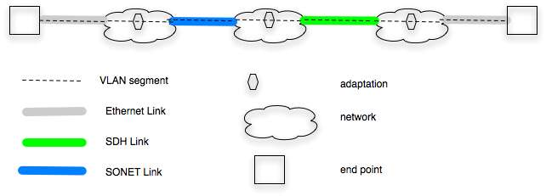

Fig X VLAN segments over links with different technology

The above figure shows an ete VLAN connection that consists of segments from multiple links and networks. The links are different technologies but carry VLANS and the networks can concatenate the segments and provide adaptation between the technology types.

Connection Groups

Connection group is a set of interconnected networks and links over which connections of a particular type can be made. The links and nodes provide topology information to the Group. Pathfinding within the group allows potential connections between end points within the group.

Some examples of connection groups:
1) A connection group might be formed by group of NS agents that agree to share topology and connectivity information between each other and have the ability to reserve resources and create connections among each other.
2) Alternatively middleware acting as a user agent may create relationship with a number of NS agents to create a Connection Group. The middleware then uses the Group to find, reserve, and create connections.
30 Another alternative is that a NS agent has a relation with another NS agent and both are connected to the same NS. This set of agents then becomes a connection group.

A connection group can appear as a NS to other NSs. The following picture shows a connection group.

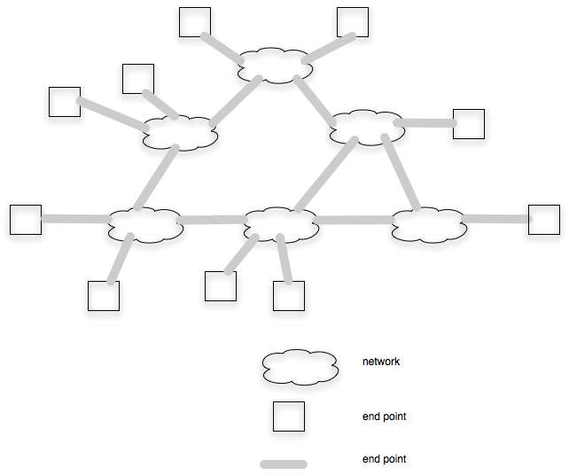

Figure XX Connection Group
In the connection group any end system may be connected to any other end system. It is not able to make connections outside the group. A Group implies sharing connectivity information, the ability to find paths that cross multiple Networks, trust between NSs, some common understanding of performance attributes, and possibly other characteristics.

A Connection Group may act as a Network to other networks. In this case the Group must have a NSI which acts on behalf of the Group as a whole.

Connection Groups and Multi-level pathfinding

There is work being done to investigate the ability to modify Group topology to allow the topology to support dynamic traffic better. An example of this is given in the next subsection. In this case, topology in Group A is modified by adding a Link between networks. This can be done by adding a connection in a different group and using that connection as a Link in Group A. One way of dealing with this is to include “potential” Links in Group topology and add a cost function for implementing the potential link as well as the cost for using it.

Example: Infrastructure with multiple waves over a geographic area. Wave switching is done at X locations. On top of this infrastructure, at a subset Y of the X locations there is VLAN switching. The Y locations are interconnected with links where the links are wave connections between the locations. Assume that links are initially between geographic neighbors. If a large VLAN request that requires most of a wave arrives, and the requested VLAN would go through several VLAN switches, then the pathfinder might opt to create a link from the end VLAN swithes by making a Wave connection between them.

This shows hat
- Links in one Group can be connections in another
- Naming of Networks and Links needs to be specific to connection type

User facing connections information

The definition of a user needs to be defined. For sake of discussion, the following are suggested as classes of users

- application user – purpose is to create connections to transport data between end systems I think this is the normal thing thought about when talking about users.
- Network user – purpose is to create a data connection between end points to support users
- Network operators – purpose is to create connections that can be used as Links between their network

User requests are likely to be in different form than a network might use. For example users want to transfer a file in a time frame, or to have a video connection that provides a certain level of definition and stability. One job of NSI is to create user and network requests such that a one to one mapping exists between requests that fit the needs of a user and requests that meet the needs of networks.

NSI environments5
Network centric vs user centric
New paradigm vs existing paradigm
Tree vs chain

Functional requirements for NSI

This assumes that the following capabilities are provided by separate services. Thus the connection service provides connections by concatenating segments from one or more NS. Other services which are to be define provide additional services that are needed to create an interoperable set of NSs. The way these services are provided depends on the way the set of NSs is deployed: e.g. a topology service might be provided by each NS or it might be provided as part of middleware calling the NSs.

Authentication and Trust
[authorizing requestor – e.g. Professor John Smith, by “responsible” org
immediate requestor – e.g. Middleware or adjacent NS, authorized by cert?
other authorizing org – e.g. Virtual Org (e.g. ATLAS) via certs?
parameters from authorized org(s)
]

Policy Support
[policy owned by NS agent
policy may require getting params from VO
policy assumes authorized requestor
policy may require authorization by another org
]

Connection Negotiation
[Negotiation to find out what is possible between end points
may require multiple pt to pt connections at same time
need for priority and preemption
what is provided is capability between edge points
]
To create a global directed graph each NS must share its links to other NS or end devices. The capability of sharing external topology is required in NSI. Note that the Requestor for Topology information may be different that the requestor for connections.

Topology sharing
[sharing edge points
protocol to share own topology
protocol to aggregage topology among NSs – out of scope but must be allowed
]
How the topology is aggregated and used is outside the scope of the NSI.
Topology information may be aggregated in a number of ways. The Requestor Agent may be a global topology server which can also do pathfinding pathfinding. Alternatively, other NSs be Requestor Agent for topology information and each NS may create its own global topology database.
The topology (termination points, links and end sites) shared may be different for different requestors. A site may tell a Virtual Organization only about endsites that are part of the VO.

NS may provide additional information about bw, jitter, or other characteristics for paths between termination points) on its network and link segmenst as part of its topology information.

Job Control
[fit with Grid computing model
requires knowing multiple
include NS in global 2 way commit
]

Reservations

Resources vs connections
[Resources are segments
connections are concatenated segments
segment are reserved
segments concatenated at instantiation time to create connection
resource reservation may be for multiple sequential connections
]
One issue that has been raised but not resolved on NSI calls is whether resevations are for connections or for resources. The issue comes up to allow a number of endsites to reserve resources such that they may interconnect in different ways during the time of the reservation. One example is to LHC tier1s and tier2s reserving resources that allow any one Tier2 to connect to a Tier1. When one Tier2 is finished another is connected – this under control of an LHC controller.

The implications of this, as I understand them now, is that the LCH controller would need to determine what resources are required to perform this, reserve the resources, then instantiate connections as appropriate.

From the network side this means that one would not know the connection to be established at reservation time, only the set of resources. This raises the question of what resources should be available for reservation – is it enough to reserve connections between termination points on the NS or is some switching capability also required?

Reservation and instantiation

Naming
[Network and link are basic elements for NS groups
NS group is a concept to be discussed
Adaptation names
Adding Links to NS groups by creating connections in a different group
]

Prioritization and preemption
[Scheduling problem overview
need for scheduling in different NSs to cooperate
interface to general scheduling, Job Control
]

Network Service Interface details
Reserve resource
Instantiate connection
Cancel connection/ resource
Modify connection
Schedule connection/ resource
Share topology
Path finding
Authenticate
Authorize
????

Appendix

An issue under discussion

