The following are two diagrams of adaptation. Fig one shows adaptation where a link (with its link connections or segments) is adapted to a lower layer. This is the case where the lower layer is where the physical link is implemented, while link connections are multiplexed over the link.

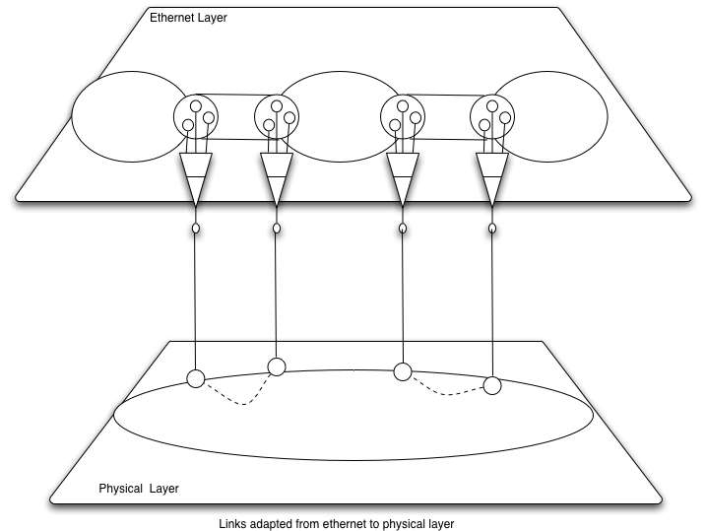
Figure 1 – Links implemented at lower layer

Figure two show adapation between layers where each layer can carry the same client information with layer information but still multiplexed. The principal examples of this are Ethernet carried as VLAN over tagged Ethernet Links, Ethernet carried as GFP encoded STS channels over SONET, and Ethernet carried over MPLS tunnels. Other cases are theoretically possible but I can’t think of other actual cases – perhaps others can.
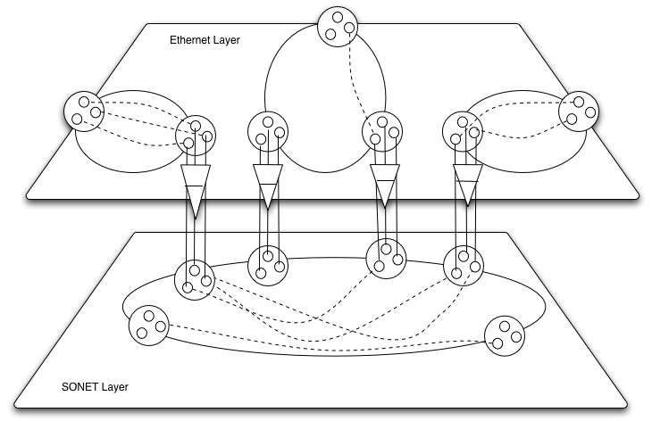
Figure Two - Multiplexed connections over two layers

In the Figure two case, network connections are made over two layer networks – Ethernet and SONET. In order to find a path for a connection one must know topology of both layers.

NSI layers

For NSI it seems that the fig one case, adaptation is not interesting. NSI wants to know only the subnets and links between subnets in order to do pathfinding or make a connection.

In the figure 2 case one needs to know the topology and adaptation between layers in order to make connections on the Ethernet layer. Note that there are no links between subnets on the Ethernet layer.

Note also that SONET connections can be made at the SONET layer between ports that do not automatically adapt to Ethernet. SONET STS channels cannot (as far as I know right now) be adapted to be carried on Ethernet, so making SONET connections does not require knowledge of Ethernet topology.

Extending this to Ethernet over MPLS would be interesting – I think this would be the ESNET case where Ethernet over SONET is the Internet2 and AuthBahn case.

