Network Service Interface Architecture
Product of OGF-NSI wg

Overview of Document

This document describes the architecture of a Network Service Interface and the network service which the interface supports. The network service supported by the NSI is connection oriented, in some places this document uses the term CO-NS for connection oriented network service to emphasize the distinction, and in others the connection oriented prefix is assumed.

A quick overview of the document organization follows. Section 2 is an overview of the NSI and the Network Service architecture as well as a glossary of terms used in the architecture. Section 3 describes how the architecture fits with some specific network technologies, Section 4 describes some environments which NSI is able to support, Section 5 describes various functional capabilities that must be possible over the interface, and Section 6 is a more detailed overview of the interface. An appendix shows a Web Service example of how the interface might be implemented.

This document defies a set of functions to control individual Network Services. When a set of networks are interconnected at the data layer, these functions become the basic building blocks of a infrastructure supporting dynamic multidomain connections. In this environment, the NSI provides atomic capabilities can be combined in a number of ways similar to the way that UNIX shell commands can be combined in different ways.

Examples of a network service might be a small wireless capability in a home, a national infrastructure, a campus or business network or a global federation of infrastructure provider.

By combining atomic capabilities, connections can be built up from multiple network services. For example, network service provider organizations can interoperate to provide connections to user communities as is the case with the current IP network. In this model, a user requests an end to end connection and has little or no control over how the connection is provided or over the resources that are used to support those connections.

Alternatively, where atomic capabilities are advertised to the user, they may wish to nominate specific distributed network resources as part of the service request. The user in this case might be an individual process, a virtual organization, or middleware. Middleware could incorporate this functionality into larger resource management schemes such as Grid and Cloud computing.

NSI Architecture overview

The NSI interface

The Network Service Interface is defined as being the interface between a Requestor Agent and a Network Service Agent. This relationship is shown in the following diagram.

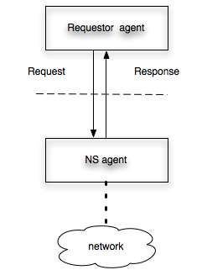
Figure 2-1: NSI operates between the requestor agent and the NS agent

The scope of this NSI architecture document is to define the messaging between Requestor Agent and Network Service Agent and to define the functions supported by the NSI interface. These functions may include establishing, monitoring, and terminating network connections. The detailed protocol and messaging specification for the NSI will be defined in a separate messaging recommendation.

A requestor agent might be, for example, server middleware, or another NS agent. A NS agent might support a home network, a department infrastructure, a national infrastructure provider, an exchange point or other types of networks.

Connection Oriented Network Service

Network service
The NSI is used to request connection oriented network services. Where NS or Network service is referred to in this document, a connection oriented network service is assumed.

In general a ‘connection oriented’ service refers to a service which is not connectionless. That is, the service should have a known and predictable performance in terms of latency, bandwidth and so on. General IP services are not considered to be connection oriented, whereas pseudowire over IP is connection oriented.

The connection oriented network service will have performance attributes such bandwidth, latency and so on.

Base Elements of Network Services

A Network Service is created with base elements These base elements include:

- Networks
- Links
- Edge points

- Segments

Segment
Connections are made from concatenating segments. A segment can be created over either Links and Networks, however, a Network is characterized by the presence of a NS Agent. This can be contrasted to a Link which has no NS agent. So two types of segment may be identified:

- Link-segment
- Network-segment

Network
A network is the network infrastructure capable of supporting a link-segment. Segments exist between edge points. Edge points exist at the boundary of a network. Thus the NSI can request the creation of a link-segment by nominating the edge points and associate performance parameters.
This is shown in the following diagram.
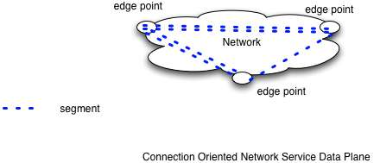

Figure 2-2: Relationship between network-segments, edge pints and the network

Adaptation
A network may also provide adaptation such that segments may use different technology stacks at each edge point. For example one edge point may be a native Ethernet interface and the other a vlan on an Ethernet trunk.

Link
A link connects edge points on two networks. A link can carry multiple segments. A link is entirely passive, it cannot perform any switching, concatenation or adaptation. An example of a link is a local Gigabit Ethernet trunk between two operator PoPs within an exchange, where the segments are formed as VLANs. Another example is a long-haul trunk circuit connecting two networks, where the operator providing the trunk link does not offer circuit control via NSI.

Since a link is passive, the segment on it is configured by the networks at each end of the link. This segment may for example be created by adding a vlan to an Ethernet trunking port at the edge of the adjacent network. Segments on a link are identified by labels such as VLAN id, wavelength, fiber or TDM slot.



Figure 2-3: Relationship between link-segments, edge pints and links

Note: where an operator wishes to implement a link and retain policy control over usage of this link, the operator will need to implement a NS agent. The functionality of the link will not support segment/connection control but will support policy functions. Enforcement policy by each NS in a ete connection requires that path authorization include each link that has its own policy.

Combining link-segments with network-segments
It is expected that between each network one link will exist. i.e. it is not valid to have one network adjacent to another without a interconnecting link.

At edge points each network-segment may be connected to a link-segment. In this way alternate link-segments and network-segments can be recursively concatenated to form new segments.

Building a connection from segments

As described above, Networks are interconnected with Links. The end of a connection is known as an end-point. The end-point may either be a network edge point or a port on an end device. End devices (hosts, routers, switches) also attach to a network with a link.

Links, networks and end devices are the infrastructure over which connections are made. Connections consist of a chain of concatenated segments between end-points.

The figure below shows a set of networks interconnected by Links. This provides a connected graph over which pathfinding can be performed. The set of networks and links over which pathfinding can be performed is called a connection group or topology at a level, and is discussed in more detail in section below.

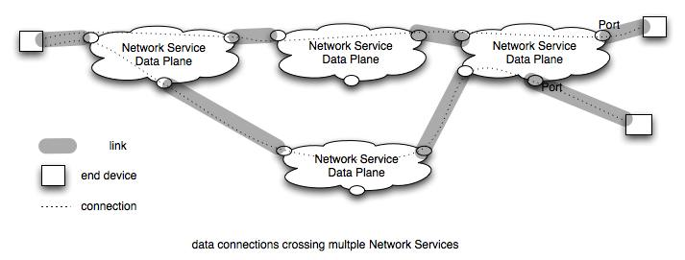
Figure 2-4: Networks connected by links

Note that Networks are active and can control creation of segments between edge points and cross connecting segments at edge points. Networks can enforce policy on their own resources. Links are not able to control access to their resources directly and must depend on networks or middleware to require link policy to be obeyed.

Segments exist over a network or over a link. Each segment has performance characteristics which may be defined by attributes. A connection’s performance is limited by the performance of each segment and the interaction between these segments.

Glossary

Naming of the elements in the architecture is necessary to build a clear definition of what can be requested over an NSI. Final naming will be done in conjunction with the NML working group. The following is a list of concepts and the names currently assigned to them.

Requestor Agent - The process that participates in dialog with the NS agent over the NSI interface. The requestor agent might be part of an application, another NS, middleware, a webserver. The request may typically be for connection/segment creation or information from a NS agent regarding the reachability of edge points or existing segment reservations.

NS agent – The process that manages Network Services. Network Services is typically used to create connection segments, to concatenate segments at edge points, and provide information about reachability of edge points or existing segment reservations.

Network Service – The primary Network Service is a connection segment between edge points.. A segment is also a link at a lower layer. Other Network services are reservations, topology information, pathfinding, authorization.

Network or CO network – Is the data-plane infrastructure of a transport network that is capable of creating connection oriented network services.

Edge point - point where segments (or links at layer) from can interconnect

End point – The last edge points of a connection

Network edge points – A network edge point (often referred to as simply an edge point or port) is the point on a network to which Links connect and where segments over a link can be cross connected to segments over the network. Note that this is similar to a connection point (CTP) in ITU terminology.

End device – A host, switch or router that
includes an endpoint

Link – A link is the connection two networks. Links contain segments.

Segment – A connection between two edge points provided by a Network Service. Segments have attributes which affect their performance. Segments may be created by concatenating other segments.
Link-segment – is a client service provided over a link
Network-segment – is a client service provided over a network

Connection – a segment that connects two endpoints. Note that by definition this is the same as an end to end connection.

Topology information – Information about connectivity. A Network provides information about end devices and networks to which it is connected. The information provided may differ for different requestors. A network may, but is not required, to share internal connectivity with others. Topology information will use NML naming definitions.

Pathfinding – Determining one or more paths between end points using a directed topology information from multiple NSs.

Adaptation – The ability to adapt a connection carried on a link with technology A so that it can be carried on a link with technology B.

Segment Attributes – characteristics of a segment that are carried by attributes. Attributes can be used in defining policy and requirements.

Resource - device used to provide connection service

Connections – network and user views

The architecture discussion in the previous section is abstract and is intended to apply to multiple types of connections, including waves, VLANs, and TDM slots. This section describes some of the ways this can be done.

Network view of Connections

Connections and adaptation between segments
Segments are carried over links and networks. An example of may be a vlan carried over an Ethernet trunk. Multiple segments (vlans) are supported on link (Etherent trunk).

Adaptation is used here in accordance with the ITU-T definition. It refers to the ability to adapt a connection carried on a link of technology A so that it can be carried on a link of technology B. A network-segment can optionally include a adaptation function.

A segment is built on a link or network. Links may carry segments in various different ways. A good example of this is that VLANs may be carried natively as Ethernet VLANs in an Ethernet Link, or as GFP encoded Ethernet in a SONET or SDH link, or as a tunnel in MPLS, or as SDUs in OTN. Where segments are carried by Links of different types, an adaptation is needed to convert the connection information from one link type to the other.

Figure 3-5 shows an example of a ete VLAN connection that consists of segments from multiple links and networks. The links are different technologies but carry VLANS and the networks can concatenate the segments and provide adaptation between the technology types.

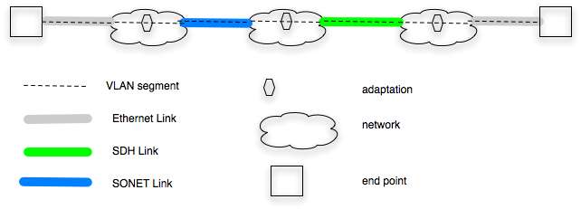

Figure 3-5: VLAN segments carried by links of different technologies

User facing connections information

The following classes of user are proposed:

- application user – their goal is to create connections for the purpose of transporting data between end systems. These application users are typically systems supporting higher layer applications. A typical example of a application user is grid middleware.
- Network user – purpose is to create a data connection between end points to support users
- Network operators – purpose is to create connections that can be used as Links between their networks.

User requests are likely to be in different form than a network might use. For example users want to transfer a file in a time frame, or to have a video connection that provides a certain level of definition and stability. One job of NSI is to create user and network requests such that a one to one mapping exists between requests that fit the needs of a user and requests that meet the needs of networks.

NSI environments
Network centric vs user centric
New paradigm vs existing paradigm
Tree vs chain

Functional requirements for NSI

Authentication and Trust

The NS Interface MUST support integrity between Requestor agent and Network service agent. The mechanisms to support this must be detailed in the protocol document. The expectation is that the requirements will be defined abstractly and at least one specific method of implementing this using Web Service will be defined.

Policy Support
A NS may have internal policy which it can use to accept or deny any request it receives. In order to support this policy, the NSI MUST support a set of attributes in a request. These attributes will include

- Service parameters – e.g. bandwidth, loss, delay, start-time, service type (e.g. scavenger, guaranteed, tentative – start time to be determined)
- Technology parameters – e.g. VLAN id, SONET ports
- User parameters – e.g. requestor id, id for other networks providing resources, id of responsible requestor, delegated trust parameters

A NS may use deployed infrastructure to achieve some of these goals, and in particular might use tools like VOMS or Co-Manage. How these are used and deployed is an issue for federating NSs to determine – the NSI needs to be able to support parameters needed by services.

Negotiation
Negotiation implies that the NS will be allow requestor and NS agent to find a set of resources that satisfy each other – if such is available. The protocol mechanisms for doing this need to be defined in the protocol document. Some cases where negotiation will be used should be include in this protocol document.

Job Control

This section is a submission from Sebastien Soudan. The section is about more than just Job Control – it describes the sorts of network resources needed and the mechanisms required to include reservation of the resources with other (e.g. computing) resources. This section should be edited and perhaps renamed – I include it here so it is part of the body of work that we want to include at OGF meeting in Chapel Hill]

#title Network Reservation

* Network Model

** Resource description:
Domains are made of:
- _Ingress points_: {ip}
- _Egress points_: {ep}
- _Reservable services_: {(ip,ep, service_description)}

** Reservable Service's description:
- minimum duration
- maximum duration
- bandwidth granularity
- minimum bandwidth
- maximum bandwidth
- supported technologies
- minimum notification delay
- supported reservation types

* Network Requests
We define a request as:
((src, tech), (dst, tech), time_constraints, type, constraints)

** Common attributes:
- =((src,technology), (dst,technology))=

** Time constraints:
- **tn**: limit for notification
- **tf**: limit for final version
- **ts**: start time
- **te**: end time

** Types:
- **C**: connectivity service
- **P**: provisioned service
- **M**: malleable service

** Network constraints specification:
We define 3 kind of services that users can request:

*** **Connectivity service**
- loss rate
- delay
- buffer size (buffer at Customer Edge)

*** **Provisioned service**
- rate
- buffer size (buffer at Customer Edge)
- delay
- loss rate

*** **Malleable service**
- volume
- minrate (could eventually be a function of time)
- maxrate (same)
- buffer size (buffer at Customer Edge)
- delay
- loss rate
- objective: mct, ...

* Reservation States
For each reservation, we define the following states, transitions and
semantic of each state (what can be assumed regarding the request when
it is in a given state). Some of the states can not be changed once
reached: terminal state.

** States
- _new_
- _scheduled_
- _granted_
- _running_

** Terminal states
- _rejected_
- _terminated_
- _error_

** Semantic
- _new_: no decision regarding this request/transfer has been made.
- _scheduled_: request will be accepted but the definitive allocation
of resources is not known.
- _granted_: request is in its definitive form, no change will occur regarding the allocation.
- _running_: transfer is running.
- _rejected_: request has been rejected and transfer
won't happen. This state is only reachable from "new" state.
- _terminated_: transfer is finished.
- _error_: this state is reached when an error (transition not
described above) occur.

** Allowed Transitions
- _new_ -> _rejected_
- _new_ -> _scheduled_
- _scheduled_ -> _granted_
- _granted_ -> _running_
- _running_ -> _terminated_

* Negotation Process
Negotation process needs, first, a information service to find the
description of the available network service and local constraints. And then
a submission interface.

** Resource Discovery:
Each domain expose its own list of services.
Interlinks must also be exposed.

** Three-way reservation process:
This is based on the three following steps:
- (1) request submission
- (2) notification of acceptability from the service
- (3) confirmation from the client

This allows to service composition by the client. It has to be
constrained by time to avoid locking.

*** Description:
_(1) Submission:_
User submit the request to the service.

Request issued by client:
((src, tech), (dst, tech), Time_constraints, type, constraints)

_(2) Notification:_
Then service send (at least make it available) its decision to user
within the time constraint.
This allows users to consider another network service if this one
fails to reply within the time constraints.
Notification sent back to the client is :
=(price, deadline_for_confirmation (tc) )=
Notification of acceptance/rejection must comes before tn as given
in time_constraints part of the request.

_(3) Confirmation:_
User must confirm he still wants what he asked before
tc (specification in notification message).

_(4) Grant:_
Service has time to optimize the allocation and modify it as long as
it satisfies the constraints specified by the request. Allocation
can still be modified by the service until date tf as specified in the request.

Reservation parameters

Altogether a fully described single-domain connection request may contain the following parameters:
- Globally unique name
- Edge-point addresses
- Path signaling status and start/end time
- Circuit performance characteristics, eg bandwidth
- Technology specific extensions - Layers
- A/Z end edge point logical addresses

This is summarized in detail in the following table.
The only compulsory items in these connection parameters are name, end-point addresses, bandwidth and signaling type.

Category | Parameter | Type | Compulsory?
Id | Globally unique path id | String | No
Address parameters | A end edge point | NML URN | Yes
Address parameters | Z end edge point | NML URN | Yes
Reservation | Signaled | Boolean | Yes
Reservation | Start time | Time | No (default start asap)
Reservation | End time | Time | No (default no end time)
Performance parameters | Min bandwidth | Integer: bps | Yes
Performance parameters | Max burst size | Integer: bits | No
Performance parameters | Redundancy | Boolean | No (default unprotected)
Performance parameters | Reliability | Real: 0..1 | No
Performance parameters | MTU | Integer  MTU size, 1..9600 | No
Performance parameters | Latency | Integer,  milliseconds | No
Technology extensions:  Layer | Service Layer | Enumerated:  OTN E-NNI  Transp. SDH/SONET  GFP SDH/SONET  Ethernet MAC transp.  Ethernet tunnel  VLAN | No (default Ethernet)
A end  Logical address | SDH/SONET:  Concatenation type | Enum:  Virtual  Contiguous | No
A end  Logical address | SDH/SONET:  VC-4/STS3c | Array of integers: timeslot, 1..256 | No
A end  Logical address | SONET:  STS1 | Array of integers: timeslot, 1..768 | No
A end  Logical address | Client VLAN id | TPID/PCP/CFI/VID  Integer 0x0-0xFFFFFFFF | No
A end  Logical address | Network VLAN id | TPID/PCP/CFI/VID  Integer 0x0-0xFFFFFFFF | No
Z end  Logical address | SDH/SONET:  Concatenation type | Enum:  Virtual  Contiguous | No
Z end  Logical address | SDH/SONET:  VC-4/STS3c | Array of integers: timeslot, 1..256 | No
Z end  Logical address | SDH/SONET:  VC-3/STS1 | Array of integers: timeslot, 1..768 | No
Z end  Logical address | Client VLAN id | TPID/PCP/CFI/VID  Integer 0x0-0xFFFFFFFF | No
Z end  Logical address | Network VLAN id | TPID/PCP/CFI/VID  Integer 0x0-0xFFFFFFFF | No

Globally unique path id
Each reservation request requires a globally unique path id. The path id should be assigned when a path is created. The path id may be created by either the middleware or the network service agent. The path id will be a string conforming to OGF-NML requirements.

A/Z end edge points
Each reservation requests shall include edge points at both ends of the connection to be defined, i.e. A end edge point and Z end edge point. These will be in the form of URNs in accordance with OGF-NML requirements.

Signaled/not signaled
Each reservation request shall include a flag to indicate if the reservation is signaled. If the reservation is marked as signaled, the reservation state will only become active in response to signaled activation request. If the reservation is marked as not-signaled, then the reservation becomes active at the start time and is removed at the end time. If the reservation is marked as signaled it is compulsory to add the start and end times.

Performance parameters
Each reservation request shall include a set of connection parameters. Bandwidth must be specified, but the other parameters are optional. Where a parameter is not specified, no defaults are specified. It is up to the NS agent to select an value based on local defaults.

Bandwidth is specified in bits per second (bps).
In some network equipment it is possible to nominate a maximum burst size (for example on an L2-MPLS circuit. For this reason a maximum burst size parameter is included – this is specified in bits.
To indicate to the NS agent that local redundancy is required the redundancy flag may be set.
To indicate to the NS agent the minimum reliability (ratio of good packets to total packets) of the connection the reliability field may set with a real between 0 and 1. This may be used by the NS agent to choose between multiple transmission options of varying quality.
Where a minimum MTU size is required, a minimum MTU size may be specified in the range 1 to 9600.

Resources vs connections
One issue that has been raised but not resolved on NSI calls is whether reservations are for connections or for resources. The issue comes up whether to allow a number of services to reserve resources such that they may interconnect in different ways when ete connections are created.

One example of where thiswould be useful is to allow LHC tier1s and tier2s to reserve resources that will allow any one of N Tier2s to connect to a single Tier1. When one Tier2 finishes with the Tier1, another is connected – this under control of an LHC controller. Tier2s might also connect to other Tier2s when not connected to the Tier1. Control of changing the connections would rest with LHC middleware.
The implications of this, as I understand them now, is that the LCH middleware would need to determine what resources are required to perform different connections,, reserve the resources it thinks are appropriate, then instantiate connections as appropriate.

From the network side this means that one would not know the connection to be established at reservation time, only the set of resources. For tracking the interface would need to support different ids to identify reservations and actual connections.

Reservation and instantiation

The reservation of a resource may be done at a different time than the instantiation of the reservation. Additionally the Instantiation and reservation requests may be done by different entities.

To support this, the return from a reservervation request must be able to support a token that can be used by an instantiation requestor to show that it is authorized to request instantiation.

This is a security issue and needs help from security people.

Naming

The following is for discussion between NML and NSI working groups at Chapel Hill OGF.

DCN interdomain topology consists of a set of networks and hosts interconnected by links. Links attach to networks and hosts at ports (NMwg) or edgepoints (NSI). Hosts or endpoints also connect to networks via links.

A small issue - currently links in NMwg are defined as belonging to ports, but I believe the intent is to define them as independent entities which attach to ports. This change makes them identical to links defined in NSI.

Networks and hosts may be interconnected by links into a topology which is used by path computation algorithms to satisfy a request for a connection between ports. An example of such topology is shown in the figure below.

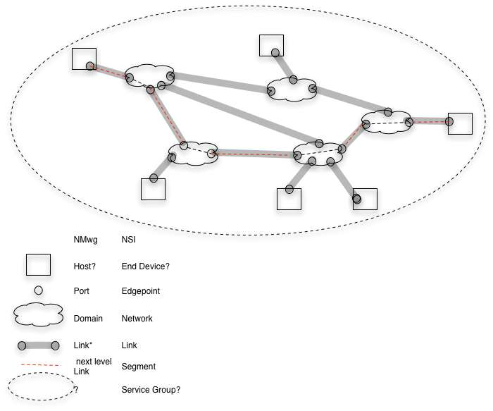
The topology used by a path computation obviously determines which paths are chosen to satisfy a particular request. This topology is collected by querying NS agents for connections to other entities. The collection may be done in different ways for different applications. For example it might be done by a central server that queries all agents or it might be done by having each domain flood information to other domains. It might include networks and hosts from global locations or it might be limited to networks and links used by a particular virtual organization.

NSI includes a concept for the topology used to do pathfinding and is looking for a name for it. Some possible names are “service group” or “topology group”. NMwg has the concept of group, so this can be included in NMwg schema.

In NMwg a connection over a topology is a link. This is not a link in the topology group over which it is created. It is a link at a different level. I.e. a connection in the NSI terminology is a link at a different level in NMwg schema.

To summarize what I think the issues are –

- Names from NML should be used in NSI – need to agree on names like domain/network, port/edgepoint
- NMwg link is being defined as a separate entity from port – it connects to or uses ports at each end of the link and has its own resources.
- Topology or service group should be defined as a NMwg group
- A connection is an alias for different level link - the term “level” may need to be defined in NMwg / NML.
- A segment is a “link at at different level” between ports. Segments exist between ports over a network and between ports over a link. Segments have resources allocated from the higher level link or network.
- Networks/ domains support segments or links at a different level – I am not sure this concept is in NMwg/ NML

NSI will include NML naming in its architecture document.

Prioritization and preemption

Network Service Interface details
Reserve resource
Instantiate connection
Cancel connection/ resource
Modify connection
Schedule connection/ resource
Share topology
Path finding
Authenticate
Authorize
????

Appendix

To create a global directed graph each NS must share its links to other NS or end devices. The capability of sharing external topology is required in NSI. (this needs more definition/ description)

The working group decided on these names after discussing other names for each side of the interface and deciding that those names implied implementations that might be allowed, but are not required by this interface. Some of the rejected names (for information purposes) were Network Service organization, User, Network Service Provider, and User organization.

