Network Service Interface Architecture
Product of OGF-NSI wg

Overview of Document

This document describes the architecture of a Network Service Interface and of the network service which the interface supports. The network service being supported by the NSI is connection oriented, so explicitly excludes, for example, connectionless IP networking, but would not exclude, pseudowire. In some places the document uses the term CO-NS for connection oriented network service to emphasize the distinction, and in others the connection oriented prefix is assumed.

A quick overview of the document organization follows. Section 2 is an overview of the NSI and the Network Service architecture as well as a glossary of terms used in the architecture. Section 3 describes how the architecture fits with some specific network technologies , Section 4 describes some environments which NSI is able to support, Section 5 describes various functional capabilities that must be possible over the interface, and Section 6 is a more detailed overview of the interface. An appendix shows a WS example of how the interface might be implemented.

In this NSI architecture document the concept of an ‘atomic’ function is introduced. These ‘atomic’ capabilities can be combined in a number of ways, similar to the way Unix shell commands can be combined to use capabilities in different ways. The network that provides the NS might be a small wireless capability in a home. It might be a national infrastructure. It might be operated by an individual or campus or by an infrastructure provider.

By combining these atomic capabilities, connections can be created from multiple network services. For example, network service provider organizations can interoperate to provide connections to user communities as is the case with the current IP network. In this model, users request an end to end connection and have little or no control of how the connection is provided or over the resources that are used to support those connections.

Another example is where atomic capabilities are available to users directly and allow distributed network resources to be requested and combined by the user. The user in this case might be an individual process, a virtual organization , or middleware. Middleware could incorporate this functionality into larger resource management schemes such as Grid and Cloud computing.

NSI Architecture overview

The NSI interface

The Network Service Interface is defined as being the interface between a Requestor Agent and a Network Service Agent. This relationship is shown in the following diagram.

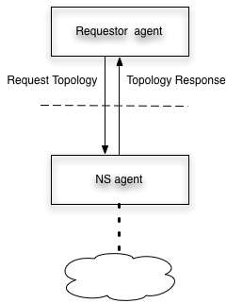
Figure 2-1: NSI operates between the requestor agent and the NS agent

A requestor agent might be , for example, server middleware, or another NSI agent. A NS agent might support a home network, a department infrastructure, a national infrastructure provider, an exchange point or other types of networks. The scope of this NSI architecture document is to define the messages between Requestor Agent and Network Service Agent and to define the functions supported by the NSI interface such as establishing, monitoring, and terminating network connections. The detailed protocol and messaging specification for the NSI will be defined in a separate messaging recommendation.

The group decided on these names after discussing other names for each side of the interface and deciding that those names implied implementations that might be allowed, but are not required by this interface. Some of the rejected names (for information purposes) were Network Service organization, User, Network Service Provider, and User organization.

Connection Oriented Network Service

The NSI may be used to request connection oriented network services. Where NS or Network service is referred to in this document, a connection oriented network service is assumed.

A connection oriented network service provides connections between edge points of a network infrastructure. These edge points are typically ports at the edge of a network, this is depicted in Figure 2-2. Two basic variants ofkinfrastructure are defined:

- Link
- Network

A segment can be created over both Links and Networks, however, a Network is characterized by the presence of a NS Agent. This can be contrasted to a Link which has no NS agent. So two types of segment may be identified:

- Link-segment
- Network-segment

Network

A network supports client segments between edge points. This allows the network to create a segment consisting of two segments from links each connected to an edge point and a network segment between the two edge points. In other words, segments may be concatenated in a recursive way within a network to create new segments within that network. This is shown in the following diagram.

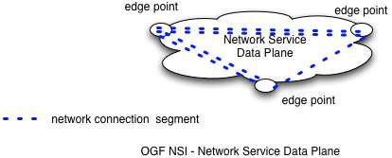
Figure 2-2: Relationship between network-segments, edge pints and the network

A network may also provide adaptation such that segments implemented on different technologies may be concatenated.

Link
A link connects edge points on two networks. A link can contain multiple client segments.

A link is entirely passive, it can not perform any switching, concatenation or adaptation. An example of a link is a local Gigabit Ethernet trunk between two operator PoPs within an exchange. Another example is a long-haul trunk circuit connecting two networks, where the operator providing the trunk link does not offer circuit control via NSI. Also, a set of fibers connecting two edge points of two networks can be a link.

Since a link is passive, the segment on it is configured by the networks at each end of the link. This segment may typically be created by adding a vlan to an Ethernet trunking port at the edge of the adjacent network.Segments on a link are identified by labels such as VLAN id, wavelength, fiber or TDM slot.

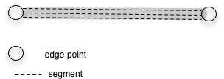

Figure 2-3: Relationship between link-segments, edge pints and links

Note: where an operator wishes to implement a link and retain policy control over usage of this link, the operator will need to implement a NS agent. In this case the link becomes a reduced version of a network and no longer called a link. I.e. a network with two edge points and no path creation ability. The functionality of the network will not support segment/connection creation, but will be reduced to policy functions.

Combining link-segments with network-segments
It is expected that between each network one link will exist. i.e. it is not valid to have one network adjacent to another without a interconnecting link.

At edge points each network-segment may be connected to a link-segment. In this way alternate link-segments and network-segments can be recursively concatenated to form new segments.

Building a connection from segments

As described above, Networks are interconnected with Links. The end of a connection is known as an end-point. The end-point may either be a network edge point or a port on an end device. End devices (hosts, routers, switches) also attach to a network with a link.

Links, networks and end devices are the infrastructure over which connections are made. Connections consist of a chain of concatenated segments between end-points.

The figure below shows a set of networks interconnected by Links. This provides a connected graph over which pathfinding can be performed. The set of networks and links over which pathfinding can be performed is called a connection group and is discussed in more detail in section below.

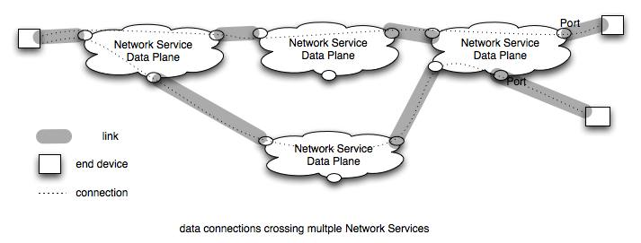
Figure 2-4: Networks connected by links

Note that Networks are active and can control creation of segments between edge points and cross connecting segments at edge points. Networks can enforce policy on their own resources. Links are not able to control access to their resources directly and must depend on networks or middleware to require link policy to be obeyed.

Segments exist over a network or over a link. Each segment has performance characteristics which may be defined by attributes. A connection’s performance is limited by the performance of each segment and the interaction between segments.

Glossary

Naming of the elements in the architecture is necessary to build a clear definition of what can be requested over an NSI. Final naming will be done in conjunction with the NML working group. The following is a list of concepts and the names currently assigned to them.

Requestor Agent - The process that participates in dialog with the NS agent over the NSI interface. The requestor agent might be part of an application, another NS, middleware, a webserver. The request may typically be for connection/segment creation or information from a NS agent regarding the reachability of edge points or existing segment reservations.

NS agent – The process that manages Network Services. Network Services is typically used to create connection segments, to concatenate segments at edge points, and provide information about reachability of edge points or existing segment reservations..

Network Service – The primary Network service is the ability to create a connection by creating segments and concatenating these segments. Other Network services are segment reservations, topology information, pathfinding, authorization.

Network or CO network – Is the data-plane infrastructure of a transport network that is capable of creating connection oriented network services.

Network edge points – An edge point is a part of the network where Links can connect and where segments from a link can be cross connected to segments from the network.

End devices – A host, switch or router that terminates a connection

End point – The end point of a connection.

Link – A link is the connection to a network or end-device. Links support link-segments.

Segment – A connection between two edge points provided by a Network Service. Segments may have attributes which affect their performance. Segments may be created by concatenating other segments.
Link-segment – is a client service provided over a link
Network-segment – is a client service provided over a network

Connection – a segment that connects two end devices. Note that by definition this is the same as an ete connection.

Connection group – needs to be defined

Topology information – Information about connectivity. A Network provides information about end devices and networks to which it is connected. The information provided may different for different requestors. A network may, but is not required, to share internal connectivity with others. For NSI the expectation is that Topology information will use NML naming definitions.

Pathfinding – Determining one or more paths between end points using a directed topology information from multiple NSs.

Adaptation – The ability to transform a connection carried on a link with one technology so that it can be carried on a link with a different technology.

Segment Attributes – characteristics of a segment that are carried by attributes. Attributes can be used in defining policy and requirements.

Resource -

Connections – network and user views

The architecture discussion in the previous section is abstract and is intended to apply to multiple types of connections, including waves, VLANs, and TDM slots. This section describes some of the ways this can be done.

Network view of Connections

Connections and adaptation between segments

To understand how the abstract topology fits real networks, the concept of connection and client signals is introduced. At an abstract level, a connection allows the transfer between two end points of a client signal . The requestor agent will nominate specific performance parameters for the connection. It is up to the NS agent to provide this level of performance Note that the performance parameters are associated with the connection, but will determine the level of service observed on the client signal.

Some examples:
1) VLAN number XXX where the client signal will include all Ethernet frames tagged as XXX and the connection parameters include bandwidth, jitter, latency and frame loss rate.
2) A fiber where the client signal may be a wavelength with any bit rate and format. The connection parameters include fiber type (G.652, G.655) wavelength band, insertion loss etc.
3) A transparent OTN OTU-2 circuit where the client signal is a 10,709,225 b/s bit stream of any format and the parameters are delay, and bit error rate.

A segment carries a client signal of a particular type, e.g. VLAN, wavelength or bit stream. Concatenating segments means that connection information from one segment is sent to the adjacent segment. Sometimes the segments must be adapted to go from one link type to another as described below.

A segment is built on a link or network. Links may carry segments in various different ways. A good example of this is that VLANs may be carried natively as Ethernet VLANs in an Ethernet Link, or as GFP encoded Ethernet in a SONET or SDH link, or as a tunnel in MPLS, or as SDUs in OTN. Where segments are carried by Links of different types, an adaptation is needed to convert the connection information from one link type to the other.

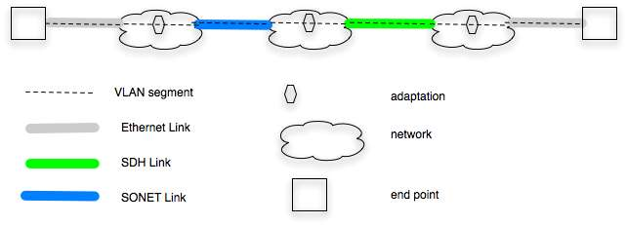

Figure 3-5: VLAN segments carried by links of different technologies

The above figure shows an ete VLAN connection that consists of segments from multiple links and networks. The links are different technologies but carry VLANS and the networks can concatenate the segments and provide adaptation between the technology types.

Connection Groups

Connection group is a set of interconnected networks and links over which connections of a particular type can be made. The links and nodes provide topology information to the Group. Pathfinding within the group allows potential connections between end points within the group.

Some examples of connection groups:
1) A connection group might be formed by group of NS agents that agree to share topology and connectivity information between each other and have the ability to reserve resources and create connections among each other.
2) Alternatively middleware acting as a requester agent may create relationship with a number of NS agents to create a Connection Group. The middleware then uses the Group to find, reserve, and create connections.
3) Another alternative is that a NS agent has a relation with another NS agent and both are connected to the same NS. This set of agents then becomes a connection group.

A connection group can appear as a NS to other NSs. The following picture shows a connection group.

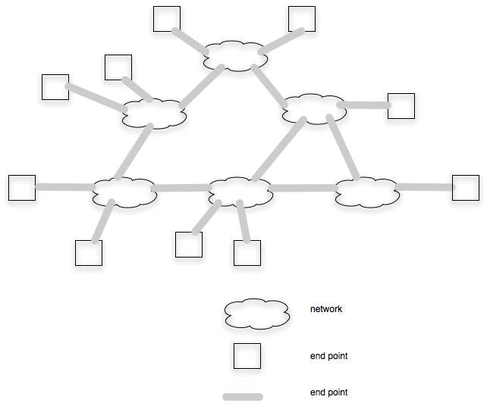
Figure 3-6: Connection group

In the connection group any end system may be connected to any other end system. It is not able to make connections outside the group. A Group implies sharing connectivity information, the ability to find paths that cross multiple Networks, trust between NSs, some common understanding of performance attributes, and possibly other characteristics.

A Connection Group may act as a Network to other requestor agents. In this case the Group must have a NSI which acts on behalf of the Group as a whole.

Connection Groups and Multi-level pathfinding

There is work being done to investigate the ability to modify Group topology to allow the topology to support dynamic traffic better. An example of this is given in the next subsection. In this case, topology in Group A is modified by adding a Link between networks. This can be done by adding a connection in a different group and using that connection as a Link in Group A. One way of dealing with this is to include “potential” Links in Group topology and add a cost function for implementing the potential link as well as the cost for using it.

Example: Infrastructure with multiple waves over a geographic area. Wave switching is done at X locations. On top of this infrastructure, at a subset Y of the X locations there is VLAN switching. The Y locations are interconnected with links where the links are wave connections between the locations. Assume that links are initially between geographic neighbors. If a large VLAN request that requires most of a wave arrives, and the requested VLAN would go through several VLAN switches, then the pathfinder might opt to create a link from the end VLAN switches by making a Wave connection between them.

This shows hat
- Links in one Group can be connections in another
- Naming of Networks and Links needs to be specific to connection type

User facing connections information

The following classes of user are proposed:

- application user – their goal is to create connections for the purpose of transporting data between end systems. These application users are typically systems supporting higher layer applications. A typical example of a application user is grid middleware.
- Network user – purpose is to create a data connection between end points to support users
- Network operators – purpose is to create connections that can be used as Links between their network.

User requests are likely to be in different form than a network might use. For example users want to transfer a file in a time frame, or to have a video connection that provides a certain level of definition and stability. One job of NSI is to create user and network requests such that a one to one mapping exists between requests that fit the needs of a user and requests that meet the needs of networks.

NSI environments
Network centric vs user centric
New paradigm vs existing paradigm
Tree vs chain

Functional requirements for NSI

[This assumes that the following are elements which might be on either the “user” or “network” side of the interface, depending on the implementation of the infrastructure.]

Authentication and Trust

Policy Support

Negotiation

Job Control

Reservations

Reservation parameters

Altogether a fully described connection request may contain the following parameters:
- Globally unique name
- End port addresses
- List of preferred inter-domain port addresses
- Path start/end time
- Circuit performance characteristics, eg bandwidth
- Technology specific extensions for logical ports
- Technology specific extensions for connection transparency

This is summarized in detail in the following table.
The only compulsory items in these connection parameters are name, end addresses and bandwidth. The following table summarizes a set of parameters necessary to fully specify a path.

Category | Parameter | Type | Compulsory?
Id | Path id | String | Yes
Address parameters | A end port address | NML URN | Yes
Address parameters | Z end port address | NML URN | Yes
Address parameters | Set of N optional transit addresses for interdomain routing constraints | NML URN | No
Reservation | Start time | Time | No  (default start asap)
Reservation | End time | Time | No (default no end time)
Performance parameters | Min bandwidth | Integer: bps | Yes
Performance parameters | Directionality | Enumerated: Uni/bi | No (default bi-directional)
Performance parameters | Redundancy | Boolean | No (default unprotected)
Performance parameters | Reliability | Real: 0..1 | No
Performance parameters | MTU | Integer  MTU size, 1..9600 | No
Performance parameters | Latency | Integer,  milliseconds | No
Technology extensions:  Transparency | Ethernet:  VLAN service tag transparency? | Boolean | No
Technology extensions:  Transparency | Ethernet:  Mac transparency? | Boolean | No
Technology extensions:  Logical ports | Ethernet:  VLAN service tag | Integer: tag id | No
Technology extensions:  Logical ports | SDH/SONET:  Concatenation type | Enum:  Virtual/contiguous | No
Technology extensions:  Logical ports | SDH/SONET:  VC-4/STS3c | Array of integers: timeslot, 1..256 | No
Technology extensions:  Logical ports | STS1 | Array of integers: timeslot, 1..768 | No

Resources vs connections

Reservation and instantiation

Naming

Prioritization and preemption

Network Service Interface details
Reserve resource
Instantiate connection
Cancel connection/ resource
Modify connection
Schedule connection/ resource
Share topology
Path finding
Authenticate
Authorize
????

Appendix

To create a global directed graph each NS must share its links to other NS or end devices. The capability of sharing external topology is required in NSI. The following figure shows this part of the NSI interface. Note that the Requestor for Topology information may be different that the requestor for connections.

How the topology is aggregated and used is outside the scope of the NSI.
Topology information may be aggregated in a number of ways. The Requestor Agent may be a global topology server which can also do pathfinding pathfinding. Alternatively, other NSs be Requestor Agent for topology information and each NS may create its own global topology database.
The topology (termination points, links and end sites) shared may be different for different requestors. A site may tell a Virtual Organization only about endsites that are part of the VO.

NS may provide additional information about bw, jitter, or other characteristics for paths between termination points) on its network and link segments as part of its topology information.

An issue under discussion

One issue that has been raised but not resolved on NSI calls is whether reservations are for connections or for resources. The issue comes up to allow a number of endsites to reserve resources such that they may interconnect in different ways during the time of the reservation. One example is to LHC tier1s and tier2s reserving resources that allow any one Tier2 to connect to a Tier1. When one Tier2 is finished another is connected – this under control of an LHC controller.

The implications of this, as I understand them now, is that the LCH controller would need to determine what resources are required to perform this, reserve the resources, then instantiate connections as appropriate.

From the network side this means that one would not know the connection to be established at reservation time, only the set of resources. This raises the question of what resources should be available for reservation – is it enough to reserve connections between termination points on the NS or is some switching capability also required?

