Use Case description for NSA with both Provider and Requestor NSI

NSI overview
The NSI is a protocol that operates between a NSI Requestor and an NSI Provider. There are (or will be) several services that use the NSI. The service defined in version 1 of NSI protocol is the Connection Service.
.
.
.

NSI Connection Service

The connection service allows the requestor to reserve a connection between Service Termination Points (STPs) known to the Provider NSI. In addition to reservations it has a number of other functions described in more detail in following sections.

The service provided over the NSI is for a single connection (or multiple single connections in the future).

A Requestor gets a connection between STPs and information about the connection that can use to support an application in the Requestor’s space.

A Provider allocates and reserves resources to support connections and delegates them to the Requestor

An Requestor NSI may have sessions with multiple Provider NSIs. Similarly, a Provider NSI may interact with multiple Requestor NSIs.

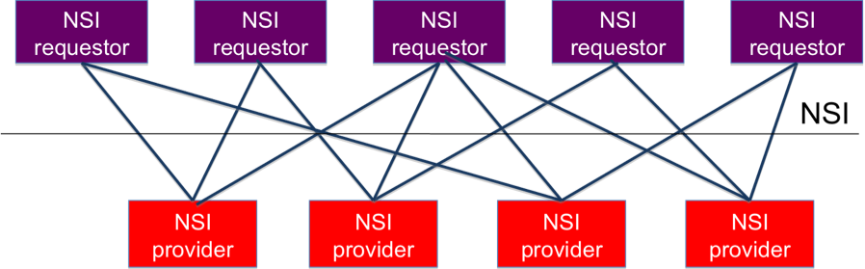
.
.
.

Network Service Agent

A Network Service Agent is software that includes one or more NSI. An NSA may have a single NSI, either Requestor or Provider, or two NSIs – both requestor and Provider.

An NSA with only a Requestor NSI typically gets connections that allow compute and storage resources to be connected to support a particular application.

An NSA with only a Provider NSI owns or manages resources that it is able to delegate to the requestor. It may be helpful to think of these as resources it owns in the sense that it has the ability to authorize the use of the resources and keep track of the requestor to whom they have been delegated at particular times.

An NSA that has both Provider and Requestor NSIs is able to get resources to satisfy requests by dividing a request into segments and then requesting connection for each segment from other NSAs. This is used primarily to support network federation, where connections segments in different areas are provided by different providers. This ability to segment connections requires an application in the NSA that segregates connections into multiple requests and aggregates multiple responses to a single response. This segregation/ aggregation application is called “Segmap” [????].

Segmap is a particular use case for NSI which has implications for the Connection Service and for other NSI services to be defined in the future.

Segmap – Segmenting and Aggregating Use Case

This discussion of Segmap describes what Segmap requires from the NSI, it does not define how these requirements are met.

An NSA which has both a Provider and Requestor NSI may also have resources which it owns directly. The part of an NSA which manages owned resources is called the Network Resource Manager (NRM).

Segmap breaks a request for a connection on its Provider NSI into requests for connection segments from its NRM or from other NSAs, as appropriate. The following picture shows a Segmenting NSA.
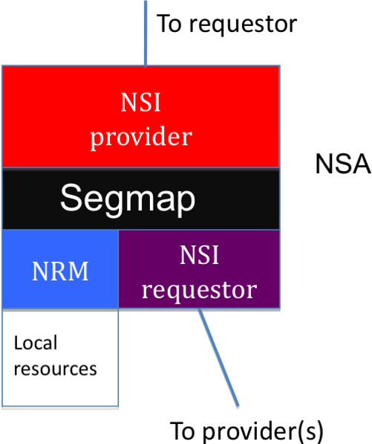

Segmap accepts requests from NSI Provider and gives the Provider information to return to its Requestor.

It does this by breaking a request into segments and then getting segments either locally from an NRM or, using NSI Requestor, from other NSAs.

Segmap is an application that takes requests for connection between two STPs from the provider, breaks thems into pieces and sends requests for each piece to different NSAs or to its own NRM. How Segmap breaks a connection into segments, how it knows what STPs are available from different NSAs, how it gets information about resources in other NSAs, how it aggregates responses from multiple requests, and how it keeps state about connections it has scheduled are out of scope for the Connection service description. Some of these may be defined in future services of NSI.

Some requirements of NSI Connection Service from Segmap
Segmap creates connections with multiple segments, and this puts requirements on the NSI to allow. Some of these are described below.

- paths with multiple segments must be monitored on data plane by services independent of Segmap.
- Multi segment connections may be instantiated by services independent of Segmap [to be discussed—not confirmed for v1]
- State of multi-segment connections must be reported to requestor of the connection. State must be consistent between child segments and aggregated connections using them.
- Roll-back and cancellation of multi-segment connections must be able to be done
Some requirements of NSI based on the above Segment needs are in the following sections.

Definition of Path that includes multiple segments
A path made up of multiple segments MAY include information about one or more segments in addition to end points
Depends on whether a provider is willing to share this info publicly

Notification of connection state change
During a request sequence
During reservation and instantiation
Different ways Segmap can maintain state have not been defined
[need to define ways this could be supported]

Rollback of request to partially completed connection segments
This may require information about partial connections to be maintained

Notification of Resource and STP availability change
I believe this is out of scope for Connection Service

Ability to monitor connection with multiple segments
Need ability to collaborate with monitoring service to define what is monitored for a particular connection

Need to identify chain of NSAs authorizing a multi-segment connection
There are approaches to this that have not been well defined. It is necessary to know what NSA to request a connection segment from as well as to know which NSA to notify when a connection is rolled back for any reason.

Other?

Issues to be resolved
[to be done]

