Network Service Use Cases and Topology descriptions

The following are a set of use cases for describing topology and connections. The initial cases show a simple topology and a connection – or found path – between two users.

The intent is to describe the topology and connection in NML terms, hopefully using the UML model, and perhaps including both UNIS and NDL descriptions.

I believe the relevant topology elements are
Dynamic Circuit Topology elements –
User – device with link to a network
User port ( or endpoint = final edgepoint )
Link - connects edgepoints, carries segments using Link resources
Network – connect edgepoints, carries segments using Network resources
Network port or edgepoint
Adaptations - adapts segments from one technology to another

(dynamic) Connection (Link at a different layer) is created by cross connecting segments from multiple resources
Ete path – sequence of segments connecting endpoints
Segment – virtual link between edgepoints using resources of DC Topology
User Service Payload – what is carried over ete connection

A connection request consists request for an ete connection between two endpoints which is capable of carrying User Service Payload from one end to the other. The request may include information about the desired path and it will include performance parameters.

The following use cases are to illustrate some of the ways that networks and links may be cross-connected to create ete path. Adatations to support carrying the User Specified Payload on different technologies is also described.

Use Cases
The following use cases build on one another. The examples all describe connecting data between endpoints, using Ethernet framing to carry the data from end to end. The model briefly defined above is intended to work on multiple levels, including waves, time division multiplexing, and fiber bundles, someof which may be described in use cases later.

Case 1
This is a simple case of users connected to two different networks, with Ethernet Links in all cases. The only difference in Links is that L.1 is untagged, the others are tagged. The untagged Ethernet by the above definitions is a virtual link on a physical link. A tagged Ethernet is a virtual link on a Ethernet Link.

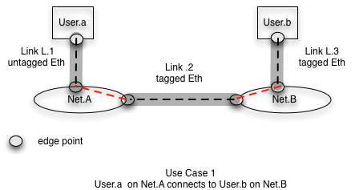

Use Case 2
This changes the link between networks to SONET. It now requires that both Nets have adaptation capability. In this case a virtual Link or segment must be adapted before cross connecting with another segment.
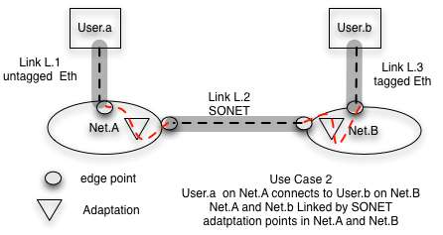

Use Case 2A
This is modified from the earlier cases in that the Link between Net.b and User.b is SONET rather than Ethernet. The eliminates the need for adaptation in Net.B. It also adds the complication that the technology at each user is different. In this case, Link L.3 carries a vittual link or segment as a set of SONET channels. The intent here is to show that technology at both ends does not need to be identical.

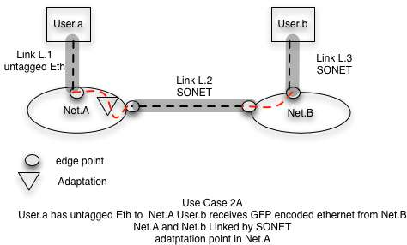

Use Case 3

This case is similar to case 2 except an additional network is inserted between Net.A and Net.B. The requirement here is for describing transit resources that are not related to input technology. That is the middle network does not need to know about endpoint technology, only its own edgepoint technology. Path computation algorithms need to understand that adaptations are possible and that resources which carry USP over these adaptations are available.

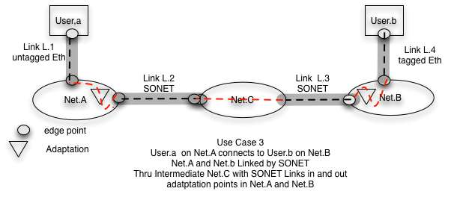

Use Case 4
This case is similar to case 3 except that additional networks with different technologies on Links between them are inserted between Net.A and Net.B

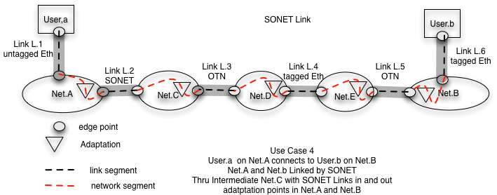

ETE Connections and User Service Payload

A connection carries User Service Payload from one endpoint to the other. The connection has attributes that describe its performance. The endpoints connect to network elements using a specific technology.

The following figure shows a network with two links (more would be normal but for purposes of this discussion only two are needed). Over each link, multiple segments or virtual links are possible. Over each virtual link a User Service Payload is carried. In this diagram, the two red links are cross-connected. What is actually cross connected is the User Specified payload.

In order to do the cross connect the USP must be de-encapsulated on one side and re-encapsulated on the other. If the technology on both sides is the same, then there is no need to encapsulate and de-encapsulate. If the technology on each side is different, then there is a need to encapsulate the User Service Payload differently. This modifying of how the USP is encapsulated is called an adaptation.

Note that the endpoints of a circuit may have different technologies and that the connection by a user is to a virtual port which connects to a virtual link. What is carried by the virtual port is the User Service Payload.

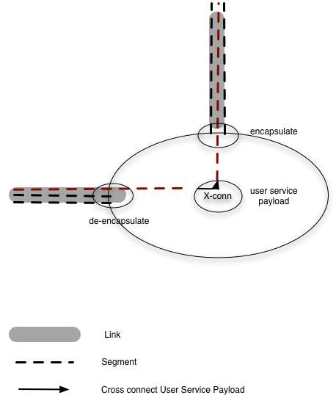

A

Pathfinding and adaptations

Path finding requires that one be able to create paths that carry a User Service Payload over multiple networks.and links. It is assumed that some networks will have links with different technologies and will have an adaptation service that converts from one technology to the other if needed. The PCE must be able to handle these cases.

However, adaptations between all technologies is not possible. Either there is no adaptation generally available to do the transition or the particular network does not have such an adaptation available. A particular use case for this is described below.

Multi-level use case

I describe the following as a multi-level use case. This because in order to create an ete connection a new Link in the topology must be created before an ete link can be created, In this case two links are created, each at different level, hence multi-level.

In this diagram below the intent is to create and ete connection between user.a and user.b. Link L.3 is a fiber carrying sublinks of wave. Other Links have different technology but each have sublinks that can carry VLANS,

In order to create a ete connection over this path, one must create a Link between Net.C and Net. D over which VLANs can be carried. More specifically a Link which ca

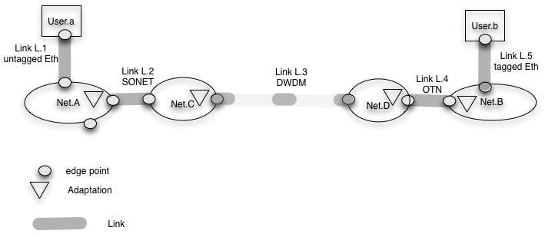 In order to do this, it would need to do an adaptation to L.3 which would allow it to carry the connection between Net.C and Net.D.

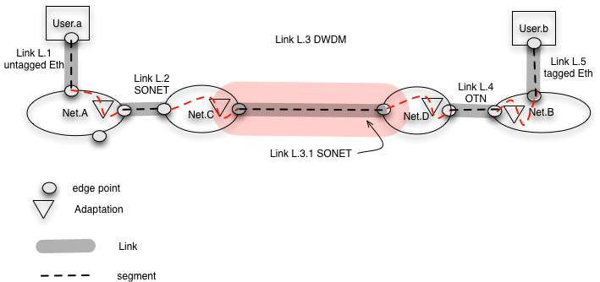

If the DWDM were able to be multiplexed in units of STS or OTN a single level adaptation could be done. Perhaps in the future spectrum sharing at this granularity will be possible. With existing equipment an adaptation to take a wave and create a SONET or OTN link over it is first needed, then an adaptation to create a VCG over SONET or SDU over OTN.

Desired Response from NML

Topology description – some possible actions
This is (most likely) not completely correct, but I include it to help discussion. I note that Links, connections, etc are unidirectional.

Define Topology at a layer – I think the following is what people are thinking.

User.a and User.b are Network devices that have ports
Net.A and Net.B are Groups that have ports
Links L.1, L.2 and L.3 are Links that attach to ports

Ports have subports. Subports carry virtual links. A virtual link is also called a segment by NSI.

Adaptation points can adapt between virtual Link technologies; adaptations are part of network

Each element – Link, Network, User and Adaptation is described independently and related to the others.

A connected set of network elements is required to do pathfinding. Users, Links, Networks and adaptation points are network elements. I believe that adaptation might also be a service, so this could be changed, but adaptation requires resources so must at least be included in connection description and path computation(below).

Connections

The following concepts need to be stated in NML terms.

Networks and Links are resource providers that can allocate resources to an ete connection, The resource allocated to a particular request by a provider is a segment. Segments are virtual links. An ete connection is a sequence of cross connected segments. Segments and ete connections are both links, and each is identifiable as an individual entity and in relation to the other.

A route (or path or connection ?) consists of a sequence of hops, each of which defines one or more (segment) of the route. A hop may be a link, a net, a hierarchical sequence of hops, or a potential hop. A potential hop may indicate where a segment is needed and some hints about how such a segment may be found. I am not sure whether defining route is part of NML or an NSI function. I note that hop is a GMPLS (among other) name which may or may not be appropriate for NML.

An adaptation point is a resource, normally provided by a Network. It seems to me that it be included as a segment in a route. I would like input on how NML considers adaptations for purposes of pathfinding, resource finding and resource allocation..

