Network topology descriptions in optical hybrid networks

Status of This Document
This document provides information to the Grid community regarding the context for the work in the OGF NML-WG. Distribution is unlimited.

Copyright Notice
Copyright © Open Grid Forum (w). All Rights Reserved.

Contributors to article:
Paola Grosso, UvA
Anand Patil, DANTE
Pascale Primet, INRIA
Aurélien Ceyden, ENS-Lyon

Abstract
The NML-WG goal is to define a schema for description of optical hybrid network topologies. This schema is to be used by lightpath provisioning application to exchange topology information intra and inter domain.
This document constitutes the deliverable 1 of the working group. It provides a detailed overview of the framework in which the working group operates, detailing the already existing topology schemas and providing the basis for the integration of the various projects.

Contents
Abstract 1
1. Introduction 2
2. NDL – Network Description Language 2
2.1 RDF and Semantic Web 3
2.2 NDL schemas 3
2.2.1 NDL topology schema 3
2.2.2 NDL layer schema 4
2.2.3 NDL domain schema 5
3. PerfSONAR 5
4. GÉANT2 5
4.1 Common Network Information Service (cNIS) 5
4.2 cNIS Use Cases 6
4.3 cNIS Schema 6
4.3.1 Common Schema 6
4.3.2 Technology specific schemas 6
4.3.3 Extensions 7
4.4 cNIS Interfaces 7
4.5 cNIS Future Work 7
5. Topology descriptions in Grid'5000 7
5.1 Grid5000 overview 7
5.2 Grid'5000 usage 8
5.3 Network monitoring tools and their usage 8
5.4 Grid5000 graphical network description 9
5.4.1 Infrastructure and topologies description needs in Grid5000 10
6. Toward a standard schema 10
6.1 Usecases 10
6.1.1 Path finding 11
7. Conclusions 11
8. References 11

Introduction
As e-Science applications have become more distributed in nature and can take advantage of the various R&E computing Grids, they have also started to have more specific requests on the performance and services offered by the underlying networks. If data moves from one location to another, from one Grid cluster to another, the time the transfer takes – the bandwidth, the variation in arrival time at destination - the jitter, or the time for a packet to get to destination – the delay, all become critical components to be accounted for in the computational model of the application.
To provide applications with guaranteed, reliable and reproducible network services the R&E networks around the world have started to offer lightpaths to end users. Lightpaths are dedicated circuits in the network of which the application is the sole user, and consequently has control on the traffic and no competition for network resources; this results in a more reliable network service.
The trend is clear looking at the network architecture design in many of the NRENs in the last years. These networks have moved to a so-called hybrid model: routed IP services for traditional network use are complemented by the novel concept of lightpaths. Just to name a few we can think of the SURFnet6 network in the Netherlands, or the European network GÉANT2 with its Premium IP service and point-to-point circuits or the Internet2 network in the USA with the HOPI project.

Lightpaths are often called lambdas as they are provisioned for the end user as dedicated wavelengths in the DWDM network. Analogous to computing Grids, the goal is to have lambda Grids in which network connections are created ad-hoc when needed and reliably. To achieve this, there are two important aspects that still need a solution and are being addresses by the research community: a true dynamicity in the setup of paths and the extension of the path beyond a single domain to a true multi-domain setup.
If the creation of a new circuit takes too much time and it requires manual intervention applications cannot interactively and in real time make use of them. If lightpaths are confined to a single network domain under the same administrators, applications cannot effectively communicate. Both issues are tackled by the provisioning systems under development in all the R&E networks.

Interoperability of provisioning systems requires communication of network information among them. Network topologies, network capabilities, scheduling information, and much more, need to travel between domains. This working group focuses on the definition of a standardized model for network information exchange to be used in Lambda Grids for the setup of lightpaths.
In following sections we will give an overview of the existing schema for topology description in use within the international research community. This list does not intend to be exhaustive, but intends to set a ground for the definitions of the necessary elements in a standard Network Markup Language.
Drawing on the experiences in the current models we follow with the overview of the required components in a standardized schema.

NDL – Network Description Language
NDL[1] is data model developed by researchers at the University of Amsterdam to describe (computer) networks. NDL comprises of a series of RDF schemas that categorize information for network topologies, network technology layer, network devices configuration and capabilities, network domain abstractions.
The main use-cases so far have been generation of network maps, lightweight offline path finding and more recently multi-layer path finding, and network topology information exchange.
NDL has been used primarily in the research community in the Netherlands: UvA, SARA and SURFnet. It also been applied to the GLIF Optical Exchange Points (see: http://www.glif.is).

RDF and Semantic Web
One of the main differences of NDL over other topology schema is its use of RDF – Resource Description Framework – as language syntax and the grounding of the model in the Semantic Web framework.
The extensive reasons for the RDF choice instead of XML are explained in document available in the NML-WG project web site (ref: http://forge.ogf.org/sf/go/doc14257?nav=1). To roughly summarize this document we can say that NDL chooses RDF because:
- It allows easier exchange of information between independent domains.
- It is easily extendible and it allows integration of independent data models developed in other fields, by other researchers
Several tools that consume RDF data are publicly available and make the use of this syntax straightforward.

NDL schemas
The Network Description Language (NDL) is a modular set of schemas, defining an ontology to describe computer networks:
- The topology schema describes devices, interfaces and connections between them on a single layer;
- The layer schema describes generic properties of network technologies, and the relation between network layers;
- The capability schema describes device capabilities;
- The domain schema describes administrative domains, services within a domain, and how to give an abstracted view of the network in a domain;
- The physical schema describes the physical aspects of network elements, like the blades in a device.

NDL topology schema
The classes and properties in the topology schema describe the topology of a hybrid network, without detailed information on the technical aspects of the connections and their operating layer. The idea is that that through this lightweight schema we can provide an easy toolset for basic information exchange and path finding.
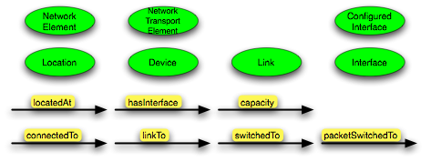
The linkTo property corresponds to a link connection or edge, while the connectedTo property corresponds to a network connection or a path. linkTo and connectedTo describe external connections, between two devices.
The switchedTo and packetSwitchedTo properties define internal connections within a device: the configuration of a device.
The immediate applications of the topology schema are visualization of network maps and input to path finding systems.

NDL layer schema
The topology schema defines network topologies on a single layer. The NDL layer schema allows applications to describe multi-layer networks, like hybrid networks.
The NDL layer schema is based on a formal model, which uses ITU-T G.805[2] functional elements and the concept of labels as described in GMPLS[3].
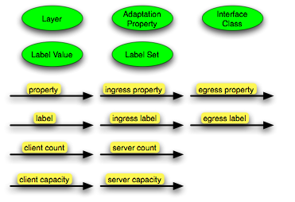
A Layer is a specific encoding in network connection; most Layers have a associated Label Set that defines which channels are used to make switching decision in a device. For example, the label on the wavelength division multiplexing (WDM) layer is a wavelength.
Each Interface instance operates at a certain Layer. When data from one layer needs to be encapsulated in another layer we use Adaptation. The client (layer) and server (layer) refer to the Layers before and after the Adaptation.
This layer schema does not define actual adaptation functions, but instead provides a common vocabulary to describe technologies, layers and the relation between layers. We make use of the layer schema in a tool for path finding across multiple layers.

NDL domain schema
The NDL domain schema defines administrative domains and the services offered by a domain. It allows network operators to provide an abstracted view of their domain to neighboring domain, rather than the full topology.
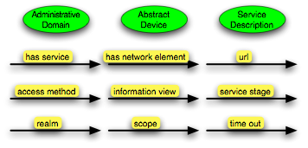
The current schema only describes administrative domains, not owner domains. This was done to keep the schema as simple as possible.
An important concept in the domain schema is that of Service Descriptions. Service descriptions allow domains to point applications to the (web)services they offer.

The idea is that domains publish static information in NDL, and provide a webservice for dynamic information or more confidential data, like reservation requests. Furthermore, different domains will have different opinions on what is ``static'' and ``non-sensitive''.

PerfSONAR

GÉANT2

GÉANT2 [4] is the pan-European research and education network connecting the European National Research and Education Networks (NRENs). The GN2 project within which the network is being operated also includes an integrated research program [5] and development of advanced services [6] for network users. Among others, these activities include network monitoring, network security, bandwidth on demand, cross border fibers, authentication and authorization infrastructure, multi-domain premium IP service etc.

Common Network Information Service (cNIS)

Several activities within the GN2 project as well as external clients, for example Grid middleware, require network information. These activities were developing, populating and storing their own unique data store according their respective requirements. This would lead to duplication of effort, increased load on network elements and replication of data as well as potential inconsistent views of the same underlying network.

The aim of the cNIS is to provide an interface to a unified repository of all relevant network information about a single domain’s network infrastructure for client applications. There will be one instance of cNIS per domain, with data being collected and stored separately for each domain. The collection of cNIS instances work together so that a client application can receive whatever network information it requires, even if this spans several domains. Each NREN is expected to operate an instance of cNIS themselves.

The success of cNIS depends upon the efficiency of automatic data collection, population and verification. A plug in architecture for this is currently under development.

cNIS Use Cases

The design of cNIS was driven by the use cases and requirements of the client applications. Different client applications have different, and often conflicting, requirements. For example some clients wanted to know the physical topology of the network down to interface cards and patch cables, whereas others only wanted abstract connectivity information.

Some design considerations that influenced the schema are as follows:

- ability to store past, present and future topology data
- ability to store technology specific data
- ability to convert technology specific data to different levels of abstractions
- ability to extend to other technologies
- ability to define allowed relationships between elements
- ability to store dynamic information like LSPs, VPNs, VLANs, circuits etc
- ability to link information from multiple domains using lookup services
- ability to search for specific topology elements
- ability to find paths between end points

cNIS Schema

The cNIS schema is a RDBMS schema rather than an XML schema. The background, scope, design, data model of the schema is described in a GN2 deliverable [7].

The schema does not make any reference to the standard OSI 7 layer model as technologies like Ethernet and MPLS do not map cleanly onto an OSI layer and techniques such as tunnelling may lead to a situation where a lower-layer protocol runs on top of a higher-layer protocol, leading to confusion.

The schema can be divided into:
- Common Schema
- Technology specific schemas
- Extensions

Common Schema

The Common Schema includes generic entities (such as node, interface and link). This means that the model does not contain any direct or hard-coded relationship between technology specific tables, and so the schema remains flexible and open to extensions for any other technologies. The common schema adds a time dimension to the data store.

Technology specific schemas

The technology specific schemas describe individual technologies. Currently SDH, Ethernet and IP technology schemas are defined with MPLS draft under development.

Extensions

Some requirements from activities like end-to-end monitoring of cross border fibers traversing multiple administrative domains do not fit easily into common schema or technology specific schema. For such cases the schema design is extensible to accommodate application specific requirements.

cNIS Interfaces

cNIS provides two different types of interfaces:

- A management interface for a system users to perform various administrative tasks and visualization.
- An operational interface for external applications.

Some of the client applications had already defined interfaces for retrieving information from cNIS, for example PerfSONAR uses NMWG schema as described in section 3 PerfSONAR. To ensure a smooth transition for the applications cNIS was decided to honor all these individual interfaces. Ideally these bespoke interfaces will be temporary, such that as cNIS and its clients evolve all applications will be able to work towards one common unified interface or in other words a standard schema.

cNIS Future Work

For the remainder of GN2, the project will investigate potential extensions to the scope of the cNIS to possibly include the storage, retrieval and analysis of real-time networking data, advanced visualization of database contents and storage of multi-domain information, as well as support for a “trouble ticketing system” and multi-domain circuit provisioning.

GN2 supports NML-WG effort for defining a standard schema and will actively promote its use by the cNIS client applications.

Topology descriptions in Grid'5000

Grid5000 overview
Grid5000, is a 5000 CPUs nation-wide Grid infrastructure for research in Grid computing. Grid5000 is designed to provide a scientific tool for computer scientists similar to the large-scale instruments used by physicists, astronomers, and biologists. Grid'5000 serves as an experimental testbed for research in Grid Computing at all levels: from Application, Programming Environment, Middleware, Operating System, Network Protocols. It is a research tool featured with deep reconfiguration, control and monitoring capabilities designed for studying large scale distributed systems and for complementing theoretical models and simulators.

Up to 17 french laboratories involved an 9 sites are hosting one or more clusters. of about 500 to 1000 cores each. A dedicated private optical networking infrastructure, provided by RENATER, the French NREN and composed of 10Gb/s lambdas is interconnecting the Grid5000 sites. Two international interconnections are also available: one with DAS-3 in Netherland and one with Naregi in Japan.

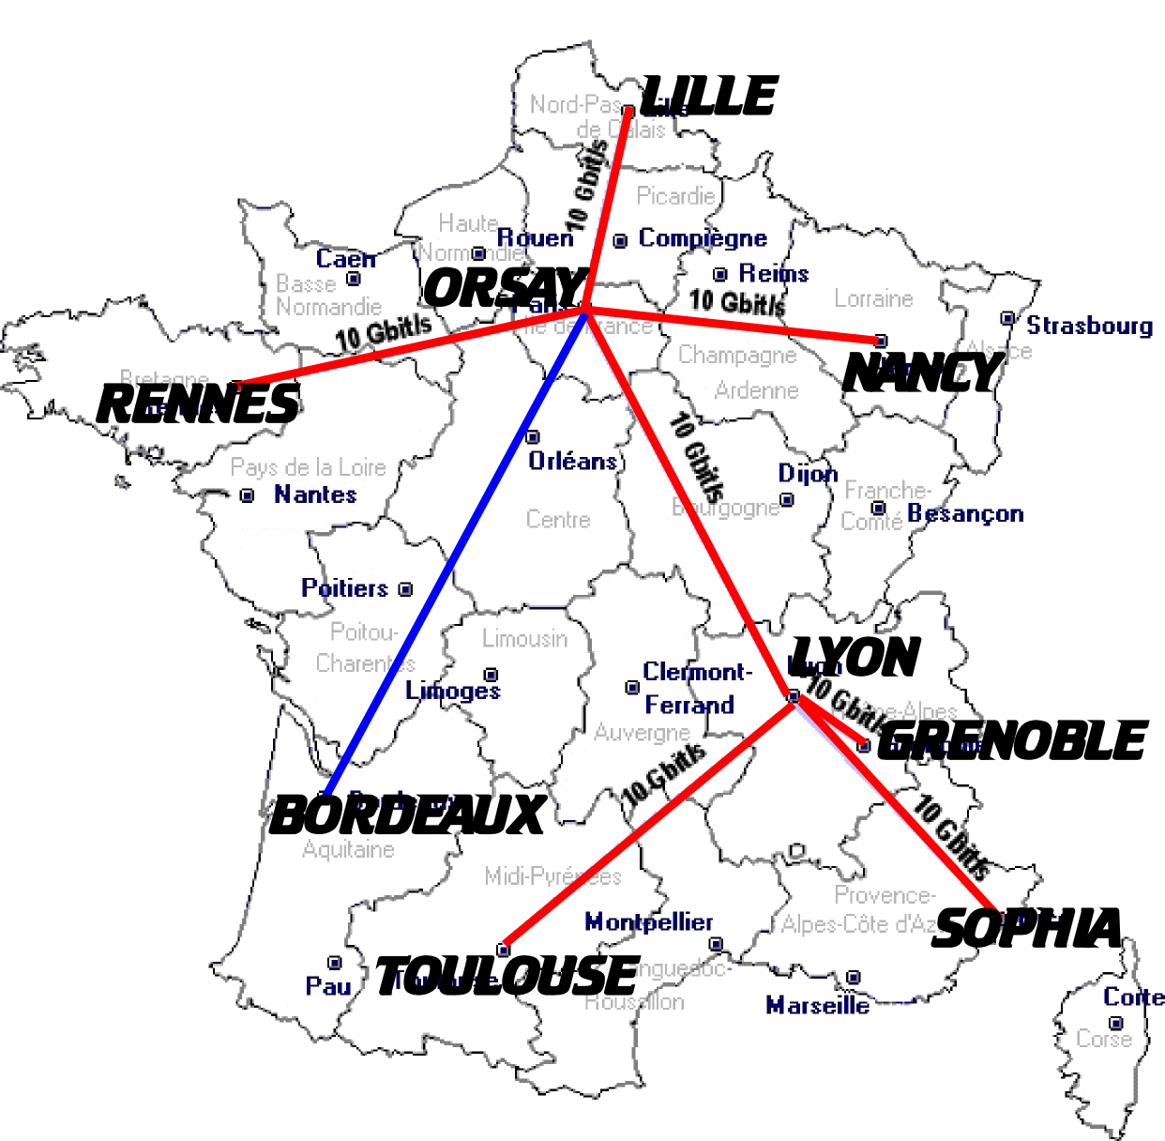

Grid'5000 usage
The main particularity of Grid'5000 is to provide users with the ability to deploy their own operating system on the resources they reserve for a limited number of hours.
Grid'5000 exposes two tools to implement these features: OAR, a reservation tool , and Kadeploy, an environment deployment system. OAR offers an accurate reservation capability (CPU/Core/Switch reservation) and integrates the Kadeploy system. With Kadeploy, each user can make his own environment and have a total control on the reserved resources.

Network monitoring tools and their usage
In terms of monitoring tools, users have access to the RENATER Monitoring tool, the Grid'5000 infrastructure description, Nagios tool, Ganglia and SFlow (Only at lyon).
The RENATER Monitoring tool provides a view of all connections on the Grid'5000 backbone. With it, the users can see the availability and the usage of the global links.
The Grid'5000 infrastructure description gives all information about the different Grid'5000 platforms. It shows, graphically, on all sites their internal connections, that means, what kind of network hardware is used and what are the different links between them.
The Nagios tool is used to warn the administrators about connectivity and services problems.
Ganglia provides to users the bandwidth usage per nodes and others information, not necessary network specific such as the disk space available, the CPU usage and so on.
The Sflow tool is an experimental monitoring tool which provides a sampling of the network traffic.

We can distinguish three types of actors in Grid5000: 1) researcher and experimenters, 2) Application Users, 3) Administrators. These different communities do not require and use the same type of network monitoring tools. The researchers and experimenters and administrators are using all of them while applications users only use the provider tools and the infrastructure description. But we have observed that the infrastructure description is widely required. It is why the Grid5000 administrator have designed a two –level graphical network description of the tesbed.

Grid5000 graphical network description
The Grid5000 graphical network description is defined in two-level. The first level gives a general view of the topology(tiop drawing) while the site view explicit all the networking elements of a site (lower drawing).
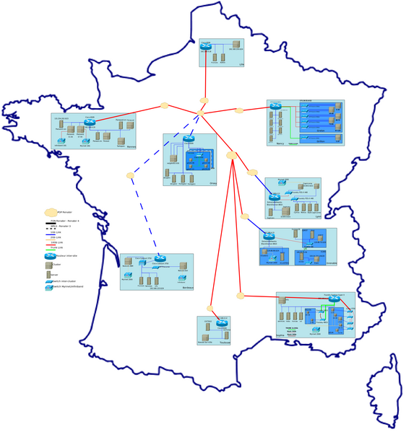

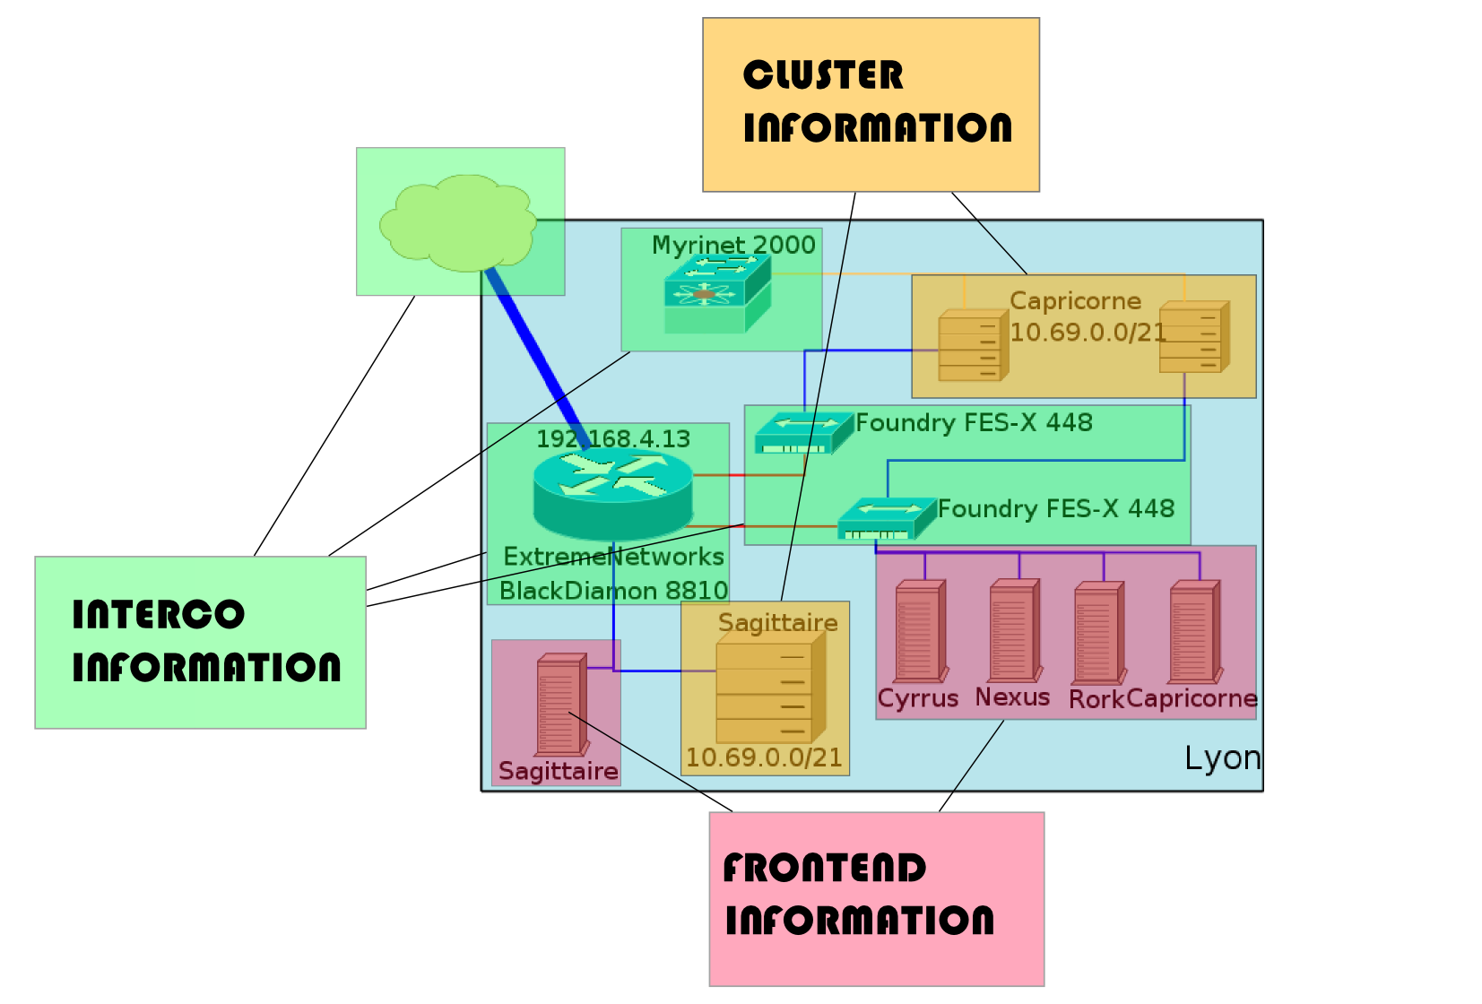

These graphics inform the reader on the long distance link capacities, but do not give the details of the internal equipments in the provider network. These equipments are hidden to any Grid5000 community. For example, in Lyon and Paris, the Grid5000 dedicated lambdas are converted in 10Gb/s Ethernet links and interconnected within a 10Gb/s switch. The Grid5000 community do not have access to the specificities (backplane capacities, buffer space, equipment type, activated functions…) of these switches. The given figure only represents the service (virtual links) provided by RENATER, in terms of their capacities (1Gb/s, 10Gb/s, 2Gb/s) and their medium (copper, optical). On the other side, or the detailed description of the site’s networks and their access, the equipments information are given: type (switch/routeur), vendor name, IP address. Then a logical description of internal resources is given: Nodes/Frontends name, Nodes network.

This kind of infrastructure representation presents several problems: 1) the
representation is static, 2) the representation is only graphical, 3) it requires an heavy synchronization and updating work.

Infrastructure and topologies description needs in Grid5000
In this section, we try to summarize the needs expressed by each Grid5000 community:
The users ( researchers, developers, grid applications users) want to
- Know which devices their traffic crosses
- Know what are the theoretical weight of links (edges)
  - links capacity
  - links latency
  - orientation (unidirectional, bidirectional..)
- Know what are the links status (up or down, available bandwidth)
- Have a Multiview of the network
  - Hardware view
  - Transport layer view
  - Application view (user space)
- Filter the different information

Generally, from this information they try to infer the end to end performance they obtain and to debug them.

The administrators need a view of all connections (compute network, admin network, etc...). They want to be able to:
- Locate the resources
- Access to the hardware representation (all information about the hardware is interesting (router vendor, nodes type))
- Identify the routing path

This show that all type of users need both a graphical view and but also query tools.
Some application developers and researcher need an API to directly access the network description with which their network-oriented services interact: Bulk Data Transfer Scheduling Service (BDTS), Network Virtualisation and Reconfiguration Service (SRV), Virtual Cluster/Virtual Network Overlay Composer (HiperCal/HiperNet), High Speed Transport Test Service (HSTTS).
In this context, data models for network topology information exchange are highly desirable for several type of usage.

Toward a standard schema
We described in the preceding sections (some of) the current efforts in the definition of suitable data models for network topology information exchange. It is obvious that the convergence towards a common standard model facilitates its adoption from the various provisioning systems that in turn can more easily interoperate.

Usecases
It has been suggested in the WG that standard network description language would be employed for:
- Path finding
- Visualization
- Asset management (inventory of network devices)
- Network measurements
In the following sections we provide a more detailed description of one of these usecases and the role the standard NML will play in them.

Path finding
Finding lightpaths is the most interesting and most relevant application for the NML.
In general there are two ways in which inter-domain paths can be found:
- In-band, letting the network devices autonomously negotiate among themselves. This is for example what a GMPLS network would do;
- Out-of-band, letting the provisioning system exchange topology information and perform the calculation.
The GMPLS approach requires network domain to be willing to let information about their internal topology to be autonomously and seamlessly be exchanged at the domain boundary. Network engineers and administrator can exert less control on their own resources. For this reason many providers prefer an offline approach in which the information on the network is exchanges by the mean of predefined schemas and there is more control on the data that is exposed externally. In this case the NML finds its best applicability.

Which data is necessary to expose to find a lightpath?
We need:
- Topology information – which devices connect to which devices
- Capability information – what kind of services are available between connecting interfaces
- Scheduling information – (this might be optional) – what are the available timeslots for the requested service

Conclusions
This document provides to the reader the research and business context in which the work of the NML-WG takes places. We described a few of the existing network topology languages and provided details on their implementation and usecases.

References
[1] – NDL web page URL: http://www.science.uva.nl/research/sne/ndl
[2] ITU-T Recommendation G.805: Generic functional architecture of transport networks, URL: http://www.itu.int/rec/T-REC-G.805/en
[3] E. Mannie, “Generalized Multi-Protocol Label Switching (GMPLS) Architecture”, URL: http://www.ietf.org/rfc/rfc3945.txt
[4] GÉANT2 website URL: http://www.geant2.net
[5] GÉANT2 Joint Research Programme website URL: http://www.geant2.net/server/show/nav.753
[6] GÉANT2 Services website URL:http://www.geant2.net/server/show/nav.744
[7] GÉANT2 common Network Information Service Schema Specification URL: http://www.geant2.net/upload/pdf/GN2-07-045v4-DS3-13-1_common_Network_Information_Service_Schema_Specification.pdf

