Network Service Capabilities

This is strawman definiton of a network service. It is based on my interpretation of discussions on the NSI wg calls over the past couple months.

The NSI interface

The OGF NSI working group has defined an Network Service Interface as being the interface between a Requestor Agent and a Network Service Agent.

The NSI wg charter is to define the messages between Requestor Agent and Network Service Agent to support establishing, monitoring, and terminating network connections.

The group decided on these names after discussing other names for each side of the interface and deciding that those names implied implementations that might be allowed, but are not required by this interface. Some of the rejected names (for information purposes) were Network Service organization, User, Network Service Provider, and User organization.

NSI Network Service

The principal function of an OGF Network Service is to create connections between termination points on the Network. NSI is concerned with connection oriented, not connectionless, networks. A diagram of this is shown below.

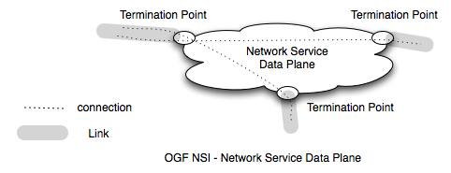

A Network Service can be integrated with other NSs by connecting the NSs with Links. End devices (hosts, routers, switches) also have Links to a NS. Links are permanent connection to a NS. ETE connections between end sites one linked NSs are concatenations of connection segments provided by different Network Services.

Note that a connection may be created at different network layers. For example a connection might be a VLAN, or a tcp session, or a wave carried by a fiber. (Note that there is some discussion about how tcp sessions as connections – one issue is to describe the link that carries tcp)

Links attach to termination point on a NS. NSs that each have termination points on the same Link can create connections between between the termination points on thedifferent services.

A Link for a VLAN would be an Ethernet trunk (or a SONET trunk that carries VLANs as VCGs), for a wave the link would be a fiber. [ As noted above, I am not sure what it would be for a tcp session, and I am not sure we want to include tcp sessions in our OGF-NSI definition of a Network Service – any thoughts about this?]

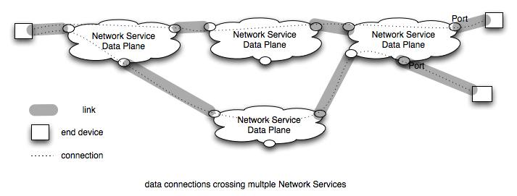

The figures above show a set of NS dataplanes interconnected by Links. This provides a connected graph over which connections can be made.

Connections between endpoints consist of connection segments that are concatenated to create an end to end connection. Segments exist over a network or over a link. Each segment has performance characteristics, and an ete connection’s performance is limited by the performance of each segment and the interaction between segments.

Naming of the elements in the diagram is necessary to build a clear definition of what can be requested over an NSI. Actual naming will be done in conjunction with the NML working group. We need to have a name for

Network Service
Network termination points
Link
Connection
Connection segment
Link segment
Network segment
Topology information

Pathfinding and sharing of Link Information

To create a global directed graph each NS must share its links to other NS or end devices. The capability of sharing external topology is required in NSI. The following figure shows this part of the NSI interface. Note that the Requestor for Topology information may be different that the requestor for connections.

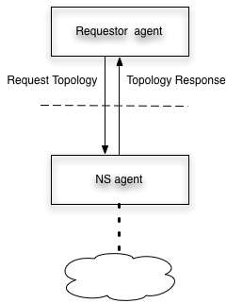

How the topology is aggregated and used is outside the scope of the NSI.
Topology information may be aggregated in a number of ways. The Requestor Agent may be a global topology server which can also do pathfinding pathfinding. Alternatively, other NSs be Requestor Agent for topology information and each NS may create its own global topology database.
The topology (termination points, links and end sites) shared may be different for different requestors. A site may tell a Virtual Organization only about endsites that are part of the VO.

NS may provide additional information about bw, jitter, or other characteristics for paths between termination points) on its network and link segmenst as part of its topology information.

An issue under discussion

One issue that has been raised but not resolved on NSI calls is whether resevations are for connections or for resources. The issue comes up to allow a number of endsites to reserve resources such that they may interconnect in different ways during the time of the reservation. One example is to LHC tier1s and tier2s reserving resources that allow any one Tier2 to connect to a Tier1. When one Tier2 is finished another is connected – this under control of an LHC controller.

The implications of this, as I understand them now, is that the LCH controller would need to determine what resources are required to perform this, reserve the resources, then instantiate connections as appropriate.

From the network side this means that one would not know the connection to be established at reservation time, only the set of resources. This raises the question of what resources should be available for reservation – is it enough to reserve connections between termination points on the NS or is some switching capability also required?

