Activity instance schema use cases

1. Scheduling use case

Description:
A client sends a request to a scheduler (could be EMS in OGSA speak) using an activity template which describes the requirements of the submitted work unit.

The initially receiving (primary) scheduler takes the template and, if it is willing to handle it, creates an activity instance for it, storing the initial template and, if applicable, additional information. The latter should at least include a "provenance record" which denotes that the current scheduler has taken over responsibility for the execution of the given activity. Other candidate information may include scheduling attributes, dependencies to other activities, and the current state of the activity, possibly reusing the BES state model.

On activity delegation, the delegator acts like a client towards the potential delegatee, offering the job to another scheduler. Again, if the delegatee is willing to accept the job, it takes over responsibility and the provenance records and depending information (e.g. the expected BES) are updated. If necessary, the activity template may be modified, as long as the manipulation history is kept.

Throughout the whole process, state information is constantly updated in the activity record. After activity completion, the resource consumption is written to the activity record. The corresponding entries and dependent parts of the record could then be sealed (marked final) as to denote the completion of the activity.

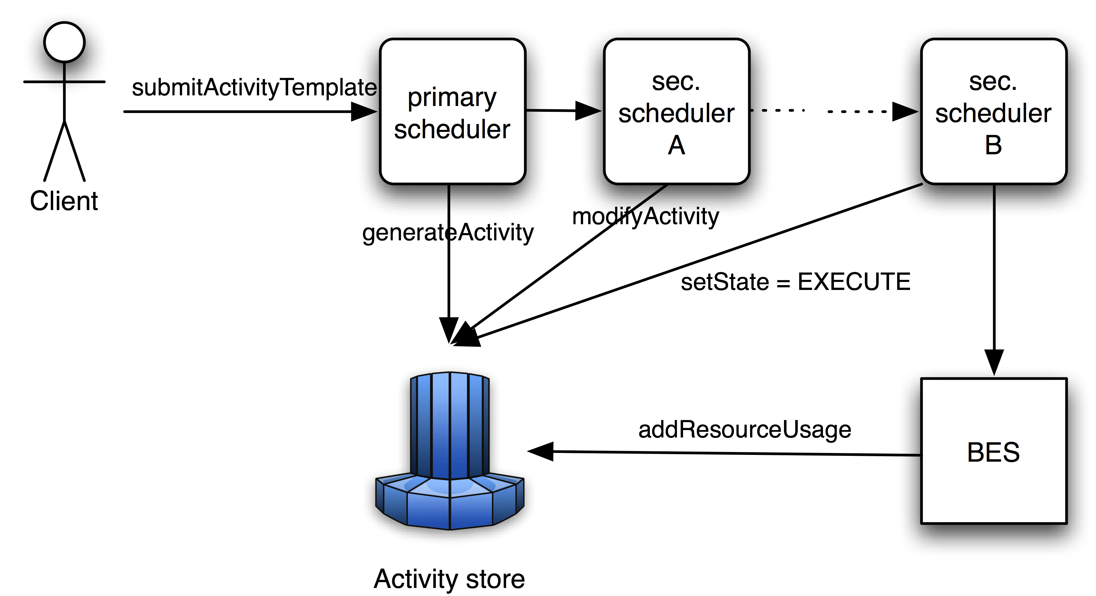

Actors:
- Client. Maybe a user accessing the Primary Scheduler directly or a component doing it on the user’s behalf.
- Primary Scheduler. The scheduler that receives the Activity template and that generates the Activity.
- Secondary Scheduler(s). An arbitrary number (but at least one) of schedulers, to which the Activity is delegated.
- BES. Executes the job related to the Activity.
- Activity Store. Some instance (potentially distributed) where the Activity is stored.

Endorsed by:
- Grid Scheduling Architecture Research Group
- D-Grid (Germany)

Specific requirements:

2. Job lifecycle tracking use case

Description:
The general purpose of this use case is to track a job (and its attributes) throughout the entire life cycle of a job. This is from the point in time where the job enters the system (activity creation; “Pending” in BES terms) to a point in time where the job is not active any more.

It is very useful to be able to see various bits of information about a particular job (an activity instance) at various phases within its life cycle. Different types of information are particularly relevant at different points in the job lifecycle, and the information can be used for various job-related activities such as job monitoring, system diagnosis, or capacity planning. The types of information that should be tracked for this use case are as follows:

- The point at which an activity has been submitted (and the unmodified parameters that were provided at submission).
- Any state changes that occur (according to the underlying state model). This would include information about the time of the change, the old state, and the new state.
- Information about the activity being forwarded from one scheduler to another (pertains to meta-scheduling and peer scheduling use cases). This part of the use case is similar to the delegation part of the “Scheduling use case”.
- A report of resources consumed by the job both during the run time of the job, as well as a final “accounting” record that summarizes the job resource usage.

It is essential for this use case that the system provides access mechanisms which allow to access the different types of information mentioned above during job runtime by querying the BES (for example). In addition there is a demand for the possibility to examine a file that contains activity records.

Actors:
- End users. Those are monitoring the job progress and potentially the job’s history.
- Administrators. They need diagnose means to analyse information about system exceptions (and take the necessary measures). The granularity of the information provided may vary with the specific application domain.
- Scheduler/broker/etc. Those entities (or humans) exploit the activity-related information to plan the job’s execution, migration, re-scheduling, etc.

Endorsed by:
- Platform Computing

Specific requirements:

