HPC Job Delegation Best Practices
Status of This Document
This document provides information to the Grid community about use cases and requirements for the delegation of High Performance Compuing jobs between schedulers in different administrative domains. It does not define any standards or technical recommendations. Distribution is unlimited.
Copyright Notice
Copyright © Open Grid Forum (2008, 2009). All Rights Reserved.
Trademark
OGSA is a registered trademark and service mark of the Open Grid Forum.
Abstract

Contents
1. Introduction 3
2. Notational Conventions 3
3. Background 3
4. Requirements 3
4.1 General Issues 3
4.2 Use Case-specific Issues 5
5. Current Standardization Efforts 6
5.1 Core Aspects 6
5.2 Optional Aspects 6
5.3 Related Aspects 6
6. Recommendations 7
6.1 General Recommendations 7
6.2 Use Case-specific Recommendations 7
7. Contributors 8
8. Glossary 8
9. Intellectual Property Statement 8
10. Disclaimer 8
11. Full Copyright Notice 9
12. References 9

Introduction
Modern science more and more relies on experimental scientific discovery made with extensive simulations, and during the last decade, Grid Computing has become the key infrastructure in academia to support this development. The use of Grid Computing, however, is not anymore limited to HPC/HTC-centric communities such as High Energy Physics, Astronomy, or Climate Research, which have a certain tradition of using such infrastructures. Other sciences – e.g. Financial Services, Construction Engineering, and even arts and humanities – also start to adopt Grid Computing as a tool for e-Science, and show an ever-increasing demand for computing power and storage space.
While well-established approaches such as the EGEE environment have relied on centralized middleware infrastructures for whole e-Science communities, other – mostly emerging – efforts have chosen a Service Grid approach with smaller, more community-tailored Grids. In the latter case, however, a strong demand for enabling collaboration and cooperation on the infrastructure layer between the different communities and Grids can be observed.
A major issue in such collaborations is the possibility of inter-community resource usage: Although most communities run their own data centres, working together in an ad-hoc manner by allowing alien workload to be run on community hardware is still a tedious task and usually requires resorting to 1980ies-style command line interfaces and undesirable micro-management. This is mainly due to technical issues: Many e-Science infrastructures show a lack of inter-project standardization, and therefore, collaborations between the workload gateways (usually Grid schedulers or brokers) from different vendors both from the academic and industrial domain fail on a compatibility level.
As such, the standardized and interoperable delegation of HPC jobs in Utility Computing environments such as Grid systems is an important, yet unsolved issue. This document reviews established OGF work and, using a best practices approach, introduces a general protocol for tackling this issue. On the basis of this protocol, working groups that develop related standards are encouraged to build profiles towards a full delegation protocol recommendation.

Notational Conventions
The key words ‘MUST,” “MUST NOT,” “REQUIRED,” “SHALL,” “SHALL NOT,” “SHOULD,” “SHOULD NOT,” “RECOMMENDED,” “MAY,” and “OPTIONAL” are to be interpreted as described in RFC 2119 [BRADNER1].

Scenario & Use Case
This section describes the general scenario of delegating an HPC job from one scheduling system to another, i.e. one scheduler sends a job to another scheduler based on an agreement between the two. The reason for a scheduler to execute such a delegation is not of interest in the scenario we consider, but common reasons, to name two different, are the lack of suitable resources within the domain controlled by the delegating scheduler or a temporary situation of high load.
Please note that the scenario described below is not only valid for HPC jobs, but for any activity which is processed by a scheduler. This may be a service call, a database request or some workflow to be executed. The reason why this document’s focus is on HPC jobs is two-fold: (i) although there is a large number of use cases (as e.g. described in [GFD.64]), current interest within OGF and the community involved in the work described here is in the HPC job processing area and (ii) it seems appropriate to take the inductive approach taking the expertise and experience into account OGF has with HPC-related standards and best practices.

The Scheduler Interoperability Scenario
For the delegation of jobs between HPC systems (i.e. the scheduling systems which , we assume a simple scenario as depicted in Figure 1.

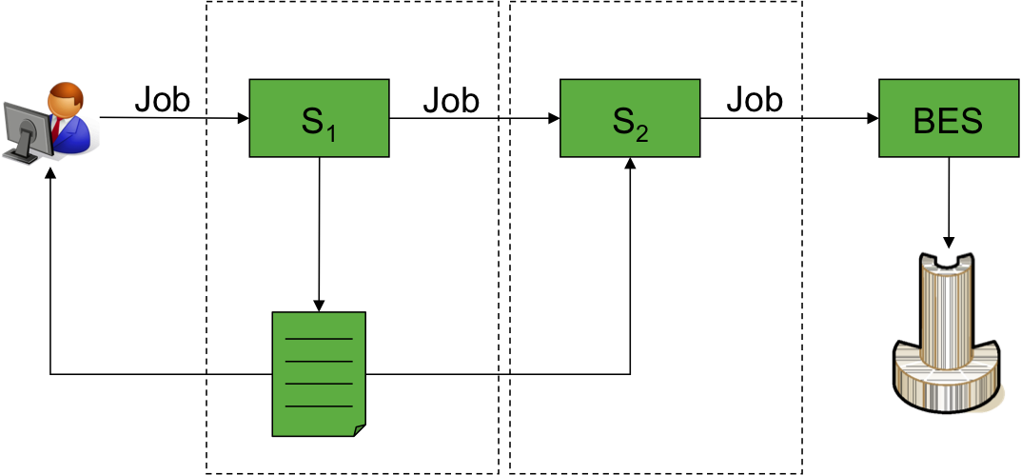
Figure 1 Basic job delegation scenario

In this context, a job that has been initially submitted to a scheduling system S₁ is to be delegated to a second scheduling system S₂ in a different domain (as depicted by the dotted lines). In this delegation process, the two scheduling systems need to notify each other on the planned delegation, agree on the delegation parameters, and delegate responsibility for the execution of the job from one scheduler to the other. Finally, the scheduler that took over responsibility ensures the execution of the job on an appropriate container.
The basic protocol for agreement and responsibility delegation is depicted in Figure 2.
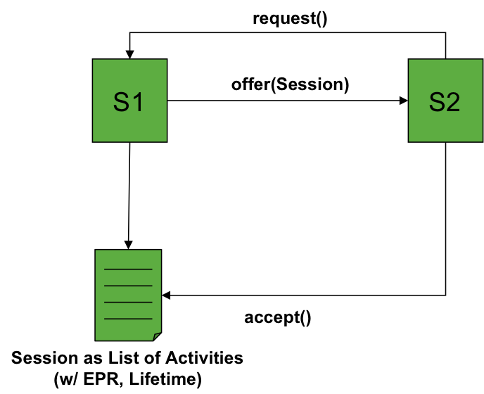
Figure 2 Basic protocol steps
Here, the scheduler S1 creates a session of activities (jobs) that are to be delegated, adds a lifetime for the session, and offers the session to scheduler S2, which in turn can accept or reject the offer. An ante-delegation extension to the protocol is the notion of requests, which notifies another scheduler that a delegation offering is requested.

Use Cases

Inter-Scheduler Delegation within a National Grid

IANOS
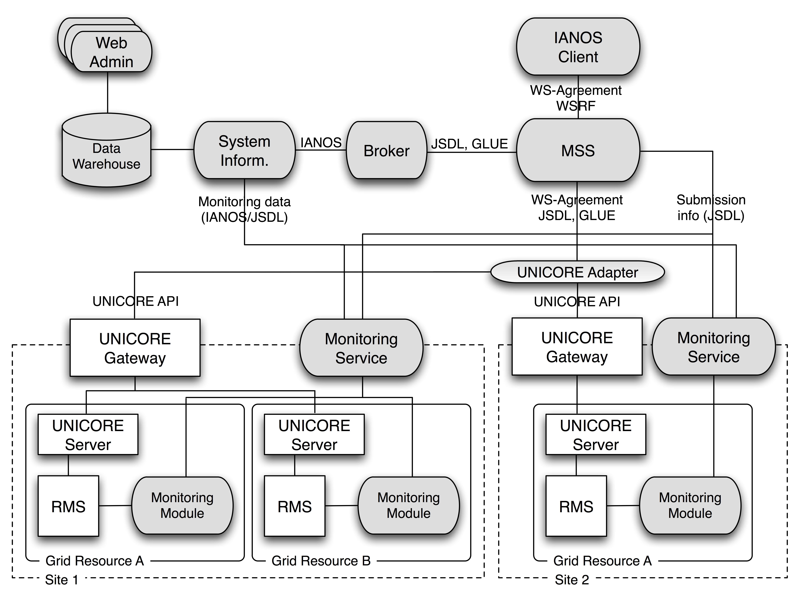

Current OGF Standardisation Efforts related to the Scheduling Interoperability Scenario

Job Submission Description Language (JSDL)
The Job Submission Description Language, version 1.0, currently has the status of a proposed recommendation. In its original state, it covers the definition of basic resource requirements, a command with parameters to be executed on a resource and the provisioning/staging of input and output data. Extensions cover applications for POSIX-compatible operating systems, single-program/multiple-data jobs and parameter sweeps. JSDL is extensible in terms of adding new or modified dialects for other aspects in almost all contexts of the specification.

OGSA Resource Selection Services (OGSA-RSS)
The OGSA Resource Selection Service, version 1.0, currently has the status of a working draft. RSS covers the selection and planning of resources for the execution of an activity. It features two basic services: a Candidate Set Generator (CSG), which is responsible for finding appropriate resources for given requirements, and an Execution Planning Service, which provides advice regarding which resource from a (CSG-generated) set of resources is the most appropriate one with respect to client-specified and other requirements. OGSA-RSS development is still ongoing and, as such, open to modifications and extensions.

OGSA Basic Execution Services (OGSA-BES)
The OGSA Basic Execution Service, version 1.0, currently has the status of a proposed recommendation. In its original state, it provides a common interface for the submission of a general activity for execution on a given resource. A profile, OGSA-HPCP, has been created which narrows OGSA-BES and JSDL for the execution of High Performance Computing jobs. In general, OGSA-BES is extensible in terms of accepting arbitrary information besides the job description; however, the use of at least one JSDL description for the creation of an activity is mandatory.

WS-Agreement (GRAAP)
WS-Agreement version 1.0 is currently in the status of a proposed recommendation. WS-Agreement defines a language and a protocol to create service level agreements between a service provider and a service consumer. WS-Agreement itself is not limited to any environment but allows using specific term languages to express the service level objectives within an environment. For example, JSDL (see Section) is used to describe SLOs related to the execution of jobs using Grid resources. WS-Agreement also includes the possibility of defining guarantee terms and penalties in case a service level agreement is not fulfilled later.

OGSA Usage Record (OGSA-UR)
The OGSA Usage Record Format currently has the status of a proposed recommendation. Its main focus lies in the specification of basic accounting and usage data for job execution on computational resources. Although UR provides an extension model for the tracking of other resource types, the tailoring to HPC use cases seems to be quite strict. As such, an extension to other types of activities seems to be difficult without modifying the current specification.

Discussion and Gap Analysis
The overall scenario can be divided into four distinct steps, which need to be addressed by standardization in order to cover the full lifecycle of job delegation in the depicted use cases:
- Generation of a delegation session, including the provisioning of a set of jobs to the delegatee,
- Handover of responsibility for a distinct job from the delegator to the delegatee on a reliable, traceable basis,
- Execution of the delegated job on a matching HPC resource, and
- Tracking of the job’s execution state during and its resource usage after execution.

Delegation Session Generation
Before the delegation itself can take place, it is necessary to provide a stable view on the set of delegatable jobs. To this end, the delegator needs to create a session which can be presented to the delegatee in order to let him decide on whether to accept or decline the offer and, in case of the former, which job to take over responsibility for.
For the depicted steps, no recommendations within the OGF ecosystem are actually suitable.

Session Creation
The creation of a session is not covered by any standard currently, but the abstract Candidate Set Generator interface from within the OGSA-RSS-WG can serve as a template.
A new service definition, the Delegation Candidate Generator (DCG), should offer the interface to creating a session which contains delegatable job candidates. Here, the delegator of a set of jobs should generate a delegatee-specific session containing jobs that are generally suitable for delegation to the target scheduler.
The interface of the session service should provide an analogous interface to what is offered by the current concretization of the OGSA-RSS CSG, namely the Basic Execution Planning Service (BEPS): the client to the session service should be able to pass a request, containing JSDL-compliant resource constraints, and expect a response comprising JSDL job descriptions that match the given constraints.
The ordering of the jobs within the session is generally set by the delegator, descending in delegation priority. The delegatee should be allowed to request an ordering, but the delegator is not required to fulfill this request.
The interface of the factory service for such sessions, is not necessarily public. However, in order to not only allow for delegator-initiated delegation, but also delegatee-initiated delegation, the interface could be public – and accordingly, specified along with the DCG session interface – to streamline access to delegation sessions.

Session Offering
While the creation of the Delegation Candidate Session can be covered with a derivation from OGSA-RSS, the publication of such a session is currently not covered at all. Here, two possibilities exist:
- Delegator-initiated session handover
- Delegatee-initiated session handover
The latter case can be easily covered by publishing the DCG Factory service such that every potential delegatee can request a Delegation Candidate Session on her own without having to establish any other kind of interaction with the delegator, and directly proceed to the handover of responsibility.
The former case is more problematic in terms of relying on available and well-established (and accepted) recommendations only.
<TBD>

Handover of Responsibility
Should be done with WS-Agreement: one partner generates agreement template within factory, containing one or more jobs to delegate in JSDL format, other partner agrees or declines handover. On agreement settling, delegation of responsibility is complete.

Execution of Job
The execution of a HPC jobs is currently embraced by the HPC Basic Profile Working Group, which already has defined a recommendation for running HPC jobs on corresponding resources via a standardized interface. This recommendation can be used without further modification.

Usage Tracking
Keeping track of the delegated job after successful responsibility handover is also an open issue. This does not only cover the obvious case of having delegated a job between different scheduling domains, but also in the step before: When a user submits a job to a workload management system, she expects to acquire a handle on the job in order to lookup the status or to cancel execution.
The main issue here is that, only relying on BES statuses is not sufficient, since the job’s lifecycle starts significantly earlier – directly after submission by the user to the first scheduler in the delegation chain – than the BES resource is created for the first time. As such, an additional resource that describes the whole lifecycle of a job (including delegation steps) has to be provided.
Currently ongoing work within JSDL-WG aims to cover this issue in a general way: the Activity Instance (AI) schema provides an instance record (in contrast to template record types such as JSDL) for generic activities, containing data on the initial submission, a change history covering states, exceptions, and other information, as well as final usage records after completion of the activity. Although AI is not particularly designed for documenting delegation steps, the delegation state can be covered by an extension to BES states, which are already considered within the schema.

Recommendations
From the given use cases and the gap analysis in the previous parts, a set of recommendations for other working groups have been derived. While in most cases, usage profiles that concretize certain aspects of already available standards are sufficient, it is partly necessary to fill certain gaps with new service and protocol definitions.

Usage Profiles

WS-Agreement

JSDL

BES and HPC-BP

UR

Gap Bridging

Delegation Candidate Service

Protocol for Session Offering

Contributors
Joachim Lepping
Dortmund University of Technology
Email: joachim.lepping@udo.edu

Ariel Oleksiak
Poznan Super Computing Centre
Email: ariel@man.poznan.pl

Alexander Papaspyrou (editor)
Dortmund University of Technology
Email: alexander.papaspyrou@tu-dortmund.de

Nicola Tonellotto
Information Science and Technologies Institute (ISTI)
Email: nicola.tonellotto@isti.cnr.it

Oliver Wäldrich
Fraunhofer SCAI
Email: oliver.waeldrich@scai.fraunhofer.de

Philipp Wieder (editor)
Dortmund University of Technology
Email: philipp.wieder@udo.edu

Ramin Yahyapour
Dortmund University of Technology
Email: ramin.yahyapour@udo.edu

Wolfgang Ziegler
Fraunhofer SCAI
Email: wolfgang.ziegler@scai.fraunhofer.de

Contact information for authors. You can also use this section to recognize contributions by people who are not listed on the title page, but made a useful contribution (it’s OK to mention the nature of the contribution).
The actual Authors (or Editors) listed on the title page are those committed to taking permanent stewardship for this document – receiving communication in the future and otherwise being responsive to its content. The GFSG recommends at most three Author/Editors be listed on the title page, unless there are compelling reasons to list more.

Glossary
Recommended but not required.

Intellectual Property Statement
The OGF takes no position regarding the validity or scope of any intellectual property or other rights that might be claimed to pertain to the implementation or use of the technology described in this document or the extent to which any license under such rights might or might not be available; neither does it represent that it has made any effort to identify any such rights. Copies of claims of rights made available for publication and any assurances of licenses to be made available, or the result of an attempt made to obtain a general license or permission for the use of such proprietary rights by implementers or users of this specification can be obtained from the OGF Secretariat.
The OGF invites any interested party to bring to its attention any copyrights, patents or patent applications, or other proprietary rights which may cover technology that may be required to practice this recommendation. Please address the information to the OGF Executive Director.

Disclaimer
This document and the information contained herein is provided on an “As Is” basis and the OGF disclaims all warranties, express or implied, including but not limited to any warranty that the use of the information herein will not infringe any rights or any implied warranties of merchantability or fitness for a particular purpose.

Full Copyright Notice
Copyright (C) Open Grid Forum (2007, 2008). All Rights Reserved.
This document and translations of it may be copied and furnished to others, and derivative works that comment on or otherwise explain it or assist in its implementation may be prepared, copied, published and distributed, in whole or in part, without restriction of any kind, provided that the above copyright notice and this paragraph are included on all such copies and derivative works. However, this document itself may not be modified in any way, such as by removing the copyright notice or references to the OGF or other organizations, except as needed for the purpose of developing Grid Recommendations in which case the procedures for copyrights defined in the OGF Document process must be followed, or as required to translate it into languages other than English.
The limited permissions granted above are perpetual and will not be revoked by the OGF or its successors or assignees.

References
Note that only permanent documents should be cited as references. Other items, such as Web pages or working groups, should be cited inline (i.e., see the Open Grid Forum, http://www.ogf.org). References should conform to a standard such as used by IEEE/ACM, MLA, Chicago or similar. Include an author, year, title, publisher, place of publication. For online materials, also add a URL. It is acceptable to separate out “normative references,” as IETF documents typically do.
[BRADNER1] Bradner, S. Key Words for Use in RFCs to Indicate Requirement Levels, RFC 2119. March 1997.
[GFD.64]

