Production Grid Infrastructure Roadmap
Draft Version 0.01

Status of this Memo
TBD: Set of profiles…

Copyright Notice
Copyright © Open Grid Forum (2009). All Rights Reserved.

Abstract
TBD: Similar like charter but shorter…

The objective of this working group is to formulate a well-defined set of profiles, and additional specifications if needed, for job and data management that are aligned with a Grid security and information model that addresses the needs of production grid infrastructures.

Contents
1 Introduction 3
2 Terms 4
3 Use Cases 5
3.1 Use cases of GIN group 5
3.2 Identified Basic Use Case 5
4 Encountered Limitations 6
5 PGI Ecosystem 7
5.1 Ecosystem overview 7
5.2 Ecosystem Key Elements 8
6 Document Overview 9
7 Author Information 10
7 Author Information 10
8 Contributors & Acknowledgements 11
9 Full Copyright Notice 12
10 Intellectual Property Statement 12
11 Normative References 13

1 Introduction
TBD: Similar like charter

The origin of this working group is from the Grid Interoperation Now (GIN) community group. The GIN-CG has representatives from production Grid infrastructures (such as EGEE, OSG, NAREGI, NorduGrid, TeraGrid, NGS, etc) and supporting organizations (such as OGF-Europe, OMII-Europe, OMII-UK, etc.). Over the last two years the members of GIN that are working daily in world-wide production grids have been working within the OGF to explore the interoperability issues in:

- jobs submission and job monitoring
- data access and movement
- authentication and authorization
- information representation and discovery
As a result of this collaborative activity the GIN-CG now feels there is sufficient understanding and motivation within the group to define a set of profiles around a well-defined use case. This use case should use open standards from different areas of OGF to facilitate interoperability among production Grid infrastructures. This is the focus of this working group.
This basic use case identified in production Grids is as follows: on behalf of an authorized user, a tool interrogates the information system (representing a grid or a single resource), locates an optimal execution resource, submits the job to the execution resource, which in turn interprets the submitted job description and locates and fetches the necessary input data from a remote storage - also on behalf of the user. Upon the completion, the newly created data is uploaded to a storage resource where this user is authorized (as a member of a Virtual Organization), registered in the necessary data indexing catalogs, and the job record is updated in the accounting and monitoring system.
Thus the milestones this working group must meet are particularly ambitious due to the needs of the production Grid infrastructures. There is a need to come to a common proven end-to-end interoperable definition of the services and their interactions within the next 18 months for the European middleware developers. This development work will take place within this time period – we feel it is imperative to attempt to do this work within OGF.
The scope of this working group is restricted to dealing with job and data management issues found in production grid infrastructures that together use a limited number of security specifications and information models. The resulting Web service interfaces and schemas defined by this working group will be a set of profiles of open standards and specifications such as OGSA-Basic Execution Services (GFD.108), Job Submission Description Language (GFD.136), GridFTP (GFD.20), Storage Resource Manager (GFD.129), and efforts of the GLUE2 (GFD tbc) working group. The additional work bv this group will go beyond the current specifications and extensions to include an authentication and authorization model, an extended state model, an integrated resource and informational model, and a data transfer and storage model – all tuned to the use cases found in production grid infrastructures.

2 Terms
TBD: Production Grid

TBD: Interoperability Ecosystem (instead of reference model)

TBD: Plumbings

3 Use Cases
TBD: Important: PGI is driven by use cases (bottom-up from the infrastructures) instead of an OGSA roadmap (top-down approach)

3.1 Use cases of GIN group
TBD: Some activities of GIN out of GIN Journal Paper
TBD: pre-production setups of WISDOM, VPH, etc.

3.2 Identified Basic Use Case
TBD: Basic Use case

This basic use case identified in production Grids is as follows: on behalf of an authorized user, a tool interrogates the information system (representing a grid or a single resource), locates an optimal execution resource, submits the job to the execution resource, which in turn interprets the submitted job description and locates and fetches the necessary input data from a remote storage - also on behalf of the user. Upon the completion, the newly created data is uploaded to a storage resource where this user is authorized (as a member of a Virtual Organization), registered in the necessary data indexing catalogs, and the job record is updated in the accounting and monitoring system.

4 Encountered Limitations
TBD: Missing Links
TBD: Refinements necessary
TBD: Tunings necessary

TBD: Problems of standards landsscape, basically talk Balazs and CERN Meeting elements
TBD: How deep technical should this be?!

5 PGI Ecosystem
TBD: Indicate that the whole set of profiles should be used together, otherwise again a wide variety of useless profiles
TBD: Ecosystem takes encountered limitations into account

5.1 Ecosystem overview
TBD: Describing the ecosystem as a whole
TBD: Ideas of plumbings and their mapping to different profiles

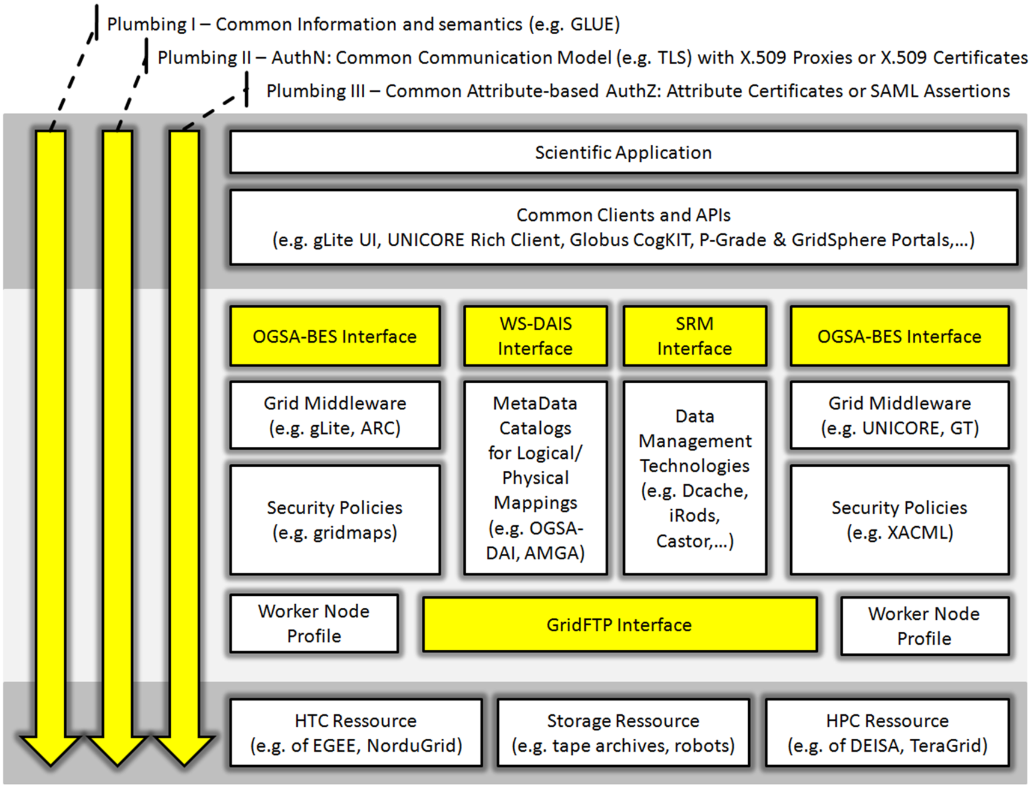

TBD: Add OGF Secure Addressing in the Plumbing I space

5.2 Ecosystem Key Elements
TBD: Describing the key elements with focus on the missing links, tunings, and refinements we plan to provide
TBD: Mapping of these key elements to expected profiles
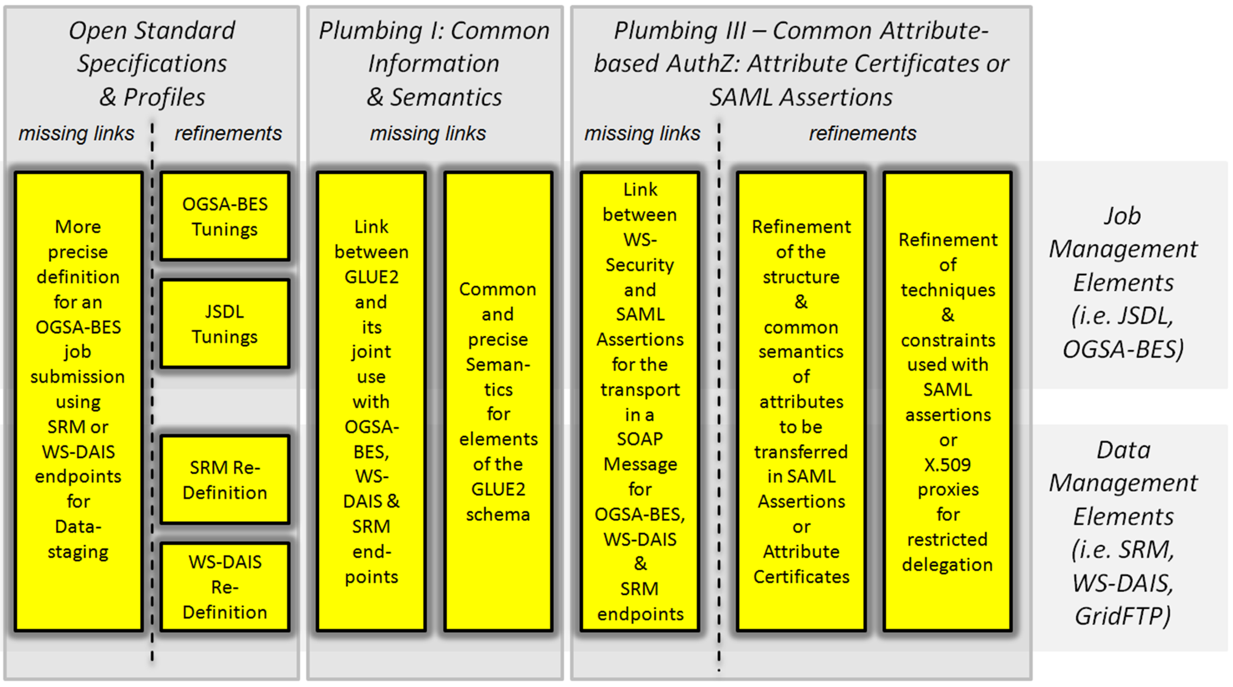

6 Document Overview
TBD: how documents cover our necessary ecosystem

TBD: how documents cover our basic use case

This group will deliver the following documents:

- Production Grid Infrastructure Roadmap Document (GFD-I),
provides an overview of missing links between open standards and the fundamental motivation for standardization of the production grid infrastructure profiles
- Secure Job and Data Management Profile in Production Grids (GFD-R.P),
develop a job/data/security profile assuming an deployed computing endpoint is already known by an end-user
- Secure Information Profile in Production Grids (GFD-R-P),
allows a user to discover resources that are appropriate for their request and that they are authorized to access
- Secure Accounting Profile in Production Grids (GFD-R-P),
develop an accounting profile that allows services to securely update a service within information about the resources they have used on behalf of a user.
- Secure Monitoring Profile in Production Grids (GFD-R-P),
develop a profile that allows services to securely record in a service the progress of an activity.

7 Author Information
TBD: Morris

TBD: Balazs, Moreno, etc.

8 Contributors & Acknowledgements
TBD: Morris

9 Full Copyright Notice
Copyright (C) Open Grid Forum (2008). All Rights Reserved.

This document and translations of it may be copied and furnished to others, and derivative works that comment on or otherwise explain it or assist in its implementation may be prepared, copied, published and distributed, in whole or in part, without restriction of any kind, provided that the above copyright notice and this paragraph are included on all such copies and derivative works.

However, this document itself may not be modified in any way, such as by removing the copyright notice or references to the OGF or other organizations, except as needed for the purpose of developing Grid Recommendations in which case the procedures for copyrights defined in the OGF Document process must be followed, or as required to translate it into languages other than English.

The limited permissions granted above are perpetual and will not be revoked by the OGF or its successors or assignees.

10 Intellectual Property Statement
The OGF takes no position regarding the validity or scope of any intellectual property or other rights that might be claimed to pertain to the implementation or use of the technology described in this document or the extent to which any license under such rights might or might not be available; neither does it represent that it has made any effort to identify any such rights. Copies of claims of rights made available for publication and any assurances of licenses to be made available, or the result of an attempt made to obtain a general license or permission for the use of such proprietary rights by implementers or users of this specification can be obtained from the OGF Secretariat.

The OGF invites any interested party to bring to its attention any copyrights, patents or patent applications, or other proprietary rights which may cover technology that may be required to practice this recommendation. Please address the information to the OGF Executive Director.

Disclaimer
This document and the information contained herein is provided on an “As Is” basis and the OGF disclaims all warranties, express or implied, including but not limited to any warranty that the use of the information herein will not infringe any rights or any implied warranties of merchantability or fitness for a particular purpose.

11 Normative References
[BES10] Foster, I., Grimshaw, A., Lane, P., Lee, W., Morgan, M., Newhouse, S., Pickles, S. Pulsipher,
D., Smith, C., and Theimer, M. OGSA Basic Execution Service, Version 1.0. GFD 108.
August 2007. Available at http://www.ogf.org/documents/GFD.108.pdf.

