GGF DFDL Example Uses

Status of This Memo

This memo provides information to the Grid community regarding the specification of a Data Format Description Language. The specification is currently a draft. It does not define any standards or technical recommendations. Distribution is unlimited.

Copyright Notice

Copyright © Global Grid Forum (2005). All Rights Reserved.

Abstract

A Data Format Description Language (DFDL) is proposed as an open industry standard. Rather than prescribing a data format, DFDL is descriptive of existing formats. DFDL leverages the XML standard and XSD standard for defining the structure of data, but extends these to include the ability to describe data formats.

Revision History
Latest entry at the top please
Version | Author/Contributor | History | Date(yyyy-mm-dd)

Contents
GGF DFDL Example Uses 1
Abstract 1
Revision History 2
Contents 3
1. Introduction 4
2. Generic Access to Scientific Datasets 4
3. Generic Access to Business Data 4
4. Federated Data Access 6
5. Archiving 7
6. Intellectual Property Statement 8
7. IPv6 Considerations 8
8. Full Copyright Notice 8
9. Author Information 8
10. References and Notes 8

Introduction
This note presents some example uses which motivate and illustrate the use of the Data Format Definition Language (DFDL). These examples are intended to provoke and focus discussion, and guide the design and development of the DFDL.

Title | Description | Discussion
Generic Access to Scientific Datasets | Generic access to data in different formats
Generic Access to Business Data | Generic access to data in different formats
Federated Data Access | Interoperating Data from Relational, XML, and other sources | This example could be elaborated to discuss streams and data services
Archiving | Documenting data for long term preservation | This case is important, but it remains to be seen if the DFDL will be useful (REMcG).

Generic Access to Scientific Datasets
In QCD physics, independent research groups from all over the world have data which is always a 4d array of floating point values. However, different groups have different standards for precision, dimension order, byte order. As a result, sharing conceptually similar data can require substantial work to port and/or customize software.
At the simplest level the QCD physicists (described above) would like to be able to have a single API that would allow them to read any described piece of data, and carry out all the transformations required to ensure that they get the correct array in memory.
At the next level we would like to supply a high level DFDL description that captures a standard view of the data, and have generic DFDL logic that can transform an existing DFDL-described format into this generic view. This is one of the primary motivations for "layers" in the standard. It is a very powerful feature but it introduces scoping issues: What transformations can DFDL not describe? (also what transformations can DFDL not describe efficiently).
A DFDL library should provide generic data access: the ability to interrogate a data description and read all aspects of the data into memory. An example of a generic tool is a browser that will allow arbitrary DFDL-described data to be displayed in some sensible human-readable form. This case requires the standard to specify an API for reading and interrogating the data. The favoured suggestion for this is to extend DOM/SAX to allow the reading of data fields directly into in-memory types (float, int, char etc.)

Generic Access to Business Data
This use case is taken from the retail industry. As in the first case, the application needs to operate on conceptually similar data that arrives in several formats.
The scenario is as follows:
- Sales data is typically gathered by point of sales (PoS) devices within retail stores in a data format known as TLOG. Several different flavours of TLOG exist (eg, ACE, GSA). All flavours are very compact data formats that use text delimiters to separate individual data fields, the fields themselves can be binary or text, and groups of fields are preceded by initiators.
- This sales data is then wrapped in XML and transmitted to head office. Because the TLOG data is effectively binary data, SOAP with Attachments (SwA) is used as the transmission format. This appears ‘on the wire’ as a multipart MIME message, the first part being the SOAP message, and subsequent parts being the TLOG data. (SwA uses MIME in this manner to ensure that attachments are safely transmitted).
- At head office the sales data is centrally recorded by an application such as ARTS DataMart. The recorded format would typically be different from the TLOG format created by the PoS device. One such format is XML and is called POSLog.
This sales data may also be forwarded to other subsystems to be used for sales analysis. An example would be the Retek Sales Analysis module (RESA).
A different DFDL Schema can be used to describe each of the different flavours of TLOG.
Because TLOG is a very compact format, some of the data fields are packed in a TLOG-specific way. For example, numeric strings and decimals are both represented in a packed format not unlike S/390 packed decimal. Adjacent Booleans are packed together into a similar packed format. DFDL extensibility features would be needed to parse this packed data.

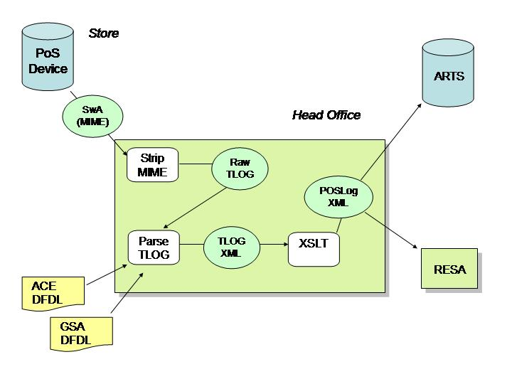

Federated Data Access
This use case is one commonly expressed in the grid world, but it applies equally to non-grid. The intent is to manipulate federated data from any data source of interest, using XQuery or XPath, ie, as if it were XML. This presents a common API to the end user of the data, independent of the data source.
There are three different kinds of data source that can participate in this federation, Relational, XML and everything else. RDBMS Schema are available to describe the first, XML Schema to describe the second. For the third, a DFDL Schema would be associated with each different non-Relational, non-XML data format.
The DFDL description implies an associated XML document. This document can be queried using XPath/XQuery to extract pieces of data. This leads to toward “XML without tags”, or providing XML wrappers around binary data.
There are groups who would like to use DFDL as a sort of cheap data compression technique. An example here is particle physics collision data. This is stored as a set of sparse (hence variable sized) trees of results. The data is richly structured trees and they would like to access it and talk about it as if it were in XML but they don't want to (cannot afford to) represent it using XML markup or use conventional XML tools to parse it.
The idea is that such a group would design a new binary format that could be described in XML and then they would work with the implied XML data. Note: naturally these folks do not want to access their floating point values as strings so they would want the sort of DOM extensions that we alluded to earlier. For this same reason things like Binary XML do not solve their problem.

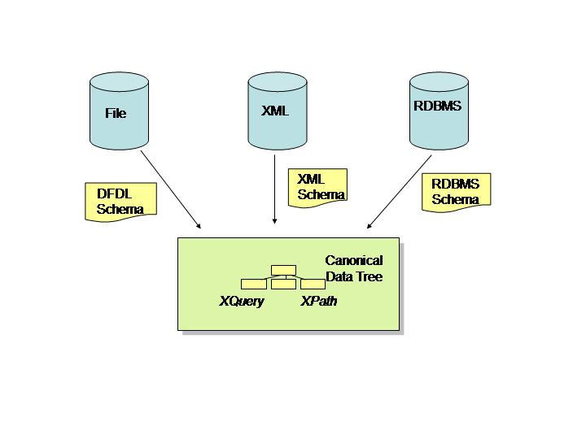
Another example comes from the astronomy community has recently moved from a long-standing binary data format (FITS) to an XML version (VOTable). FITS was very rich in metadata but also included binary images and large tables of observational data representations. VOTable is great for capturing the metadata in a standard way but leads to excessive bloat for images and large tables. The community has ended up with a complicated compromise in which they allow raw binary data in at the bottom of the XML file. A DFDL-described format could provide a cleaner solution.
An advantage of this approach is that the DFDL mixes naturally with metadata languages, so that XPath/XQuery expressions that can be used to query a document can provide external (format independent) annotations. For example NASA stores photographic images of hurricanes. A scientist can identify a blob of pixels that correspond to the hurricane in an image. They could like to store this annotation is such a way that the will be preserved through future transformations (e.g. new image format, or different pixel depth, or compression level). Note the point here is that a byte offset into the image data cannot do this.

Archiving
Data needs to be stored, but the programs and systems for reading it become obsolete. The DFDL provides a valuable possibility of describing all the details of a particular format so that the data can be accessed in whatever manner is required by a future system. Ideally, the description (and the standard) would provide sufficient information to access archived data, even if there were no programs able to read a format.
Data that is archived for long periods of time will need to be refreshed, and may need to be transformed as it is moved to up to data physical media (changes of precision) etc. It would be nice if DFDL could (a) annotate these changes (b) (perhaps) be used to ensure that the changes did not result in data loss.

Intellectual Property Statement
The GGF takes no position regarding the validity or scope of any intellectual property or other rights that might be claimed to pertain to the implementation or use of the technology described in this document or the extent to which any license under such rights might or might not be available; neither does it represent that it has made any effort to identify any such rights. Copies of claims of rights made available for publication and any assurances of licenses to be made available, or the result of an attempt made to obtain a general license or permission for the use of such proprietary rights by implementers or users of this specification can be obtained from the GGF Secretariat.
The GGF invites any interested party to bring to its attention any copyrights, patents or patent applications, or other proprietary rights which may cover technology that may be required to practice this recommendation. Please address the information to the GGF Executive Director.

IPv6 Considerations
None.

Full Copyright Notice
Copyright (C) Global Grid Forum (2005). All Rights Reserved.
This document and translations of it may be copied and furnished to others, and derivative works that comment on or otherwise explain it or assist in its implementation may be prepared, copied, published and distributed, in whole or in part, without restriction of any kind, provided that the above copyright notice and this paragraph are included on all such copies and derivative works. However, this document itself may not be modified in any way, such as by removing the copyright notice or references to the GGF or other organizations, except as needed for the purpose of developing Grid Recommendations in which case the procedures for copyrights defined in the GGF Document process must be followed, or as required to translate it into languages other than English.
The limited permissions granted above are perpetual and will not be revoked by the GGF or its successors or assigns.
This document and the information contained herein is provided on an "AS IS" basis and THE GLOBAL GRID FORUM DISCLAIMS ALL WARRANTIES, EXPRESS OR IMPLIED, INCLUDING BUT NOT LIMITED TO ANY WARRANTY THAT THE USE OF THE INFORMATION HEREIN WILL NOT INFRINGE ANY RIGHTS OR ANY IMPLIED WARRANTIES OF MERCHANTABILITY OR FITNESS FOR A PARTICULAR PURPOSE."

Author Information

References and Notes

