GGF DFDL Use Cases

Status of This Memo

Copyright Notice

Abstract

Revision History
Latest entry at the top please
Version | Author/Contributor | History | Date(yyyy-mm-dd)
 | Robert E. McGrath |  | 2005-09-23
 | Steve Hanson |  | 2005-09-29

Contents

GGF DFDL Use Cases 1
Abstract 1
Revision History 2
1. Introduction 4
2. Attribute-Relation File Format (ARFF) 4
3. Relational Database 5
4. Grid Application 9
5. Example: MODIS Level 2 Data (NASA Earth Observing System) 12
5.1 The Data Product 12
5.2 Views of the Data 13
5.3 The File Layout 14
5.4 DFDL Description(s) for this Dataset 17
5.5 Layers 17
6. Federated Data Access 18
7. Processing of Retail Point of Sales Data 19
8. References 20

Introduction
This note presents some possible use cases for the Data Format Definition Language (DFDL).
These use cases are intended to instigate discussion and guide design. These cases do not reflect formal requirements on the DFDL.

Attribute-Relation File Format (ARFF)
An ARFF (Attribute-Relation File Format) file is an ASCII text file that describes a list of instances sharing a set of attributes. ARFF files were developed by the Machine Learning Project at the Department of Computer Science of The University of Waikato for use with the Weka machine learning software ([7]).
This format is similar to many other simple text formats. There is a header with free text, followed by data definitions that define one dimensional records, followed by a sequence of records in comma delimited strings.

% 1. Title: Iris Plants Database
%
% 2. Sources:
% (a) Creator: R.A. Fisher
% (b) Donor: Michael Marshall (MARSHALL%PLU@io.arc.nasa.gov)
% © Date: July, 1988
%
@RELATION iris
@ATTRIBUTE sepallength NUMERIC
@ATTRIBUTE sepalwidth NUMERIC
@ATTRIBUTE petallength NUMERIC
@ATTRIBUTE petalwidth NUMERIC
@ATTRIBUTE class {Iris-setosa,Iris-versicolor,Iris-virginica}
@DATA
5.1,3.5,1.4,0.2,Iris-setosa
4.9,3.0,1.4,0.2,Iris-setosa
4.7,3.2,1.3,0.2,Iris-setosa
4.6,3.1,1.5,0.2,Iris-setosa
5.0,3.6,1.4,0.2,Iris-setosa
5.4,3.9,1.7,0.4,Iris-setosa
4.6,3.4,1.4,0.3,Iris-setosa
5.0,3.4,1.5,0.2,Iris-setosa
4.4,2.9,1.4,0.2,Iris-setosa
4.9,3.1,1.5,0.1,Iris-setosa

Figure 1. Adapted from [cite].
The DFDL use case has two variants:
- ingesting ARFF data
- converting data into ARFF
Figure 2 is a sketch of the first case: an application needs data in a specific format, but needs to read data from ARFF. A DFDL-aware reader will be able to use a DFDL description to read the ARFF data into the required internal layout.
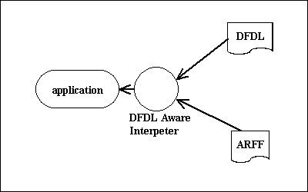
Figure 2
This case is interesting because the ARFF itself includes a data definition language. This means that the DFDL should actually be generated for each ARFF file, i.e., the declaration part of the ARFF should be used to generate a description of the records.
Figure 3 is a sketch of the second case: the program needs data in ARFF, but needs to read data from other sources. In this case, the DFDL is used to parse the data, which is written in a conventional ARFF file.

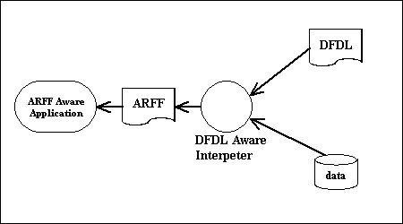
Figure 3
Again, this case is somewhat interesting, because the ARFF needs to have a data definition at the front. The DFDL-aware reader will use the DFDL to generate this header information in the output ARFF.

Relational Database
Many Grid applications will be accessing relational databases through custom or standard interfaces. This will be analogous to conventional client-server interactions:
- The application (client) will issue a query in a structured language
- the data server (database) will process the query, to formulate an answer
- the result will be returned to the client in a standard format, e.g., as a table.
Figure 4 shows a sketch of this operation.
The client and database share a data definition language and a common schema for the data in question. These are used to formulate a valid query, to interpret query, to formulate a valid response, and to interpret the response (Figure 5).

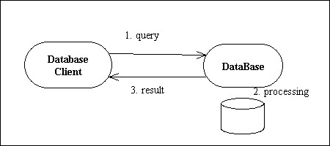
Figure 4

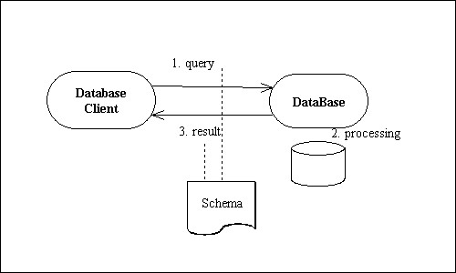
Figure 5
In a Grid environment, data users and data sources will be less tightly coupled, and applications will want to use data from many sources which may have many different schemas. The DFDL can enhance interoperability by providing a standard way to define the data, independent of the specific database language and schema.
Figure 6 sketches a possible use of DFDL to define the format of the query and answer. The general idea is that the DFDL would enable a generic query to be translated into specific query format for one or more physical databases. The DFDL description of the answer will enable the receiver to decode results from different sources.

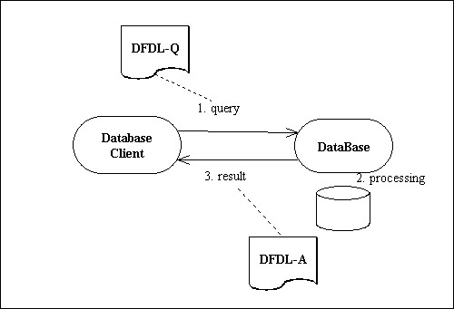
Figure 6
The database or database service presents data in a canonical form, e.g., as a table. This canonical form is what the DFDL in Figure 6 is describing.
However, the data service probably does not store a simple image of the table described by the schema. Instead, the data may be stored in paged memory, with one or more indexes, and multi-level caches. Some parts of the table may be computed instead of store. Thus, the actual stored representation of the data may be quite different from the view shown at the interface (Figure 7). The relationship between the stored data and the view is quite complex and depends on the implementation.
In this more extensive view, the DFDL could be used in several addition parts of the system. The structure of the database at the interface could be described (Figure 8, DFDL-T). For example, a database table could be described just as if it were a flat file.
Inside the server itself, the data structures that make up the table could, in principle, be described by DFDL layers (Figure 8, DFDL-Layers).
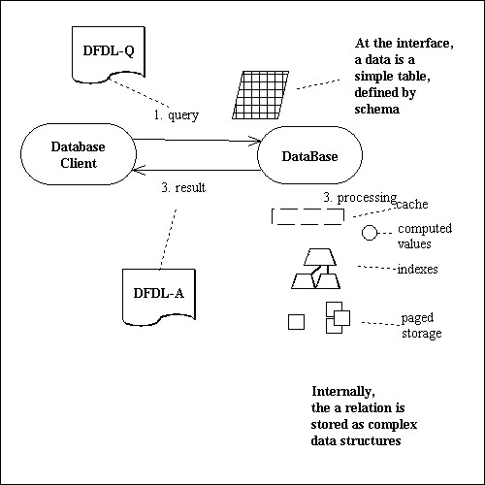
Figure 7

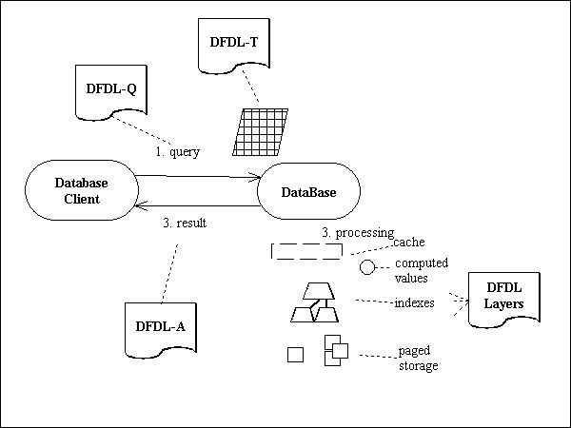
Figure 8
However, even if this DFDL were available, it is unlikely that it would be visible to the client. This illustrates a case where the data “format” of interest is not the physical bits.

Grid Application
This section is modeled after the Linked Environments for Atmospheric Discovery (LEAD) project, is a large, multi-institution effort to create an integrated, scalable cyberinfrastructure for mesoscale meteorology research and education [3].
Like the relational database case, it is a client-server model for data access, except the data may have no schema.
One important class of users will be remote access to data via Data Services. In this use case, the application accesses virtualized data, and should never need to see the stored objects. The services manage stored objects, and present data through their interfaces.
The implication of this virtualization is that there are two different uses of DFDL, one for the client/server interface, and the other for managing the physical data. It is important to point out that the client application definitely should not deal with DFDL descriptions of the physical data.
Consider a weather simulation running on the Grid. The program ingests initial conditions in the form of a large array, (latitude x longitude x altitude), containing values for physical parameters such as temperature, humidity, and wind velocity. (Figure 9)
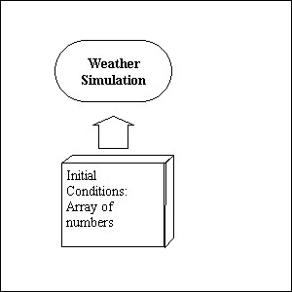
Figure 9
For the Grid application, this array of initial conditions should be virtualized, so that it can be populated by data sources from the Grid, such as satellites, radar, ground stations, and distributed archives. Ideally, the input array can be constructed by requests to Grid Data Services.
This would done through a “conversation with the data ([6])” suggested in Figure 10:
- Send message to one or more services: “please give me data from (describe targets), in the following layout (describe the required input array)”
- The service collects the data (if possible), and constructs a result.
- The reply from the service may be “can’t do it”, or it might be “here is the data (which might not be the layout requested).
Note that DFDL can play a critical role in this exchange: it enables the parties to describe what they want and/or are really sending. Furthermore, it enables the client to work with data from many sources, so long as the service can provide the data needed along with a DFDL description.
Figure 11 suggests where DFDL descriptions would be used in this protocol. First, the input array could be described with DFDL. This description could also be sent as part of the data request message. The second use would be a description of the returned dataset. (This would likely include other metadata about the provenance and characteristics of the data.)

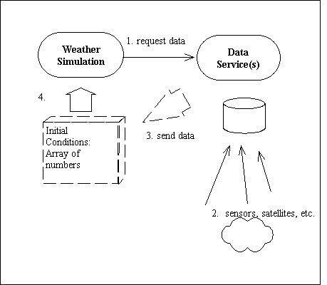
Figure 10
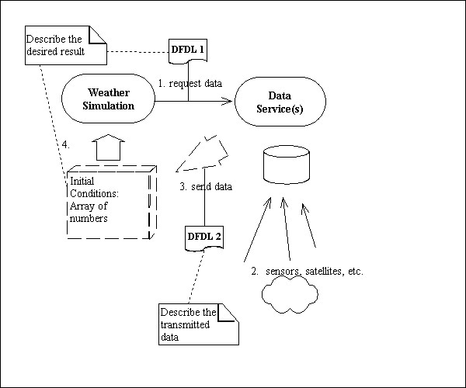
Figure 11
Both of these descriptions have no necessary relationship to the format of the stored data. As Figure 12 suggests, additional DFDL could be used on the service side, to describe the sensor data and the archived data.
The DFDL is useful in different ways on the two sides of the conversation.
For the application, it can use the DFDL to describe the format of its input files, either local or “virtual”. This description can be used in requests to services.
The DFDL is a critical piece of the data service interface, defining the request and the response.
Within the data service, the DFDL is used to manage data from different sources, and to implement data transformation algorithms.
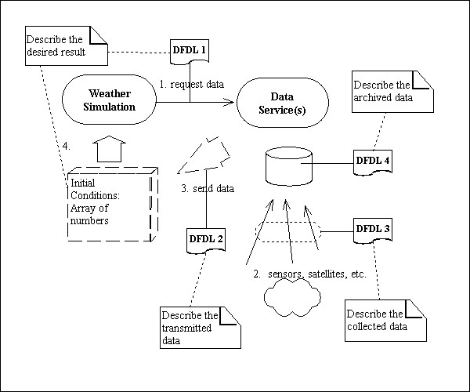
Figure 12

Example: MODIS Level 2 Data (NASA Earth Observing System)
The NASA Earth Observing System continuously measures the Earth, producing a Terabyte data per day in 2004. This data is distributed in a number of forms, and processed into hundreds of derivative products.

The Data Product
One of the key data products are the “Level 1B” data from the Moderate Resolution Imaging Spectrometer (MODIS), e.g., the 205m radiances (MOD02QKM) [1].
Each of these data sets contains 5 minutes of data, 288 datasets per day. The 250m data is 2 spectral bands, 1354 pixels per scan, 2030 scans per data product.
The data is stored and distributed in HDF-EOS, which is a profile of the HDF4 binary format [2]. The data is organized into standard data products, each instance is a file with extensive metadata and an array of satellite measurements. The data is access via custom readers that are linked with the HDF-EOS and HDF libraries.

Views of the Data
This dataset can be viewed in different ways. Physically, the data is collected as measurements from an orbiting satellite. The observations are horizontal scans across the orbital path of the satellite, which is a rectangle along the Earth (Figure 13a).
This data is stored in HDF-EOS as a single “swath” object [2]. The swath has multiple fields (one for each sensor band), with each pixel position geospatially located. That is, the latitude and longitude of each measurement is stored. Note that because of the geometry of the orbit, the data is not a rectangle with respect to the geo referenced grid (Figure 13b).
This object is stored as several HDF4 objects. The data is stored as a multidimensional array, with one plane per band. A second table holds the latitude and longitude for each position in the data array (Figure 13c). The file also contains substantial amounts of metadata as well.
The HDF objects are stored according to the HDF4 specification [3]. The file will contain a number of metadata objects, linked lists, and so on, which are managed by the internals of the library.

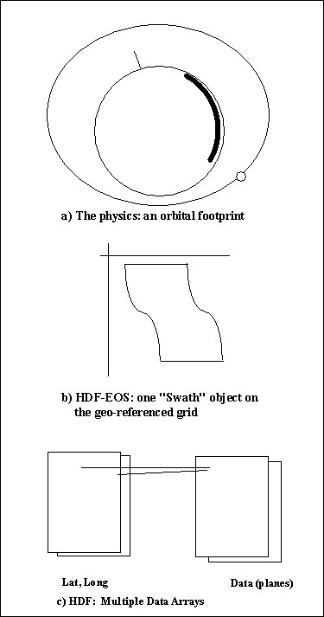
Figure 13

The File Layout
Table 1 lists the objects in one of these data products, and Table 2 shows the attributes with metadata. Each file in this series will have the same objects.

Table 1. HDF4 objects in MOD02QKM.A2004317.0000.004.2004317072459.hdf (original size: 286,058,198).
Attr: global attributes, VG: VGroup, VD: Vdata table, SDS: Datasets.
Type | Object | Dimensions | Number type | Size (bytes) | Attrs
Attr | Global attributes (50) |  |  | 76,474
VG | MODIS_SWATH_Type_L1B
VG | MODIS_SWATH_Type_L1B/Geolocation Fields
SDS* | MODIS_SWATH_Type_L1B/Geolocation Fields/Latitude | 2030x1345 | Float 32 | 10,921,400 | (3 attrs)
SDS * | MODIS_SWATH_Type_L1B/Geolocation Fields/Longitude | 2030x1345 | Float 32 | 10,921,400 | “
VG | MODIS_SWATH_Type_L1B/Data Fields
SDS * | MODIS_SWATH_Type_L1B/Data  Fields/EV_250_RefSB | 2 x 8120 x 5416 | Uint 16 | 175,911,680 | (14 attrs)
SDS * | MODIS_SWATH_Type_L1B/Data Fields/EV_250_RefSB_Uncert_Indexes | 2x8120x5416 | Uint 8 | 87,955,840 | (7 attrs)
VD | MODIS_SWATH_Type_L1B/Data Fields/Band_250M | 1 |  | 32
VG | MODIS_SWATH_Type_L1B/Swath Attributes
SDS*! | Noise in Thermal Detectors | 16x10 | Uint8 | 160
SDS*! | Change in relative responses | 16x10 | Uint8 | 160
SDS * | DC Restore Change for Thermal Bands | 203x16x10 | Uint8 | 32,480
SDS * | DC Restore Change for Reflective 250m Bands | 203x2x40 | Int8 | 16,240
SDS * | DC Restore Change for Reflective 500m Bands | 203x5x20 |  | 20,300
SDS * | DC Restore Change for  Reflective 1km Bands | 203x15x10 |  | 30,450
VD | Level 1B Swath Metadata | 203 | 64 bytes/ rec | 12,992

In this example product, there are dozens of objects, with three important blocks of metadata (StructMetadata.0, etc.), and a large payload of data (EV_250_RefSB)which is 2 x 8120 x 5416 elements, over 150MB.
These logical objects are written and physical records to the HDF4 file. The order and position of the objects in the file would depend on the precise sequence of writes in the program that creates the file.

Table 2. Global Attributes in MOD02QKM.A2004317.0000.004.2004317072459.hdf
HDFEOSVersion | 11 | char
StructMetadata.0 | 32,000 | char
CoreMetadata.0 | 16,515 | char
ArchiveMetadata.0 | 2,921 | char
Number of Scans | 1 | Int32
Number of Day mode scans | 1 | Int32
Number of Night mode scans | 1 | Int32
Incomplete Scans | 1 | Int32
Max Earth View Frames | 1 | Int32
%Valid EV Observations | 38 | Int32
%Saturated EV Observations | 38 | Float32
% L1A EV All Scan Data are Missing | 1 | Float32
% L1A EV RSB DN Not in Day Mode | 490 | Float32
% L1A EV DN Missing Within Scan | 490 | Float32
% Dead Detector EV Data | 490 | Float32
% Sector Rotation EV Data | 490 | Float32
% Saturated EV Data | 490 | Float32
% TEB EV Data With Moon in SVP | 490 | Float32
% EV Data Where Cannot Compute BG DN | 490 | Float32
% RSB EV Data With dn** Below Scale | 490 | Float32
% EV Data Where Nadir Door Closed | 490 | Float32
% EV Data Not Calibrated | 490 | Float32
Bit QA Flags Last Value | 1 | Uint32
Bit QA Flags Change | 1 | Uint32
Granule Average QA Values | 50 | Float32
Electronics Redundancy Vector | 2 | Uint32
Electronics Configuration Change | 2 | Uint32
Reflective LUT Serial Number and Date of Last Change | 21 | char
Emissive LUT Serial Number and Date of Last Change | 21 | char
QA LUT Serial Number and Date of Last Change | 21 | char
Focal Plane Set Point State | 1 | Int8
Doors and Screens Configuration | 1 | Int8
Reflective Bands With Bad Data | 22 | Int8
Emissive Bands With Bad Data | 16 | Int8
Noise in Black Body Thermistors | 12 | Int8
Noise in Average BB Temperature | 1 | Uint8
Noise in LWIR FPA Temperature | 1 | Uint8
Noise in MWIR FPA Temperature | 1 | Uint8
Noise in Scan Mirror Thermistor #1 | 1 | Uint8
Noise in Scan Mirror Thermistor #2 | 1 | Uint8
Noise in Scan Mirror Thermistor Average | 1 | Uint8
Noise in Instrument Temperature | 1 | Uint8
Noise in Cavity Temperature | 1 | Uint8
Noise in Temperature of NIR FPA | 1 | Uint8
Noise in Temperature of Vis FPA | 1 | Uint8
Dead Detector List | 490 | Int8
Noisy Detector List | 490 | Int8
Detector Quality Flag | 490 | Uint8
Earth-Sun Distance | 490 | Float32
Solar Irradiance on RSB Detectors over pi | 330 | Float32

DFDL Description(s) for this Dataset
This dataset could be described by DFDL at any of these views.
From a scientific point of view, it would probably be most useful to have a DFDL description that describes the swath object: a single, array with geospatial coordinates (as in Figure 13b). This data is available through calls to the HDF-EOS library layer.
It would also be possible to describe the stored objects, i.e., the data arrays and georeference arrays (as in Figure 13c). This would describe several arrays, along with blocks of metadata. This could be accessed via the HDF library layer.
Finally, the layout on disk can (in principle) be stated precisely. It would be theoretically possible to write a DFDL description for a given MODIS file, i.e., the exact location, type, and size of the control and data blocks in the physical file. These would be accessible through standard file system calls.
Of course, the file level description would be both complex and distantly related to the conceptual view of the data as a single array with attached metadata.

Layers
The DFDL is designed to handle data transformations via “layers”. In this example, one could imagine modeling the multiple views with layers.
This would require multiple descriptions, and a mapping between them. Note that the mapping would be essentially a reengineering of the HDF and HDF-EOS library code (whose function is to implement this mapping).
More likely, the data should be described at an intermediate level (some form of array), with call outs to the appropriate library when the data is needed.

Federated Data Access
This use case is one commonly expressed in the grid world, but it applies equally to non-grid. The intent is to manipulate federated data from any data source of interest, using XQuery or XPath, ie, as if it were XML. This presents a common API to the end user of the data, independent of the data source.
There are three different kinds of data source that can participate in this federation, Relational, XML and everything else. RDBMS Schema are available to describe the first, XML Schema to describe the second. For the third, a DFDL Schema would be associated with each different non-Relational, non-XML data format.

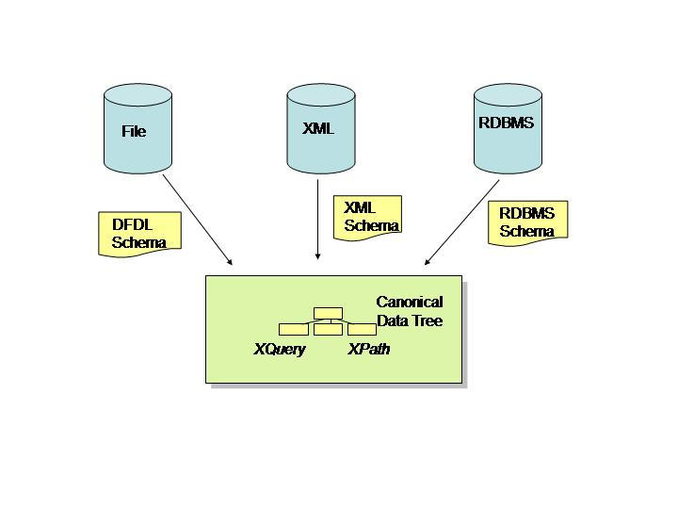

Processing of Retail Point of Sales Data
This use case is taken from the retail industry. The scenario is as follows:
- Sales data is typically gathered by point of sales (PoS) devices within retail stores in a data format known as TLOG. Several different flavours of TLOG exist (eg, ACE, GSA). All flavours are very compact data formats that use text delimiters to separate individual data fields, the fields themselves can be binary or text, and groups of fields are preceded by initiators.
- This sales data is then wrapped in XML and transmitted to head office. Because the TLOG data is effectively binary data, SOAP with Attachments (SwA) is used as the transmission format. This appears ‘on the wire’ as a multipart MIME message, the first part being the SOAP message, and subsequent parts being the TLOG data. (SwA uses MIME in this manner to ensure that attachments are safely transmitted).
- At head office the sales data is centrally recorded by an application such as ARTS DataMart. The recorded format would typically be different from the TLOG format created by the PoS device. One such format is XML and is called POSLog.
- This sales data may also be forwarded to other subsystems to be used for sales analysis. An example would be the Retek Sales Analysis module (RESA)..
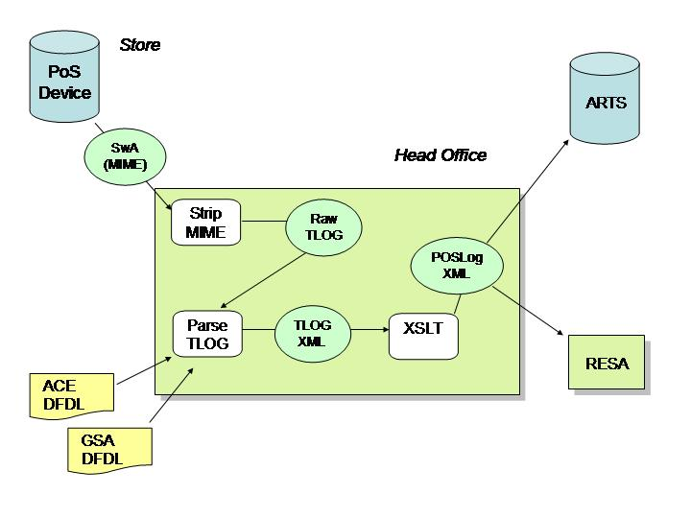
A different DFDL Schema can be used to describe each of the different flavours of TLOG.
Because TLOG is a very compact format, some of the data fields are packed in a TLOG-specific way. For example, numeric strings and decimals are both represented in a packed format not unlike S/390 packed decimal. Adjacent Booleans are packed together into a similar packed format. DFDL extensibility features would be needed to parse this packed data.

References

- MODIS Characterization Support Team, “MODIS Level 1B Product User’s Guide”, MCSA Document # PUB-01-U-0202-REV B, NASA Goddard Space Flight Center, 2003.
- http://hdfeos.gsfc.nasa.gov
- http://hdf.ncsa.uiuc.edu/doc.html
- lead.ou.edu
- Attribute-Relation File Format (ARFF), http://www.cs.waikato.ac.nz/~ml/weka/arff.htm
- Robert E. McGrath, Joe Futrelle, Ray Plante, Damien Guillaume, ``Digital Library Technology for Locating and Accessing Scientific Data'', accepted for ACM DL'99, August, 1999.
- Ian H. Witten and Eibe Frank, Data Mining: Practical Machine Learning Tools and Techniques (Second Edition), Morga Kauffnan, 2005.

Automatically translating between database schemas is very difficult (believed to be undecidable). But once such mappings are created, the DFDL can be used to apply them automatically.
Data, software, and documentation are available from NASA, e.g., http://daac.gsfc.nasa.gov/

